[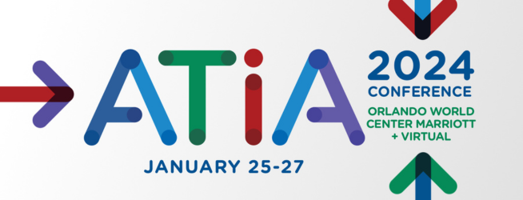](https://www.atia.org/atia-2024/)

**ATIA 2024: Connect. Discover. Inspire!**

**Speaker Marketing Kit**

Dear ATIA 2024 Speaker,

We’re excited you will be speaking at [ATIA 2024](https://www.atia.org/atia-2024/), taking place January 25–27 at the Orlando World Center Marriott (+ virtual)!

We encourage you to invite your contacts as well. We’ve created a toolkit to help you inform your colleagues, friends, and family about the conference. The toolkit includes:

1. Social Media
   * ATIA’s social media accounts
   * Share ATIA’s social media posts
   * Create your own social media posts
2. Email
   * Promotional email

Your promotion of ATIA 2024 ensures that your contacts and community are aware of your involvement, will help increase attendance, and create excitement about your session.

Things to remember:

* Conference webpage –[atia.org/conference](https://www.atia.org/atia-2024/)
* Webpage to register – [atia.org/register](https://www.atia.org/register/)
* Link for social media – <https://ow.ly/lWZv50PTHy4>
* Official conference hashtag – **#ATIA2024**

If you are looking for additional tools to help you promote or have any questions, please contact [marketing@atia.org](mailto:marketing@atia.org).

Sincerely,   
The ATIA Education Team

**Social Media**

**ATIA’s Social Media Accounts**

* Be sure to follow ATIA on social media:
* Facebook – [facebook.com/ATIA.org](https://www.facebook.com/ATIA.org/)
* Instagram – [instagram.com/atiaorg](https://www.instagram.com/atiaorg/)
* LinkedIn – [linkedin.com/company/assistive-technology-industry-association](https://www.linkedin.com/company/assistive-technology-industry-association/)
* YouTube – <https://www.youtube.com/@ATIAorg>
* Twitter/X – [twitter.com/ATIAorg](https://twitter.com/ATIAorg)

**Share ATIA’s Social Media Posts**

**The easiest way to help spread the word** about your session at ATIA 2024 is to share posts that ATIA has already shared on social media. Here’s how:

* Go to the social media platform of your choice and in the “search” feature search for the hashtag **#ATIA2024**.
* Pick any of the posts that ATIA has shared and select “share” (or repost, depending on the platform) through your social accounts.
* Before you share, there is an option to add your own message. Customize your post and add anything you want!

**Create Your Own Social Media Posts**

Another way to help promote your session and ATIA 2024 is to create your own social media posts. Make sure you include the social media link, <https://ow.ly/lWZv50PTHy4>, OR your unique session link**\***, and the official conference hashtag **#ATIA2024** in your posts.

We’ve provided sample copy and graphics for you to use below. All you need to do is fill in the yellow highlighted text with your specific session information.

1. **Social Media Copy:**

I’ll be speaking at ATIA 2024, January 25–27 in Orlando. Attend my session, [SESSION TITLE], to discover more about [TOPIC]. <https://ow.ly/lWZv50PTHy4> #ATIA2024

If you’re coming to ATIA 2024, January 25–27 in Orlando (or virtually), plan to attend my session, [SESSION TITLE], where you will learn about [TOPIC]. <https://ow.ly/lWZv50PTHy4> #ATIA2024

Want to learn more about [SESSION STRAND]? I’ll be speaking about [TOPIC] during my session, [SESSION TITLE], at ATIA 2024 in Orlando this January. Hope to connect with you there! <https://ow.ly/lWZv50PTHy4> #ATIA2024

1. **Social Media Graphics:**

Add one of the graphics below to your social media copy. *To save the graphic, right click on the image and select “Save as Picture”.*

**Social media graphic 1 – Connect. Discover. Inspire**

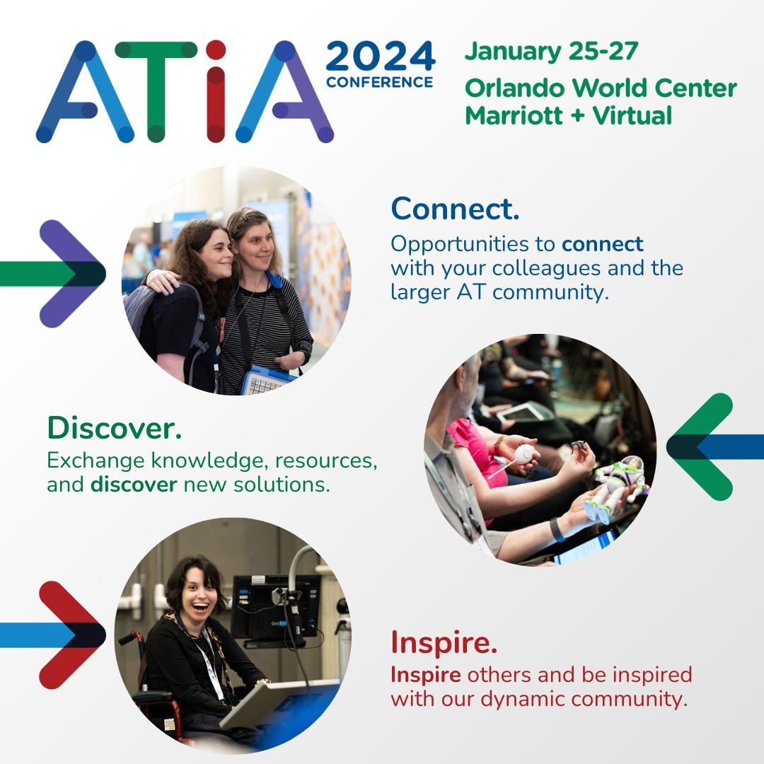   
Alternative text:ATIA 2024 Conference, January 25 through 27, at the Orlando World Center Marriott plus Virtual. Connect - Opportunities to connect with your colleagues and the AT community. Discover - Exchange knowledge, resources, and discover new solutions. Inspire - Inspire others and be inspired with our dynamic community!

**Social media graphic #2 – Join Me!**

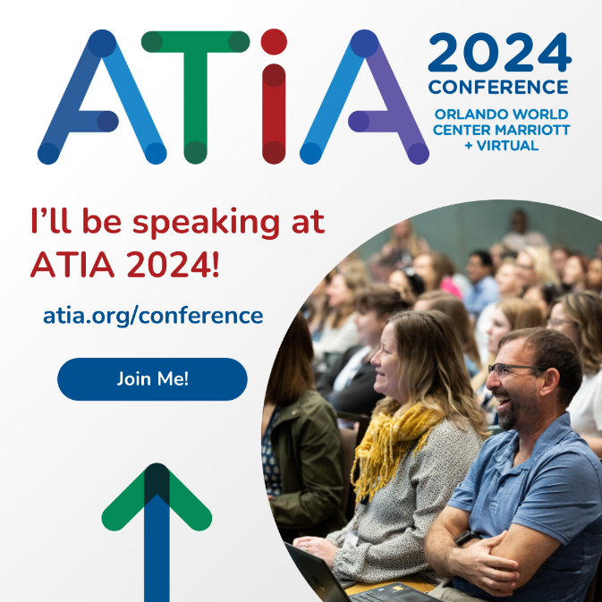  
Alternative text: ATIA 2024 Conference, Orlando World Center Marriott + Virtual. I’ll be speaking at ATIA 2024! atia.org/conference – join me!

**\*How to obtain links to your specific session(s) information:**

**Option 1 – Session Link**

* Go to the [Session Directory](https://s3.goeshow.com/atia/orlando/2024/new_session_directory.cfm)
* Select the “Search/Filter” option
* Under “Speaker(s)” select your name from the dropdown options
* It will then populate all sessions where you are a speaker
* Click on the session title
* A pop-up page with your session information will appear
* In the upper right corner of this new pop-up page, click on the white arrow
* Your session information will now open up into a new tab
* The URL in your browser is your unique session link that you can share on social media if you want to direct people to information about your specific session.

**Option 2 – Biography Link**

* Go to the [Session Directory](https://s3.goeshow.com/atia/orlando/2024/new_session_directory.cfm)
* Select the “Search/Filter” option
* Under “Speaker(s)” select your name from the dropdown options
* It will then populate all sessions where you are a speaker
* Click on your name
* A pop-up page with your biography and speaker sessions will appear
* Next to your name of this new pop-up page, click on the white arrow
* Your biography and speaker session information will now open up into a new tab
* The URL in your browser is your unique biography link that you can share on social media if you want to direct people to information about you and all of your sessions.

**Email**

In addition to your social media efforts, you may also want to email your contacts. Simply fill in the yellow highlighted text with your information, copy into your email platform, and send!

**Subject: Join Me at ATIA 2024!**

Dear [CONTACT NAME],

I will be presenting at [ATIA 202](https://www.atia.org/atia-2023/)4 and I invite you to join me and the AT community! The conference will take place January 25–27 in Orlando, and virtually.

As an attendee, you’ll have opportunities to connect with the larger AT community, exchange knowledge and discover new solutions, and inspire others (and be inspired yourself!).

There will be 300+ sessions and 500+ speakers covering a variety of [session strands](https://www.atia.org/atia-2024-strands/). Access and search the [online session directory](https://s3.goeshow.com/atia/orlando/2024/new_session_directory.cfm) to start planning your schedule.

I invite you to attend my session, [SESSION TITLE], to learn more about [SESSION DESCRIPTION].

The ATIA conference offers great value with flexibility. Multiple [registration options](https://www.atia.org/atia-2024-registration/) are available—select the package that works best for you. Can’t join me in Florida? There’s also an option to attend [virtually](https://www.atia.org/atia-2024-virtual-event/).

[Registration](https://www.atia.org/register/) is open now—I hope to see you there!

Sincerely,

[SIGNATURE]