Manuscript Preparation Guidelines for Authors
Updated July 2023

All manuscripts will be reviewed by external peer reviewers as well as members of the ATOB Editorial Board. Recommendations on suitability for publication will be taken as final by the Editor. The Editorial Board reserves the right to refuse any manuscript, or to edit copy with the approval of contributors.
Authors should refer to the ATOB Editorial Policy for information regarding the Journal’s aim and scope, submission categories, and types of articles accepted.

General Guidelines
Each submission should have at least the following components submitted as separate files:
- Cover letter, including:
  - A description of the work’s contribution to the field, and relation to the issue’s topic
  - A note if the manuscript has been published in whole or substantial part by another publisher and/or is not currently under review by another journal (if applicable)
  - The article’s submission category (Voices from the Field, Voices from the Industry, Voices from Academia), as described in the ATOB Editorial Policy.
  - The type of article, as described in the ATOB Editorial Policy.
- Title page submitted as a separate file, including:
  - Full name, title, and organizational affiliation (if any) of each author
  - Identification of the corresponding author
  - Full contact information of the corresponding author, including email address, postal address, telephone and fax numbers
- Manuscript – should be no more than 20-25 pages of text with references excluding Tables and Figures. Main text should include:
  - Title (up to 10 words) – should not include abbreviations
  - Abstract (75 to 150 words) – presenting the main points of the paper and the conclusions regarding outcomes and benefits
  - 3-4 keywords separated by commas (e.g., communication devices, families)
  - Main body of paper. Please refer to the Sample Outline for Voices from the Field (for Voices from the Field and some Voices from the Industry manuscripts) and Sample Outline for Voices from Academia (for Voices from Academia and some Voices from the Industry manuscripts). The main body should include two sections that are unique to ATOB.
    - Target Audience and Relevance section – short description of the article’s target audience, and the article’s relevance to that audience. Authors may describe their work as it relates to more than one audience, specifying the value that each group may derive from the work.
    - Outcomes and Benefits section – discussion related to outcomes and benefits of the AT devices/services experiences addressed in the article
  - References
- Tables and Figures – should be submitted in a separate file.
- A copy of IRB approval (or a local equivalent including but not limited to an independent ethics committee (IEC), ethical review board (ERB), research ethics board (REB), etc.) should be submitted along with the manuscript for any paper describing work that was subject to such requirements.
  - Many Voices from the Field submissions will not be subject to IRB approval. If Authors are uncertain whether their work requires IRB approval, they are encouraged to contact the Editor at: atobeditor@atia.org.
  - If a submission is not subject to IRB approval, the Main Body should include a sentence to the effect of, “This manuscript represents the perspective of the author and the work reported herein was not subject to IRB oversight.”
  - International authors may refer to International Compilation of Human Research Standards published by the Office of Human Research Protections (OHRP) for regulations and guidelines on human subjects’ protections in over 100 countries.

Submission & Review Process
- To submit a manuscript, authors should complete the manuscript submission and author agreement forms as well as upload their manuscript and all accompanying documents on the ATOB Volume 18 Open Call webpage.
- Manuscripts will undergo a desk review by the ATOB Editorial Board. Decisions to either reject or move manuscripts on for peer review will be communicated with authors.
- For those manuscripts undergoing blind peer review, the Editorial Board will make acceptance/rejection decisions, while taking peer reviewer feedback into consideration.
- After a manuscript has been accepted for publication and subsequent to making changes recommended by peer reviewers and the Editorial Board, authors must email a copy of the revised manuscript and a cover letter describing all changes to the Editor at: atobeditor@atia.org.
- All manuscripts will also be assessed for accessibility. Authors will be asked to provide appropriate descriptions for all tables and figures.
- Galley proofs will be shared with authors for approval prior to publication.

Review Criteria
Each manuscript submitted will be reviewed by the Editorial Board and blind peer reviewers based on the following criteria:
- Significance of the manuscript to the field – Does the manuscript represent an original contribution to the field of assistive technology?
- Relevance to the specific issue’s focused topic area – does the manuscript’s general content address the focused area?
- Adequacy of background information
  - Voices from the Field: Does the author provide enough context/background to understand the basis for their perspective? Are any general statements supported by citations from existing research (if applicable)?
  - Voices from Academia: Does the manuscript frame the main point(s) within the current state of the practice within the field offering adequate discussion regarding the state of practice? Is the purpose of the study clearly stated and justified by the review of relevant literature?
- Appropriateness of new knowledge presented
  - Voices from the Field: Main Body Section - Does the author include the detailed description of personal experiences and lessons learned using AT? Does the author successfully support their claims/statements with examples and explanations based on personal experience, and are general statements supported by evidence?
  - Voices from Academia: Methods/Results/Discussion sections
    - Appropriate research design - Are the methods adequately described such that a reader can determine the quality of the study and potentially replicate the results? Is the method and sample population appropriate for research questions?
    - Appropriate data analysis and presentation of results - Are the results sufficiently described such that a reader can determine the quality of the study? Are appropriate analyses used?
    - Appropriate interpretations of results - Are the interpretations and conclusions justified by the results? Are research limitations and implications for future research discussed? Are implications for AT practice discussed?
- Target Audience and Relevance (Special ATOB Section) – Does the manuscript appropriately identify the audiences who are likely to have an interest in the paper’s content? Are any stakeholder groups missing or is the significance to any groups overstated?
- Outcomes and Benefits (Special ATOB Section)
  - Voices from the Field: Does the manuscript adequately summarize the author’s perspective and offer practical implications for other AT users?
  - Voices from Academia: Does the author adequately detail the manuscript’s value for the AT field?
- Organization - Are the sections structured in a logical order?
- Clarity - Is the manuscript understandable and readable?

Specific Guidelines
Authors are also asked to adhere to the following guidelines:
- Each manuscript must reflect the style guidelines of the 7th edition Publication Manual of the American Psychological Association (APA) - https://apastyle.apa.org.
- All manuscripts should be submitted in a Microsoft® Word format (ONLY).
- Manuscripts should be no more than 20-25 pages in length (double-spaced) including references but excluding tables and figures.
- Tables and figures should be submitted in a separate file. Preferred location of figures and tables should be identified in main text (e.g., [Insert Table 1 here]).
- Articles should be subdivided into unnumbered sections, using short, meaningful headings according to Publication Manual of the APA.
- Footnotes and endnotes are not accepted; all such information should be included in main text.
- Hyphenation is allowed in compounds words only (see pp. 162-163 of APA Manual 7th Edition for hyphenation guidelines)
- Authors should not use underline to emphasize text, but use italics instead.
- Authors should avoid the use of acronyms when describing people with disabilities.
- Acronyms should be used sparingly and with the intent of improving the readability of a paper.
- All statistical symbols should be in italics.
- Authors are encouraged to write in the third person, with the exception of Voices from the Field submissions, which may use the first person.
- Authors should use “person-first” language, i.e., the individual precedes the disability. For example, phrases such as “persons with disabilities,” “students with intellectual disabilities,” “and “adults with cognitive impairments” are more appropriate than such phrases as “the disabled,” or “learning disabled students.”
- Formatting Tables
  - Captions (maximum 6 to 8 words each) must be provided for every table (above the table) and must be referenced in the text.
  - Tables should not be graphic images, but should be original tables created using the Table feature of Microsoft® Word (see pp. 195-224 of APA Manual 7th Edition for table preparation guidelines).
Sample table:
Table 1
Focus Group Participant Demographics
Professional | Gender | Degree | Yrs. Education | Role | Classroom
Sam | M | BS | 16 | Teacher | Pre-K
Joan | F | BS | 17 | Aide | Pre-K
Deborah | F | BS | 16 | Aide | Pre-K
Makela | F | HS | 12 | Aide | ECE
Tom | M | BS | 14 | Aide | ECE

- Formatting Figures
  - Preferred figure formats include .tiff, .eps, and .jpg. If copying and pasting the figure/graph from Excel, also submit that Excel file.
  - All figures should include alt text titles and long descriptions to ensure that pertinent information is available to visually impaired readers who may be using a screen reader.
  - Figures should be embedded in the text narrative at appropriate places and centered horizontally.
  - Captions (maximum 6 to 8 words each) must be provided for every figure (above the figure) and must be referenced in the text.
  - If scanned images are used as figures, authors are responsible for ensuring that they are crisp images (i.e., no pixilation, fuzziness, or shading artifacts).
  - Figures should NOT have text captions embedded in them. Text captions should be contained in the narrative.
  - Figures that are copyrighted or adapted from copyrighted figures must have approval for use. Notation of this approval should be included in the figure caption, and a letter from the copyright holder indicating approval for use or adaptation should be submitted with the manuscript (see p. 225-250 of APA Manual 7th Edition for guidelines).
Example figures:

Figure 1
Comparison of Direct Teaching vs. use of Calculator on Functional Performance
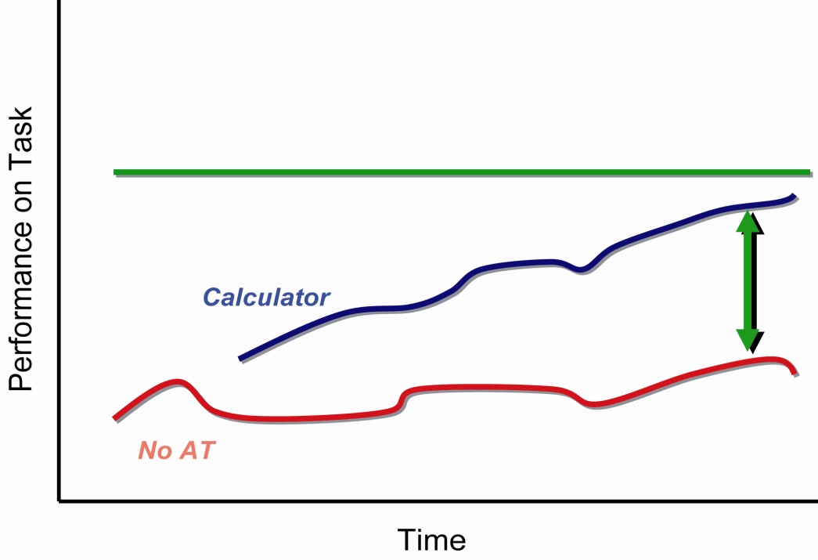
Note: Source - ©2007, SEAT Center. Used with permission.
If the figure is excerpted or adapted from a previously published source:
Figure 1
Comparison of Direct Teaching vs. use of Calculator on Functional Performance
Note: Source - Parette, H. P., Peterson-Karlan, G. R., Wojcik, B. W., & Bardi, N. (2007). Monitor that progress! Interpreting data trends for AT decision-making. Teaching Exceptional Children, 39(7), p. 6. Used with permission.
- The References section should contain appropriate citations in the format noted in the APA Manual (7th ed.)

Sample Citations
Journal article
James, P., & Tatem, J. J. (2003). Assistive technology benefits. American Journal of Occupational Therapy, 39(4), 336-337. https://doi.org/11111.11
Conference paper presentation
Stuart, S. K., & Kemp, L. M. (2022, January 25-29). Assistive technology and AAC issues. Paper presented to the Annual Meeting of the Assistive Technology Industry Association, New Orleans, LA.
Book
Kalyanpur, M., & Harry, B. (1999). Culture in special education. Building reciprocal family-professional relationships. Brookes.
Book chapter
Soto, G., Huer, M., & Taylor, O. (1997). Multicultural issues in augmentative and alternative communication. In L. Lloyd, D. Fuller, & H. Arvidson (Eds.), Augmentative and alternative communication (pp. 406-413). Allyn and Bacon.
Legislation (Any law that is described in the manuscript narrative must be included in the Reference List; see p. 404 of APA Manual)
Individuals with Disabilities Education Act Amendments, 20 U.S.C. § 1400 et seq (1997).
No Child Left Behind Act, 20 U.S.C. 6301 et seq. (2001)
Electronic Resources (For any electronic citation, please refer to the APA Manual for appropriate formats. Please be sure that the most current link to the file or website is presented in the reference). For electronic resources that may get updated, include a retrieval date.
Examples:
Assistive Technology Industry Association. (n.d.). What is AT? https://www.atia.org/at-resources/what-is-at/
The U.S. Equal Opportunity Commission. (2020). Facts about the Americans with Disabilities Act. Retrieved March 15, 2022, from http://www.eeoc.gov/facts/fs-ada.html

