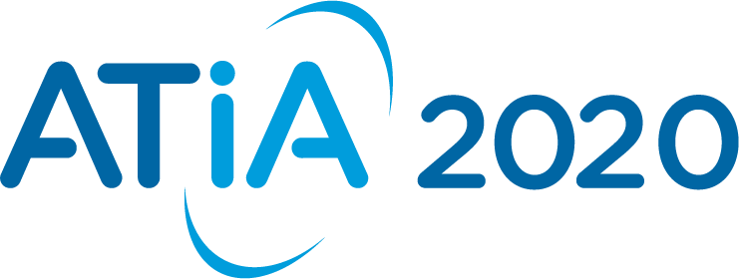

ATIA 2020 Orlando Conference and Exhibition
Pre-Conference Seminars: January 28-29, 2020 (Separate fee to participate)
Conference & Exhibit Hall Open: Wednesday, January 29 – Saturday, February 1, 2020
Caribe Royale All Suites Hotel & Convention Center
Orlando, Florida

PRIVACY STATEMENT FOR ATIA 2020
By registering, you acknowledge the following privacy statement:

The Assistive Technology Industry Association (the “Association”) values your trust, and we understand the importance of protecting your privacy. We want to make sure you understand how your information is collected and used by the Association. This privacy statement describes what information we collect about you, including when and how we collect it; how we use it; with whom we may share it; and what choices you have regarding our use of your information.

The Association will collect your name, title, organization, address, email, telephone number and other demographic questions related to your role and interests in AT. This information will be used for communications concerning the event and future marketing of Association programs and events. This information, excluding telephone numbers, will be included in a bar code located on your event badge.

Exhibitors and the Association who scan your event badge will be able to use your information for promotional purposes.

YOU HAVE THE RIGHT TO OPT OUT OF THIS PROMOTIONAL ACTIVITY BY NOT ALLOWING THE SCANNING OF YOUR BADGE.

ATTENDEE REGISTRATION FORM

Please print clearly or type (this form may be copied for additional registrants.)

First Name: _______________________________________________________________________________

Last Name: ________________________________________________________________________________

Badge Nickname: ________________________Position/Title: ________________________________________

Company Name: ____________________________________________________________________________

Address: __________________________________________________________________________________

City/State/Zip Code/Country: __________________________________________________________________

Phone: ____________________________________Fax: ____________________________________________

E-mail: ______________________________ Additional Confirmation Email: ____________________________

If you need to be accompanied by an assistant, please enter their name here for a complimentary assistant badge. Please note: assistant registrants are not eligible for continuing education credit.

Assistant First Name: ___________________ Assistant Last Name: ________________________________

Assistant Email: __________________________________________________________________________

If you are paying with a purchase order, please provide billing contact information.
Billing Contact Name: _______________________________________________
Billing Contact Phone Number: ________________________________________
Billing Contact Email Address: ________________________________________

If you have any special needs, accommodations, or dietary requests, please detail your requirements below:
Please note: Requests for sign interpreters must be made one month in advance of the conference. Unfortunately, requests for sign interpreters after Friday, December 27, 2019 will not be accommodated. Sighted guides are available for one hour periods onsite based on availability. Accessible conference materials will be available for download in advance of the conference.
______________________________________________________________________________________
______________________________________________________________________________________
_______________________________________________________________________________________________

ATTENDEE PROFILE

Please indicate your interest area(s) (select all that apply):

(A) AAC (Augmentative & Alternative Communication)

(B) Accessibility

(C) Blind/Low Vision

(D) Deaf/Hard of Hearing

(E) Education & Learning

(F) Higher Education

(G) Physical Access/Mobility

(H) Transition/Workplace

(I) Other (please specify)

___________________________________

Registration Categories / Fees
Please identify the fees in the proper tier associated with your registration category and include the total below.

Exhibit Hall (Wednesday thru Saturday) | $0.00
Pre-paid Lunch Ticket: Select Days required:  Tuesday / Wednesday / Thursday / Friday | $18.50 per lunch ticket

5 WAYS TO REGISTER
ONLINE: www.atia.org/registerORL FAX: 847-277-7414
EMAIL: registration@atia.org TELEPHONE: 847-620-4471
MAIL: ATIA Registration, 8324 Solutions Center, Chicago, IL 60677-8003

If you submit this form via fax, email, online, or mail, you are agreeing to the applicable policies outlined below.

Cancellation Policy: A full refund will be granted to cancellations made in writing on or before Monday, November 25, 2019. Name changes and substitutions are allowed at no fee. Regrettably, no refunds will be given on cancellations received on or after Tuesday, November 26, 2019. Phone cancellations will not be accepted. Written cancellations must be sent by email to registration@atia.org or faxed to +1 847-277-7414.
If any circumstances or event beyond the control of ATIA causes cancellation of all or any portion of the event, ATIA agrees to refund any portion of the registration fee which ATIA is reimbursed by insurance or other third party and shall not be liable for any other refund or payment arising from the cancellation or for other liability or damages arising from the event.

Please Note:
I understand that by registering and participating in ATIA and its events, activities, programs and other functions, I agree that ATIA shall not be held responsible for any claims, demands, actions, judgments, costs, and expenses, including costs of defense thereof, incurred by me, my employees, guests or clients, which arise due to any products and/or services delivered or otherwise provided to me, my employees, guests or clients.
On occasion, an ATIA photographer may take photos of participants at ATIA 2020 participating in conference functions or activities. Please be aware that these photos are for ATIA's use only, and may appear in ATIA conference programs, brochures, newsletters, website and other publications and materials. In addition, some sessions may be videotaped. Your attendance constitutes your permission and consent for this photography and videography and subsequent usage.

