Assistive Technology Outcomes and Benefits Journal
Published by Assistive Technology Industry Association (ATIA)

Manuscript Preparation Guidelines for Authors
Updated March 2019

All manuscripts will be reviewed by external peer reviewers, as well as members of the ATOB Editorial Board. Recommendations on suitability for publication will be taken as final by the Editor. The Editorial Board reserves the right to refuse any manuscript, or to edit copy with the approval of contributors.

Authors should refer to the ATOB Editorial Policy for information regarding the Journal’s aim and scope, submission categories, and types of articles accepted.

General Guidelines

Each submission should have at least the following components:
- Cover letter, including:
  - A description of the work’s contribution to the field, and relation to the issue’s topic
  - Affirmation that the manuscript has not been published in whole or substantial part by another publisher and that it is not currently under review by another journal
  - The article’s submission category (Voices from the Field, Voices from the Industry, Voices from Academia), as described in the ATOB Editorial Policy.
  - The type of article, as described in the ATOB Editorial Policy.
- Cover page, including:
  - Full name, title, and organizational affiliation (if any) of each author
  - Identification of the corresponding author
  - Full contact information of the corresponding author, including email address, postal address, telephone and fax numbers
- Title (up to 10 words)- should not include abbreviations
- Abstract (75 to 150 words)- presenting the main points of the paper and the conclusions regarding outcomes and benefits
- 3-4 keywords separated by commas. Each keyword phrase should have initial caps (e.g., Communication devices, Families)
- Main body of paper. The main body should include two sections that are unique to ATOB:
  - Outcomes and Benefits section- discussion related to outcomes and benefits of the AT devices/services addressed in the article
  - Target Audience and Relevance section- short description of the article’s target audience, and the article’s relevance to that audience. Authors may describe their work as it relates to more than one audience, specifying the value that each group may derive from the work
- References

Each manuscript must reflect the style guidelines of the 6th edition Publication Manual of the American Psychological Association (APA). Authors are also asked to adhere to the following guidelines:
- All manuscripts should be submitted in a Microsoft® Word format.
- Manuscripts should be no more than 25 pages in length (double-spaced), including references, tables, and figures.
- Articles should be subdivided into unnumbered sections, using short, meaningful headings according to Publication Manual of the APA.
- A copy of IRB approval should be submitted along with the manuscript for any paper describing work that was subject to such requirements.
  - Many Voices From the Field submissions will not be subject to IRB approval, particularly Consumer and Caregiver Perspective pieces. If Authors are uncertain whether their work requires IRB approval, they are encouraged to contact the Editor at: atobeditor@atia.org.
  - If a submission is not subject to IRB approval, the Main Body should include a sentence to the effect of, “This manuscript represents the perspective of the author and the work reported herein was not subject to IRB oversight.”
- Footnotes and endnotes are not accepted; all such information should be included in main text.
- Authors should not use underline to emphasize text, but use italics instead.
- Authors should avoid the use of acronyms when describing people with disabilities.
- Acronyms should be used sparingly and with the intent of improving the readability of a paper.
- All statistical symbols should be in italics.
- Authors are encouraged to write in the third person, with the exception of Consumer and Caregiver Perspectives submissions, which may use the first person.
- Authors should use “person-first” language, i.e., the individual precedes the disability. For example, phrases such as “persons with disabilities,” “students with intellectual disabilities,” “and “adults with cognitive impairments” are more appropriate than such phrases as “the disabled,” or “learning disabled students.”

- Formatting Tables
  - Tables should be included in the text at appropriate places and centered horizontally.
  - Captions (maximum 6 to 8 words each) must be provided for every table (above the table) and must be referenced in the text.
  - Tables should not be graphic images, but should be original tables created using the Table feature of Microsoft® Word (see pp. 125-150 of APA Manual for table preparation guidelines).
Example table:
Table 1
Focus Group Participant Demographics
Professional | Gender | Degree | Yrs. Education | Role | Classroom
Sam | M | BS | 16 | Teacher | Pre-K
Joan | F | BS | 17 | Aide | Pre-K
Deborah | F | BS | 16 | Aide | Pre-K
Makela | F | HS | 12 | Aide | ECE
Tom | M | BS | 14 | Aide | ECE

- Formatting Figures
  - Preferred figure formats include .tiff, .eps, and .jpg.
  - All figures should include alt text titles and long descriptions to ensure that pertinent information is available to visually impaired readers who may be using a screen reader.
  - Figures should be embedded in the text narrative at appropriate places and centered horizontally.
  - Captions (maximum 6 to 8 words each) must be provided for every figure (below the figure) and must be referenced in the text.
  - If scanned images are used as figures, authors are responsible for ensuring that they are crisp images (i.e., no pixilation, fuzziness, or shading artifacts).
  - Figures should NOT have text captions embedded in them. Text captions should be contained in the narrative.
  - Figures that are copyrighted or adapted from copyrighted figures must have approval for use. Notation of this approval should be included in the figure caption, and a letter from the copyright holder indicating approval for use or adaptation should be submitted with the manuscript (see p. 173 of APA Manual for guidelines).
Example figures:
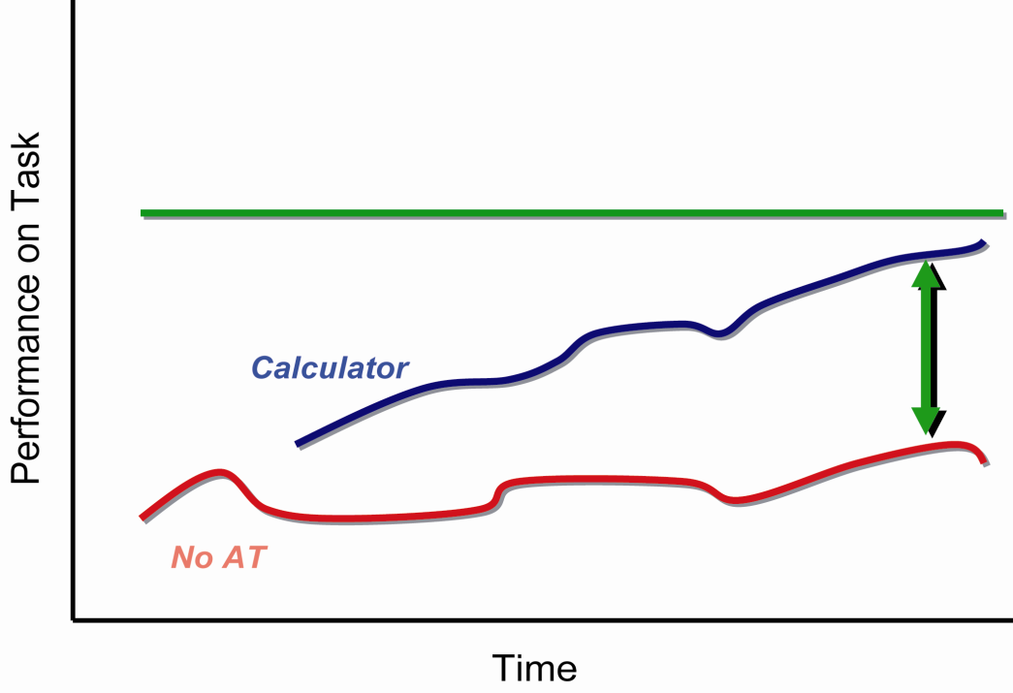
Figure 1. Comparison of direct teaching vs. use of calculator on functional performance. Source: ©2007, SEAT Center. Used with permission.

If the figure is excerpted or adapted from a previously published source:
Figure 1. Comparison of direct teaching vs. use of calculator on functional performance. Source: Parette, H. P., Peterson-Karlan, G. R., Wojcik, B. W., & Bardi, N. (2007). Monitor that progress! Interpreting data trends for AT decision-making. Teaching Exceptional Children, 39(7), p. 6. Used with permission.

- The References section should contain appropriate citations in the format noted in the APA Manual (6th ed.)
Sample citations
Journal article
James, P., & Tatem, J. J. (2003). Assistive technology benefits. American Journal of Occupational Therapy, 39, 336-337.
Paper presentation
Stuart, S. K., & Kemp, L. M. (2003, January). Native Americans and AAC issues. Paper presented to the Annual Meeting of the Assistive Technology Industry Association, New Orleans, LA.
Book
Kalyanpur, M., & Harry, B. (1999). Culture in special education. Building reciprocal family-professional relationships. Baltimore: Brookes.
Book chapter
Soto, G., Huer, M., & Taylor, O. (1997). Multicultural issues in augmentative and alternative communication. In L. Lloyd, D. Fuller, & H. Arvidson (Eds.), Augmentative and alternative communication (pp. 406-413). Boston: Allyn and Bacon.
Legislation (Any law that is described in the manuscript narrative must be included in the Reference List; see p. 404 of APA Manual)
Individuals with Disabilities Education Act Amendments, 20 U.S.C. § 1400 et seq (1997).
No Child Left Behind Act, 20 U.S.C. 6301 et seq. (2001)
Electronic Resources (For any electronic citation, please refer to the APA Manual for appropriate formats. Please be sure that the most current link to the file or website is presented in the reference.)
Examples:

Assistive Technology Industry Association. (n.d.). What is AT? Retrieved April 25, 2016, from https://www.atia.org/at-resources/what-is-at/

The U.S. Equal Opportunity Commission. (2008). Facts about the Americans with Disabilities Act. Retrieved March 10, 2016, from http://www.eeoc.gov/facts/fs-ada.html

Submission Instructions
- To submit a manuscript, authors should email the following to atobeditor@atia.org:
  - Manuscript submission form
  - Author agreement
  - Manuscript
  - Cover letter
- Manuscripts will undergo a desk review by the ATOB Editorial Board. Decisions to either reject or move manuscripts on for peer review will be communicated with authors.
- For those manuscripts undergoing peer review, the Editorial Board will make acceptance/rejection decisions, while taking peer reviewer feedback into consideration.
- After a manuscript has been accepted for publication and subsequent to making changes recommended by peer reviewers and the Editorial Board, authors must email a copy of the revised manuscript and a cover letter describing all changes to the Editor at: atobeditor@atia.org.
- Galley proofs will be shared with authors for approval prior to publication.

