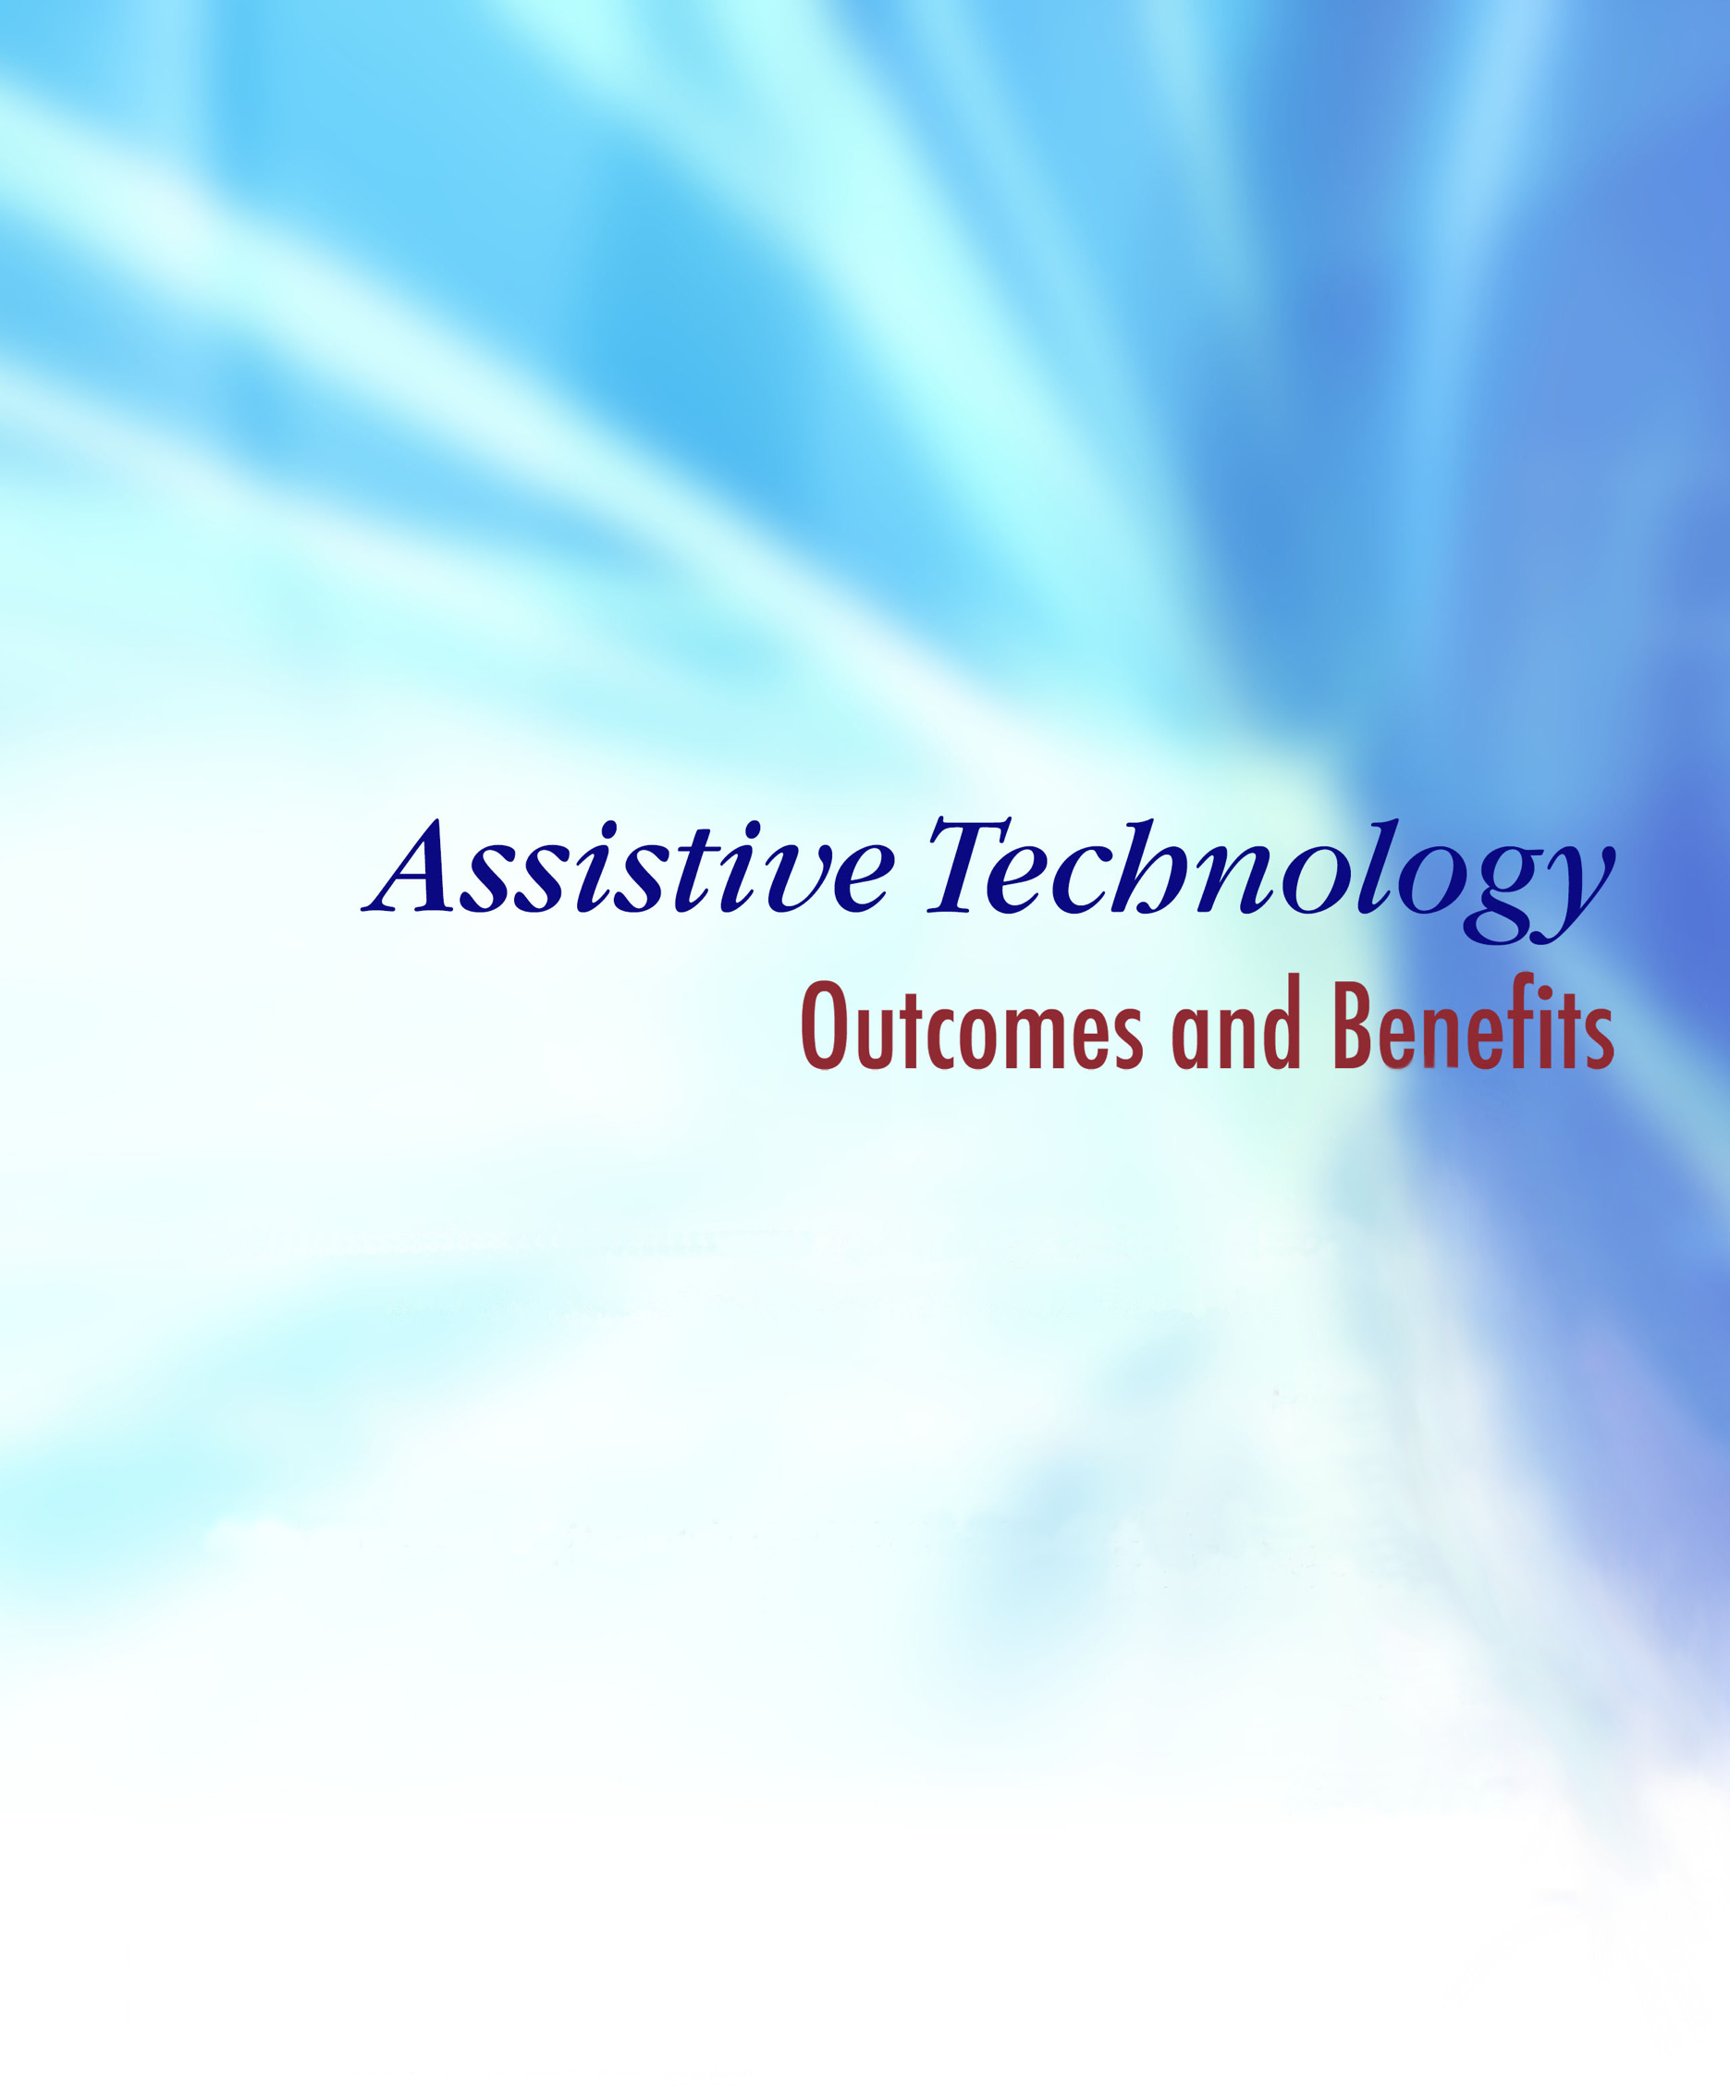
Published by the Assistive Technology Industry Association (ATIA)
Volume 12
Summer 2018

Implementing AT in Practice: New Technologies and Techniques
Jennifer L. Flagg
Editor-in-Chief

Kate Herndon &
Carolyn P. Phillips
Associate Editors

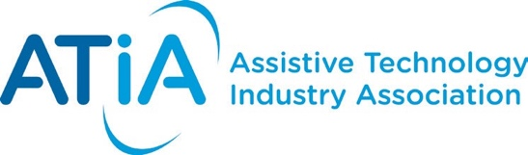

Copyright © 2018

Assistive Technology Industry Association

ISSN 1938-7261

Assistive Technology Outcomes and Benefits

Implementing AT in Practice: New Technologies and Techniques
Volume 12, Summer 2018

Editor-in-Chief
Jennifer L. Flagg
Center on KT4TT & TCIE, University at Buffalo

Publication Managers

Victoria A. Holder

Tools for Life, Georgia Institute of Technology

Elizabeth A. Persaud

Tools for Life, Georgia Institute of Technology

Caroline Van Howe

Assistive Technology Industry Association

Associate Editors

Kate Herndon

American Printing House for the Blind

Carolyn P. Phillips

Tools for Life, Georgia Institute of Technology

Copy Editor

Beverly Nau

Assistive Technology Outcomes and Benefits is a collaborative peer-reviewed publication of the Assistive Technology Industry Association (ATIA).

Editing policies of this issue are based on the Publication Manual of the American Psychological Association (6th edition) and may be found online at www.atia.org/atob/editorialpolicy. The content herein does not reflect the position or policy of ATIA and no official endorsement should be inferred.

Editorial Board Members and Managing Editors

David Banes

Managing Director, David Banes Access and Inclusion Services

Russell T. Cross

Director of Clinical Operations, Prentke Romich Company

Anya Evmenova

Assistant Professor, Assistive and Special Education Technology, George Mason University

Lori Geist

Research Associate/Project Director, Center for Literacy & Disability Services, UNC Chapel Hill

William E. Janes

Assistant Professor, Department of Occupational Therapy, University of Missouri

Beth Poss

Administrator, Montgomery County Schools, Maryland

Ben Satterfield

Research Consultant, Center for AT Excellence, Tools for Life at Georgia Institute of Technology

Judith Schoonover

Occupational Therapist and AT Specialist, Loudoun County District Public Schools, Virginia

AOTA Fellow

Joy Zabala

Co-Director, National Center on Accessible Educational Materials

Director of Technical Assistance, CAST

Peer Reviewers for ATOB Volume 12

Implementing AT in Practice: New Technologies and Techniques

The Editorial Board would like to thank the peer reviewers who generously donated their time and talent to reviewing manuscripts for this Volume 12 of ATOB.
Charles William Binko
Carrie Bruce
Siobhán Long
Mike Marotta
Tessa McCarthy
Laura Nichols
Luis Perez
Patricia Politano
Ben Satterfield
Judith Schoonover
Larry Skutchan
Laura Smith
Stephen Sutter
Lisa Wadors Verne

Assistive Technology Outcomes and Benefits

Editorial Policy

Aim and Scope
Assistive Technology Outcomes and Benefits, published by the Assistive Technology Industry Association, is an open access, peer-reviewed journal that publishes articles specifically addressing the benefits and outcomes of assistive technology (AT) for Persons with Disabilities across the lifespan. The journal’s purpose is to advance the AT industry by (a) fostering communication among stakeholders interested in the field of AT, including manufacturers, vendors, practitioners, policy makers, researchers, consumers with disabilities, and family members; (b) facilitating evidence-based demonstrations and case-based dialogue regarding effective AT devices and services; and (c) helping stakeholders advocate for effective AT devices and services.

Assistive Technology Outcomes and Benefits invites for consideration submissions of original papers, reports and manuscripts that address outcomes and benefits related to AT devices and services. These may include (a) findings of original scientific research, including group studies and single subject designs; (b) marketing research related to AT demographics or devices and services; (c) technical notes regarding AT product development findings; (d) qualitative studies, such as focus group and structured interview findings with consumers and their families regarding AT service delivery and associated outcomes and benefits; (e) project/program descriptions in which AT outcomes and benefits have been documented; (f) case-based reports on successful approaches to service delivery; and (g) consumer perspectives on AT devices and services.

Submission Categories
ATOB welcomes scholarly contributions. However, many stakeholders engaged in the field of AT do not have an academic background. ATOB offers a unique opportunity for these stakeholders to contribute their expertise and experience in the context of achieving successful outcomes and beneficial impacts. ATOB understands that many potential authors may lack experience in authoring papers for peer-reviewed journal publication. Therefore, the ATOB Editorial Board is pleased to offer assistance in preparing and refining relevant submissions.

Voices from the Field
Articles submitted under this category should come from professionals who are involved in some aspect of AT service delivery with persons having disabilities, or from family members and/or consumers with disabilities. Submissions may include case studies, project or program descriptions, approaches to service delivery, or consumer perspective pieces. All submissions should have a clear message and be written with enough detail to allow replication of results.

Voices from the Industry
Articles submitted under this category should come from professionals involved in developing and marketing specific AT devices and services. Case studies, design, marketing research, or project/program descriptions are appropriate for this category.

Voices from the Academia
Articles submitted under this category should come from professionals conducting research or development in an academic setting. Submissions are likely to include applied/clinical research, case studies, and project/program descriptions.

Types of Articles
Within each of the voices categories, authors have some latitude regarding the type of manuscript submitted and content to be included. However, ATOB will only accept original material that has not been published elsewhere, and is not currently under review by other publishers. Additionally, all manuscripts should offer sufficient detail to allow for replication of the described work.

Applied/Clinical Research
This category includes original work presented with careful attention to experimental design, objective data analysis, and reference to the literature.

Case Studies
This category includes studies that involve only one or a few subjects or an informal protocol.

Design
This category includes descriptions of conceptual or physical design of new AT models, techniques, or devices.

Marketing Research
This category includes industry-based research related to specific AT devices and/or services, demographic reports, and identification of AT trends and future projections.

Project/Program Description
This category includes descriptions of grant projects, private foundation activities, institutes, and centers having specific goals and objectives related to AT outcomes and benefits.

Approaches to Service Delivery
This category includes descriptions of the application of assistive technology in any setting (educational, vocational, institutional, home-life) to improve quality of life for people with disabilities.

Consumer and Caregiver Perspectives
This category offers an opportunity for product end users, family members, and caregivers to share their experiences in achieving successful outcomes and benefits through the application or use of AT devices and services.

Mandatory Components of All Articles
Authors must include a section titled Outcomes and Benefits containing a discussion related to outcomes and benefits of the AT devices/services addressed in the article.

Authors must include a short description of the article’s target audience, and indicate the article’s relevance to that target audience. Authors may describe their work as it relates to more than one audience, and should specify the value that each group may derive from the work.

Publishing Guidelines
Each manuscript must reflect the style guidelines of the Publication Manual of the American Psychological Association (6th edition, 2009).

Manuscripts should be no more than 25 pages in length (double-spaced), including references, tables, and figures.

Due to the electronic format of the journal, all submissions should be submitted as email attachments in a Microsoft® Word format.

See the detailed Manuscript Preparation Guidelines for Authors for more information on formatting requirements and submission instructions.

For More Information

Please see ATOB’s Editorial Policy at http://www.atia.org/at-resources/atob for more details regarding the submission and review process, ATOB’s Copyright Policy, and ATOB’s Publication Ethics and Malpractice Statement.

Assistive Technology Outcomes and Benefits

Implementing AT in Practice: New Technologies and Techniques
  - Volume 12, Summer 2018
Table of Contents

Introduction to Volume 12 viii
Improving Assistive Technology in Practice: Contributions from Interdisciplinary Research and Development and Collaboration 1
The Assistive Wearable: Inclusive by Design 11
The ECHO Model® for Enhancing Assistive Technology Implementation in Schools 37
Teacher Experience, Text Access, and Adolescents with Significant Disabilities 56
What Adults Who Use AAC Say About Their Use of Mainstream Mobile Technologies 73

Assistive Technology Outcomes and Benefits

Volume 12, Summer 2018, pp. viii-x

Copyright ATIA 2017 ISSN 1938-7261

Available online: www.atia.org/atob

Introduction to Volume 12

Jennifer L. Flagg¹, Lori Geist²

¹Center on Knowledge Translation for Technology Transfer, University at Buffalo

²Center for Literacy and Disability Studies, University of North Carolina at Chapel Hill

Corresponding author:
Jennifer L. Flagg
Email: jlflagg@buffalo.edu

Welcome to Volume 12 of Assistive Technology Outcomes and Benefits (ATOB). In response to an ever-increasing number of available assistive technology (AT) solutions, the theme of this issue is “Implementing AT in Practice: New Technologies and Techniques.” The AT community is continuously benefitting from major technological advancements in the fields of communication, prototyping, artificial intelligence, and machine learning. The articles in this issue touch upon a wide range of interrelated issues, ranging from descriptions of collaborative endeavors related to AT research and development to practical aspects of AT use.

Improved Product Insights from Collaborative Endeavors: This issue beings with “Improving Assistive Technology in Practice: Contributions from Interdisciplinary Research and Development Collaboration.” In this article, Medola and colleagues describe the importance of ensuring that devices are not only practical and functional, but also offer appropriate aesthetics and symbolism. This combination of design priorities is aimed at making sure the AT will contribute to the individual’s functional abilities as well as acceptance of the product, ultimately leading to greater satisfaction. To that end, Medola and coauthors describe a collaboration between a rehabilitation center and a university. Researchers, students, and rehabilitation team members work together to design and conduct studies about how design changes impact user actions, while students begin some development work through design projects. The authors note that the greatest benefits for AT users can only be achieved through the manufacture and distribution of solutions by industry partners. The authors suggest that as technology advances, it may be tempting to integrate all sleek components into new products; but that in an industry such as AT where reimbursement caps often direct purchases, decisions regarding new products and features should be tempered by consumer input to guide designers and manufacturers to offer products that will be affordable and desired by users.
Accessible Wearable Technology - Important Considerations for Designers: The second article in this issue, “The Assistive Wearable: Inclusive by Design,” by Zeagler, Gandy and Baker, tackles the importance of placement of sensors and displays for wearable technology. The authors use body map images to help designers of wearable AT better understand appropriate placement of their products on the human body. Indeed, as technology becomes more and more integrated not only with our lives, but as something that may be affixed to our bodies, comfort, usability, and accessibility challenges become magnified. Whereas a person may continue to use somewhat uncomfortable but helpful technology, so long as they can put it down, users are unlikely to continue wearing unusable or uncomfortable technologies for long periods of time. This article will be of great interest to designers and researchers alike who can use this information to inform the creation of products that are useful to and valued by their target audiences.

Using Technology to Improve AT Implementation in Schools: Root-Elledge and colleagues discuss a hub and spoke model for connecting experts with practitioners through remote professional development training. In their article “The ECHO Model® for Enhancing Assistive Technology Implementation in Schools,” the authors share results from a study demonstrating that professionals participating in ECHO trainings reported increased knowledge and skills, improved professional satisfaction, and decreased professional isolation. The use of such efficient and immediate strategies for AT training offers tremendous promise to benefit clients through the delivery of new knowledge to AT device and service providers who are working in resource constrained or geographically diverse areas.

Improving Literacy Among Students with Intellectual Disabilities: In the article “Teacher Experience, Text Access, and Adolescents with Significant Disabilities,” Hatch and Erickson share the results of a quasi-experimental study measuring literacy gains among adolescents with moderate to profound intellectual disabilities. The intervention, Start to Finish Literacy Starters, is a commercially available product that uses age-appropriate and ability-appropriate texts to provide students with engaging material that meets their unique reading-level needs. Results demonstrate that students with intellectual disabilities stand to gain from this tailored approach to their literacy instruction, and educators will continue to see increasing improvements as they use the program more frequently. This product demonstrates how existing technology, resources, and strategies can be combined in new and unique ways to improve literacy outcomes. Results from this study may help educators justify the use of this or similar programs to help students achieve their full potential in literacy.

Mobile Technology Use by People who use AAC: Bryen and Chung share insights gathered from people who use AAC devices in their article, “What Adults Who Use AAC Say About Their Use of Mainstream Mobile Technologies.” Manufacturers of both AAC and mobile devices will appreciate the data and recommendations presented in this article, which provide insight into the unique challenges experienced by people with complex communication needs. As technology continues to evolve, we must ensure that people with disabilities are engaged in conversations regarding accessibility. Accordingly, the method used for gathering and analyzing data may also be of interest not only to manufacturers, but also to policymakers who are seeking consumer input to guide accessibility regulations.

The collection of articles presented here offers a glimpse of the ever-evolving world of accessible mainstream and assistive technologies. As the capabilities of these devices continue to improve, so too will our capabilities as technology consumers. The critical piece is ensuring that designers are aware of the usability implications of their design decisions. It is our hope that this issue of ATOB will help to close the gap between user expectations and product performance. Please review and reflect upon these articles and share them broadly to help us make the world a more accessible place.

Declarations

This content is solely the responsibility of the authors and does not necessarily represent the official views of ATIA. No financial disclosures and no non-financial disclosures were reported by the authors of this paper.

Assistive Technology Outcomes and Benefits

Volume 12, Summer 2018, pp.1-10

Copyright ATIA 2017 ISSN 1938-7261

Available online: www.atia.org/atob

Improving Assistive Technology in Practice: Contributions from Interdisciplinary Research and Development and Collaboration

Fausto Orsi Medola¹, Frode Eika Sandnes², Sara Raquel Martins da Silva¹, Ana Cláudia Tavares Rodrigues³

¹São Paulo State University (UNESP), School of Architecture, Arts and Communication, Bauru, Brazil

²Department of Computer Science, Faculty of Technology, Art and Design, Oslo Metroploitan University, Oslo, Norway

³SORRI-BAURU Rehabilitation Center, Bauru, Brazil

Corresponding author:
Fausto Orsi Medola
São Paulo State University (UNESP)
Av Eng Luiz Edmundo Carrijo Coube, nº 14-01, Department of Design, UNESP, Bauru, SP, 17033-360
Phone (14)3103-6062
E-mail: fausto.medola@unesp.br

Abstract

This paper describes a collaborative strategy shared by a rehabilitation center and a public university with a goal to improve the knowledge on assistive technology and rehabilitation research and development in Brazil. Here, we focus on the contributions, challenges and investigations performed so far.

Keywords: assistive technologies; design; rehabilitation; interdisciplinary.

Introduction

Data from the World Health Organization (WHO, 2017) indicates that more than 1 billion people in the world experience disability. In Brazil, approximately 24% of the population has some type of disability (IBGE, 2010). Many people with disabilities do not have the necessary support in terms of health care, rehabilitation service, education, and employment opportunities, thus preventing them from actively participating in society (WHO, 2011). This is even more problematic in countries with a low gross domestic product (GDP) (Borg and Larsson, 2011), and scientific research and innovation on Assistive Technologies (AT) is therefore necessary to, ultimately, enhance users’ independence, social participation, and quality of life.

In Brazil, AT is defined as an area of knowledge with an interdisciplinary character. This encompasses products, resources, methodologies, strategies, practices, and services that aim to promote the functionality related to the activity and participation of people with disabilities, incapacity, or reduced mobility. The goal is autonomy, independence, quality of life, and social inclusion (CAT, SEDH, 2007).

The International Classification of Functioning, Disability, and Health (ICF) developed by the World Health Organization (WHO, 2001) substitutes the negative focus of disability and incapacity for a more positive perspective, considering the activities that a person who presents changes of function and/or body structure can perform, as well as his/her social participation. In this context, the AT design and provision must consider not only the users’ disability and needs, but also his/her potentialities and the activities and context in which the resource will be used.

Despite the growing demand for assistive technologies, Brazil still faces many challenges in terms of AT design and provision in a biopsychosocial model, which requires the focus on the user as the center of the AT actions, the integrated involvement of the professionals of different areas of knowledge, and the evaluation of such practices (CAT, CORDE, 2009). This scenario highlights the need to improve scientific evidence supporting technological innovation in this field, to provide products that best meet the users’ needs and expectations.

AT prescription and provision require an interdisciplinary approach to effectively match the users’ characteristics, meet the users’ needs and their preferences. In Brazil, many people with disabilities depend on the public health system for access to assistive devices. Such products are provisioned by places that provide AT related services, that is, every service that directly supports a person with disability in the selection, acquisition, or use of a AT device (CAT, CORDE, 2009). Despite some recent advances in the public system for AT provisioning, still some users do not have access to a specialized AT prescription and provision system, which ultimately prevent them from having access to the device best suited to their characteristics, needs, and preferences (Medola, Elui and Santana., 2010). As a result, users’ acceptance and satisfaction with the device may be affected, which may lead to abandonment of the equipment (Phillips and Zhao, 1993). Users with disabilities are often quite conscious about how they and their assistive technologies are being perceived by others (Sandnes, 2016).

To prevent the abandonment of the equipment, it is important that the user participates in the AT process and that his/her characteristics, potentialities, and preferences are considered.

Many times, the resource used in rehabilitation therapies can turn into a more permanent assistive resource. This happens when a tool being trialed in therapy provides a desired outcome. At that point the rehabilitation team, along with the user, decide to acquire the resource so it can be used in daily life. From the moment the resource is used in the daily routine to benefit the users’ functionality, it becomes an AT resource. Therefore, for the optimization of the users’ functionality, it is important that the reha¬bilitation and the resource complement each other.

Brazilian public universities are recognized institutions of high quality education and research. Complementarily, public universities are also committed to benefit the community by making the produced knowledge available, supporting evidence-based decisions, and addressing social issues. The actions of the universities are defined in three fundamental pillars: education, research, and outreach. Outreach refers to the actions performed outside the campus, that is, a variety of approaches developed in col¬laboration – and benefit – with the community. This type of action provides a learning experience for students, professors, and researchers while having the opportunity to make their knowledge useful to solve/minimize social problems and increase general well-being.

This article reports on the collaboration between a university and a rehabilitation center, based on a strategy of exploring the contributions of the research on product design and ergonomics for the area of the AT and rehabilitation technology and how it may benefit the end users.

Target Audience and Relevance

This article may be of special interest for universities, research institutions, and rehabilitation centers from developing countries, as well as health professionals, researchers, designers, and engineers that work with AT design, prescription, and provision. Universities, research institutes, and rehabilitation centers may also benefit from this article as it describes a blueprint for collaborative research and development in AT.

Interdisciplinary Solutions

From a design perspective, daily life products can be analyzed under three different, yet complementary, aspects: practical, aesthetical, and symbolical (Lobach, 2001). The practical aspects are directly related to the performance and efficiency with the use of a product in a given a task. The aesthetics and sym¬bolic functions of a product refer to the appearance and significance, respectively. In AT products, the practical aspects are emphasized to provide the users the best condition to perform their daily life activities more effectively. However, aesthetics and symbolic aspects are equally relevant in AT devices, as they may influence users’ acceptance and satisfaction.

In contrast to general products, many devices designed for people with disabilities have characteristics that may be associated with symbolic loads such as stigma (Gaffney, 2010). The wheelchair, one of the most representative AT products, has important symbolic representations, considering that the wheelchair itself is the symbol that represent disability and accessibility (Lenney and Sercombe, 2002). This symbolic load related to AT devices may be associated with problems of user’s acceptance and satisfaction with the product. Therefore, it is important to investigate how the design of AT products can be optimized in its practical, aesthetical, and symbolical aspects. This knowledge can support innovative proposals on the design of AT devices focusing on empowering users’ functionality, independence, and satisfaction.

To carry out research exploring the different perspectives of the interface between assistive device and the user, the investigation must be built up based on an interdisciplinary approach. Professionals from the area of Rehabilitation have a unique view on the users’ characteristics, needs, functionality, and performance during functional tasks, which can mainly contribute to the analysis of the practical aspects of the product, while designers and engineers have skills to address the user-device interface from the perspective of the product, that is, investigating factors such as materials, shape, size, surface, constructive issues, colors (Sandnes, 2016), text (Berget, Mulvey and Sandnes, 2016), readability (Eika, 2016), among others. These features determine what the product says about the user, which may influence users’ acceptance and satisfaction.

Outcomes and Benefits

The current manuscript presents an initiative of interdisciplinary approach in research and development on AT and rehabilitation. Although the practical contributions might be local, the idea on how to implement the knowledge gained from research carried out by universities in the rehabilitation process may serve as a simple and flexible model to improve the quality of the AT system. In the context of Brazil, we understand that public universities are high-skilled centers able to carry out research that can be directly applied and implemented by rehabilitation and AT services.

The collaboration between Sorri Bauru Rehabilitation Center and the Department of Design of the Sao Paulo State University (UNESP-Bauru) grew up from the need to improve the research and development in AT by means of an interdisciplinary approach. Sorri Bauru is a specialized rehabilitation center accredited by the Ministry of Health, with competences on physical, intellectual, and auditory disabilities, as well as having an orthopedic workshop. Sorri Bauru was funded forty-one years ago and by 2017 it had handled more than 171,000 issues for 4,340 users, with 2,774 AT devices provided (Sorri Bauru, 2017).

There are numerous benefits from this collaboration: UNESP researchers and students have gained much and learned from the experience together with patients and the rehabilitation team. Sorri Bauru has been presented with new possibilities of addressing AT issues from a scientific perspective in the areas of design, ergonomics, and rapid prototyping. Since 2014, the collaboration between Sorri Bauru and UNESP has resulted in studies addressing the interface between users and their assistive technologies. In particular, the studies have addressed the significance of manual wheelchairs for their users (Lanutti, Medola, Goncalves, da Silva, Nicholl, and Paschoarelli, 2015), functional difficulties in wheelchair mobility (Silva, Boiani, Silva, Paschoarelli, and Medola, 2016), and problems experienced in computer usage by subjects with tetraplegia (Medola, Lanutti, Bentim, Sardella, Franchinni, and Paschoarelli, 2015). Manual wheelchair mobility is another topic that has been addressed as part of the collaboration between Sorri Bauru and UNESP, focusing on how changes in wheelchair design and configuration influences users’ actions during manual wheelchair propulsion. Additionally, innovation in the design of walkers was reported (Nicholl et al., 2015), which is currently under evaluation to verify possible benefits in gait with the use of a walker with posterior support. These walkers were designed by Sorri Bauru as an alternative to conventional anterior-support walkers and aim to improve postural alignment and balance development in ambulation (See Figure 1).

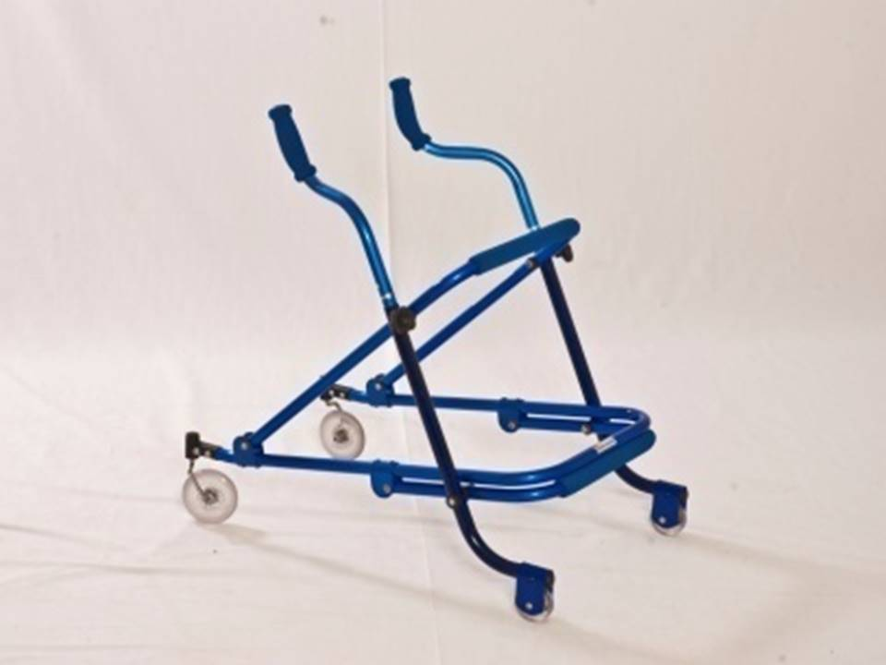
Figure 1. SORRI Walker. Source: Sorri Bauru collection.

An important characteristic of the studies in collaboration with SORRI is that we have explored not only the practical aspects of product usage, but also the aesthetical and symbolic aspects of the design of AT devices. This is important considering that, many times, equipment abandonment is related to problems with users’ acceptance and satisfaction with the device. Ultimately, the research on the interface between user and assistive device, that is, how the design features of AT devices influence usability and meet the users’ needs, preferences, and expectations, may provide additional knowledge and scientific evidence supporting decisions for the innovative design of assistive technologies.

Finally, an example of combining education, research, and development of assistive and rehabilitation technology is the platform of the course “Inclusive Design” of the bachelor program in design at UNESP-Bauru. During this semester course, the students developed projects based on practical demands raised by the Sorri Bauru rehabilitation team. After a theoretical introduction and the contact and lectures with a member of the Sorri Bauru rehabilitation team, the students were able to identify needs and potentialities of projects that can be developed and implemented in the rehabilitation practice. This resulted in objects to be used by the rehabilitation team during the therapy with patients, such as a tactile memory game, a domino game, an inclusive children’s book, a tangram puzzle, and 3D pieces for interactive storytelling, all of them designed with inclusivity concepts (See Figures 2 and 3). Besides the actual rehabilitation benefits, such experience is also very positive for the students from UNESP as they develop empathy and learn to design for inclusion.

Figure 2: Inclusive tools designed by UNESP students in collaboration with SORRI. Source: the authors.

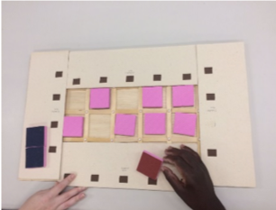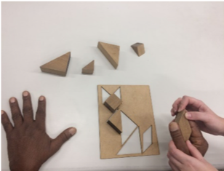
Figure 3: Inclusive tools designed by UNESP students used in real context of rehabilitation at SORRI BAURU. Source: SORRI collection.

Discussion/Conclusion

Optimizing AT design, prescription, and provision requires improving scientific knowledge to support decisions based on evidence and innovation. A collaborative interdisciplinary initiative integrating knowledge from health, social sciences, and product design can provide a wide scope that covers the many aspects that characterize the interface between user and assistive technologies. As the interaction between user and assistive device is not limited to practical aspects, but also semantic aspects, interdisciplinary research is necessary to understand the interface from a more complete perspective. This ultimately can contribute to the design of assistive devices that meet not only users’ characteristics and functional needs, but also acceptance and satisfaction. Here, we reported on some integrated initiatives in research, product development, and education combining the areas of rehabilitation and product design, as a result of a collaboration between a public university and a rehabilitation center. Developing technological solutions valuing the users’ knowledge about his/her needs, expectations, and the context that such technology is going to be applied, favors the user to be engaged and truly makes use of a technology that meets his/her expectations (CAT, CORDE, 2009).

It is also important to expand the understanding about AT beyond just equipment and products that help in functionality, but also services, strategies, practices and, above all, the application of the knowledge aimed to promote the independence and social participation of people with disabilities (CAT, CORDE, 2009).

There are still many questions that need to be explored to have a more complete understanding of the role of technology for people with disabilities. Some of these questions can be addressed by means of our university and rehabilitation center collaboration, and are listed below:

- To what extent are people with disabilities limited in social participation?
- To what extent can AT improve users’ independence and social participation?
- How can we ensure that people with disabilities have access to the best product for their specific needs and characteristics? What are the consequences of using an AT device that is not the most appropriate for the user?
- What more do we need to know about the AT users’ needs, characteristics, expectations, their interaction with the environment, and participation in society?
- Is there enough evidence available to improve the design, prescription, and provision of AT? How is evidence-based knowledge implemented in the AT system?

Having access to such, and more, information would benefit the entire AT community from a wider perspective, favoring designers, engineers, rehabilitation and health professionals, policy makers, companies, and stakeholders.

While the information presented here is a result of a collaboration between a public university and a rehabilitation center, the practical implications may have limited reach. To ensure this knowledge gets transmitted to the field in a wider and more effective way, it is important that AT companies participate and get integrated in research and development initiatives.

Declarations

This content is solely the responsibility of the authors and does not necessarily represent the official views of ATIA. No financial disclosures and no non-financial disclosures were reported by the authors of this paper.

Acknowledgements

The authors would like to thank SIU (UTFORSK grant UTF-2016-long-term/10053) and FAPESP (Process 16/05026-6) for the financial support.

References

Berget, G., Mulvey, F., & Sandnes, F.E. (2016). Is a visual context in textual search interfaces beneficial to dyslexia users? International Journal of Human Computer Studies, 92, 17-29.

Borg, J., Linström, A., & Larsson, S. (2011). Assistive technology in developing countries: a review from the perspective of the Convention on the Rights of Persons with Disabilities. Prosthetics and orthotics international, 35(1), 20-29.

Brasil. (2004) Decreto n°5.296 de 02 de dezembro de 2004 – Diário Oficial (República Federativa do Brasil) de 03/12/2004. Available in: http://www.planalto.gov.br/ccivil/_ato2004-2006/2004/decreto/d5296.htm. Access in: Aug 06, 2017.

Brasil. (2010). Instituto Brasileiro de Geografia e Estatística – Censo 2010. Available at: http://censo2010.ibge.go.br. Access in: Aug 04, 2017.

Brasil. (2007). Secretaria Especial dos Direitos Humanos. Coordenadoria Nacional para Integração da Pessoa Portadora de Deficiência – CORDE – Comitê de Ajudas Técnicas, 2007. Available in: http://www.mj.gov.br/sedh/ct/corde/dpdh/corde/comite_at.asp. Access in: Aug 05, 2017.

Brasil. (2009) Subsecretaria Nacioal de Promoção does Direitos da Pessoa com Deficiência. Comitê de Ajudas Técnicas. Technologia Assistiva. – Brasília: CORDE.

Eika, E. (2016). Universally Designed Text on the Web: Towards Readability Criteria Based on Anti-Patterns. Studies in health technology and informatics, 229, 461.

Gaffney, C. (2010). An exploration of the stigma associated with the use of assistive devices. Journal of Sociology, 3(1), 67-78.

Lanutti, J.N.L., Medola, F.O., Gonçalves, D.D., da Silva, L.M., Nicholl, A.R.J., & Paschoarelli, L.C. (2015). The Significance of Manual Wheelchairs: A Comparative Study on Male and Female Users. Procedia Manufacturing, 3, p. 6079-6085.

Lenney, M., & Sercombe, H. (2002). ‘Did you see that guy in the wheelchair down the pub?’ Interactions across difference in a public place. Disability & Society, 17(1), 5-18.

Lobach, B. (2001). Design Industrial: Bases para a configuração de produtos. São Paulo: Blucher, 208p.

Medola, F.O., Elui, V.M.C. & Santana, C.S. (2010). La selección de la silla de ruedas y la satisfacción de indivíduos con lesión medular. Revista Iberoamericana de Fisioterapia y Kinesiología,13(1),17–21.

Medola, F.O., Lanutti, J., Bentim, C.G., Sardella, A., Franchinni, A.E. & Paschoarelli, L.C. (2015). Experiences, Problems and Solutions in Computer Usage by Subjects with Tetraplegia. Lecture Notes in Computer Science. 1ed.: Springer International Publishing, 131-137.

Nicholl, A.R.J., Busnardo, R.G., Silva, L.M., Rodrigues, A.C., Luz, F.R., Bentim, C.G., Medola, F.O. & Paschoarelli, L.C. (2015). Development of the SORRI-BAURU Posterior Walker. In: Cecilia Sik-Lányi, Evert-Jan Hoogerwerf, Klaus Miesenberger, Peter Cudd. (Org.). Studies in Health Technology and Informatics: Assistive Technology (pp. 1003-1008). Amsterdam: IOS Press.

Phillips, B., & Zhao, H. (1993). Predictors of assistive technology abandonment. Assistive technology, 5(1), 36-45.

Sandnes, F.E. (2016). Understanding WCAG2. 0 Colour Contrast Requirements Through 3D Colour Space Visualisation. Studies in health technology and informatics, 229, 366-375.

Sandnes, F. E. (2016, July). What Do Low-Vision Users Really Want from Smart Glasses? Faces, Text and Perhaps No Glasses at All. In International Conference on Computers Helping People with Special Needs (pp. 187-194). Springer International Publishing.

Silva, S.R.M., Boiani, J.A.M., Silva, L.M., Paschoarelli, L.C. & Medola, F.O. (2016). Dificuldades funcionais no uso de cadeira de rodas manuais: um estudo preliminar. In: I CBTA - I Congresso Brasileiro de Pesquisa & Desenvolvimento em Tecnologia Assistiva, 2016, Curitiba. Anais do 1° CBTA Congresso Brasileiro de Pesquisa & Desenvolvimento em Tecnologia Assistiva: Engenharia e Design. I Congresso Brasileiro de Pesquisa & Desenvolvimento em Tecnologia Assistiva, p. 1-6.

SORRI-BAURU. (2017). Relatório Anual 2017. Bauru: 2017.

World Health Organization. (2001). The International Classification of Functioning, Disability and Health (ICF). 2001; Geneva, WHO http://www.who.int/classifications/icf/en/.

World Health Organization. (2011). World report on disability 2011. 325p. Geneva, WHO. http://www.who.int/disabilities/world_report/2011/en.

Assistive Technology Outcomes and Benefits

Volume 12, Summer 2018, pp. 11-36

Copyright ATIA 2017 ISSN 1938-7261

Available online: www.atia.org/atob

The Assistive Wearable: Inclusive by Design

Clint Zeagler, Maribeth Gandy, Paul M.A. Baker

Georgia Institute of Technology

Corresponding author:
Clint Zeagler
2608 Church St. NW
Atlanta, GA 30318
Email: clintzeagler@gatech.edu

Abstract

Wearable technology has the potential to usher in a new wave of assistive technology. Many wearable devices are already being used by people with disabilities as assistive technology. Here we discuss how designers might use design considerations and body maps to make sure that the wearable devices they are creating are accessible to everyone. The hope is that, with a thoughtful process, new wearable technology can also act seamlessly as assistive technology.

Keywords: wearable technology, design guidelines, design process
Introduction

Wearable technology, in its many forms, following the path of smartphones, is rapidly becoming a part of everyday life (Abowd, Tech, & Mitchell, 2005; Morris, Jones, & Sweatman, 2016). New forms of wearable technology have all kinds of uses and can be worn on many different parts of the body. These wearable devices not only sync with our smart phones, but increasingly are able to establish a wide variety of wireless connections to give quicker and more meaningful interactions with information. The creators of the first wave of smart phones may not have incorporated accessibility as a driving factor of design, a condition which was addressed via policymaking and regulatory interventions, and subsequently is part of the current development approach. (Baker & Bellordre, 2004; Baker & Moon, 2008; Mitchell et al., 2004). In fact, developers of wearable technology are increasingly taking into account accessibility and usability, and consequently, enhancing a wearable device’s use as assistive technology (Oliver, 2017). As such, these design objectives become a key factor influencing marketability.

Assistive technology applications have been developed using the smart phone’s inherent multimodal display and input capabilities (Frey, Southern, & Romero, 2011; Morris & Mueller, 2014; John Morris, Mueller, & Jones, 2014). One of the most important uses of assistive smartphone applications can be lifesaving in emergency situations, as noted by Mitchel and Lucia (Mitchel & Lucia, 2014) , who outline a number of considerations for accessible emergency communications. In terms of important design parameters, technological considerations focus on developing or providing accessible formats to disseminate alerts and information, and to manufacture cost effective, universally designed devices. The usefulness of wearable devices could have the same assistive functionality, especially if accessibility considerations are incorporated into the early stages of the design process.

To aid designers in the process of developing inclusive wearable technology, we have developed a set of Body Maps that include design and accessibility considerations for placement and use of wearable technology (Zeagler, 2017a, 2017b). The information contained in the Body Maps is based on a synthesis of over 100 academic papers from the last 50 years on how technology can be and should be worn on the body for optimal use.

Target Audience and Relevance

The primary target audience for the design considerations and Body Maps described in this paper includes developers and designers of wearable technology. We anticipate that those with specific aims of creating wearable assistive technology would search and find the information presented here to be a useful tool. Ultimately, our hope is that all those who design wearable technology might begin the design process with a better understanding of how the choices they make affect the accessibility, and more broadly, the usability of the wearable devices they create.
New Tools for Inclusive Design: Body Maps and Wearable Placement

What follows is a list of considerations that designers and creators of wearable technology should take into account as they develop wearable products. These considerations are organized by the requirements of certain types of on-body technology with respect to the types of sensing and input/output the systems utilize, and the locations where devices might be worn on the body. The Body Maps are diagrams of the human body with regions highlighted where appropriate on-body devices might be worn. We specifically highlight here device Accessibility Considerations, a subset of a more robust list of the design considerations developed by Zeagler (Zeagler, 2017a, 2017b). Some information (such as thermal tolerances) are dictated by the human body, while others (such as networking) are limitations in technology when combined with the human body. Many of the wearable lessons incorporated within the Body Maps come from insights generated while developing assistive technology (Ghovanloo & Huo, 2014), and a large majority of the design considerations have direct impact on the design of new assistive technology. The maps were graphically generated from older diagrams, or descriptions within the academic texts as interpreted by an expert in wearable technology.

Proxemics
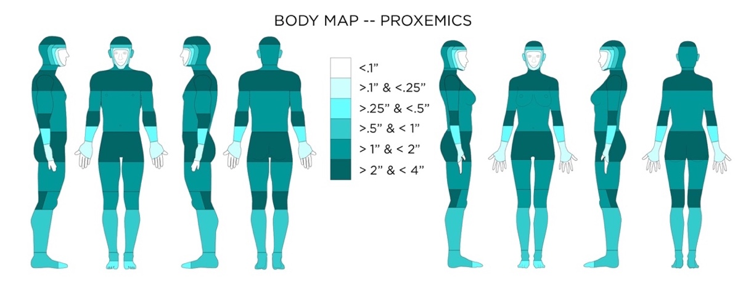
BODY MAP 1 – Proxemics Map - Proxemics as defined here is a human’s perception of self-size. The distance from the body portrayed on this body map indicates how far from the body a wearable device might extend and still be naturally considered part of the person’s self-size awareness. Items extending beyond this distance from the body might take a period of time for a person to adjust and account for the object within their personal self-size envelope.

Proxemics, as defined here (Body Map 1), is a human’s perception of self-size. The distance from the body portrayed on this body map indicates how far from the body a wearable device might extend and still be naturally considered part of the person’s self-size awareness. Items extending beyond this distance from the body might take a period of time for a person to adjust and account for the object within their personal self-size envelope. Gemperle proposes proxemics as a consideration for “Design for Wearability” (Gemperle, Kasabach, Stivoric, Bauer, & Martin, 1998). Edward T. Hall illuminates a humans’ relationship to the space around them in The Hidden Dimension (Hall, 1990). Gemperle borrows Hall’s definition of intimate space at 0-5 inches to create an envelope around the body of the user’s perceived body size.

A Body Map, then, is produced by taking this perceptual envelope and segmenting it into zones. Using these zones, we can make suggestions of where to place wearable technology based on the distance that tech extends from the body. We also incorporated the clothing corrections guide from Henry Dreyfuss Associates “The Measure Of Man and Woman” as a proxemics minimum guide as most humans wear clothing (Tiley & Henry Dreyfuss Associates, 2001).

Accessibility Considerations for Proxemics
- Someone with a body limitation that requires the use of a wheel chair (or other assistive device) may have a much different self-perceived size that would include their assistive device and normal posture.
- Attachments to a required assistive device will also affect proxemics, and should be viewed as a “wearable”.

Weight Distribution
The weight of wearable objects matter, and heavier items can be carried by the body more comfortably in some locations than others. In the 1970s, while the US army was designing body armor, researchers were tasked with developing a system for finding load thresholds of discomfort (Scribano, Bruns, & Baron, 1970; Watkins, 1995).

“In general, the army found that the fleshy parts of the body were more able to tolerate the pressure of weight than the bony ones, and that pressure on major nerves, arteries, and veins, particularly those that supply the brain, can affect coordination, and produce fatigue.” (Watkins, 1995 pg 259).

The body map shows the amount of weight or pressure that can be placed on the area before the pressure becomes a discomfort.
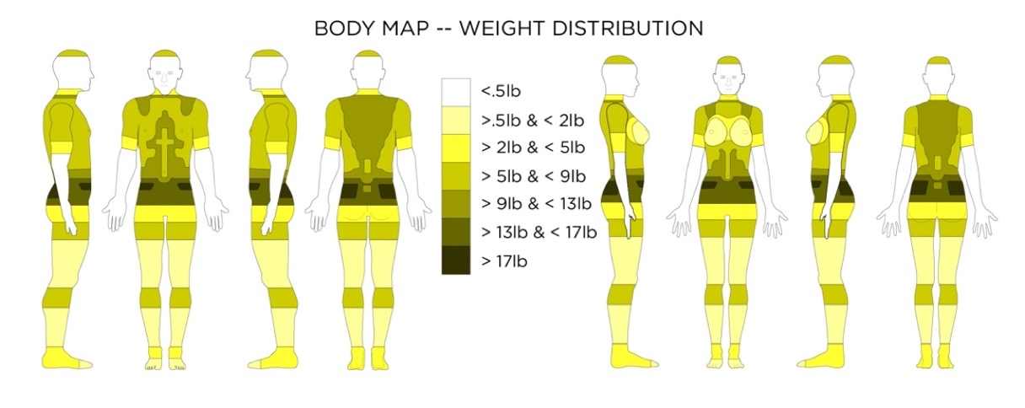
BODY MAP 2 – Weight Distribution Map - This body map shows the amount of weight, or pressure that can be placed on the area before the pressure becomes a discomfort.

Accessibility Considerations for Weight Distribution
- Watkins states: “One aspect of Load Analysis to consider is that even though these tests provide data on pressure levels, not all individuals or areas of the body respond in the same way to pressure. Age, sex, medical conditions and other factors may affect the way in which pressure affects mobility.” (Watkins, 1995 pg 259.)
- Of course, it is easy to assume that designers want the most light weight wearable technology anyway, but it is also good to remember that being light weight can make the wearable technology useful to broader communities (the elderly, individuals with a range of medical conditions, children, etc.)

Body Mechanics and Movement
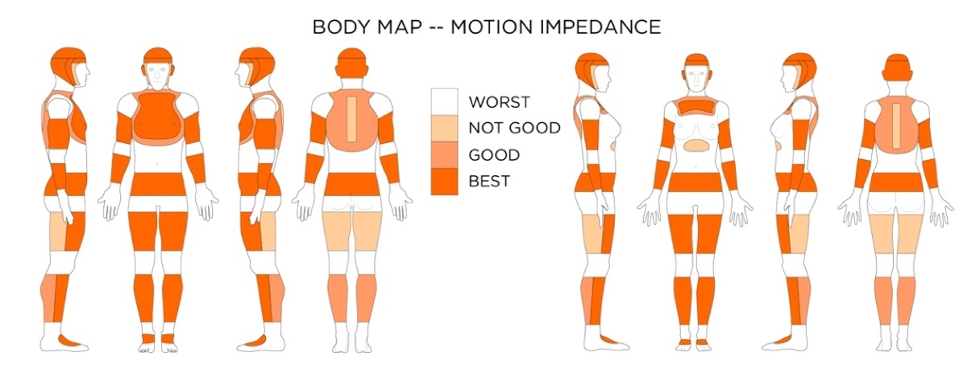
BODY MAP 3 – Zones of Motion Impedance - This body map shows the best places to put wearable devices on the body, where they will be the least obtrusive and cause the least amount of body motion impedance.

Gemperle’s main observation with respect to body movement was that wearable devices should not be placed on or inside joints (Gemperle et al., 1998). Roebuck created a system for describing body movement in the 1960s while developing space suits for NASA (Roebuck, 1968). Roebuck’s system of linkages, when combined with Henry Dreyfuss and associates’ (Tiley & Henry Dreyfuss Associates, 2001) standard range of motions charts, gives us a solid foundation for creating the Body Map of Motion Impedance. The body map shows the best places to put wearable devices on the body: where they will be the least obtrusive and cause the least amount of body motion impedance.

Design Considerations for Body Motion
- Large, bulky, or rigid objects should not be placed on the inside of joints, or the concave areas where the body bends.
- Rigid objects or flexible but non-elastic objects should be adhered to the outside of joints in a way that hinders the skin on the outside of the joint from stretching.
- Smart garments, clothing, or e-textiles should have ample room, or flexible and elastic properties to allow all parts of the body to move effectively.
- Larger or rigid objects should be located in zones on the body with relatively limited movement or linkages.

Accessibility Considerations for Body Motion
- All body movement criteria should apply the same to individuals with impaired self-movement, unless the wearable is specifically designed to stabilize the body for medical purposes.
- Individuals may be unable to feel or move parts of their body, but these body parts still have the capability of movement from outside sources. This means that a discomfort from an inappropriately placed wearable device will not be felt, and could cause harm from extended wear.

Movement Sensing Consideration
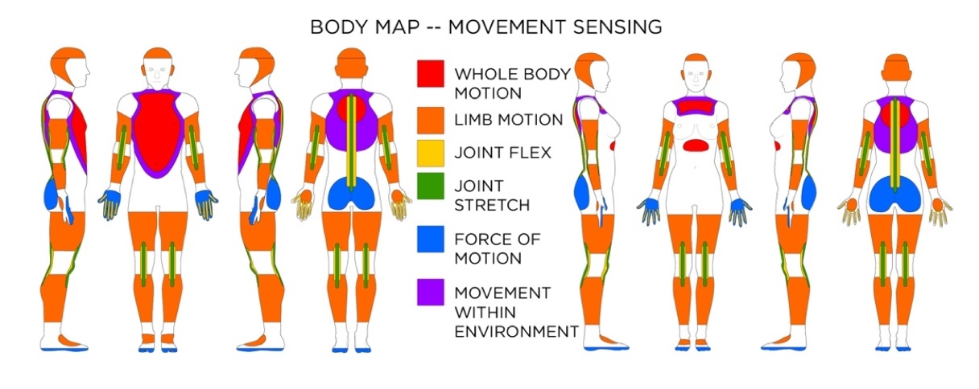
BODY MAP 4 – Movement Sensor Placement - For sensing whole body motion, and limb motion, accelerometers, gyroscopes, and magnetometers can be used at locations indicated. For sensing joint movement, flex or stretch sensors can be used at locations indicated. Force can explain the impact of movement. If trying to capture movement within an environment, magnetometers (for direction) and barometric pressure sensors (for elevation change) may be used.

Understanding the body’s movement through space and relative to itself is one of the main motivations behind wearable technology (Aminian & Najafi, 2004; Kramer, 2000; Zeagler, Starner, Hall, & Wong Sala, 2015). For sensing whole body motion and limb motion, accelerometers, gyroscopes, and magnetometers can be used at locations indicated. For sensing joint movement, flex or stretch sensors can be used at locations indicated. Force can explain the impact of movement. If trying to capture movement within an environment, magnetometers (for direction) and barometric pressure sensors (for elevation change) may be used.

Wearable technology used to determine how a person is moving can have a huge impact on assistive use. Sensors can help determine acceleration, walking/steps/running, and even posture (Farringdon, Moore, Tilbury, Church, & Biemond, 1999; Karantonis, Narayanan, Mathie, Lovell, & Celler, 2006; Sekine, Tamura, Togawa, & Fukui, 2000; Yang & Hsu, 2009). Pressure sensors under the foot can help explain how a person steps and distributes weight (Godbout & Boyd, 2010), and stretch resistance sensors placed over knee joints could aid in rehabilitation exercise adherence (Byrne, Rebola, & Zeagler, 2013). Walking and gait sensors can be used monitor improvements of individuals with movement challenges. Kuo et al. used ankle mounted accelerometers to measure walking and steps of children with cerebral palsy (Kuo, Culhane, Thomason, Tirosh, & Baker, 2009). Accelerometers and gyroscopes placed on the head might be able to tell balance, head tilt, head turning, and even falling (Lindemann, Hock, Stuber, Keck, & Becker, 2005).

Accessibility Considerations for Movement Sensing
- On-body motion/movement sensors can be a great noninvasive way to monitor someone who has a disability or is “aging in place.” Because the movement sensing can be complete and complex, but also can be done without respect to location there is a level of privacy.
- Depending on body-placement of the movement sensors whole body motion, or specific body motion can be obtained. If monitoring someone for mobility a whole-body movement sensor placed at the chest might be used to see if an aging person is “getting around”. If a person is in rehabilitation from knee surgery, perhaps a movement sensor on the knee might be used to see if they are complying with their exercises.

Thermal Tolerances
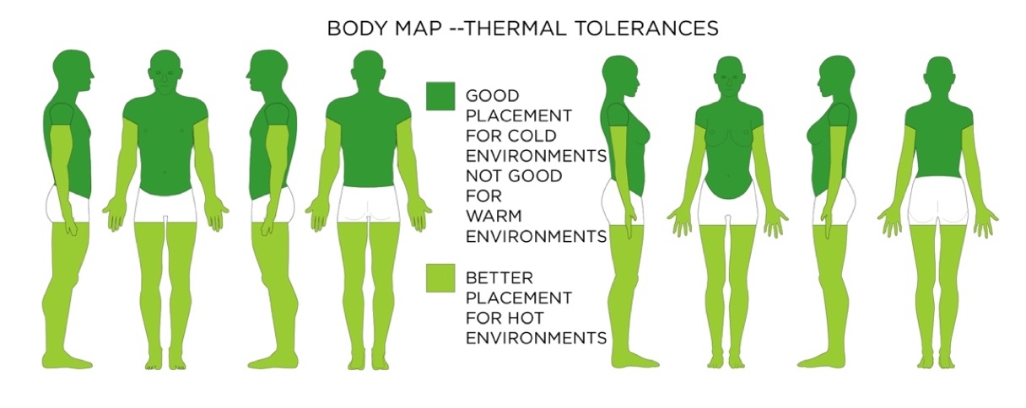
BODY MAP 5 – Zones of Thermal Tolerance - This body map shows where to place wearable technology (which adds heat through operation and added bulk and material). This map focuses on a device’s tendency to raise overall body temperature; however, tissue on the body can burn at any location if exposed to enough heat over time.

The Body Map of thermal tolerances shows where to place wearable technology (which adds heat through operation and added bulk and material). This map focuses on a devices tendency to raise overall body temperature; however, tissue on the body can burn at any location if exposed to enough heat over time.

Design Considerations for Thermal Tolerances
- In a hot environment, a wearable “should be non-conductive (so the heat from the environment or heat produced by the wearable is not conducted to the body).” (Watkins, 1995)
- In a hot environment a wearable should “allow air to circulate as freely as possible over the skin surface (to aid convective cooling and evaporation of sweat).” (Watkins, 1995)
- “Allow freedom of movement (to prevent any extra physical effort that would increase metabolism).” (Watkins, 1995)
- In a hot environment, a wearable “should provide minimum coverage or maximum ventilation for the body core.” (Watkins, 1995)
- In a cold environment, the heat produced by the wearable could be directed towards the body for extra warmth. (Watkins, 1995)
- Do not allow devices to exceed 105°F at any time when next to the skin.
- A temperature of 111.2°F for 7 hours next to the skin can cause a second or third degree burn.

Accessibility Considerations for Thermal Tolerances
- Those with sensory disabilities could be highly susceptible to burns from wearable devices, and as such, temperature sensors should be placed in wearable devices with cut off mechanisms.
- Multimodal displays including lights and sound should be used to warn of overheating. Again, if a person cannot feel a localized heat source at the body location where the wearable is placed, even lower temperatures over longer time periods can cause significant burns.

Biometric Sensing Consideration
Biometric sensing could greatly enhance the assistive application of wearable devices. Biometric sensors work best on specific locations on the body. There are many kinds of biosensors that sense different types of biosignals. Pantelopoulos and Bourbakis completed a survey of sensors on the market in 2008 and 2010 (Pantelopoulos & Bourbakis, 2008, 2010). The main types of biosignals that need to be monitored are vital signs; including heart rate, blood pressure, temperature, respiration, blood glucose, perspiration, and brain activity. There is a body map associated with each of these biosignals to aid designers in placing wearable technology (Zeagler, 2017a).

Design Considerations for Biometric Sensing
- Heart Rate / Heart Movement ECG sensors tend to be located on the chest near the heart. The more precise measurement needed the more body area these electrode-based sensors will cover.
- Stimulation/Perspiration/Hydration sensors can be placed anywhere on the body with correct calibration, and thus should come secondary in body placement to other sensors packaged with them. These sensors need direct contact with the skin.
- Blood Pressure sensors and PPG Heart Rate sensors should be placed where blood vessels are close to the surface of the skin. These sensors also need direct contact with the skin.
- Blood Glucose sensors that have a subdermal port tend to be located at the waist (perhaps for ease of supporting the external electronics on the waistband). Other types of Blood Glucose monitors are located at the source of bodily fluid they are utilizing for sensing.
- Respiration monitors generally strap around the chest and measure chest volume change (they tend to be paired with a simple ECG to collect heart rate).
- EEG Sensors have to be placed on the scalp/forehead to measure brain activity.

Accessibility Considerations for Biometric Sensing
- Designing wireless wearable technology for collecting important biometric data might be one of the best ways to allow those who need to have constant monitoring an accessible and free lifestyle.
- New glucose monitor designs that do not require a subdermal port are less invasive, but might not yet collect data with the desired accuracy and reliability needed in some cases.
- EEG sensors that are mobile and wireless offer up great potential in accessibility, especially for “locked in” patients. These sensors might not be accurate enough yet for medical use. (G.Tec Medical Engineering, 2017)
- Choices in body location of biometric sensing for impaired individuals need to both work for the biosensor to collect data and for the mobility/reachability of the individual.

Tangible / Tactile / Haptic Feedback (passive touch)
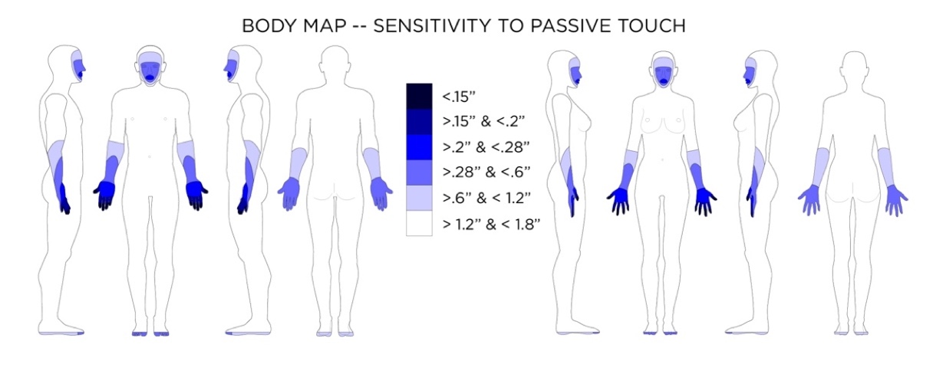
BODY MAP 6 – Body Sensitivity to Passive Touch - Average distance in two-point discrimination sensitivity test on body locations.

A large number of wearable devices use vibration to act as a notification. People’s sensitivity to passive touch not only differs across the body, but also differs between people. It is important to know where the body is most sensitive so designers can make decisions about vibration notification. This is especially important for assistive technology, where sensitivity to passive touch could have even greater variances in the population.

Design Considerations for Tangible / Tactile / Haptic Feedback (passive touch)
- When designing haptic displays for wearable devices, the sensitivity of the on-body location where the wearable is placed is very important.
- Vibrotactile displays should be programmed to account for masking and vibrotactile adaptation.

Accessibility Considerations for Tangible / Tactile / Haptic Feedback (passive touch)
- Tangible/Haptic Feedback is an important part of a multimodal display system. Multimodal feedback is important; designers need to create wearable devices that can prompt users with a variety of different abilities. Vibration and haptic alerts can aid those with visual impairments when acoustic feedback is inappropriate.
- Vibration and haptic feedback have been seen to provide added benefit in rehabilitation of injuries (such as spinal injuries) where sensation has been degraded. Mobile Music Touch has shown that rehabilitation with the vibrating piano gloves not only taught participants to play piano, but also improved their sensation and dexterity (Markow et al., 2010).

Touch (Active Touch)
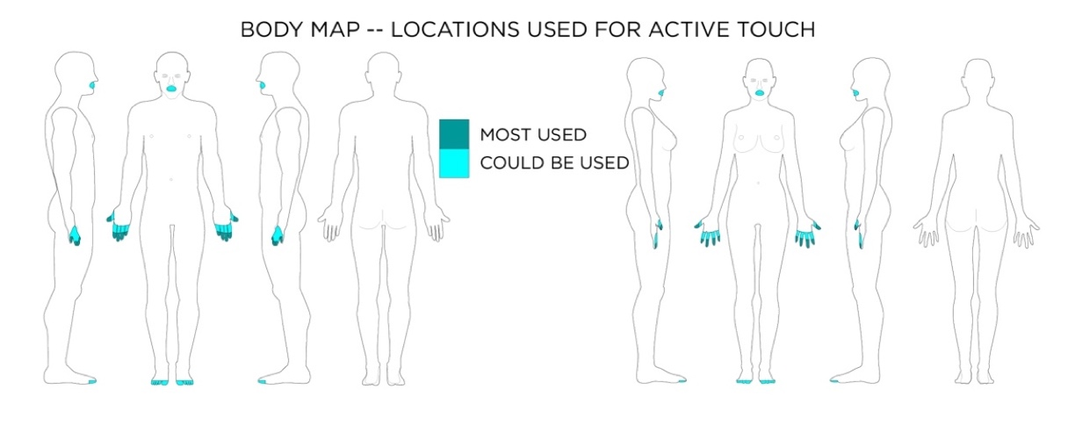
BODY MAP 7 – Body Used for Active Touch - Active touch represents the exploratory action of touching.

“Active touch represents the exploratory action of touching, which is generally involved with kinesthetic movement of the body.” (Gibson, 1962; S. Lee, 2012 pg 14). Creating interfaces that are “easy to find” through active touch is essential for wearable interfaces. Norman talks a great deal about mapping associated with physical interfaces (Norman, 2013), but the shape of buttons and levers offer affordances as well, and our hands find a way of using them through active touch. A good example would be a cylinder with ridges for grip on the side, as it affords turning.
Design Considerations for Active Touch
- Following good human factors and industrial design standards when creating physical interfaces will aid in a person’s ability to use active touch to interact with objects and controls. This is also true for interfaces on the surface of wearable devices.
- Certain shapes contain certain affordances. Concavities on top of buttons might lend themselves to a pushing type active touch investigation. Ridges on the circumference of cylinders might lend themselves to turning. Expenditures at an angle to a plane might afford a flick or leverage. Dreyfus lays out shapes and sizes for controls in his book (Tiley & Henry Dreyfuss Associates, 2001).

Accessibility Considerations Active Touch
- It is important to remember that each person has a different ability to feel or sense tactile sensation. Thus, interfaces should be designed with robust multisensory feedback. Whereas one person might feel a click of a button through tactile means, others who cannot might require an audio cue or a visual cue to know that a selection has been made.

Reachability
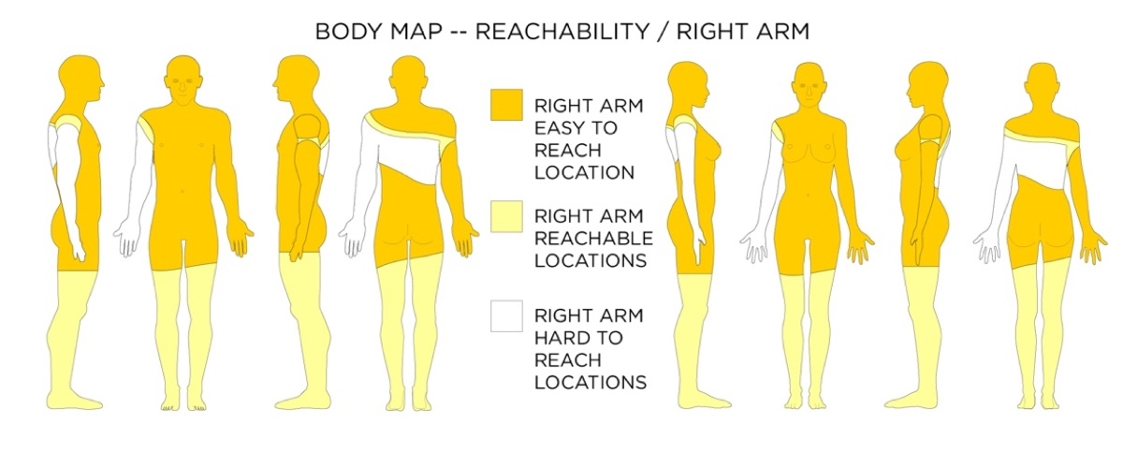
BODY MAP 8 – Map of Ease of Reach of Body Locations – Right Arm - When it comes to reach-ability there are easy-to-reach locations (where your hand can reach without any body movement), reachable locations (where you can move a part of your body to your hand to be able to reach it), and hard to reach locations (such as your center back).

Being able to reach a wearable device is important for interacting, but also for donning and doffing the device. When it comes to reachability, there are easy to reach locations (where your hand can reach without any body movement), reachable locations (where you can move a part of your body for your hand to be able to reach it), and hard to reach locations (such as your center back), as well as duration of reachability (Vatavu, 2017)

Design Considerations for Reachability
- Wearable Devices should be placed in easy-to-reach on-body locations, especially for interfaces, but also for donning and doffing.

Accessibility Considerations Reachability
- Reachability is very personal as people have different physical abilities with respect to body movement.
- It is best to design a wearable device that does not cater to a dominant body side (right / left) and also is easy to reach with the hand’s extension.
- Some people who spend most of their time in a seated position might be able to reach their upper thighs to their knees more readily. It might be better however to design wearable devices useful to everyone in the same way.

Visible Feedback
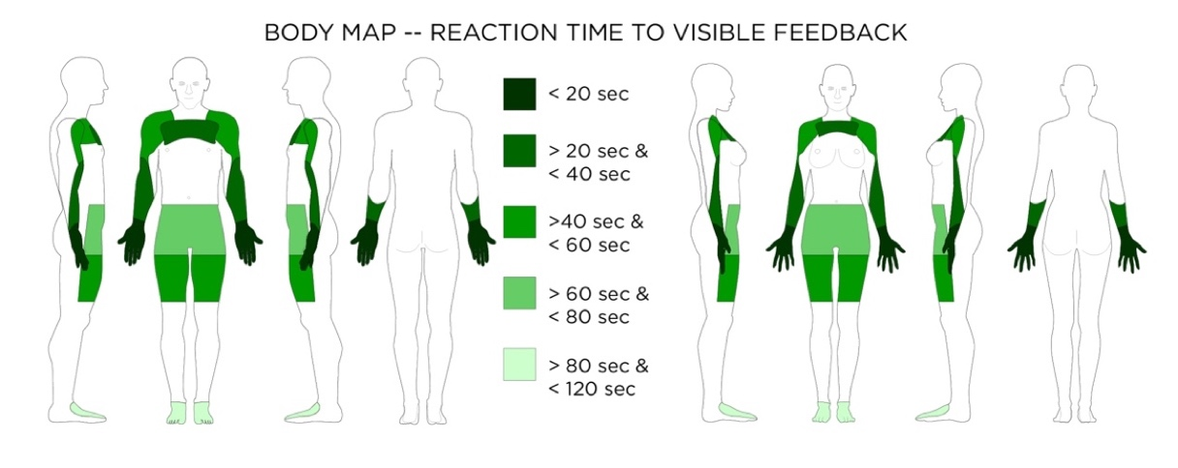
BODY MAP 9 – Visible Body Areas Map - Average reaction time to visible feedback.

In 2009 Chris Harrison developed a study to decide where on the body visible feedback would be noticed the easiest (Harrison, Benko, & Wilson, 2011; Harrison, Lim, Shick, & Hudson, 2009; Harrison, Ramamurthy, & Hudson, 2012). LED lights were used to create a system where the user was asked to push a button at the light whenever the light was illuminated. This gave an individual’s reaction time to seeing the visible feedback. The body map for visible body areas from a first-person perspective also takes into account Harrison’s reaction times; therefore, the map is more representative of where a designer should locate a wearable visual display, rather than just locations where a user can see it.

Design Considerations for Visible Feedback
- When designing a wearable device with a display or visual signal, it is important that the device be placed on a part of the body where the display can be seen, and also a place on the body where it will be noticed easily.

Accessibility Considerations for Visible Feedback
- Visual displays should be accompanied by non-visual signals for those with visual impairments.
- The visibility of on-body locations might change from person to person depending on their mobility and means of mobility. Wheelchairs or other mobility devices might occlude some on-body locations which would otherwise be acceptable for a visual display.

Networking on the body
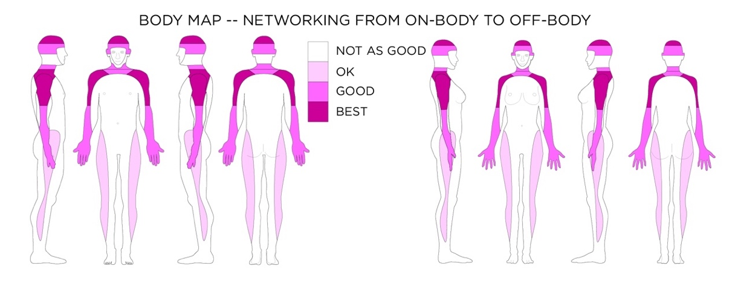
BODY MAP 10 – Networking from the Body Map - This body map shows the areas on the body where a network antenna (to communicate to the fixed off-body wireless frequencies) could be placed to have the least chance of signal interference by the mass of the body.

Thad Starner (2001) claimed networking as one of the major challenges of wearable computing.

For wearable computers, networking involves communication off body to the fixed network, on body among devices, and near body with objects near the user. Each of these three network types requires different design decisions. Designers must also consider possible interference between the networks (Starner, 2001 p. 54).

When considering on-body location, designers need to consider the location of the antenna that communicates with the off-body fixed network. The mass (water/muscle/tissue) of the body can block many of the lower-powered high-frequency wireless network signals we use for communication (S. P. Hall & Hao, 2006). At a higher power, such frequencies could have the potential to cause tissue damage, which is unacceptable for wearable devices.

Wireless Body Area Networks (WBANs) experience high path loss due to body absorption that must be minimized through heterogeneous and multi-hop links with different types of sensors at various locations. Additionally, change in operational conditions may lead to error-prone and incomplete sensor data relative to inherent sensor limitation, human postures and motions, sensor breakdown and interference. (Movassaghi, Abolhasan, Lipman, Smith, & Jamalipour, 2014, p. 1679).

There is a balance, and many people have researched the application of WBANs for medical and other wearable sensing systems (Hanson et al., 2009; Patel & Wang, 2010; Ullah et al., 2012). The body map shows the areas on the body where a network antenna (to communicate to the fixed off-body wireless frequencies) could be placed to have the least chance of signal interference by the mass of the body.

Design Considerations for Networking
- Antennas for wearable devices should be placed on the periphery of the body to have the best chance of having an unobstructed (by the body) connection to the fixed off-body network. This could mean the outer arms, shoulders, or the head. Because of the strength and abundance of fixed off-body wireless network signal, this is not as much of a problem as it would have been in 2001.
- Body Area Networked devices using low-powered wireless connections between devices on the body should also try to avoid obstruction by the body between devices. If one device on the front torso for example needs to wirelessly communicate via low powered signal to a device on the back, a third relay might be needed on the side of the body.
- All body mass compositions are unique. Outside of the general guidelines, wearable systems using wireless communication should be tested thoroughly on a variety of people and in a variety of settings.

Accessibility Considerations for Networking
- Health monitors or wearable sensing devices use Body Area Networks. Some people might have many different monitors all using different frequencies. It is important when designing a new device that it does not interfere with wearable health devices such as heart monitors or pace makers. It is also important that it does not interfere with wireless hearing aids and other assistive devices. Adding a new signal to a series of signals requires some standards, research, and testing.

Manufacturing for Garments
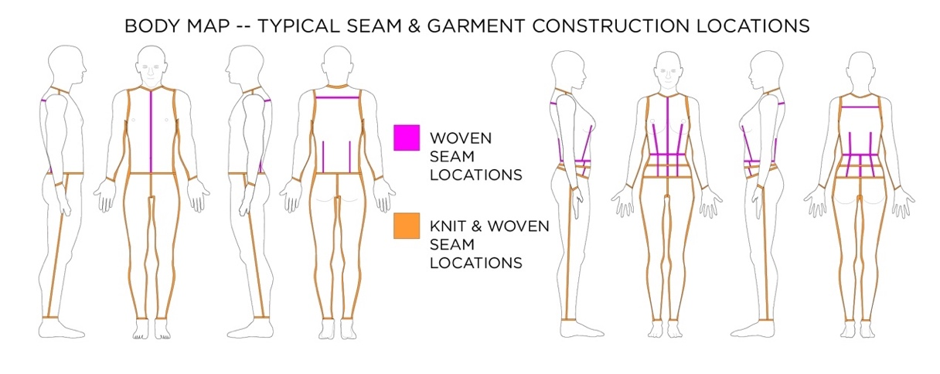
BODY MAP 11 – Typical Seam Locations and Other Garment Construction Locations

A little knowledge of fabric and garment manufacturing goes along way when designing wearable technology meant to be incorporated into clothing. A simple concept is that fabric stretches and wiring does not. Patterns can be changed to accommodate sensors that need to be placed on certain body locations (Jones, 2005; Joseph-Armstrong, 2000; Watkins, 1995; Watkins & Dunne, 2015). It is better to place wires and leads in the seams of garments that run vertical with the body rather than horizontal to the body. It is also important to account for how electronics will change the drape of clothing. Importantly some textile manipulation techniques can lend themselves to fabric interfaces (Gilliland, Komor, Starner, & Zeagler, 2010; Komor et al., 2009; Lee, Shin, Starner, Gilliland, & Zeagler, 2016; Wolff, 1996; Zeagler, Gilliland, Audy, & Starner, 2013; Zeagler et al., 2017; Zeagler, Gilliland, Profita, & Starner, 2012), and some couture sewing techniques might sometimes be used for the hand work necessary in creating some wearable technology (Shaeffer, 2001).

Accessibility Considerations for Garment Manufacturing
- Some garments are specifically designed to be donned and doffed by people with mobility issues (Watkins, 1995; Watkins & Dunne, 2015). Designing wearable systems for incorporation with these garments should follow the same strategies as any other garment. However, if redesigning seams and closures to afford the wearable technology incorporation, it is important not to impede the donning and doffing functionality of the accessible garment.

Social Acceptability
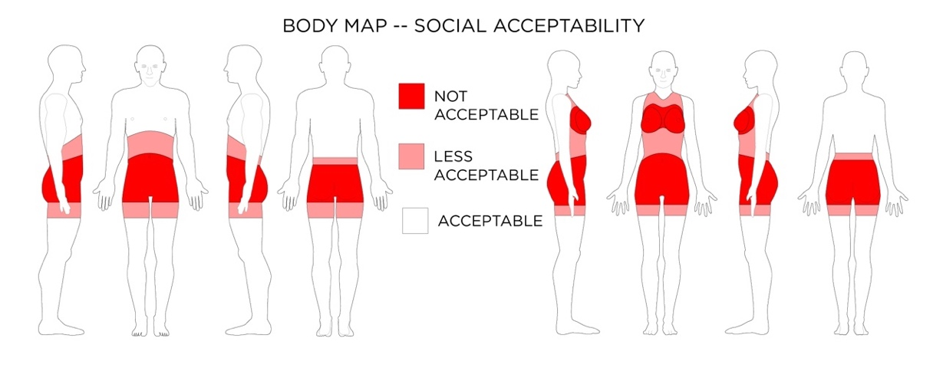
BODY MAP 12 – Social Acceptability Body Map - Social acceptability of on-body touch based interactions.

The gestures and touches users make with wearable technology to interact and control devices can cause unanticipated social reactions. This can also be especially true for people with disabilities, who might not want to draw attention to their use of assistive technology. Certain onbody placements of interactive textiles, interfaces, and the types of gestures used to control these interfaces can make a wearer/user, as well as onlookers, feel awkward. “For wearable devices, the social perception and comfort of worn artifacts often extends beyond the “static” aesthetic variables of the artifact (worn on the body, but not interacted with) into the social aesthetics of interacting with a body- worn device,” (Dunne et al., 2014; Dunne, Profita, & Zeagler, 2014). Profita et al. look specifically at body placement of interactive electronic textiles and how third-party viewers deem interactions socially acceptable when placed on different parts of the body (Profita et al., 2013).

Accessibility Considerations for Social Acceptability
- Sometimes users want assistive technology to be conspicuous so that others know about their needs. Other times users want wearable technology to be inconspicuous so they can go about their daily life without a disability being the focus. Designers should work with users to allow for wearing technology in ways that can throttle the visibility of wearable assistive technology.
- Wearable assistive technology should conform to the same social acceptability standards as other wearable technology. Assistive devices do not have to look like medical devices.

Using Body Maps and Design Considerations within the Design / Development process

The design process is iterative, but a good place to start is with an initial assessment of the needs of the users of any designed object, and wearable technology devices have a good deal of aspects to consider. By giving designers and developers a set of accessibility considerations (and Body Maps of on-body locations where these considerations might take hold in wearable technology) within the larger usability context, at the beginning of the process, designers are more likely to remember the broad spectrum of users including those who might use wearable technology in an assistive manner. The seven principles of universal design are a good example of how such principles considered at the outset of a design project can have a huge effect on the eventual design (Ross & Affairs, 2001).“The seven principles also provide useful guidelines on how wearable computer interface designers can broaden their systems’ appeal in the general population, just as Alexander Graham Bell’s invention of the telephone while pursuing the concept of a hearing aid for his wife” (Gandy, Ross, & Starner, 2003). Guidelines, affordances, and considerations help design teams form parameters and create a design brief for developing products.

In previous work, we have considered how the outcomes of iterations in the wearable technology design process could affect policy, and how policy considerations in turn could affect design (Baker, Gandy, & Zeagler, 2015; Gandy, Baker, & Zeagler, 2016). Figure 1 describes how design and accessibility considerations could be included in the iterative process, directly before design ideation takes place. If designers have some guidance before ideation, it helps to not only avoid technical pitfalls (perhaps from mislocating a sensor on the body), but also to help in designing more universally accessible devices. It can also have an effect on the types of “use case ideation and visualization” designers decide to scenario when thinking through design decisions. It would be helpful to diversify the range of potential users, including people with disabilities and other functional limitations, when visualizing wearable technology use cases.
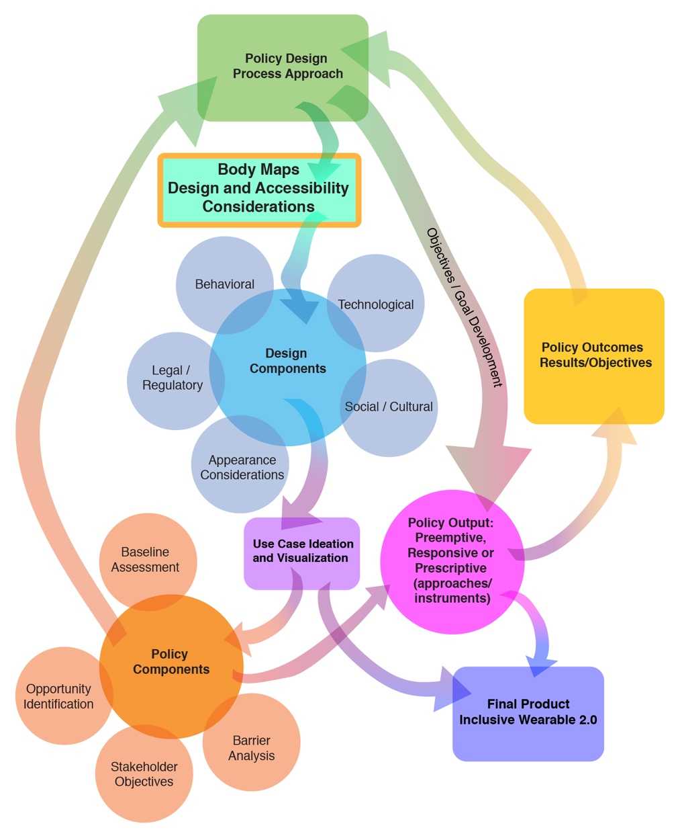
Figure 1. Incorporating Body Maps and Accessibility Considerations into the collaborative policy wearable technology design framework. (Baker et al., 2015; Gandy et al., 2016)

Use Case Scenario

Fatimah and her design group are charged with designing an application/interface for a wearable device that serves in a cognitive assistive function (e.g. reminders, calendar entries, guidance), health monitoring as well as to provide emergency alerting. Fatimah’s group has great knowledge in mobile applications and designing task management apps, but has never designed wearable technology before and do not really know where to get started. Fatimah does some initial research and comes across the Body Maps design and accessibility considerations for wearable technology. Fatimah’s group has not in the past been generally concerned with accessibility of their mobile applications; however, a new colleague has a family member with increasing physical challenges, and he brought this (the need for accessibility) to the attention of the group as a potential design objective. Fatimah and her group use the Body Maps and design considerations to decide with the rest of the device development team the interrelationship between device placement and interface design. Fatimah realizes that application notifications made through the wearable device should work for the largest set of people possible and some of those people will have a variety of disabilities.

As they begin to design the app interface for the wearable, they decide they want a screen and visual display (which helped in deciding on-body location because of visibility), and they also want to include an auditory display for notifications. They decide to include a vibration display; this helps with notifications, but also creates a multimodal notification system which could be especially useful to people who might have a hard time noticing one of the other display formats. They also take into account the placement of sensors needed to provide body data, for which the Body Maps proved to be of great help. After they complete their first design iteration, Fatimah and her group start to visualize how the early prototype could be used. In one visualization, a team member imagines a scenario where there is a disaster and people use their device along with Facebook’s Safety Check feature to let their loved ones know they are ok, and where they are. Remembering the design accessibility considerations, Fatimah decided to invite potential users with disabilities to a series of design conversations to explore potential opportunities, desired capabilities and use barriers, and to probe on ways to make sure this feature is also easy to use for those with disabilities because it is related to safety. Fatimah and her team go back through a design iteration with this feature in mind. Following this, Fatimah develops some simulations which are tested with the target user group and which are observed by the larger wearable device team. The users were especially interested as they had not before had the opportunity to see how their input was actually included in the development process, and the larger device design team was interested in observing how an inclusive design process could actually solve some problems they had not even thought of.

Current Assistive Technology Devices Analyzed Against Body Map Guidelines

There many devices on the market that it might be illuminating to look at through the lens of the Body Maps design guidelines and accessibility considerations. For simple example, we could look at the use of hearing aids. The ear affords hearing, and therefore it seems the obvious place for a hearing aid. As most hearing aids are inner ear, they fit within the proxemic thresholds for that area of the body. Hearing aids are light weight. They do not impede movement or create large amounts of heat. They are easy to reach and therefore easy to don and doff. Hearing aids are also socially acceptable to interact with due to the proliferation of earbuds and headphones used for listening to media.

A set of wearables that might not hold as well to analysis against the Body Maps guidelines are those surrounding diabetes management. Continuous Glucose Monitors CGMs are attached with a port into the fatty area of the skin, they send a wireless signal to a remote and display that must be kept on the body. Insulin pumps have a port that also must be attached to a fatty area of the body. The pumps mechanics can either be attached directly to the skin in a small housing with wireless communication to a controller, or via a small tube to the pump mechanics and controller. In either case, the small displays and mechanics need to be worn on the body. Depending on placement, even these small devices can get in the way. Proxemics around the back of the arm (where they are sometimes placed) can be precarious for devices. There is also a huge social obstacle to interaction at the normal placement of ports and equipment as well. Interacting with interfaces on the waste can be awkward in public (which is why many in the DYI diabetes community use smartphones or smart watches for CGM notifications and pump controls). There are even undergarments for evening wear to help hide the wearable components of CGMs and insulin pumps while at a formal event.

Some of the issues surrounding the design of CGMs and insulin pumps are hard to overcome because of technical requirements or the affordances of the human body. However, through the use of the Body Maps design guidelines and accessibility considerations, many of the issues could have been illuminated early in the development process. With this knowledge designers can adapt designs for flexible use, allowing the wearer to accommodate their unique and individual needs.

Outcomes and Benefits

We anticipate that the design considerations and Body Maps presented here will serve as a resource for designers developing wearable technology. We believe that if designers incorporate this knowledge into the development of wearable technology, it will be more accessible, as well as having greater assistive utility for those who might need it. A logical next step for the project could be to make this information more available through development of a web tool for designers to use to be able to explore initial choices in the design process, pointing them on an inclusive design path. This web tool could aid in choosing where on the body to place wearable devices, how to make wearable devices more accessible, and also how to create everyday devices that also act as assistive technology. Wearable technology and similar connected devices have the potential to become a game changer for people living with disabilities, but optimal use would flow from the inclusive design of technology that is accessible, usable, and sensitive to the variety of needs of the end users.

Declarations

This content is solely the responsibility of the authors and does not necessarily represent the official views of ATIA. No financial disclosures and no non-financial disclosures were reported by the authors of this paper.

Acknowledgements

The contents of this paper were developed under a grant from the National Institute on Disability, Independent Living, and Rehabilitation Research (NIDILRR grant number 90RE5025). NIDILRR is a Center within the Administration for Community Living (ACL), Department of Health and Human Services (HHS). The contents of this paper do not necessarily represent the policy of NIDILRR, ACL, HHS, and you should not assume endorsement by the Federal Government.

References

Abowd, G. D., Tech, G., & Mitchell, H. (2005). The smart phone : A first platform for pervasive computing. IEEE Pervasive Computing, 4(2) 18–19.

Aminian, K., & Najafi, B. (2004). Capturing human motion using body-fixed sensors: Outdoor measurement and clinical applications. Computer Animation and Virtual Worlds, 15(2), 79–94.

Baker, P. M. A., & Bellordre, C. (2004). Adoption of information and communication technologies: Key policy issues, barriers and opportunities for people with disabilities. Proceedings of the Hawaii International Conference on System Sciences, 37(December), 2009–2018.

Baker, P. M. A., Gandy, M., & Zeagler, C. (2015). Innovation and wearable computing: A proposed collaborative policy design framework. IEEE Internet Computing, 19(5), 18-25.

Baker, P. M., & Moon, N. W. (2008). Wireless technologies and accessibility for people with disabilities: Findings from a policy research instrument. Assist Technol, 20(3), 149–156.

Byrne, C. A., Rebola, C. B., & Zeagler, C. (2013, September). Design research methods to understand user needs for an etextile knee sleeve. In Proceedings of the 31st ACM International Conference on Design of Communication (pp. 17-22). ACM.

Dunne, L. E., Profita, H., Zeagler, C., Clawson, J., Gilliland, S., Do, E. Y. i L., & Budd, J. (2014). The social comfort of wearable technology and gestural interaction. In Annual International Conference of the IEEE Engineering in Medicine and Biology Society. I (pp. 4159–4162).

Dunne, L., Profita, H., & Zeagler, C. (2014). Social aspects of wearability and interaction. In E. Sazonov & M. Neuman (Eds.), Wearable Sensors: Fundamentals, Implementation and Applications (pp. 25–43). Elsevier Inc.

Farringdon, J., Moore, A. J., Tilbury, N., Church, J., & Biemond, P. D. (1999). Wearable sensor badge and sensor jacket for context awareness. Digest of Papers. Third International Symposium on Wearable Computers, 107–113.

Frey, B., Southern, C., & Romero, M. (2011). BrailleTouch: Mobile texting for the visually impaired. In International Conference on Universal Access in Human-computer Interaction (pp. 19–25). Springer, Berlin, Heidelberg.

G.Tec Medical Engineering. (2017). G. Nautilus Wireless Biosignal Acquisition. Retrieved February 1, 2017, from http://www.gtec.at/Products/Hardware-and-Accessories/g.Nautilus-Specs-Features.

Gandy, M., Baker, P. M. A., & Zeagler, C. (2016). Imagining futures: A collaborative policy/device design for wearable computing. Futures, 87, 106–121.

Gandy, M., Ross, D., & Starner, T. E. (2003). Universal design: Lessons for wearable computing. IEEE Pervasive Computing, 2(3), 19–23.

Gemperle, F., Kasabach, C., Stivoric, J., Bauer, M., & Martin, R. (1998). Design for wearability. In Digest of Papers. Second International Symposium on Wearable Computers. (pp. 116-122). IEEE

Ghovanloo, M., & Huo, X. (2014). Wearable and non-invasive assistive Ttechnologies. In Edward Sazonov & M. Neuman (Eds.), Wearable Sensors: Fundamentals, Implementation and Applications (pp. 563–590). Elsevier.

Gibson, J. (1962). Observations on active touch. Psychological Review, 69(6), 477–491.

Gilliland, S., Komor, N., Starner, T., & Zeagler, C. (2010). The textile interface swatchbook: Creating graphical user interface-like widgets with conductive embroidery. In Proceedings - International Symposium on Wearable Computers, ISWC. (pp. 1-8). IEEE

Godbout, A., & Boyd, J. E. (2010). Corrective sonic feedback for speed skating: A case study. Proceedings of the 16th International Conference on Auditory Display (ICAD 2010), 23–30.

Hall, E. T. (1990). The Hidden Dimension.
Hall, S. P., & Hao, Y. (2006). Antennas and propagation for body centerric wireless communication. In First European Conference on Antennas and Propagation. (pp. 1-7) IEEE

Hanson, M. A., Powell, H. C., Barth, A. T., Ringgenberg, K., Calhoun, B. H., Aylor, J. H., & Lach, J. (2009). Body area sensor networks: Challenges and opportunities. Computer, 42(1), 58–65.

Harrison, C., Benko, H., & Wilson, A. D. (2011). OmniTouch: Wearable multitouch interaction everywhere. In Proceedings of the 24th Annual ACM Symposium on User Interface Software and Technology (pp. 441-450). ACM.

Harrison, C., Lim, B. Y., Shick, A., & Hudson, S. E. (2009). Where to locate wearable displays? Reaction time performance of visual alerts from tip to toe. In Proceedings of the 27th Annual SIGCHI Conference on Human Factors in Computing Systems, (pp. 941–944).

Harrison, C., Ramamurthy, S., & Hudson, S. E. (2012). On-body interaction: armed and dangerous. In Proceedings of the Sixth International Conference on Tangible, Embedded and Embodied Interaction. (pp. 69–76). ACM.

Jones, S. J. (2005). Fashion Design (Second Edi). Watson-Guptill Publications.

Joseph-Armstrong, H. (2000). Pattern Making for Fashion Design (Third Edit). Prentice Hall.

Karantonis, D. M., Narayanan, M. R., Mathie, M., Lovell, N. H., & Celler, B. G. (2006). Implementation of a real-time human movement classifier using a triaxial accelerometer for ambulatory monitoring. IEEE Transactions on Information Technology in Biomedicine, 10(1), 156–167.

Komor, N., Gilliland, S., Clawson, J., Bhardwaj, M., Garg, M., Zeagler, C., & Starner, T. (2009). Is it gropable?–Assessing the impact of mobility on textile interfaces. In International Symposium on Wearable Computers, ISWC (pp. 71–74).

Kramer, J. F. (2000). Accurate, rapid, reliable position sensing using multiple sensing technologies. United States Patent.

Kuo, Y. L., Culhane, K. M., Thomason, P., Tirosh, O., & Baker, R. (2009). Measuring distance walked and step count in children with cerebral palsy: An evaluation of two portable activity monitors. Gait and Posture, 29(2), 304–310.

Lee, H. S., Shin, H. C., Starner, T. E., Gilliland, S. M., & Zeagler, C. (2016). Sensor for measuring tilt angle based on electronic textile and method thereof. United States Patent.

Lee, S. (2012). Buzzwear: Supporting multitasking with wearable tactile displays on the wrist. Georgia Institute of Technology.

Lindemann, U., Hock, A., Stuber, M., Keck, W., & Becker, C. (2005). Evaluation of a fall detector based on accelerometers: A pilot study. Medical and Biological Engineering and Computing, 43(5), 548–551.

Markow, T., Ramakrishnan, N., Huang, K., Starner, T., Schooler, C., Tarun, A., … States, U. (2010). Mobile music touch : Vibration stimulus in hand rehabilitation. In Pervasive Computing Technologies for Healthcare (PervasiveHealth) (pp. 1–8). Munich.

Mitchel, H., & Lucia, F. (2014). 12 Considerations for accessible emergency communications. Rehabilitation Engineering Research Center on Wireless Technologies for Persons with Disabilities.

Mitchell, H., Investigator, P., Jones, M., Forum, I., Jayant, N., Mitchell, H., … Editor, P. S. (2004). U.S. Wireless policy and people with disabilities: A status report. Rehabilitation Engineering Research Center on Wireless Technologies for Persons with Disabilities.

Morris, J., & Mueller, J. (2014). Blind and deaf consumer preferences for Android and iOS smartphones. Inclusive Designing, (pp. 69–79). Springer, Cham.

Morris, J., Mueller, J., & Jones, M. L. (2014). Wireless technology uses and activities by people with disabilities. Journal on Technology & Persons with Disabilities. (pp. 29–45).

Morris, J. T., Jones, M. L., & Sweatman, M. (2016). Wireless technology use by people with disabilities : A national survey. The Journal on Technology and Persons with Disabilities, 4, (pp. 101–114).

Movassaghi, S., Abolhasan, M., Lipman, J., Smith, D., & Jamalipour, A. (2014). Wireless body area networks: A survey. IEEE Communications Surveys and Tutorials, 16(3), 1658–1686.

Norman, D. A. (2013). The Design of Everyday Things. Human Factors and Ergonomics in Manufacturing.

Oliver, K. (2017). How smart wearable tech design is helping people with disabilities. Retrieved February 1, 2017, from http://www.wareable.com/wearable-tech/accessibility-disabilities-smart-design-7776.

Pantelopoulos, A., & Bourbakis, N. (2008). A survey on wearable biosensor systems for health monitoring. Proceedings of the 30th Annual International Conference of the IEEE Engineering in Medicine and Biology Society, EMBS’08 - “Personalized Healthcare through Technology,” (pp. 4887–4890).

Pantelopoulos, A., & Bourbakis, N. G. (2010). A survey on wearable sensor-based systems for health monitoring and prognosis. IEEE Transactions on Systems, Man and Cybernetics Part C: Applications and Reviews, 40(1), 1–12.

Patel, M., & Wang, J. (2010). Applications, challenges, and prospective in emerging body area networking technologies. IEEE Wireless Communications, 17(1).

Profita, H., Clawson, J., Gilliland, S., Zeagler, C., Starner, T., Budd, J., & Do, E. Y.-L. (2013). Don’t mind me touching my wrist: a case study of interacting with on-body technology in public. Proceedings of the 17th Annual International Symposium on Wearable Computers. (pp. 89–96).

Roebuck, J. (1968). A system of notation and measurement for space suit mobility evaluation. Human Factors, 10(l), 79–94.

Ross, D. A., & Affairs, V. (2001). Implementing assistive technology on wearable computers. IEEE Intelligent systems 16(3), 47-53.

Scribano, F., Bruns, M., & Baron, E. R. (1970). Design , Development and Fabrication of a Personnel Armor Load Profile Analyzer. (No. C/PLSEL-75). IIT Research INST Chicago IL.

Sekine, M., Tamura, T., Togawa, T., & Fukui, Y. (2000). Classification of waist-acceleration signals in a continuous walking record. Medical Engineering and Physics, 22(4), 285–291.

Shaeffer, C. B. (2001). Couture Sewing Techniques. The Taunton Press.

Starner, T. (2001). The challenges of wearable computing: Part 2. IEEE Micro. 21 (pp. 54–67).

Tiley, A. R., & Henry Dreyfuss Associates. (2001). The Measure Of Man And Woman: Human Factors In Design. John Wiley & Sons.

Ullah, S., Higgins, H., Braem, B., Latre, B., Blondia, C., Moerman, I., … Kwak, K. S. (2012). A comprehensive survey of wireless body area networks on PHY, MAC, and network layers solutions. Journal of Medical Systems, 36(3), 1065–1094.

Vatavu, R. (2017). Smart-Pockets : Body-deictic gestures for fast access to personal data during ambient interactions. Journal of Human Computer Studies, 103(January), 1–21.

Watkins, S. M. (1995). Clothing: The Portable Environment. Iowa State Press.

Watkins, S. M., & Dunne, L. E. (2015). Functional Clothing Design: From Sportswear to Spacesuits. Bloomsbury Publishing.

Wolff, C. (1996). The Art of Manipulating Fabric. Krause Publications.

Yang, C. C., & Hsu, Y. L. (2009). Development of a wearable motion detector for telemonitoring and real-time identification of physical activity. Telemedicine and e-Health, 15(1) 62–72.

Zeagler, C. (2017a). Wearable technology affordances body maps. Retrieved November 4, 2017, from http://wcc.gatech.edu/content/wearable-technology-affordances-body-maps.

Zeagler, C. (2017b). Where to wear it : Functional, technical, and social considerations in on-body location for wearable technology, 20 years of designing for wearability. In Proceedings of the 2017 ACM International Symposium on Wearable Computers. (pp. 150-157). ACM.

Zeagler, C., Gandy, M., Gilliland, S., Moore, D., Centrella, R., & Montgomery, B. (2017). In harmony: making a wearable musical instrument as a case study of using boundary objects in an interdisciplinary collaborative design process. In Designing Interactive Systems DIS2017. Edinburgh: ACM.

Zeagler, C., Gilliland, S., Audy, S., & Starner, T. (2013). Can I wash it?: The effect of washing conductive materials used in making textile based wearable electronic interfaces. In Proceedings of the 2013 ACM International Symposium on Wearable Computers. (pp. 143-144). ACM.

Zeagler, C., Gilliland, S., Profita, H., & Starner, T. (2012). Textile interfaces: Embroidered jog-wheel, beaded tilt sensor, twisted pair ribbon, and sound sequins. In Proceedings International Symposium on Wearable Computers, ISWC (pp. 60–63). IEEE.

Zeagler, C., Starner, T., Hall, T., & Wong Sala, M. (2015). Meeting the Challenge: The Path Towards a Consumer Wearable Computer. Georgia Institute of Technology.

Assistive Technology Outcomes and Benefits

Volume 12, Summer 2018, pp. 37-55

Copyright ATIA 2017 ISSN 1938-7261

Available online: www.atia.org/atob

The ECHO Model® for Enhancing Assistive Technology Implementation in Schools

Sandra Root-Elledge, M.A.¹, Canyon Hardesty, M.S.¹, Mary Jo Cooley Hidecker, Ph.D^{2,1}, Gayl Bowser, M.Ed^{1,3}, Elizabeth Leki, Ph.D.¹, Susan Wagner, Ph.D⁴, Eric Moody, Ph.D^{1,5}

¹University of Wyoming, Wyoming Institute for Disabilities

²University of Wyoming, Communication Disorders

³Assistive Technology Collaborations

⁴Data Driven Enterprises

⁵University of Colorado Anschutz Medical Campus, JFK Partners

Corresponding Author:
Sandra Root Elledge
Email: sre@uwyo.edu

Abstract

In this article, we describe the implementation of the ECHO model® for use in education to build capacity among educators and professionals to implement assistive technology. ECHO® is a professional development model that relies on video-conferencing, didactic trainings, and case presentations to improve professional capacity and ultimately student outcomes. This article describes how a large rural state is effectively using this technology to connect to rural school districts for the purposes of providing training, mentoring, and skills development for educators, administrators, and related professionals on emerging and promising practices in assistive technology. The data from our first full academic year of implementation, 2014-2015, shows that the ECHO model can be effectively used in educational settings, reaches large numbers of professionals, and improves self-reported knowledge and skills related to assistive technology.

Keywords: assistive technology, professional learning, capacity building, ECHO model®
Introduction

Most students with disabilities spend the majority of their time during the school day in the general education classroom (National Center for Education Statistics, 2016). Research suggests that appropriate assistive technology (AT) can provide critical tools to improve educational outcomes of all students, especially students with disabilities (Edyburn, 2013). However, education professionals and related service providers (e.g., speech-language pathologists, occupational therapists, and physical therapists) report that they lack the up-to-date knowledge and skills related to AT policies, procedures, devices and strategies, which limits their ability to implement AT for students (Bausch, Ault, & Hasselbring, 2015). Education professionals, therefore, have demonstrated a need to know specific technologies and strategies that will allow them to integrate AT in their classrooms and schools (Bausch & Hasselbring, 2004, Bausch, et. al, 2015). Unfortunately, in large rural states like Wyoming, few opportunities exist to increase educators’ skills and knowledge related to AT.

To address this problem, the Wyoming Institute for Disabilities at the University of Wyoming adapted the components of Project ECHO® (Arora, Thorton, Komaromy, Kalishman, Katzman & Duhigg, 2011; Arora, Thorton, Murata, Deming, Kalishman, Dion, et. al, 2014; http://echo.unm.edu) for use in educational settings. ECHO was originally developed for interdisciplinary teams of health care professionals based in rural areas to increase their knowledge of specialty care and improve outcomes of patients in primary care settings. The four core components of the ECHO model™ provide a framework for strategically building capacity of health care professionals (Arora, et. al, 2011). These components include: 1) the use of technology to leverage scarce resources, 2) didactic training, 3) case presentation, comanagement and mentoring, and 4) rigorous outcome evaluation. The Wyoming Institute for Disabilities uses these same four components, but each has been adapted for use with interdisciplinary teams of educators interested in learning about AT.

Target Audience and Relevance

The target audience of this article includes education professionals such as educators, administrators, service providers and other educational professionals, and parents of children with disabilities. Educators will find this article relevant as they consider opportunities to learn about AT devices and strategies to improve student outcomes. Educational professionals will recognize the value of mentoring interdisciplinary teams of professionals engaged in implementing AT. The large returns on small investments of time and resources when utilizing videoconference technology will appeal to administrators and agencies looking to replicate the model. Parents will appreciate the timely manner in which AT can be considered, implemented, and evaluated for effectiveness through educators’ participation in ECHO.

Literature Review

Assistive technology has been shown to improve functional capabilities of students (Marino, Marino, & Shaw, 2006) and allows greater student engagement and higher attainment in education (Murchland & Parkyn, 2010). To improve the use of AT in schools, education professionals should be trained in the assessment of student AT needs, the spectrum of technologies available to students, and effective implementations of AT in the classroom (Bausch et al, 2015). While both general and special education teachers acknowledge the potential of AT, they are daunted by the responsibilities of understanding and using AT with their students (Lee, Yuenoo & Vega, 2005). Indeed, numerous barriers often exist to adopting AT in school settings. These include cost, uncertainty about usability, and lack of training (Flanagan, Bouck and Richardson, 2013; Ertmer, Ottenbriet-Leftwich, Sadi, Sendurur & Sendurur, 2012). Effective integration of AT depends upon the knowledge and skills of teachers and related service providers. The expansion of AT capacity in diverse groups of professionals has the potential to provide significant benefits to students with disabilities.

While there is a demonstrated need for AT to improve outcomes for children with disabilities, most schools in rural areas lack trained personnel to make AT recommendations or provide necessary support when AT is needed (Bausch, et.al, 2004; Bausch, et.al, 2015). Given this challenge, the Wyoming Institute for Disabilities, the lead agency for the state’s Assistive Technology Act program at the University of Wyoming, explored possible solutions that would build more capacity in AT skills and knowledge among educators who work within the context of rural and frontier communities. In 2014, we launched a virtual professional learning community of practice using the core components of the ECHO model (http://echo.unm.edu; Arora, et. al, 2014, Root-Elledge, Hardesty & Wagner, 2015-2016; Root-Elledge & Hardesty, 2015).

University of Wyoming ECHO in Assistive Technology
(UW ECHO in AT)

The model, UW ECHO AT (http://www.uwyo.edu/wind/echo/assistive-technology), delivers professional learning opportunities and guided practice to increase the learners’ capacity to provide AT to students within their schools and districts. The ECHO model is built upon a network of specialists and learners through a hub-and-spoke knowledge-sharing system. The “hub” of specialists guides conversations with learners throughout the state. Hub team members include certified AT specialists, occupational therapists, speech-language pathologists, audiologists, general and special educators, and vision and hearing specialists from the University of Wyoming and the Wyoming Department of Education. The “spokes” are the community of learners that join the training and mentoring through videoconference and/or phone connections from their schools and classrooms around the state of Wyoming. Learners include general and special education professionals, AT professionals, occupational therapists, physical therapists, and speech-language pathologists. The ECHO network connects a community of learners via video conferencing to join a series of sessions that include short trainings (i.e., didactics) followed by case discussions presented by the learners (i.e., spoke participants). The hub of specialists provides oral and written recommendations for each case discussion. This model is unlike traditional AT training programs that rely on a fixed cohort participating in person at a physical location. Rather, ECHO allows learners to self-select topics of interest and engage virtually as their schedule allows.

To determine the impact of UW ECHO in AT, we measured the degree of participation in the network, learners’ satisfaction with the program, their perceived change in AT knowledge and skills, and their desire for future ECHO sessions.

Method

Participants
During the 2014-2015 academic year, 157 (unduplicated) participants attended at least one ECHO session. As part of the weekly attendance data, participants were asked to report their contact information along with a simple set of demographics including school district and current role. The professionals who attended the sessions represented 26 of the 48 school districts in Wyoming (54%) and included numerous roles depicted in Table 1.

Table 1. Professional Roles of UW ECHO in AT Participants
Role | Count (%)
General or Special Educator | 31 (30%)
AT Specialist | 16 (15%)
Expert Trainer | 13 (13%)
Case Manager | 10 (10%)
Occupational Therapist | 9 (9%)
Speech Language Pathologist | 9 (9%)
Special Educator, Director | 6 (6%)
Principal | 3 (3%)
Student | 3 (3%)
Paraeducator | 2 (2%)
Physical Therapist | 1 (1%)
Family Mentor | 1 (1%)
Table 1. Self-reported professional roles of participants in weekly UW ECHO in AT Network sessions.

In addition to the attendance data, we collected data from a more detailed questionnaire from a subset of these participants (n = 39) as part of a research study. All research activities were approved by the Institutional Review Board of the University of Wyoming prior to use and all participants were treated in accordance with the ethical standards of the American Psychological Association (American Psychological Association, 2002).
Procedure
In consultation with key stakeholders, UW ECHO faculty and staff planned training topics, developed trainings in their expertise area, recruited other speakers, solicited case presentations from the community of learners, provided facilitation and technology support during weekly 90-minute ECHO sessions, and provided oral and written recommendations for each case. To determine the impact of the UW ECHO in AT network on learners’ self-reported satisfaction as well as professional knowledge and skills, a questionnaire, described in the methods section, was developed. Attendees who participated in at least one ECHO session were asked to complete the questionnaire during the last two weeks of network in May 2015. Questionnaires typically took 30 minutes to complete and the responses were recorded electronically.

Measures
Participation data. We measured the degree of participation in the network, learners’ satisfaction with the program, and their perceived change in AT knowledge and skills during the 2014-15 academic year. Faculty and staff tracked attendance of each participant during the weekly sessions. Participants reported their names, phone numbers, current roles, and districts or agencies of current employment. These data are housed in an electronic database, iECHO, supported by the ECHO InstituteTM.

Questionnaire. The instrument used here was internally generated and consisted of 64 items, including both qualitative and quantitative questions. These items examined respondent demographics, network participation, satisfaction, knowledge and skills, as well as perceived knowledge related to (10) categories of AT (i.e. reading, access, writing, mobility/seating/positioning, augmentative communication, learning/studying, vision technology, math, activities of daily living, and hearing technology). These questionnaires were designed to capture the extent of participants’ changes in knowledge and skills related to specific AT assessments, interventions and strategies, as well as overall quality and program improvement recommendations for the UW ECHO in AT network. Pre- and post-network participation AT knowledge and skills were assessed in a single questionnaire administration. Participants first indicated their perceived skill levels after completion of the academic year of the UW ECHO in AT network, then they rated their perception of skill level prior to participating in the network (i.e., retrospective pre-test). While not directly measuring change in skills or knowledge, the retrospective post- then pre-evaluation captures the participants’ perceived changes (Rockwell & Kohn, 1989). This method has been shown to avoid the response-shift effect which occurs when a respondent’s frame of reference regarding their knowledge changes significantly during an intervention (Howard, Dailey & Gulanick, 1979; Howard & Dailey, 1979). Further, this method is more convenient for respondents than a traditional pre- and post-test administered before and after the intervention; the retrospective pretest is administered just once (Pratt, McGuigan & Katzey, 2000).

Analysis Plan
To determine the impact of this program on participants, we analyzed the data in four ways. First, we wanted to understand how much participation the program received and the roles of those who used it. Therefore, we calculated weekly attendance and the numbers of participants with specific roles. Second, in order to understand the level of satisfaction participants had with the program, we calculated the proportion of individuals who reported the sessions were useful for each type of topic presented. Third, to understand the impact of the program on skills and knowledge about AT, we computed paired sample t-tests of self-reported skills and knowledge. Finally, to explore the desire for future trainings, we calculated the proportion of respondents who expressed an interest in additional training related to AT.

Results

Program Participation
The UW ECHO in AT network included 32 weekly sessions that ranged from 9/8/2014 to 5/18/2015. Overall network participation, as measured by the sum of attendance for each weekly session, was 481. As suggested by Table 2, these 481 contacts included participants who joined the ECHO sessions repeatedly over the year. According to weekly attendance records, most participants joined the weekly sessions via videoconference connection (n = 375), while some attended via telephone or audio only (n = 41) or as part of a UW ECHO faculty and staff hub team on the University of Wyoming campus (n = 65). Weekly attendance varied, but generally increased throughout the year (see Figure 1). Those who attended held a variety of professional roles, but most were from school districts throughout Wyoming (see Table 1). Most of the participants who responded to the questionnaire (56%) reported attending at least five or more of the 23 sessions (see Table 2).

Table 2. Synchronous Attendance Data
Attendance | Count (%)
No attendance | 2 (5%)
1-2 Sessions | 7 (18%)
3-4 Sessions | 8 (21%)
5-10 Sessions | 6 (15%)
11-20 Sessions | 9 (23%)
21-32 Sessions | 7 (18%)
Table 2. Unique participants by number of sessions attended, as reported in post-network assessment.

Figure 1. Attendance of UW ECHO in AT sessions by topics.
Note: Sessions range from 9/8/2014 on left and progress weekly to 5/18/2015 on right.

Thirty-nine of 157 individuals completed the research questionnaire, resulting in a 25% response rate. They reported a range of between one and 34 years of experience (M = 9.52, SD = 8.31) in their respective roles. Services provided by these professionals ranged from assessment and consideration, instruction, technical and device support to district policy and procedure creation and maintenance. The majority (74%) of individuals from this sample attended at least one of the live sessions. Of the remaining participants, five participants reported accessing the recorded materials asynchronously without attending a live session, four reported presenting cases or trainings, and one reported accessing the session through “other” means. Although a smaller number, this indicates that professionals are accessing the material through a variety of modalities.

Program Satisfaction
As shown in Table 3, the majority of participants reported that training provided during the ECHO sessions about Universal Design for Learning (90%), the availability of current AT devices (92%), strategies for using AT devices (95%), AT assessment (87%), AT referrals (79%), implementation in the classroom (92%), and specific AT device types or AT service delivery (90%) would be “useful” or “very useful.” These data suggest an increase in confidence in the provision of AT within the participants’ classrooms, schools, and districts. Supporting this interpretation was the finding that a number of participants provided comments about their changing role in AT since they began participation in ECHO, which included an increase in their scope of duties related to AT, providing new training opportunities for staff, and additional responsibilities related to AT teams in their schools and districts. A summary of these qualitative responses is available in Figure 2.
Table 3. Perceived Reported Usefulness of Selected Training Topics
Item | Response Chosen
 | Not Useful | Somewhat | Useful | Very Useful
Universal Design for Learning (UDL) | 1 (2.56%) | 3 (7.69%) | 20 (51.28%) | 15 (38.46%)
Information on AT devices available | - | 3 (7.39%) | 17 (43.59%) | 19 (48.72%)
Information on the use of AT devices | - | 2 (5.13%) | 16 (41.03%) | 21 (53.85%)
AT assessment | - | 5 (12.82%) | 17 (43.59%) | 17 (43.59%)
AT referrals | 1 (2.56%) | 7 (17.95%) | 17 (43.59%) | 14 (35.90%)
AT implementation in classrooms | - | 3 (7.69%) | 12 (30.77%) | 24 (61.54%)
Specific AT device types or aspects of AT service-delivery | - | 4 (10.26%) | 17 (43.59%) | 18 (46.15%)
Table 3. Participant responses to an item included in the UW ECHO in AT post-network evaluation which asked the extent to which each type of training would be useful.

Figure 2. Summary of qualitative responses.

Program Impact on Knowledge, Skills and Other Professional Outcomes
Participants’ AT skillset was measured using 36 items which assessed a variety of AT domains and uses. Table 4 provides a full list of the questionnaire items, as well as the mean and standard deviation. The full instrument formed a single, reliable scale for both retrospective pre- (α = .99) and post-network (α = .98) skill assessment. As such, these items were averaged together to form two single scores (i.e., pre- and post-network skill level). A paired sample t-test was then conducted to compare participants perceived skills prior to UW ECHO in AT participation (M = 2.82, SD = 1.20), with their perceived skills following participation (M = 3.63, SD = 3.75). Results indicated significant improvement in overall skills (t = 6.04, p < .0001) from pre- to post-network. Further, the observed effect was large (r = .76), which highlights the impact potential for AT professional development training using the ECHO model.

Table 4. Descriptive Statistics for Retrospective Pre- and Post- ECHO Skill Assessment
Item | Retrospective Pre-Test | Post-Test
 | M (SD) | M (SD)
Determine a way for students to access toys, games, and other materials through enlarging, stabilizing, use of switches, etc. | 3.25 (1.5) | 4.00 (1.03)
Determine an effective way for a student to operate/access a computer and/or other AT. | 3.46 (1.48) | 4.18 (1.17)
Select and use a variety of low tech aids to position and stabilize items (e.g., for eating, drinking, dressing, hygiene, and cooking). | 3.27 (1.56) | 3.87 (1.17)
Identify a child's need for greater control of his/her environment. | 3.14 (1.36) | 3.72 (1.07)
Design opportunities to use aids to daily living and select appropriate AT. | 3.17 (1.34) | 3.77 (1.09)
Adapt or select and use adapted toys, games and recreational sports equipment. | 3.16 (1.26) | 3.69 (1.08)
Select and use a variety of AT, including software, for access and interaction. | 3.16 (1.34) | 4.08 (1.22)
Identify important features of AAC devices. | 3.16 (1.66) | 3.79 (1.40)
Match student needs with features of AAC devices. | 2.86 (1.65) | 3.72 (1.39)
Operate/utilize a variety of AAC devices from simple to complex | 2.97 (1.62) | 3.82 (1.47)
Determine the best format of vocabulary representation (e.g., pictures, symbols, words), select, and organize vocabulary in a usable system. | 2.84 (1.46) | 3.67 (1.30)
Train communication partners | 2.68 (1.63) | 3.46 (1.33)
Identify when amplification of sound may be necessary for a student in an educational setting. | 2.78 (1.33) | 3.31 (1.26)
Operate/use assistive technology for telecommunications, assisted listening and alerting. | 2.81 (1.33) | 3.18 (1.16)
Develop and use a variety of print and picture schedules. | 3.53 (1.58) | 4.24 (1.28)
Select and use a variety of aids including hand-held and on line tools to locate, highlight and track information. | 3.11 (1.55) | 3.95 (1.41)
Use software to highlight, manipulate and/or organize information. | 3.19 (1.58) | 4.05 (1.41)
Identify and use a variety of math aids and low tech AT. | 2.75 (1.48) | 3.31 (1.56)
Select and use a variety of voice output aids for math operations (e.g., counting, measuring, computation). | 2.67 (1.53) | 3.29 (1.52)
Select and use software to provide cueing assistance in math operations. | 2.47 (1.50) | 3.05 (1.53)
Recognize and analyze the impact of seating/positioning on the child's attention, energy, and ability to access AT devices. | 2.46 (1.34) | 3.26 (1.27)
Determine when and why a child may benefit from assisted mobility. | 2.43 (1.24) | 3.05 (1.19)
Identify important features of mobility devices. | 2.37 (1.31) | 2.97 (1.18)
Select and utilize AT for mobility or stabilization. | 2.23 (1.19) | 2.87 (1.14)
Design and implement a sequenced intervention to teach a child to operate/use an assisted mobility device. | 2.11 (1.13) | 2.76 (1.20)
Identify need for and use an array of low tech solutions to assist with reading text (changes in color, size, font, use of guides, etc.) | 3.14 (1.56) | 4.10 (1.33)
Create and use pictures with text to support reading. | 3.17 (1.54) | 4.23 (1.35)
Use a variety of tools to speak text to accompany the printed words (talking books, software, eReaders, etc.) | 3.06 (1.61) | 4.31 (1.38)
Use low-tech vision aids to enlarge text. | 3.06 (1.51) | 3.79 (1.32)
Operate and use text-to-speech, screen reader and screen enlarger/magnification software. | 2.93 (1.54) | 3.82 (1.35)
Operate and use Braille printers, Braille translation software, refreshable Braille, Braille keyboards and Braille notetakers. | 2.19 (1.17) | 2.59 (1.19)
Identify and use a continuum of AT solutions from low to high tech for composing written material. | 3.11 (1.63) | 4.03 (1.37)
Complete informal assessment techniques (e.g., environmental inventory, interview, observation) to determine need for AAC. | 2.86 (1.48) | 3.66 (1.40)
Identify and use a continuum of AT tools from low to mid tech for difficulties with motor aspects of writing. | 2.92 (1.65) | 3.72 (1.36)
Identify and use software to decrease or change the motor demands of writing. | 2.94 (1.66) | 3.87 (1.44)
Understand and use tools to augment writing skills such as word-prediction, macros, and electronic word walls. | 3.00 (1.66) | 3.79 (1.44)
Table 4. Retrospective pre- and post- ECHO Network Skill evaluations. Participants responded to each item using a 1 to 6 scale, where 1 = Unfamiliar: This is new to me. What is it? 2 = Awareness: I have heard about it, but I need basic information. 3 = Knowledge: I know what it is, but I'm not ready to use it. I need training. 4 = Beginning Application: I am able to apply this but need some support. 5 = Advanced Application: I am able to apply this with little support. 6 = Mastery: I am ready to work with other people to help them learn this. I feel confident enough to demonstrate this to others

In addition to this formal measure of change, participants also answered a single item which asked the extent to which they felt their AT-related knowledge had increased as a result of participation in the UW ECHO in AT. Of the 39 questionnaire participants, 33 (85%) reported at least “some” increased knowledge. Other reported benefits included improved motivation (at least “some” = 85%), increased skills, (at least “some” = 74%) and most importantly 74% stated that they would make at least “some” change to what they did in their profession as a result of participating in UW ECHO in AT (see Table 5).

Table 5. Perceived Changes Resulting from Participation in UW ECHO in AT
Item | Response Chosen
 | Did Not Participate Enough to Have an Impact | Hardly At All | A Little Bit | Some | Quite a Bit | A Lot
Has your AT-related knowledge increased? | 2 (5.13%) | - | 4 (10.81%) | 10 (27.03%) | 14 (37.84%) | 9 (24.32%)
Have your AT-related skills increased? | 5 (12.82%) | 2 (5.13%) | 3 (7.69%) | 11 (28.21%) | 13 (33.33%) | 5 (12.82%)
Has your AT-related motivation increased? | 2 (5.13%) | 1 (2.56%) | 3 (7.69%) | 7 (17.95%) | 11 (28.21%) | 15 (38.46%)
Will you change what you do back on your job? | 4 (10.26%) | 2 (5.13%) | 4 (10.26%) | 12 (30.77%) | 10 (25.64%) | 7 (17.95%)
Table 5. Participant responses to self-perceived change items included in the UW ECHO in AT post-network evaluation.

Results also indicate that participants benefitted professionally from attending ECHO networks sessions (see Figure 3). Benefits, measured by single items, included improved professional satisfaction (82%), diminished professional isolation (77%), formation of a virtual community of support (82%), and expanded access to AT implementation for students (71%).

Figure 3. Summary of professional benefits.

The Need for Further Training
Finally, in order to develop training for subsequent years and to gauge current and future practices of participants, a series of questions related to professional goals was also included in the post then pre-test. More than one-third (36%) of questionnaire participants indicated that they wanted to learn how to better screen and implement AT for students with special needs and 33% reported that they wanted to act as a local source of AT education for students, families, and other educators. Goals related to learning how to act as a local AT provider for students (26%), as well as AT assessment (18%), were also endorsed, although at a somewhat lower rate. These results are shown below in Table 6.

Table 6. Perceived Reported Current or Future Professional Goals
Item | Response Chosen
 | Currently Doing | Hope to Learn | Not Interested
Assessing students' AT needs | 27 (69.23%) | 7 (17.95%) | 5 (12.82%)
Screening and referring students with special needs to AT specialists | 19 (48.72%) | 14 (35.90%) | 6 (15.38%)
Acting as a well-trained local provider for students with AT needs | 25 (64.10%) | 10 (25.64%) | 4 (10.26%)
Acting as a local source of AT education for students, families, and other educators | 25 (64.40%) | 13 (33.33%) | 1 (2.56%)
Table 6. Participant responses to items included in the UW ECHO in AT post-network evaluation which asked the extent to which each listed goal referred to a current practice or future goal in AT service.

Discussion

Outcomes and Benefits of UW ECHO in AT
The data suggested that UW ECHO in AT was able to reach a large number of professionals across an expansive geographic area. UW ECHO in AT reached 157 professionals during 32 synchronous sessions and provided 48 hours of continuing education credits. In its first full year, UW ECHO in AT reached education professionals in more than half the school districts in Wyoming. Hub attendance during the sessions included core faculty and specialists from the University of Wyoming Assistive Technology Act program and Division of Communication Disorders along with AT experts throughout the country. Spoke sites included a wide range of education professionals from general and special education, paraeducators, and related service providers, such as speech-language pathologists, occupational therapists and physical therapists participating in weekly, virtual sessions. This suggests that a diverse group of professionals who join the ECHO network could benefit from this modality for learning and could exponentially increase the rates of implementation of AT for students. Although not directly marketed to parents and students, a small number from these groups attended the sessions with their interdisciplinary teams to engage in the case presentation portion of the session. Self-reports from these participants indicate a need to continue to enhance the opportunities for families and students to engage with professionals using this model of coaching and mentoring. Our findings align with the impacts related to increases in learners’ knowledge skills and abilities for implementation of best practices observed with the ECHO model for health (Arora et. al, 2011, Arora, et. al, 2014).

Further, participants reported this training model was a satisfactory way to deliver training in AT. Participants reported improved professional satisfaction, diminished professional isolation, the opportunity to form a virtual community of support and expanded access to AT implementation for students because of their participation in UW ECHO. Indeed, attendance increased throughout the year by both professionals, parents, and students which suggests growing interest in this program and an opportunity to engage parents along with professionals in learning and mentoring opportunities. This suggests that participants are interested in ways to improve their knowledge about AT strategies and that this model is meeting their goals.

Additionally, self-reported AT knowledge and skills increased, suggesting that educators and education professionals in rural communities may be better able to implement AT in their professional settings as a result of their participation in the UW ECHO in AT. Moreover, the majority of participants (74%) reported that they would make changes in how they deliver services. This finding is interesting given the nature of the ECHO model. That is, best practice for training AT is built upon exploration of theory, modeling of the skills, opportunity for peer coaching and ongoing feedback through direct observation (Joyce and Showers, 2002). While, the ECHO model provides many of these components, it does not rely on in person coaching. Rather, brief virtual opportunities for mentorship and case consultation are offered. Given this modality of professional support is associated with high rates of reported intention to change practice, it may be far more effective in large rural states in that it can be delivered over video-conferencing. That is, it is potentially more appropriate and cost-effective for this environment.

Taken together, these results suggest that the UW ECHO in AT network is an effective tool for building the skills and knowledge of education professionals related to AT devices and strategies for students and is highly acceptable to participants.

Limitations
Despite these positive findings, several limitations should be noted. First, although there was a large number of participants that attended one or more ECHO sessions over the course of the year, only a small percentage of them responded to the questionnaire. Given that this is the first implementation of this program, these preliminary results are promising. In future research, we will explore different ways to increase the number of responses and collect additional demographic information from our learners. As we continue to implement this program, our body of data will increase and permit more detailed analyses.

Also, our measure of skill and knowledge change also may not reflect true change in these domains. That is, we used a retrospective self-assessment of skills and knowledge. This was necessary because the program was initiated prior to approval from the University of Wyoming Institutional Review Board (IRB) for research related to outcomes of the ECHO model for AT. The necessary approvals were granted during administration of the network. Therefore, we could question participants only after completion of the program. Although this method may suffer from recall bias or memory effects, retrospective pre-tests are also known to be less prone to overestimation of knowledge before a program. That is, respondents often overestimate their skills and knowledge using traditional pre-measure (Howard, Dailey, & Gulanick, 1979; Howard & Dailey, 1979; Pratt, McGuigan & Katzev 2000). Clearly, additional research is needed to understand the impact of this program on practitioners’ ability to use AT, but these results are, at least, suggestive.

Future Directions
To further explore the utility of UW ECHO in AT, we intend to extend this work in several ways. First, we will attempt to increase the number of respondents to the questionnaire and examine learner factors that might influence participation. As the sample sizes increase, we will have additional statistical power to estimate the amount of learning and skill acquisition that occurs as a result of the UW ECHO in AT. Further, we will be able to better determine the learners’ baseline skill level, which will allow us to better understand if learners are using ECHO to build new skills or refine existing skills, and may relate to improved educator self-efficacy, job satisfaction, and job retention.

We also plan to explore how the skills taught in this program are actually used with students and the impact this has on student outcomes. While our current data are only self-reported perceptions of knowledge and skills, it is possible that actual skills use may have improved as well. If so, this could lead to increased rates of implementation of AT in school settings and this could ultimately impact student outcomes. Further, the skills educators gain could ultimately impact a large number of students if the educators are able to apply them in subsequent years. This could lead to broader system change throughout the state; however, additional research will be needed to determine how educators are actually using these new skills, and how training through ECHO compares to more traditional professional development modalities (Joyce and Showers, 2002).

Finally, we plan to explore how UW ECHO can be effectively used with other populations. For example, we had a small number of parents and students join this network. While this network was specifically designed and marketed to educators, the involvement of parents and students indicates that there are needs for these groups to learn about AT. Given this, the University of Wyoming is already examining ways to expand ECHO for use with other groups and professional learning needs. Specifically, we have developed ten ECHO networks (http://www.uwyo.edu/wind/echo) that focus on a variety of issues of interest to educators and families. We have also developed a first of its kind ECHO network specifically for parents of children with autism. This highlights the flexibility of the ECHO model and its potential to positively impact those with disabilities in rural areas; although, future research is needed to better understand the best use of the ECHO model across situations.

Conclusion

As a result of participation in UW ECHO in AT, professionals reported that AT knowledge and skills increased, their professional satisfaction improved and their professional isolation diminished. This is the first adaptation of the ECHO model to professionals working with students in education settings, and demonstrates the use of the ECHO model improves education professionals’ knowledge and skills of AT.

UW ECHO in AT is an innovative and effective way to deliver professional learning and provide ongoing mentoring to large numbers of education professionals in rural and frontier communities. Previous to our ECHO implementation, these professionals had relied heavily upon one-time visits to national conferences and with AT vendors. Now UW ECHO provides inexpensive, time-efficient, weekly didactics and expert case recommendations to a learning community in AT. These results show that ECHO in AT can be used on a large scale to transform the practice of AT implementation.

Declarations

This content is solely the responsibility of the authors and does not necessarily represent the official views of ATIA. The authors disclosed financial relationships with the University of Wyoming, and the University of New Mexico. No non-financial disclosures were reported by the author(s) of this paper.

References

American Psychological Association. (2002). Ethical principles of psychologists and code of conduct. American Psychologist, 57(12), 1060-1073.

Arora, S., Kalishman, S., Thornton, K., Dion, D., Murata, G., Deming, P., Parish, B., Brown, J., Komaromy, M., Colleran, K., Bankhurst, A., Katzman, J., Harkins, M., Curet, L., Cosgrove, E., Pak, W. (2010). Expanding access to hepatitis C virus treatment-Extension for Community Healthcare Outcomes (ECHO) project: Disruptive innovation in specialty care. Hepatology, 52(3), 1124-1133. doi:10.1002/hep.23802.

Arora, S., Thornton, K., Murata, G., Deming, P., Kalishman, S., Dion, D., Parish, B., Burke, T., Pak, W., Dunkelberg, J., Martin, K., Brown, J., Jenkusky, S., Komaromy, M., Qualls, C. (2011). Outcomes of treatment for hepatitis C virus infection by primary care providers. New England Journal of Medicine, 364(23), 2199-2207. doi:10.1056/nejmoa1009370.

Arora, S., Thornton, K., Komaromy, M., Kalishman, S., Katzman, J., & Duhigg, D. (2014). Demonopolizing medical knowledge. Academic Medicine, 89(1), 30-32. doi:10.1097/acm.0000000000000051.

Bausch, M. E., Ault, M. J., & Hasselbring, T. S. (2015). Assistive technology in schools: lessons learned from the National Assistive Technology Research Institute. In Efficacy of Assistive Technology Interventions (Vol. 1, pp. 13-50). Bingley, U.K.: Emerald Group Publishing Limited. doi: 10.1108/S2056-769320150000001013.

Bausch, M. E., & Hasselbring, T. S. (2005). Assistive technologies for reading. Assistive Technologies for Reading, 63(4), 72-75. Retrieved April 27, 2017, from http://www.ascd.org.

Department of Education: National Center for Educational Statistics. (2013). Table 204.60. Percentage distribution of students 6 to 21 years old served under Individuals with Disabilities Education Act (IDEA), Part B, by educational environment and type of disability: Selected years, fall 1989 through fall 2011. Retrieved from https://nces.ed.gov/programs/digest/d13/tables/dt13_204.60.asp.

ECHO MODEL™. Program website. University of New Mexico. Available at: http://echo.unm.edu.

Edyburn, D. L. (2013). Critical issues in advancing the special education technology evidence base. Exceptional Children, 80(1), 7-24. Retrieved April 27, 2017, from http://journals.sagepub.com/toc/ecxc/80/1.

Ertmer, P. A., Ottenbreit-Leftwich, A. T., Sadik, O., Sendurur, E., & Sendurur, P. (2012). Teacher beliefs and technology integration practices: A critical relationship. Computers &amp; Education, 59(2), 423-435. doi:10.1016/j.compedu.2012.02.001.

Flanagan, S., Bouck, E. C., & Richardson, J. (2013). Middle school special education teachers’ perceptions and use of assistive technology in literacy instruction. Assistive Technology, 25(1), 24-30. doi:10.1080/10400435.2012.682697.

Howard, G. S., & Dailey, P. R. (1979). Response-shift bias: A source of contamination of self-report measures. Journal of Applied Psychology, 64(2), 144-150. doi:10.1037/0021-9010.64.2.144.

Howard, G. S., Dailey, P. R., & Gulanick, N. A. (1979). The feasibility of informed pretests in attenuating response-shift bias. Applied Psychological Measurement, 3(4), 481-494. doi:10.1177/014662167900300406.

Joyce, B. & Showers, B. (2002). Student achievement through staff development. In B. Joyce & B. Showers (Eds.), Designing training and peer coaching: Our need for learning. Alexandria, VA: Association for Supervision and Curriculum Development.

Lee, Yeunjoo., & Vega, L. A. (2005). Perceived knowledge, attitudes, and challenges of AT use in special education. Journal of Special Education Technology, 20(2), 60-63. Retrieved April 27, 2017, from http://www.tamcec.org/publications/jset.

Marino, M. T., Marino, E. C., & Shaw, S. F. (2006). Making informed assistive technology decisions for students with high incidence disabilities. Teaching Exceptional Children, 38(6), 18. Retrieved April 27, 2017, from http://journals.sagepub.com.
Murchland, S., & Parkyn, H. (2010). Using assistive technology for schoolwork: the experience of children with physical disabilities. Disability and Rehabilitation: Assistive Technology, 5(6), 438-447. doi:10.3109/17483107.2010.481773.

National Center for Education Statistics. (2016). The digest of education statistics, 2015, (NCES 2016-014). Retrieved from https://nces.ed.gov/fastfacts/display.asp?id=59.

Pratt, C.C., McGuigan, W.M., & Katzev, A.R. (2000). Measuring program outcomes: Using retrospective pretest methodology. American Journal of Evaluation, 21(3), 341-349.doi:10.1177/109821400002100305.

Rockwell, S. K., & Kohn, H. (1989). Post-then-pre evaluation. Journal of Extension, 27(2). Retrieved from https://www.joe.org/joe/1989summer/a5.php.

Root-Elledge, S., Hardesty, C., Wagner, S. (2015, 2016). Demonstrating the possibilities: University of Wyoming ECHO in assistive technology is building capacity and demonstrating positive outcomes in Wyoming and beyond. Closing the Gap Solutions. December/January.

Root-Elledge, S., & Hardesty, C. (2015). Wyoming’s novel approach to building capacity in assistive technology: University of Wyoming ECHO in Assistive Technology. Closing the Gap Solutions. October/November.

UW ECHO IN AT. Program website. University of Wyoming. Available at: http://www.uwyo.edu/wind/echo/assistive-technology.

Assistive Technology Outcomes and Benefits

Volume 12, Summer 2018, pp. 56-72

Copyright ATIA 2017 ISSN 1938-7261

Available online: www.atia.org/atob

Teacher Experience, Text Access, and Adolescents with Significant Disabilities

Penelope Hatch, Karen Erickson

Center for Literacy and Disability Studies, University of North Carolina at Chapel Hill

Corresponding author:
Dr. Penelope Hatch
University of North Carolina at Chapel Hill
CB #7335 UNC-CH, Chapel Hill, NC 27599-7335
Email: phatch@med.unc.edu
Abstract

This study examined the effects of seven weeks of daily access to a library of age respectful, beginning level texts, the Start-to-Finish Literacy Starters® (STFLS®) on the literacy skills of 43 adolescents with moderate to severe intellectual disabilities. Twenty-six of the students had teachers who participated in a prior study using three of the STFLS books with 40 companion lessons. The remaining 17 students had teachers with no prior experience. All students made statistically significant literacy gains with meaningful within group effect sizes. While there were no significant between group differences, the effect of daily access to STFLS for students whose teachers participated in the previous study was higher than it was for students whose teachers had no prior experience. Results suggest that adolescents with significant disabilities benefit from daily access to age and ability appropriate books, but the benefit is even greater when teachers have used similar books instructionally.

Keywords: adolescents, moderate to severe intellectual disabilities, comprehensive literacy instruction, Start-to-Finish Literacy Starters®
Reading and Students with Significant Disabilities

The ability to read and write is important because it allows access to information, education, and leisure (Downing, 2005), yet learning to read and write can be a challenge for students with significant disabilities. For example, one survey of the literacy skills of nearly 50,000 school-aged students with significant disabilities from 18 states (Towles-Reeves, et al., 2012) revealed that only 4% of students with significant disabilities could read fluently with critical understanding. A more recent survey suggests that only 30% can read even beginning level text with understanding (Erickson & Geist, 2016). These low numbers signal a need for change in literacy instruction provided to students with significant disabilities.

There is substantial evidence to suggest that literacy instruction for all students must be comprehensive (e.g., Pressley & Allington, 2014), meaning that everyday instruction must address word reading, written language comprehension, and fluency. In recent years, there have been numerous calls for students with significant disabilities to have access to comprehensive literacy instruction (Allor, Mathes, Roberts, Cheatham, & Champlin, 2010; Erickson, 2017); however, there is a lack of published research available to guide efforts to provide comprehensive instruction to students with significant disabilities. A recent review of research yielded only 19 studies focused on literacy instruction for adolescents with significant disabilities (Roberts, Leko, Wilkerson, 2013). Twelve of those studies focused exclusively on sight word instruction, and an additional four addressed the meaning of the individual words. Only one addressed comprehension of words in connected text. In that study (Browder, Trela, & Jimenez, 2007), researchers simplified the reading level of grade level texts by shortening the text, adding picture symbols on a word-by-word basis, and adding a repeated story line. The remaining studies used modified newspapers or grocery lists (5 studies) and flash cards with target words written on them (10 studies). In all cases, the range of reading materials was extremely restricted and did not represent the range of literature and information texts that are made available to students without disabilities in their comprehensive reading programs (Roberts, Leko, Wilkerson, 2013).

Unfortunately, adolescent students with significant disabilities, and more specifically, moderateto-severe intellectual disabilities, have very limited access to literature that allows them to apply and improve their literacy skills (Kliewer, Biklen, & Kasa-Hendrickson, 2006). One reason for this is the discrepancy between their chronological age and reading ability (Erickson & Koppenhaver, 1995; Shurr & Taber-Doughty, 2012). Most adolescents with significant disabilities read with comprehension below a second grade level (Erickson & Geist, 2016), and most texts at that level are written for younger children without intellectual disabilities. Consequently, these texts are not focused on content that is important or topics that are interesting and inviting to adolescents (Shurr & Taber-Doughty, 2012).

Self-Directed Reading: Benefits and Challenges

Regular and sustained access to self-selected texts can improve student reading performance (Krashen, 2011). In fact, increasing the amount of time struggling readers spend independently reading texts they select can help accelerate their reading development (Allington, 2012). Furthermore, student access to a wide range of books and personal choice in selecting books to read are two of the most effective ways to improve student reading motivation and comprehension (Guthrie & Humenick, 2004).

Regular and sustained access to self-selected texts is important to students at all levels of reading, even before students are able to read text at all. For these emergent readers, self-directed independent interaction with books provides the opportunity to apply and practice the book handling skills and print knowledge that they are learning during instruction (Owaki & Goodman, 2002). After students learn to read, engaging in self-directed independent reading can lead to improvements in a variety of reading skills including fluency, word recognition, prosodic reading, vocabulary, and listening comprehension (Cunningham & Stanovich, 1990, 1991; Hedrick & Cunningham, 1995; Kuhn, 2005).

Having the opportunity to independently explore books and/or read texts is an important component of emergent and conventional literacy instruction (Allington, 2012; A. Cunningham, 2005; Erickson, 2017). Providing this opportunity requires a library of diverse texts that are suited to the reading abilities of students and address topics that are interesting and enticing to them. Due to the mismatch between their chronological age and reading ability, adolescents with significant disabilities rarely have access to a diverse library of texts at their reading level that are written on topics of interest to them.

In 2004, Don Johnston, Incorporated released the library of Start-to-Finish Literacy Starters® (STFLS®) to address this problem. The 54 books in the STFLS collection cover an assortment of topics intended to capture the interest of adolescents with moderate to severe intellectual disabilities. The books include literature and information texts focused on academic content as well as topics such as independence, sports, high school life, and being part of a family. To control text complexity, the authors considered qualitative and quantitative factors including book length, vocabulary, word choice, sentence constructions, number of sentences included on each page, and use of photographs to illustrate the texts (Erickson, Musselwhite, & Ziolkowski, 2002). This library includes a variety of text types and topics needed to accommodate the fluctuating interests of students (Erickson, 2017).

Self-Directed Reading and Students with Significant Disabilities

Providing access to a diverse library of books and opportunities for self-directed reading may be a new practice for teachers of adolescents with significant disabilities. The research is certainly replete with studies focused on sight word instruction (Browder, Wakeman, Spooner, Ahlgrin-Delzell, & Algozzine, 2006), but lacking in guidance regarding fluency, vocabulary or reading comprehension instruction for this group of students (Al Otaiba & Hosp, 2004; Coyne, Pisha, Dalton, Zeph, Cook, & Smith, 2012; Roberts, Leko, Wilkerson, 2013). Yet, recent studies suggest that students with significant disabilities can learn to read with comprehension when they receive instruction over an extended period of time that targets a variety of skills in a comprehensive way (e.g., Allor, et al., 2010). Unfortunately, few teachers of students with significant disabilities are prepared to provide the range of instruction required for successful, comprehensive reading instruction (Copeland, Keefe, Calhoon, Tanner, & Park, 2011). Fortunately, teacher preparation combined with continuing education focused on current evidence-based strategies can have a direct impact on teacher preparedness and student outcomes (Connor et.al, 2014; Piatsa, Connor, Fishman & Morrison, 2009).

One approach to preparing teachers and keeping their instructional knowledge current is professional development. Effective professional development is multifaceted and fairly intensive, which means it is often costly. However, professional development can lead to positive outcomes when teachers believe the instructional strategies they are learning will be effective, and when they feel that the professional development will improve their ability to help their students learn (Connor et al., 2014).

Model Lessons as a Form of Professional Development

Prior to the current study, several of the teachers at this research site participated in a separate study that involved 8 weeks of instruction using 3 of the STFLS texts and 40 companion literacy lessons. The study targeted comprehensive instruction through the use of 12 word study lessons (i.e., word wall, vocabulary), 15 comprehension lessons, and 13 writing activities. Rather than focusing on mastery, the lessons focused on helping students apply the skills they were learning in a variety of reading and writing activities with increased independence expected over time. As such, these teachers had an opportunity to use model lessons to engage in a more comprehensive approach to literacy instruction than they had before. Importantly, the teachers did not receive professional development. They received the books and the 40 prescriptive lessons. The researchers then investigated how the teachers used materials and what impact they had on students. The results of the initial study suggested that teachers were effective at adopting the new instructional approach and students’ literacy skills increased (see Hatch & Erickson, 2009). This led to the question driving the current study: would this previous experience with comprehensive instruction provide added benefit when students in the current study were provided with access to the SFTLS library for self-directed reading?

Outcomes and Benefits of the STFLS Library

The results of this study have the potential to promote a variety of outcomes and benefits for students with significant disabilities and their teachers. For example, the STFLS library has the potential to provide students with significant disabilities with increased access to the age and ability appropriate books required to benefit from self-directed reading (Allington, 2012; Guthrie & Humenick, 2004). The improved literacy outcomes that can result will then provide increased access to information, education, and leisure (Downing, 2005). While finding interesting books at beginning reading levels for adolescents is difficult, the issue is compounded when students have physical challenges that make manipulating a traditional book difficult if not impossible.

Computers, tablets and assistive technology can support students in accessing texts. Electronic texts afford the benefits of independent access to books through various means including swiping a screen, clicking a switch use, or eye gaze (Erickson, 2017). During the current study, the STFLS texts were available in paperback and electronic formats. Students who had difficulty manipulating a book or simply preferred computer access could read electronic texts by clicking a mouse or using the scanning option with a switch to turn the pages. The electronic texts could be read silently; however, students could also listen to them via high-quality, professional narration. All of the books also included high quality photographs featuring adolescents, including those with disabilities. The multiple and flexible formats of the books in the STLFS library had the benefit of providing students with significant disabilities access to a diverse library of age and ability appropriate books, which has the potential to improve literacy and life outcomes.

Target Audience and Relevance

The current study was inspired by the large number of adolescents with significant disabilities, particularly those with moderate to severe intellectual disabilities, who cannot yet read connected text with comprehension. Teachers, clinicians, assistive technology providers, and families who interact with these students in school, the community, and at home may find this information useful. This information may also be of interest to administrators, curriculum coordinators, coaches, and media specialists who all make purchasing decisions that impact student access to age and ability appropriate text. The primary research questions addressed in this study were: (a) Does daily access to age respectful and ability appropriate texts result in literacy gains for adolescents with moderate to severe intellectual disabilities; and (b) Do adolescents with moderate to severe intellectual disabilities make greater gains when daily access to age respectful and ability appropriate books is provided by teachers who have previously used similar books with companion literacy lessons?

Method

Teacher Participants
This study employed a pretest/posttest, quasi-experimental nested design. The aim was to determine the benefits of providing adolescent emergent readers with moderate to severe intellectual disability with daily access to the STFLS library. Nine certified special education teachers from a single, public separate school volunteered to participate in the study. Four of these teachers participated in an investigation of three of the STFLS books with 40 companion lessons in the spring preceding the current study. Five other teacher volunteers did not participate in the previous study and therefore did not have prior experience with STFLS books or the companion lessons. These five teachers had an average of 12.6 years of teaching experience (2, 4, 19, 25, & 26 years). The four teachers with prior STFLS experience had an average of 18.5 years of teaching experience (3, 4, 24, & 30 years). Note that each group included at least 1 teacher who had taught for 4 years or less and 2 teachers who had taught for 24 years or more.

Student Participants
Table 1: Student Participant Demographic Information
 | Teachers’ Experience with STFLS and Model Lessons
 | No Prior Experience | 40 Lessons
Male | 15 | 19
Female | 2 | 7
Free or Reduced Lunch | 53% | 69%
Race/Ethnicity
African American | 23% | 38%
Asian | 0% | 8%
Caucasian | 65% | 46%
Latino | 6% | 8%
Multi-racial | 6% | 0%
Special Education Eligibility
Autism | 47% | 35%
Moderate Intellectual Disability | 18% | 38%
Severe/Profound Intellectual Disability | 12% | 4%
Multiple Disabilities | 23% | 23%

Forty-three students between the ages of 12 and 21 participated in the study. All had a documented intellectual disability in the moderate to severe/profound range as measured by a standardized IQ test. Because intellectual disabilities often coexist with other conditions, a number of student participants had accompanying communication, motor, and/or sensory impairments. Table 1 provides additional demographic information regarding student participants. Of the 17 students in classrooms with teachers who did not have prior experience, 10 participated in the previous research. Of the 26 students in classrooms of teachers with prior experience, 21 participated in the previous research and 5 did not.

Because the reading technology used in the study had a universal design, all students in the classrooms of volunteering teachers were welcomed and encouraged to participate. The resulting range of students with a variety of eligibility categories added to the external validity of the study by representing the range of students typically found in self-contained special education classrooms for individuals with moderate to severe intellectual disabilities.

Assessment Instruments
Each teacher completed pre- and post-intervention interviews that focused on professional experience, the amount and types of books available to students in their classroom libraries, the frequency and type of literacy instructional activities in their classes, and how often students engaged in self-selected reading.

Researchers administered the Universally Accessible Emergent Literacy Battery (UAELB; Erickson et al., 2005) to all students before and after the intervention. Student participants who were able to read also completed Level 1 of the Gates-MacGinitie Reading Test - Fourth Edition (GMRT®) (MacGinitie, MacGinitie, Dreyer & Hughes, 2000). The first author or a trained research assistant who had experience with students with disabilities administered all assessments to students individually in a quiet room selected by the school.

The UAELB was used to assess the emergent literacy skills of all student participants. The UAELB specifically measures: concepts about print, writing, alphabet identification, and phonological awareness (i.e., initial sound identification, rhyme identification, and phoneme blending). The UAELB demonstrated adequate internal consistency reliability in prior studies (r = .83 - .87) and slightly lower but adequate internal consistency reliability in the current study (r = .77 - .83). Investigation of the subtests of the UAELB in the current study revealed that most participants knew all or almost all of the letters of the alphabet. That isolated subtest resulted in ceiling scores that are difficult to interpret. Further, the alphabet knowledge subtest was poorly correlated with the other components of the assessment. As such, the total score on the UAELB reported herein was the total raw score on all items excluding the letter identification items.

The UAELB was selected for this study because it supports multiple response modes including pointing, partner assisted scanning, and yes/no responses. The UAELB does not require verbal responses or the ability to physically point. Raw scores were used to measure gains from pretest to posttest with a total of 42 points possible. With the exception of the writing sample, which was scored on a scale from 1 – 5 (uncontrolled scribbling to conventional letters with phonemic spelling), correct responses earned 1 point and error responses were scored as 0.

The GMRT is a reliable and valid test of early conventional reading skills (Hirsch, 2007; MacGinitie et al., 2000). The GMRT measures word identification and text comprehension, but does not rely on wh- comprehension questions and does not require oral reading. Instead, it requires students to identify the word that best matches a picture (word identification) and the picture that best matches short segments of paragraph-length texts (text comprehension). As with the UAELB, if a student did not have the motor control to point to the desired response, students completed the assessment using partner assisted scanning. Due to the brief intervention period and reports in the literature of the GMRT being used as a criterion-referenced test (Hirsch, 2007), raw rather than standard scores were used to calculate gains from pretest to posttest. Correct responses received a score of 1 and incorrect responses were scored as 0.

Inter-Rater Reliability
Since the GMRT and the UAELB were administered individually, two researchers scored students’ responses during test administration for 15% of the 86 administrations of the UAELB (6 pretests and 7 posttests). The researcher administering the assessment to the student recorded student responses on the protocol per the directions provided by the test developers. The second researcher sat at the same table, observed, and simultaneously yet independently recorded the student’s responses. Inter-rater reliability ranged from 90 to 100% agreement, with an average of 95.8%. For the GMRT, inter-rater reliability was calculated for 20% of the 10 test administrations (1 pretest and 1 posttest) and ranged from 98 to 100% agreement with an average of 99%. Following calculation of inter-rater reliability, the raters discussed discrepancies, and a final decision was determined based on consensus.

Procedures
For approximately 7 weeks (31 school days), teacher participants were asked to make the STFLS books available to their students for at least 30 minutes each day during teacher-directed instruction, self-selected reading, or a combination of the two. Because the STFLS books were available in both paperback and electronic formats, teachers were asked to read the Literacy Starter Guide that accompanied the library to become familiar with the software and learn how to customize access for individual students. Specific instructions included making the reading technology and paperback books accessible to students during unstructured class times and for any specified self-selected reading time. Additionally, teachers were encouraged to use the STFLS materials during literacy instruction, but unlike the previous study, no suggested or prescribed lesson plans were provided.

Data Collection Methods and Instruments
To track the instructional use of books, teachers kept a log of the texts they used during literacy lessons. Teachers were also asked to provide the researcher with copies of any lesson plans or instructional materials they created. For example, a teacher book log might show that a class read the book Not Until You’re 16 (Stemach, 2006) to predict the ending (purpose for reading) on a Monday. In addition, the teacher might provide the chart students completed while engaged in the lesson. The researcher collected teacher book logs at the end of every 2nd week of the intervention.

Treatment Fidelity
Fidelity of implementation at a rate of 30 or more minutes of book access daily was tracked through the teacher logs, which were collected and analyzed bi-weekly. In addition, each classroom was observed at least twice while the STFLS books were being used.

Results

Scores for all participants combined and by group are presented in Table 2. As a single group, the 43 participants improved their scores on the UAELB from pretest to posttest. This data met the requirements to run a paired samples t-test (e.g., the data were normally distributed). The t-test indicated that the pretest to posttest gains were statistically significant, t(42) = -3.794, p < .001, d = .60. Separately, students in the two groups also improved their scores from pretest to posttest on the UAELB. However, the scores were not normally distributed (i.e., a plot of scores did not look like a typical bell curve). Therefore, a non-parametric Wilcoxon ranked sums test was used instead of a t-test for the next analysis. The Wilcoxon ranked sums test revealed statistically significant differences between pre- and posttest scores for the group whose teachers had no prior experience, z = -1.764, p = .002, with a moderate effect (r = .42), but the median ranked score on the UAELB remained stable from pretest to posttest (Md = 13.0). A Wilcoxon ranked sums test also revealed significant gains from pretest to posttest on the UAELB for students in the classes with teachers with experience with STFLS, z = -2.736, p = .002 with a moderate effect (r = .54). However, for the group with teachers with experience, median ranked scores increased from pretest (Md = 17.0) to posttest (Md = 21.5) on the UAELB.

To test for differences between the two groups at posttest, we had to first check for significant differences at pretest. It was clear that the pretest scores for students in the classes of teachers with experience with STFLS were higher than the pretest scores for students in the classes of teachers without experience. A Mann-Whitney U test indicated that these differences were statistically significant (U =113.50, p = .003). This required us to take pretest scores into account when comparing posttest scores. To accomplish this, differences between the groups at posttest were calculated using an ANCOVA to control for pretest UAELB scores.

Table 2: Student Pre- and Posttest Mean Scores (Standard Deviations) Combined and by Group
 | Universally Accessible Emergent Literacy Battery
 | Pretest | Posttest
All Participants (n = 43) | 17.42 (9.38) | 20.21 (10.56)
Groups
Teachers with previous experience (n = 26) | 19.88 (9.37) | 23.35 (10.54)
Teachers with no previous experience (n = 17) | 13.65 (8.29) | 15.41 (8.87)

As a first step in conducting the ANCOVA, pretest scores were subjected to a reliability correction. This process helped adjust for pretest error measurement that results from non-equivalent group designs such as the one used in the current study. This process involves adjusting each participant’s pretest score for unreliability by an amount that is proportional to the reliability of the measure. Using Cronbach’s Alpha as a measure of reliability (α = .818 and .791 for the treatment and control groups respectively), pretest scores were adjusted with resulting adjusted scores used in the subsequent ANCOVA.

The results of the ANCOVA indicate that the covariate, pretest UAELB, was significantly related to the participants’ posttest scores F(1, 40) = 130.834, p < .001, r = .87. In other words, the higher posttest scores for students in the classes of teachers with experience with STFLS were influenced by the fact that they had higher scores at pretest. After controlling for pretest performance, there were no significant differences between the scores of the two groups at posttest F(1, 40) = .072, p = .789, r = .0016.

Five of the students in the classes of teachers with prior experience were reported to be beginning level readers at the onset of the study. As such, these students also completed the GMRT at both pretest (M = 37.4) and posttest (M = 44.2). A paired samples t-test confirmed that this gain was statistically significant, t(4) = 2.146, p = .049, d = .47. This suggests that access to age and ability appropriate texts delivered by teachers who had experience with the STFLS books and related lessons had a moderate effect for students who were reading at an early conventional reading level.

All teachers provided students with the required 30 minutes of access to the STFLS books on each day of the study. However, inspection of the teacher book logs showed some differences in the frequency of literacy lessons and the total number of different books used between the two groups of teachers during their teacher-directed instruction. The group of teachers with no prior experience used the STFLS books in instruction an average of 2.8 times per week as compared to the teachers with prior experience who used the books in instruction an average of 3.2 times per week. The mean number of different books used in instruction across the 7-week study was 5.4 for the teachers with no prior experience and 10.5 for teachers with prior experience.

Teacher interviews indicated some important changes in beliefs regarding instruction. Prior to the onset of the study, two of the four teachers with no prior experience reported that their students would destroy books if they were available without adult supervision. At the conclusion of the study, these teachers made books continuously accessible to their students for free independent reading. Three of the nine teachers reported that they felt participation in the study had improved their teaching and made them feel empowered. Additionally, six of the nine teachers said that they were now committed to continuing the practice of providing regular literacy instruction and commented that they now viewed literacy instruction as necessary and critical for their students. Finally, all teacher participants reported providing text comprehension lessons at least two times a week.

Discussion

Findings from the current study add to the evidence base that individuals with significant disabilities, specifically those with moderate to severe intellectual disability, can improve their literacy skills, even in a short period of time, when provided with appropriate instruction and reading materials. As a group, the 43 adolescents who participated in this study made significant gains when given 31 days of ongoing access to age and ability appropriate texts, as measured by the UAELB. In addition, students whose teachers had experience with three of the STFLS books and companion lessons targeting word study, comprehension, and writing experienced a stronger effect from the intervention than students whose teachers were unfamiliar with the texts and model lessons.

The differences in student outcomes across the two groups may be the result of numerous factors. For example, there were differences in teacher use of the books. Lesson logs revealed that teachers with prior experience used a greater variety of the STFLS books and used them slightly more frequently in teacher-directed instruction (3.2 times as compared to 2.8 times per week). While all teachers consistently made a variety of books available for self-directed reading, the additional use of a variety of books during teacher-directed instruction may have contributed to the improved outcomes for students whose teachers had prior experience with the SFTLS books and lessons.

The literature on incorporating instructional changes into practice, such as using the STFLS texts as part of teacher-directed instruction, indicates that teachers are more likely to do this when they feel that these practices help them improve their students’ outcomes (Connor et. al, 2014). The feeling of self-efficacy, or more explicitly, the belief teachers have in their own ability to deliver instruction that will make a difference for their students, is also a critical and motivating factor (Brady et. al, 2009; Carlisle, Cortina, & Katz, 2011; Connor, et. al, 2014). These beliefs were reflected in several of the teacher interviews at the conclusion of the study. For example, three of the nine teachers reported that they felt participation in the study helped them become better teachers and made them feel empowered. Additionally, six of the nine teachers said that they now viewed literacy instruction as necessary and critical for their students. These teachers reported a commitment to providing regular literacy instruction after the conclusion of the study.

The teachers in this study with previous experience had already become accustomed to delivering comprehensive instruction aligned with the STFLS texts during the earlier study and seeing their students’ response. While no lesson plans were provided during this study, teachers could use their knowledge of the previous lessons to develop similar lessons for the additional books. The more frequent use of STFLS texts during instruction suggests that they were able to modify their practice without intensive or expensive training, but based on effective models they used in their own classrooms.

Limitations
There are several limitations to this study. These include the brevity of the intervention, the small sample size and unequal number of students in each group, the higher mean pretest performance of students in the group with teachers who had previous experience with STFLS, and ceiling effects of the UAELB, including the need to exclude the alphabet subtest from the total score on that measure. The first of these, overall length of the intervention, was constrained by limited resources. More time would surely have magnified the effect of the teachers’ prior experience if that, in fact, was one of the factors that led to better outcomes for the group of students in the classes of teachers who had prior experience.

The small sample size and unequal number of student participants in each group decreased the overall statistical power of the investigation. The small sample in the group of students with teachers who did not have prior experience resulted in a pretest distribution that was not normally distributed, which impacted decisions regarding statistical analysis. Larger and equal groups would have provided the statistical power necessary to detect group differences that effect sizes suggest may exist.

In addition to the need to exclude the alphabet subtest, the fact that four students earned scores of 39 or more of a possible 42 points on the UAELB presents a further limitation. There was very little room for growth on this measure, which placed limits on the gains from pretest to posttest for the group. While the growth of these students was captured on the GMRT (they made significant gains), the tests for group differences and group effect sizes were based solely on the results of the UAELB. Having a single measure that captured the full range of pre- and posttest abilities of all participants would have been more effective in capturing true group differences.

Another limitation was the conscious decision to increase the external validity of the intervention by giving teachers the option to make books accessible to their students for 30 minutes each day through self-selected reading, teacher-directed instruction, or a combination of the two. This made it impossible to track the exact combination of exposure each student had or the amount of time specifically allocated for self-selected reading. Furthermore, the teacher reading logs indicated the titles of books used during teacher-directed instruction, but the quality of these lessons was not measured systematically. Finally, no measures were employed to capture how enthusiastically teachers encouraged their students to engage in self-selected reading on a day-to-day basis. More information in any of these areas would have allowed us to better explain the difference in gains between groups.

The higher mean pretest performance of students in the group with teachers who had previous experience may very well have been an artifact of the initial experience almost all of the students in that group (21 of 26) had with comprehensive literacy instruction in the spring prior to the current study. In contrast, 10 of the 17 students in the group with teachers who had no prior experience had been part of the study the prior spring. We took these differences into account by using the ANCOVA procedures, but future work might include randomization procedures that would reduce these differences.

Implications
There are two primary implications from this study. First, it is important to help teachers find good books to use instructionally with adolescents with significant disabilities. These include literature and information texts written at ability-appropriate levels about a variety of topics that are interesting to adolescents. Books must also be physically accessible for all students. In this study, the STFLS library was used, but teachers may also want to investigate additional text sources including websites such as tarheelreader.org, an open-source library of books for beginning readers of all ages. The second implication from this study is that teachers can benefit from prescriptive lessons that teach them how to use a collection of books effectively without requiring lessons for every book. This potential to provide models that support long term implementation is worthy of further investigation as the field works to identify effective approaches to professional development and teacher support.

Declarations

This content is solely the responsibility of the authors and does not necessarily represent the official views of ATIA. No financial disclosures and no non-financial disclosures were reported by the authors of this paper.
Acknowledgements

The books used in this project were generously provided to the school where the study was conducted by Don Johnston, Inc. and the Greensboro Chapter of the Autism Society.

References

Al Otaiba, S., & Hosp, M. (2004). Service learning: Training preservice teachers to provide effective literacy instruction to students with Down syndrome. Teaching Exceptional Children, 36(4), 28-35.

Allington, R. (2012). What really matters for struggling readers: Designing research-based programs (3/e). New York: Longman.

Allor, J., Mathes, P., Roberts, J., Cheatham, J., & Champlin, T. (2010). Comprehensive reading instruction for students with intellectual disabilities: Findings from the first three years of a longitudinal study. Psychology in the Schools, 47(5), 445-466. https://doi.org/10.1002/pits.20482.

Brady, S., Gillis, M., Smith, T., Lavalette, M., Liss-Bronstein, L., Lowe, E., … Wilder, T. D. (2009). First grade teaches' knowledge of phonological awareness and code concepts: Examining gains from an intensive form of professional development and corresponding teacher attitudes. Reading and Writing, 22, 425-455.

Browder, D., Trela, K., & Jimenez, B. (2007). Training teachers to follow a task analysis to engage middle school students with moderate to and severe developmental disabilities in grade-appropriate literature. Focus on Autism and Other Developmental Disabilities, 22(4), 206-219.

Browder, D., Wakeman, S., Spooner, F., Ahlgrin-Delzell, L., & Algozzine, B. (2006). Research on reading instruction for individuals with significant cognitive disabilities. Exceptional Children, 72, 392-408.

Carlisle, J. F., Cortina, K. S., & Katz, L. A. (2011). First-grade teachers' response to three models of professional development in reading. Reading and Writing, 27, 212-238.

Connor, C. M., Alberto, P. A., Compton, D. L., & O’Connor, R. E. (2014). Improving reading outcomes for students with or at risk for reading disabilities: A synthesis of the contributions from the Institute of Education Sciences Research Centers (NCSER 2014-3000). Washington, DC: National Center for Special Education Research, Institute of Education Sciences, U.S. Department of Education. This report is available on the IES website at http://ies.ed.gov/.

Copeland, S., Keefe, E., Calhoon, A., Tanner, W., & Park, S. (2011). Preparing teachers to provide literacy instruction to all students: Faculty experiences and perceptions. Research and Practice for Persons with Severe Disabilities, 36(3-4), 126-141. doi: 10.2511/027494811800824499.

Coyne, P., Pisha, B., Dalton, B., Zeph, L. & Cook Smith, N. (2012). Literacy by design: A universal design for learning approach for students with significant intellectual disabilities. Remedial and Special Education, 33(3), 162-172.

Cunningham, A. (2005). Vocabulary growth through independent reading and reading aloud to children. In E. H. Hiebert & M. L. Kamil (Eds.), Teaching and learning vocabulary: Bringing research to practice (pp. 45-670). Mahwah, NJ: Erlbaum.

Cunningham, A. E. & Stanovich K. E. (1990). Assessing print exposure and orthographic processing skill in children: A quick measure of reading experience. Journal of Educational Psychology, 82, 733-740.

Cunningham, A. E. & Stanovich K. E. (1991). Tracking the unique effects of print exposure in children: Associations with vocabulary, general knowledge, and spelling. Journal of Educational Psychology, 83(2), 264-274.

Don Johnston Incorporated. (2004). Start-to-Finish Literacy Starter Kits. Volo, IL.

Downing, J. (2005). Teaching literacy to students with significant disabilities: Strategies for the K-12 inclusive classroom. Thousand Oaks, CA; Corwin.

Erickson, K. (2017). Comprehensive literacy instruction, interprofessional collaborative practice, and students with severe disabilities. American Journal of Speech-Language Pathology, 26, 193-205.

Erickson, K. & Geist, L. (2016). The profiles of students with significant cognitive disabilities and complex communication needs. Augmentative and Alternative Communication, 32(3), 187-196. doi: 10.1080/07434618.2016.1213312.

Erickson, K. & Koppenhaver, D. (1995). Developing a literacy program for children with severe disabilities. The Reading Teacher, 48(8), 676-684.

Erickson, K., Musselwhite, C., & Ziolkowski, R. (2002). The beginning literacy framework. Volo, IL: Don Johnston, Inc. Retrieved from http://www.donjohnston.com/research/beg_lit_framework.pdf.

Guthrie, J. T., & Humenick, N. M. (2004). Motivating students to read: Evidence for classroom practices that increase motivation and achievement. In P. McCardle & V. Chhabra (Eds.), The voice of evidence in reading research (pp. 329–354). Baltimore: Paul Brookes.

Hatch, P., & Erickson, K. (2009, November). Literacy instruction for students with significant disabilities: Two complementary studies. Paper presented at the meeting of the American Speech Language Hearing Association, New Orleans, LA.

Hedrick, W. B., & Cunningham, J. W. (1995). The relationship between wide reading and listening comprehension of written language. Journal of Reading Behavior, 27, 425-438.

Hirsch, E. D. (2007). The knowledge deficit: Closing the shocking education gap for American children. NY, New York: Houghton Mifflin Company.

Kliewer, C. & Biklen, D. (2001). “School’s not really a place for reading”: A research synthesis of the literate lives of students with severe disabilities. Journal of the Association for Persons with Severe Handicaps. 26(1), 1-12.

Krashen, S. (2011). Free voluntary reading. Santa Barbara, CA: Libraries Unlimited.

Kuhn, M. (2005). A comparative study of small group fluency instruction. Reading Psychology, 26, 127-146.

MacGinitie, W., MacGinitie, R., Maria, K. Dreyer, L., & Hughes, K. (2000). Gates-MacGinitie Reading Tests (4th Edition). Rolling Meadows, IL: Riverside Publishing.

Pressley, M., & Allington, R. (2014). Reading instruction that works: The case for balanced teaching (4th ed.). New York: Guilford.

Roberts, C., Leko, M., & Wilkerson, K. (2013). New directions in reading instruction for adolescents with significant cognitive disabilities. Remedial and Special Education, 34(5), 305-317.

Shurr, J. & Taber-Doughty, T. (2012). Increasing comprehension for middle school students with moderate intellectual disability on age-appropriate texts. Education and Training in Autism and Developmental Disabilities, 47(3), 359-372.
Stemach, J. (2006). Not until you’re 16. /Start-to-Finish Literacy Starters/. Volo, IL: Don Johnston Incorporated.

Towles-Reeves, E., Kearns, J., Flowers, C., Hart, L., Kerbel, A., Kleinert, H. & Thurlow, M. (2012). Learner characteristics inventory project report (A product of the NCSC validity evaluation). Minneapolis: University of Minnesota. Retrieved from http://www.ncscpartners.org/media/default/pdfs/lci-project-report-08-21-12.pdf.

Assistive Technology Outcomes and Benefits

Volume 12, Summer 2018, pp. 73-106

Copyright ATIA 2017 ISSN 1938-7261

Available online: www.atia.org/atob

What Adults Who Use AAC Say About Their Use of Mainstream Mobile Technologies

Diane Nelson Bryen¹, Yoosun Chung²

¹College of Education, Temple University

²Division of Special Education and disAbility Research, George Mason University

Corresponding Author:
Diane Nelson Bryen
Email: dianeb@temple.edu

Abstract

Mobile technology – cell phones, smartphones and tablets – has expanded communication and social interaction, commerce, and access to information for many people with disabilities. Survey research has shown that adults with complex communication needs who rely on Augmentative and Alternative Communication (AAC) continue to face barriers in using mainstream mobile technology. In order to learn more about their experiences, eight adults who have complex communication needs and who use both AAC and mainstream mobile technology participated in a 10-week online focus group. Using the 173 unedited posts, a thematic analysis resulted in 4 themes: (1) use of mobile technologies, (2) recommendations for the AAC and mobile technology industries, (3) intelligent digital assistants, and (4) feedback and social exchanges. Fifteen subthemes also emerged from the first two themes. Detailed accounts of each of the themes and subthemes, through the voices of adults who use these technologies, provided the bases for the results. Conclusions include outcomes and benefits for the design of future specialized AAC and mainstream technologies, policy makers and people who use these technologies.

Keywords: complex communication needs, augmentative and alternative communication, mobile technology, online focus groups
Introduction

Mobile technology – cell phones, smartphones and tablets – has become ubiquitous, reaching out to the most isolated and least served communities worldwide (G3ict & ICT, 2012). These technologies enhance communication with friends, family, and co-workers. They provide access to information, entertainment, banking, and commerce at any time from almost anywhere. The world has gotten smaller and more accessible – at least for some.

According to the Pew Research Center (2015), cell phones (portable telephones that use cellular technology) are as common in low-income countries as they are in high-income countries. Smartphones – cell phones that run complete operating systems and that can access the Internet and applications (“apps”) with robust features such as calendars, media players, GPS navigation, web browsing, and much more – are increasing world-wide (Bryen & Moolman, 2015).

Mobile Technology and People with Disabilities

Despite the many advantages of mobile technology, people with disabilities continue to have more limited access to these mainstream technologies with only 35% of persons with disabilities in North America having access to them compared to 75% of non-disabled people (Center for an Accessible Society, 2014; Duchastel de Montrouge, 2014). The importance of mobile technology in equalizing opportunities for people with disabilities has been reinforced by the United Nations in the Convention on the Rights of Persons with Disabilities (CRPD). Article 9 of the CRPD states that:

“To enable persons with disabilities to live independently and participate fully in all aspects of life, States Parties shall take appropriate measures to ensure to persons with disabilities access, on an equal basis with others, to the physical environment, to transportation, to information and communications, including information and communications technologies and systems, and to other facilities and services open or provided to the public, both in urban and in rural areas. These measures, which shall include the identification and elimination of obstacles and barriers to accessibility, shall apply, inter alia (Article 9, para. 1):
…. g. To promote access for persons with disabilities to new information and communications technologies and systems, including the Internet;
h. To promote the design, development, production and distribution of accessible information and communications technologies and systems at an early stage, so that these technologies and systems become accessible at minimum cost (United Nations, 2006, Article 9, State Parties para. g).”

Internationally, the CRPD recognizes the importance of accessible mobile technology for the approximately 1 billion individuals with disabilities worldwide, including those with complex communication needs (CCN). This human rights treaty has been used as a mechanism for monitoring digital accessibility and as an instrument for change.

In the United States, Section 508 of the Rehabilitation Act of 1973, Section 255 of the Telecommunications Act of 1996, and the Twenty-First Century Communications and Video Accessibility Act of 2010 have promoted improved accessibility of mobile phones and services for individuals with hearing, vision, dexterity, and, to some extent, cognitive disabilities. However, to date, the needs of people with complex communication needs who use AAC have not been specifically addressed.

Mobile Technology and People with Complex Communication Needs Who Use AAC

Mobile technology offers many potential benefits for individuals with CCN who require AAC. Benefits include improved communication and social interaction, as well as increased access to information and commerce. In addition, mobile technology has increased “awareness and social acceptance of AAC in the mainstream, greater consumer empowerment in accessing AAC solutions, increased adoption of AAC technologies, greater functionality and interconnectivity, and greater diffusion of AAC research and development” (McNaughton & Light, 2013, p. 108). Nguyen, Garrett, Downing, Walker, and Hobbs (2008) demonstrated that when mobile phones were interconnected with the individual’s AAC device, they were able to effectively use the mobile phone in its many modes of operation, resulting in a greater sense of independence, safety and security. Their use of mobile phones also contributed to improving their communication skills, resulting in greater self-confidence in conversation and social interactions. Mainstream mobile technology, such as smartphones and tablets, are becoming more stylish, which has resulted in their becoming fashionable accessories compared to specialized AAC devices which lack the “cool factor” and often look as if they were designed for children, or carry other markers that signify disability in some way (Foley & Ferri, 2012).

Research focused on the use of mainstream mobile technology by individuals with complex communication needs who use AAC has had a rather short history. Based on the few existing studies, survey data suggests that, in the United States, use of mainstream mobile devices by individuals who rely on AAC is growing, but a gap continues to exist between their use and that of other disability groups and the nondisabled population (Bryen, Carey, & Potts, 2006; Morris & Bryen, 2015). Furthermore, individuals who rely on AAC who responded to a national survey generally have multiple disabilities – spoken language and physical disabilities – that have not been fully addressed by the accessibility features currently built into mainstream mobile devices. This has resulted in an extra burden of retrofitting needed adaptations to their mainstream mobile devices that are not required by the general population and less required by other disability groups.

First-person “voices” of members of this low-incident community have been historically omitted from the wireless technology industry and from policy makers. Until their voices are included, the existing gap and extra burden of retrofitting needed adaptations will continue.

Purpose of this Study

The purpose of this study is to provide a first person account of the use of, barriers to, and recommendations for more equal access to mainstream mobile technology by adults who have complex communication needs who use specialized AAC technologies and who are also increasingly using mainstream mobile technology. This research builds on the work of Bryen and Pecunas (2004), Bryen, Carey and Potts (2006), Bryen and Moolman (2015), and Morris and Bryen (2015) in the United States along with colleagues in South Africa (Bornman, Bryen, Morris, & Moolman, 2016; Bryen, Bornman, Morris, & Moolman, 2017) that has provided a broad look at this population’s use of mainstream mobile technology.

Target audiences. The participants in this study were adults who have complex communication needs and who use both specialized AAC devices and mainstream mobile technologies such as cell phones, smartphones and tablets. The target audiences for this manuscript are primarily the specialized AAC technology and the mainstream mobile technology industries. They will benefit from hearing the first-person voices of individuals with complex communication needs who rely on AAC in designing more accessible and inclusive technologies. An additional target audience is comprised of policymakers. They develop and monitor consumer technology standards to ensure that the accessibility and usability needs of people with a variety of disabilities are adequately addressed in the design and manufacture of mobile technologies. Finally, people who rely on these technologies, family members, and their supporters are important audiences given that they are the end users of these important specialized and mainstream communication technologies.

Method

Research Design
A mixed-method research design was used to extend the findings of exploratory quantitative studies using the Survey of User Needs (SUN) on the use of mainstream mobile technology by adults with complex communication needs who use AAC. The SUN was originally launched in 2002 by the Rehabilitation Engineering Research Center on Wireless Technology (Wireless RERC) and has been updated 4 times to keep up with the rapid pace of technological change and the inclusion of questions that are relevant to people who have complex communication needs and who use specialized AAC technologies. Through participation via an online focus group, qualitative data was obtained so that their voices will provide direction to the design of more accessible and inclusive mobile devices.

According to Kitzinger (1995), focus groups are a form of group interview that capitalizes on communication among research participants in order to generate qualitative data. Kitzinger notes that:

“Focus groups explicitly use group interaction as part of the method. Instead of the researcher asking each person to respond to a question in turn, people are encouraged to talk to one another – asking questions, exchanging anecdotes and commenting on each other’s experiences and points of view. The method is particularly useful for exploring people’s knowledge and experiences and can be used to examine not only what people think but how they think and why they think that way (p. 299).”

Participants
Recruitment. Recruitment began once approval was obtained from the Institutional Review Board (IRB), accessible consent processes developed, and funding to compensate each participant with a $50.00 Amazon gift card secured. Recruitment for this study required multiple steps. First, potential participants were initially drawn from the 33 respondents to SUN5 who have complex communication needs, who use AAC, and who stated that they were interested in being invited to participate in further research related to mobile technology. To be eligible to participate in the online focus group, potential participants had to meet all of the following inclusion criteria:

- Completed the SUN5 (as such, they had to be 18 years or older),
- Use an AAC device for their face-to-face communication,
- Currently use mainstream mobile technology (e.g., cell phone, smartphone, or tablet), and
- Provided consent.

Participant selection and description. Thirty-three (33) respondents who use AAC completed the national SUN5. Shown in Table 1 is relevant information about these potential participants. The majority were white (87.9%), had a mean age of 43.1 years, were mostly college educated (87.9%), had a household income of between 0 and $24,999 (54.9%), and worked either part-time or full-time (54.5%). Further, almost all reported that they had difficulty speaking so others could understand them (90.9%) and also had difficulty walking (75.8%), using their arms (72.7%), and their hand and fingers (78.8%). As such, they were all adults with complex communication needs. Additionally, they all used speech-generating AAC technology for face-to-face communication. Twenty (60.6%) reported that they also used mainstream mobile technologies – cell phones, smartphones, or tablets.

From these 33 respondents, 12 (36.4%) met all the participant requirements. An invitation describing the purpose and format of the online focus group was emailed to each of the 12 individuals who met all the inclusion criteria. Nine of the 12 accepted the invitation and provided written consent to participate in the 10-week online focus group. Of the 12, two persons could not be reached and one person stated that he was interested but was too busy with work to commit to the 10-week focus group. One other person signed the consent and became a participant, but had to leave due to illness. Relevant data for the 33 people with complex communication needs who rely on a specialized AAC device and who completed SUN5 and the resultant subset of the final eight focus groups’ participants are provided in Table 1.

Table 1
Summary of the 33 Adults Who use AAC/SGD and Who Completed SUN5, and the final 8 Participants Who Met All of the Inclusion Criteria to Participate in the Online Focus Group*
Charateristics of Potential and Actual Focus Group Participants | Adults who Use AAC who Completed SUN5  N=33 | Adults who Use AAC, Completed SUN5, Use Mobile Technology & Consented to Participate  N=8*
Gender  Male | 20 (60.6%) | 4 (50.0%)
Female | 13 (39.4%)
Age  Mean | 43.10 | 45
Range | 19 – 77 | 31 – 76
Ethnicity  African-American | 1 (3.0%) | -
Latino | 1 (3.0%) | -
Asian-Pacific | 2 (6.1%) | -
Native American | 1 (3.0%) | -
White | 29 (87.9%) | 7 (87.5%)
Other | 1 (3.0%) | 1 (12.5%)
Education  Elementary school | 1 (3.0%) | -
High school diploma | 3 (9.1%) | 1 (12.5%)
GED | 13 (39.4%) | 1 (12.5%)
Some college, no degree | 3 (9.1%) | -
Associate’s degree | 8 (24.2%) | 2 (25.0%)
Bachelor’s degree, Master’s degree, or doctoral degree | 5 (15.2%) | 4 (50.0%)
Household Income  Less than $10,000 | 11 (35.0%) | 1 (12.5%)
$10,000 to $14,999 | 6 (19.4%) | 1 (12.5%)
$15,000 to $24,999 | 6 (19.4%) | 2 (25.0%)
$25,000 to $34,999 | 2 (6.5%) | 1 (12.5%)
$35,000 to $49,000 | 2 (6.5%) | -
$50,000 to $74,999 | 2 (6.5%) | 1 (12.5%)
$75,000 or more | 2 (6.5%) | 2 (25.0%)
Employment Status (N=23)  Works Full Time | 8 (24.2%) | 2 (25.0%)
Works Part Time | 10 (30.3%) | 4 (50.0%)
Not employed | 10 (30.3%) | 2 (25.0%)
Retired | 5 (15.2%) | -
How Accesses SGD Device  Direct selection – hand | 13 (39.4%) | 8 (100%)
Direct selection – feet | 2 (6.1%) | -
Direct selection – head stick | 3 (9.1%) | -
Switch/scanning | 1 (3.0%) | 1 (12.5%)
Light or laser technology | 1 (3.0%) | 1 (12.5%)
Optical indicator | 5 (15.2%) | 1 (12.5%)
Speech recognition | 2 (4.3%) | 2 (25.0%)
Other | 4 (12.1%) | 2 (25.0%)
Difficulties  Speaking so can be understood | 30 (90.9%) | 8 (100%)
Concerntrating, remembering | 2 (6.1%) | -
Worry, nervous | 6 (18.2%) | 2 (25.0%)
Seeing | 2 (6.1%) | 1 (12.5%)
Hearing | 1 (3.0%) | 2 (25.0%)
Using arms | 24 (72.7%) | 7 (87.5%)
Using hands & finger | 26 (78.8%) | 4 (50.0%)
Walking | 25 (75.8%) | 4 (50.0%)
Mainstream Wireless Technology Used?  Yes | 20 (60.6%) | 8 (100%)
No | 10 (30.3%) | -
Did not answer | 3 (9.1%) | -
*There were originally 9 participants. However, one participant became ill during the 10-week online focus group and could not continue. Consequently, he is not included in this table.

As is shown in the far right column of Table 1, the final sample of 8 participants shared many of the characteristics of the 33 persons who completed SUN5. The majority were male, white, were in their mid-40s, completed college, worked part-time or full-time, and had household incomes between 0 and $24,999. Both samples had complex communication needs, given that they both reported experiencing difficulty with speech and difficulties using their arms, hands, and fingers. The major relevant differences between the two samples were that (a) all the final 8 participants used direct selection to access their technology and (b) all used mainstream mobile technology. Presented in Table 2 are profiles of each of the 8 participants.

Table 2
Profile of Each of the Final Online Focus Group Participants
Participant | John | Matt | Alex | Chris | Julie | Ellen | Heather | Ashley
Gender | Male | Male | Male | Male | Female | Female | Female | Female
Age | 76 | 38 | 49 | 41 | 48 | 31 | 40 | 37
Difficulties | V, H, HF, A, Walk | W, HF, A, Walk | W, HF, Walk | H, HF, A | HF, A, Walk | HF, A, Walk | No other difficulty | HF, A, Walk
Education | College | High School | High School | College | College | College | College | College
Employment | Employed: FT | Employed: PT | Not Employed | Not Employed | Employed: PT | Employed: PT | Employed: FT | Employed: PT
AAC Device | S2T/T2S | VOCA | VOCA | S2T | T2S | T2S | VOCA/T2S | VOCA
Access | Direct Selection: Hand | Direct Selection: Hand | Direct Selection: Hand | Direct Selection: Hand | Direct Selection: Hand | Direct Selection: Hand | Direct Selection: Hand | Direct Selection: Hand
Notes. All participants reported not being able to speak so that others could understand them. In addition, the following difficulties were reported: W=worried a lot; HF = difficulty using hands and fingers; A= difficulty using arms; H = hearing difficulty; V = Vision difficulty; Walk = difficulty walking. AAC Device used: S2T = Speech to text, T2S = Text to speech, VOCA = Voice output communication aid also called a Speech generating device.

Materials
The 10-week focus group was conducted online using Facebook Secret Groups. This platform was chosen for three reasons. First, participants lived in several different states and travel to one spot was not possible, so an asynchronous online focus group made communication among them possible. Second, all 8 participants were already familiar with and had a presence on Facebook. Third, Facebook Secret Groups ensured privacy of any exchanges where asynchronous collaboration in sending and receiving ideas could occur anytime and from anyplace.

Each week, a different topic and set of topic-related questions were posted. The topics and questions were developed prior to the establishment of the Facebook Secret Group. All participants received the list of the 10 topics before joining the group. The topics were established based on the following sources:
- A series of questions grew out of responses to SUN5. SUN5 had been revised to include 8 items that address information uniquely relevant to adults who have complex communication needs and rely on specialized AAC technologies. Input in developing these survey items came from experts who were knowledgeable about AAC and mainstream mobile technologies. Survey items unique to SUN5 appear in Table 3.

Table 3
SUN5 Items that are Unique to Adults Who Use Voice Output Communication Aids

32. If you use a Speech Generating device or software, how do you operate it?
- Touching it directly with my finger or hand
- Touching it directly with my foot or other body part
- Touching it with a head stick or mouth stick
- Using an optical pointer, light pointer, head tracker, or eye tracker
- Using light or laser technology
- Speech recognition
- Partner-assisted scanning
- Switch-assisted scanning
- Other (please specify)

33. If you use a Speech Generating Device or Software, how do you access your CELL PHONE, SMARTPHONE or TABLET? (Check all that apply)
- Touching it directly with my finger or hand
- Touching it directly with my foot or other body part
- Touching it with a head stick or mouth stick
- Using an optical pointer, light pointer, head tracker, or eye tracker
- Using light or laser technology
- Through my AAC device
- Speech recognition using my own voice
- Speech recognition using my AAC device's digital or synthesized speech
- Partner-assisted scanning
- Switch-assisted scanning
- Intelligent Personal Assistant in the Cell or Smartphone (e.g., Cortana, Google Now, Siri, Blackberry Assistant)
- Assistance of another person
- Other (please specify)
v.3
34. If you use a Speech Generating Device or Software AND you own a cell phone or smartphone, HOW DO YOU MAKE A PHONE CALL?
- I cannot make a phone call
- I play prepared messages which my assistant speaks into the cell phone or smartphone
- My assistant interprets what I say and speaks into the phone for me
- I place the cell phone or smartphone near the speaker of my AAC device
- I plug the cell phone or smartphone into a port on my AAC device, and communicate electronically through the device
- I use Bluetooth to connect my cellphone or smartphone to my AAC device
- Other (please specify)

35. How important is it to you to be able to have a private conversation using your Speech Generating Technology and your mobile device?
- Very important
- Somewhat important
- Somewhat unimportant
- Very unimportant

36. Do you have difficulties using your Speech Generating Technology with your mobile wireless device/s?
- No
- Yes

37. If you have difficulty using your Speech Generating Technology with your mobile wireless devices, what are the specific difficulties?
v.3
38. Which of the following functions on your mobile device are you able to use? (Check all that apply)
- Make a phone call
- Receive a phone call
- Send a text message
- Receive a text message
- Send an email
- Receive an email
- Use a web browser
- Use an Intelligent personal assistant (Apple Siri, Google Now, Microsoft Cortana, BlackBerry Assistant)

39. If you cannot use any of these functions, what is the specific problem or barrier?

- A literature review was conducted to ensure that no important topics were missed (c.f., Bryen & Moolman, 2015; Caron & Light, 2015; Shane, Blackstone, Vanderheiden, Williams, & DeRuyter, 2012).

The final list of topics was emailed to each participant before they joined the Facebook Secret Group (See Appendix A).
Procedures
Data collection. Once the IRB was approved and the participants had provided consent, they were invited to join the AAC and Mobile Technology Facebook Secret Group by the first author, who acted as the moderator. The topic of Week 1 was posted to the group, which included (a) introductions, (b) schedule of weekly topics with due dates, and (c) procedures. During the first week, participants were asked to

“Introduce yourself to the group by posting an introductory message that includes 2 or 3 facts about you. Read other members’ introductions and comment on at least one member’s introduction.

Additionally, read the Procedures/Etiquette for focus group and the Outline of the Weekly posts. Post any questions or concerns that you have. Comment by [date provided]”.

Description of the procedures and etiquette included (a) visit our Private Facebook Group 2 or 3 times each week, (b) provide your response to the current week’s topic under the weekly topic, (c) comment on each week’s topic by the weekly due date, (d) if you are having any questions or concerns, comment by the weekly post-date, and (e) be respectful of all other participants, even if you do not agree with their comments.

The first week served as a warm up for the participants. They introduced themselves, met each other, and became familiar with using the Facebook Secret Group. In addition, the weekly schedule was also posted with assigned due dates for each post.

The focus group continued for 10 weeks. Midway through each week, the moderator posted a “friendly reminder” focusing on the current topic and questions, where to post participant responses, and the due date for their posts. Other than the weekly post and the reminder, the only other time the moderator posted to the group was to ask for clarification regarding an unclear post made by a participant. For example, in response to one of the weekly posts, one participant provided a picture with no text-based description.

At the end of the 10 weeks, the moderator posted a thank you message. The moderator purposely did not participate substantively in the weekly discussions in order to avoid potentially influencing the participants’ discussions.

Data analysis. Descriptive statistics were used to calculate the frequency of posts per topic and the frequency of words used by each participant to address each of the 10 topics. NVivo was then used to analyze the qualitative data. NVivo is a software packet used to analyze and find insights from qualitative data such as interviews, open-ended survey responses, articles, social media, and web content (QSR, 2015).

A grounded theory coding process (Strauss & Juliet, 1994) was used to analyze the qualitative data obtained from the 173 posts. Grounded theory is a research approach which operates inductively with the collection of qualitative data. Data analysis began by examining, line-by-line, the unedited transcript of the participants’ posts during the 10-week focus group. The researchers then created 9 corresponding nodes in NVivo, which matched the weekly topics, excluding the Week 1: Introduction and Procedures.

During the next stage of the coding process, NVivo was used to facilitate qualitative data management and analysis of the qualitative data and then to identify themes and subthemes. Four main themes were generated via NVivo: use of mobile technology, recommendations for the AAC and mobile technology industries, intelligent digital assistants, and feedback/social. Within the first theme, 7 subthemes emerged. Eight subthemes emerged within the second theme. No formal inter-rater reliability was calculated.

Results

Results of this mixed method study are described in this section. Quantitative results are briefly provided first followed by the more detailed qualitative results that yield their first-person voices.

Quantitative Results
During the 10 weeks of the online focus group, participants provided 173 different posts, ranging from a low of 7 posts during first week (Introductions) to a high of 28 posts during the third week (barriers). Topics generating more than 20 different posts were Topic 3 (barriers), Topic 5 (most important activities), Topic 8 (recommendations for the mobile technology industry), and Topic 9 (recommendations for the AAC device industry).

Unfortunately, during week 4, one of the participants had to leave the focus group due to illness. All other participants, posted at least once during each of the weekly topics. However, the frequency of posts varied among participants, ranging from 1 post per topic to 8 posts per topic. Of note, one participant consistently posted more often than the others. Participants had the most to say, as measured by the total number of words per topic, about Topic 2 (Uses and Advantages of Mobile Technology) and Topic 8 (Recommendations for the Mobile Technology Industry). There was a large range in the number of words provided for each of the posts and by different participants. Number of words per post ranged from 0 words – a picture was used instead of words – to a high of 1,230 words per participant per post. Once again, although each participant contributed to each topic, one participant was more verbose than the others. Refer to Table 4 for a more detailed look at this quantitative analysis.

Table 4
Topics, Number of Posts per Topic, and Number of Words Per Topic*
Week &Topic | Number of Posts (Range/Participant) | Number of Words (Range/Participant
1. Introduction | 7 Posts | 596 words  (Range = 9 to 507 words per participant
2. Use & Advantages of Mobility Technology | 17 Posts  (Range =1 post to 3 posts per participant) | 2,160 Words  (Range = 9 words to 507 words per participant)
3. Barriers in Using Mobile Technology | 28 Posts  (Range =1 post to 6 posts per participant) | 1,934 Words  (Range = 1 word to 1,024 words per participant)
4. Support Needed to Use Mobile  Technology | 16 Posts  (Range = 0 to 2 posts per participant) | 1,161 Words  (Range = 6 words to 844 words per participant)
5. Most Important Activities Used | 14 Posts  (Range = 1 to 8 posts per participant) | 1,563 Words  (Range = 1 words to 747 words per participant)
6. Existing Accessibility Features Most Relied On | 10 Posts  (Range = 1 to 2 posts per participant) | 979 Words  (Range = 9 words to 507 words per participant)
7. Accessibility Features Still Needed | 14 Posts  (Range = 1 to 3 posts per participant) | 536 Words  (Range = 5 words to 253 words per participant)
8. Recommendations for Mobile Technology Industry | 24 Posts  (Range = 1 to 8 posts per participant) | 2,342 Words + 3 Pictures  (Range = 2 words to 1,230 words per participant)
9. Recommendations for AAC Industry | 26 Posts  (Range = 1 to 8 posts per participant) | 1,896 Words + 3 Pictures  (Range = 2 words to 964 words per participant)
10. Use of Intelligent Personal Assistants on Mobile Technology | 17 Posts  (Range = 1 to 4 posts per participant) | 1,790 Words  (Range = 13 words to 1,465 words per participant)
Totals | 173 Posts | 14,957 words
*Topics are provided in the Appendix

Qualitative Results
Based on the results of the qualitative analysis using NVivo, 4 themes and 15 subthemes emerged when all 173 posts were analyzed. As shown in Table 5, these themes and subthemes align quite well with the 10 weekly topics. However, some additional subthemes emerged and are detailed below.

Table 5
Summary of Coding Themes and Subthemes (with frequency) and Illustrative Posts from Participants
Theme | Subtheme | Illustrative Posts from Participants
Use of Mobile Technology | Kinds of Mobile Technology Used (f = 9) | I use a iPhone and iPad daily – through the day
 | Advantages: Effectiveness (f = 22) | I use my iPad for email, games, watching TV and talking on FaceTime
 | Advantages: Efficiency (f = 10) | The advantages for me is having contact through text allows me to have the ability to answer questions of my employees instantly rather than waiting on someone to interpret or wait until I have my computer in front of me.
 | Advantages: Use as a VOCA (f = 4) | I use it when my ACC device breaks because I can save entire files on it, which is necessary when I give speeches.
 | Barriers: Physical Challenge (f = 15) | The biggest barrier that I found is the size of the keyboard. When my spasticity is at its highest peak, I will have my assistance type out a message for me.
 | Barrier: Difficulty Using as a VOCA (f = 5) | Not being able to always pair my cellphone to my AAC device. sometimes it works fine, other times it doesn't pair.
 | Use of Built-in Accessibility Features (f = 17) | AssistiveTouch allows me to lock the screen or turn the device off without using the power button, although there's no accessible way to turn it on again
Recommendations for Mainstream Mobile Technology and Specialized AAC Industries | Recommendations for Mobile Industry: Accessibility (f = 19) | I live alone and need immediate access to my phone for emergencies. Voice recognition software recognizing dysarthric speech would be awesome on so many levels -- forget about typing on a computer, AAC device, iPhone, iPad, etc. It would be so much faster and easier to use everything!
 | Recommendations for Mobile Industry: Collaboration among Companies (f = 2) | … I would like to see more cooperation among companies without fearing secrets may get out…
 | Recommendations for Mobile Industry: Universal Design (f = 19) | As to cell providers their [there] is little from my experience as far as accomodating [accommodating] our need for reasonable accomodation [accommodation].
 | Recommendations for Mobile Industry:  User Testing (f = 4) | … involve people with disabilities as testers.
 | Recommendations for AAC Manufactures: Universal Design and Interconnectivity in AAC (f = 10) | I don't want to buy expensive things to get my AAC device to work with cellphones…inter-connectivity between AAC devices and technology should be errorless.
 | Recommendations for AAC Manufacturers: Collaboration between Mobile and AAC Companies (f = 10) | … I would like to see is more Bluetooth connectivity between phones and [AAC] communication devices….”
 | Recommendations for AAC Manufacturers: Creative Funding (f = 4) | We need to incentivize young thinking minds to develop AT solutions
 | Need for Collaboration among people who use AAC (f = 11) | Can you set a delay on your phone to slow the keys down on your phone…?
Intelligent Digital Assistants (f = 11) |  | If we could get an Intelligent digital assistant to recognize a communication device, it would be game on.
Feedback/Social (f = 5) |  | I hope you share this information with various companies.

Theme 1: Use of mobile technology. Participants shared their experiences using their mobile technology. Based on the NVivo analysis, seven subthemes emerged: (1) kinds of mobile technology used, (2) advantages: effectiveness, (3) advantages: efficiency, and (4) advantages: use as a Voice Output Communication Aid (VOCA), (5) barriers to using mobile technology: physical challenges, (6) barriers to using mobile technology: difficulty using as a VOCA, and (7) use of built-in accessibility features.

Subtheme 1. Kinds of mobile technology used. Participants used a variety of mainstream mobile technologies in their everyday lives. For example, Matt and Heather use Apple iPhones. Ellen uses a Motorola Droid Maxx and Alex uses a Samsung Note 3. John uses various mobile devices, including HTC cell, Acer Android, and Microsoft Surface. Ashley uses a Nokia brick cell phone for phone calls, but she also uses an iPad. Three other participants also use Apple iPads. Among those four who use iPads, Julie has no other mobile technology for voice calling. Chris did not specify the kind of a mobile technology he uses. He did, however, indicate his reliance on wireless service (i.e., Google Project Fi).

Subtheme 2. Advantages of using mobile technology: Effectiveness (the degree to which their mobile technology accomplishes their desired tasks). Participants reported several advantages of using their mobile devices. The majority reported that texting capabilities are the number one advantage. Julie noted that texting is her main method of communicating with everyone in her life. Ashley echoed Julie by saying, “Your #1 is my #1 use of mobile technology.” Ellen also commented, “The advantage for me is having contact through text allows me to have the ability to answer questions of my employees instantly rather than waiting on someone to interpret or wait until I have my computer in front of me.” In addition, Alex noted that texting capabilities were an advantage, “…having the phone is the ability to text message or call my pca’s [personal care assistants] while I am out in the community if i need something. We also set up schedules for my staff via text messaging.” He continued, “Texting, I feel it is important to have this as way to communicate socially as well as a emergency”. These texting capabilities result in gaining confidence for participants. Matt specifically used the word, “confidence” when he commented, “I have a greater confidence level. I feel like someone is with me at all times. I have a better sense of security.”

Participants shared other uses of their mobile technology. These include checking email, posting on Facebook, reading news, gaming, and using it as a Voice Output Communication Aid (VOCA). Matt shared his unique experience with the group. He uses his iPhone as an Environmental Control Unit (ECU) so that he can control his television and entertainment systems with his iPhone. John added his unique experience with his mobile technology. Due to the nature of his job, he is testing out a variety of devices, including mobile devices. He commented, “In my work I have found no notable plusses in usage for people [with] physical, hearing, sight, articulation or cognitive issues.”

Participants noted other uses of their mobile technology. For example, Julie noted how she can effectively use FaceTime using her iPad. She explained:

“I use my iPad for email, games, watching TV and talking on FaceTime. FaceTime has opened a lot to me because my speech is impaired but I'm very understandable once you know me, but many people who understand me have a hard time understanding me on the phone because they read my lips. FaceTime solved that problem because now they read my lips when I call them”.

Ellen also expanded on the effectiveness in using of her mobile device when she noted that she “is able to respond to emails without being in front of [her] computer.” Matt made a similar point: “I enjoy using my iPhone to check both my email and Facebook rather than being glued to a computer station.” Additionally, Matt shared a personal experience with the group, “Once I fell in my basement, I could easily text both of my parents to come over to get me off the floor. I live in a big house, and it would be nearly impossible to reach a telephone in certain areas.”

Participants also described the use of their mobile technology for entertainment, such as camera/videoing capabilities (Matt, Alex, Chris), browsing the web for local restaurant deals (Ashley), playing games (Julie), and Twitter (Chris). John also described how he uses his technology regarding his work environment when stating, “electronic equipment of mixed sorts is helpful in keeping up to date and mentally viable. Input devices that fit my multi disabilities and note taking devices are the most helpful as are authoring software devices that bring information into a functional format for others to use.”

Subtheme 3. Advantages of using mobile technology: Efficiency. In addition to describing the effectiveness using mobile technology, participants commented on its efficiency in achieving desired tasks with minimum effort and not having to rely on others. Several participants discussed the timeliness that texting enables when using their mobile devices. For example, Ellen posted, “having contact through text allows me to have the ability to answer questions of my employees instantly rather than waiting on someone to interpret or wait until I have my computer in front of me.” Heather shared a similar thought, “It also is good and bad for instant access to email and texts and work - although that is common for most people now. Smile emoticon.” Heather noted, “the biggest advantage is being able to talk to people on the spot even when I don’t have pen or paper…or my laptop.”

Subtheme 4. Advantage: Use as a VOCA. Several participants noted that use of mobile technology as a VOCA was a definite advantage. Ashley uses her “Proloquo2Go app installed on her iPad when her [specialized] AAC device dies or she gets tired of carrying her heavy AAC [device]. Julie confirmed that she also uses her iPad as a VOCA. She described in detail the two apps installed on her iPad:

“I have a couple AAC apps on it. One’s called Assistive Express and the other is Voice 4 U Text to Speech. I have them both because Assistive Express has a very good voice and the ability to store phrases, but its word prediction is horrible. Voice 4 U uses Apple’s word prediction, which is the best I’ve seen, but its voice isn’t so great and you can’t store text on the free version. Although Co:Writer isn't technically an AAC app, I bought it thinking it might have better word prediction than the IOS word prediction but it doesn't. Now I use it when my ACC [AAC] device (a Tobii C8) breaks because I can save entire files on it, which is necessary when I give speeches.

Subtheme 5: Barriers to using their mainstream mobile technology due to their physical challenges. Although participants described the many advantages to using mainstream mobile technology, they also identified a major barrier being that manufacturers have not adequately addressed their physical challenges.

Several participants noted that a touchscreen is hard for them to operate mainstream mobile technology using direct selection because of their physical limitations. Ashley described this saying,

“The biggest barrier that I found is the sensitivity of the iPad screen. You have to be so precise when hitting the buttons. You also have to be very still and not have jerky movements. Spastic cerebral palsy equals jerky movements for me.” John noted similar concerns: “notably all handheld, vocal and digit (finger) driven devices are a challenge”.

Matt supported Ashley and John’s comments. He shared that

“At times I do wish I had an alternative key layout with bigger buttons and perhaps more flexibility when it comes to the sensitivity. It isn't just me, but I know some guys with big hands and these key layouts are hard to navigate.”

Interestingly, Matt described how he overcame access limitations after he eventually developed the necessary motor planning, even though it was nearly impossible to do anything when he first began using his mainstream mobile technology. However, he noted that “highlighting text on my mobile tech is still tricky.”

Two participants were especially concerned about the onscreen keyboard on their mobile phones. Ellen wrote, “The biggest barrier that I found is the size of the keyboard. I use the Google keyboard which has word prediction. When my spasticity is at its highest peak, I will have my assistant type out a message for me.” John asserted that all smartphones have useless keyboards. He shared his unique challenges with the group, “I have significant issues with functioning mobility and need a stabilizing unit to secure phones and IPads.” He added,

“As a person with hemi-paresis my leg is semi-mobile with one of my arms and one hand significantly impaired plus my stroke impairment was to my major [left] arm and hand so writing and drawing are extremely difficult. My speech disarthria has left me with a very hard to render to voice for speech engines to parse.”

Subtheme 6: Barrier to using mainstream mobile technology as a VOCA. Even though participants frequently commented that their mobile technology can be used as a VOCA and this is one of the chief advantages of using mobile technology, they also pointed out that there are also significant difficulties using their mobile device as their VOCA due to its weak built-in speaker volume. For Heather, this was the only barrier she faced. She said, “Probably the biggest problem - and one of the only ones - is the noise factor. If I am in a noisy environment, it can be almost impossible to play my voice app and have it heard.” Julie and Matt agreed with Heather’s concern. Julie stated that, “there’s no way people can hear my device [mobile technology] on the bus”. Matt also agreed with Heather, but noted that he has been pleased with the speaker quality of the iPhone.

With regard to the weak built-in speakers in mainstream mobile technology, John suggested that, based on his experience, “the use of blue tooth portable speakers can push up the volume”. Heather cautioned that, “Portable speakers are great but it's not something you just pull out of your pocket at the sidelines of an indoor soccer game, or as you are walking through an airport. Smile emoticon”. In addition, Alex cautioned about using a Bluetooth speaker because the pairing (that is, connecting the mobile device to a portable speaker) doesn’t always work.

Subtheme 7. Use of built-in accessibility features. Several participants shared how they effectively use some of the more recent built-in accessibility features on their mobile technology. Julie, Matt, and Ellen use Sticky Keys, which allows a user to press a combination of keys (e.g., Ctrl+Alt+Del) one by one without needing to press more than one key simultaneously. In addition to Sticky Keys, they also highlighted their use of Word Prediction. Matt added that he sometimes uses Speak, “where you select any text and have it spoken to you.” Chris wrote that he uses Apple Mac Dictation, a speech recognition software.

Julie uses Assistive Touch on her iPad because it “allows me to lock the screen or turn the device off without using the power button… With Assistive Touch you can also access multitasking, rotate the screen, do a triple click for the home button.” Alex uses the Assistant menu on his Note because it allows him “quick access to important functions”. He suggested to Ellen that she set a delay to slow the keys down on her phone when she expressed her concern about difficulty typing a message on her phone when her spasticity is high.

Theme 2: Recommendations. When the participants were asked about their recommendations for technology developers so that they can use mainstream mobile technology more effectively and efficiently, they shared their excitement about making recommendations to both the mainstream mobile industry as well as AAC manufacturers. John illustrated this excitement in his post, “Finally, wink emoticon….”

Four subthemes emerged that focused on recommendations for the mainstream mobile technology industry and three subthemes emerged that focused on recommendations for AAC manufacturers. In addition, participants recommended the collaboration among people who use AAC.

Subtheme 1. Recommendations for mobile technology industry regarding accessibility. The first suggestion related to accessibility issues. As noted earlier, participants pointed out that a touchscreen is hard for them to operate their mobile device because of their physical limitations. Based on their experiences, they proposed several recommendations. The first recommendation is that mobile devices be provided with a variety of alternative access methods, including joystick/mouse, switch scanning, speech recognition, and alternative keyboard layout. Matt, Ashley and Julie noted that it would be great if they could use a joystick/mouse so that they would have more control and precision. Specifically, Matt posted that he “dreamed one day we could use our wheelchair joystick to control various devices. Let's face it, why do we need duplicates of things, we just need to figure out how to switch functions. I feel that day is coming.” In addition, Ashley also wanted to use switch scanning as an alternative access method as did John.

Julie, Ashley, and John recommended better speech recognition software as an alternative access method. Julie posted, “Voice recognition that understands people with speech problems would be awesome. Then I wouldnt type so much, which would relieve some of my pain which is caused by repetitive movement.” Ashley agreed with Julie’s recommendation.

An alternative keyboard size or layout was also recommended. Ellen and Matt commented that they wanted to see a bigger onscreen keyboard and/or different keyboard layout. John offered the following recommendations:

“… an app that could resize and re sensitize the touch of keyboards the same way Windows resizes icons. Also a feature, which resizes browsers and has show hide features for controls. There is no reason why these features can't be programmed in”.

John also recommended that “different pieces of access technologies could be connected wirelessly so that different access modes” such as switch activation, joysticks, or different keyboards could be connected to their mobile devices. He lamented, however, that the current “wireless technology can be problematic if the Bluetooth connection does not function well as it is supposed to work.”

There was agreement that better Bluetooth connectivity needs to be developed, recognizing that Bluetooth depends on the compatibility of various mobile devices and various AAC devices. Matt stated that, “As a consumer, I would love to see more of these Bluetooth [enabled] phones capable of working with communication devices.”

Subtheme 2. Recommendations for mobile technology industry regarding using principles of universal design. In this subtheme, John provided several ideas about how technology can be used effectively and efficiently by anyone regardless of socioeconomic status, disability etc. His recommendations are examples of principles of Universal Design. He posted that,

“We should think in terms of universality …value for all or at least as many as far a devices go and become the vendors of the new and greatest things since sliced bread that everyone likes and could use to ease their lives.”

Similarly, Heather shared her own experiences and recommendations about the need for the compatibility among different mobile devices using principles of universal design. She noted,

“I was thinking of how certain apps are only available for iPhone vs android and so we are forced to choose app vs device in some cases (at least when I first was looking at tablets while testing the AAC apps too...I wanted a specific voice AND I liked features on a Samsung, but the best AAC apps were only for IPads at the time.”

She recommended “having apps available across all kinds of mobile devices would be beneficial to the end user.” John also commented about the need for compatibility among mobile devices by giving a specific example:

“PC's and Apples should be interchangeable software wise as one has great this while the other has great that and we are left in the middle with not ready for prime time solutions that do one thing very well and the other poorly. We should be looking at software that is PC, MAC, Android and IOS/Apple compatible…

Subtheme 3. Better collaboration among mobile technology companies. The third subtheme stresses the importance of collaboration resulting in compatibility among mobile devices. It also relates to the universal design subtheme. In order to develop universal technology that would be compatible with all of the platforms, Matt asserted that he would also like to see more cooperation among companies. He shared his experience with the group and offered recommendations specific to the mainstream mobile industry:

“Again, I would like to see more cooperation among companies without fearing secrets may get out. For an example, my communication device can only work with certain cell phones and not others. If you ask me, this is awfully unfair to the end consumer. By closing more of this gap wouldn't only help the end consumer it would help companies as well.”

Similarly, John recommended that various technology industries share “open source software” with each other.

Subtheme 4. Recommendation for mobile technology industry regarding user testing. These recommendations focused on the importance of more inclusive user testing. Alex noted, “They [mobile industry] should involve people with disabilities as testers.” Ashley, Julie and Ellen voiced agreement with this recommendation. Matt added, “It’s about time that consumers have a choice on what features to add to devices instead of always the establishment.”

Subtheme 5. Recommendations that AAC manufacturers use principles of universal design and interconnectivity. In addition to recommendations for the mainstream mobile technology industry, participants also offered recommendations targeted to the specialized AAC device industry. These recommendations focused on better interconnectivity and interoperability between their AAC and mainstream mobile technology devices.

Using principles of universal design was not just relevant for the mobile technology industry. Specific recommendations for AAC manufacturers focused more on “unlocking” specialized AAC devices so that they could be more multi-functional and universal, rather than solely maintaining a specialized AAC system that fits the funding requirements of medical insurance.

When Matt shared his hope for more compatible Bluetooth connectivity between his mobile phone and his specialized AAC device, Julie agreed with him. However, she raised the concern that medical insurance would not pay for such AAC devices because “insurances are not even paying for dedicated AAC devices that can be unlocked now.” Matt replied to her concern,

“This is true, however once the communication device reaches the end consumer the device can be unlocked… Getting to the Bluetooth connectivity, I don't see why it couldn't be sold as a separate component. Let's face it, over the years, needs/wants have changed. Sure, 2 decades ago a cell phone was a want but today it's a need. Things change over time, and people need to adapt… It has gotten so bad that they can't even ship a communication device with the calculator functioning. I believe they have now lightened on that as well.”

Julie agreed with Matt’s comment. Ashley further recommended that “inter-connectivity between AAC devices and [mainstream mobile] technology should be errorless…. user friendly and simple-to-use.”

Matt shared his hopes that his specialized AAC device would be a universal mobile technology (“like an all-in-one device”), with which he can do everything. He has “been disappointed with some of the AAC companies for not fully engaging with the mobile industry.”

Subtheme 6: Collaboration between the specialized AAC and the mainstream mobile industries. In order to develop AAC devices based on principles of universal design, several participants recommended that AAC manufacturers collaborate with the mainstream mobile technology industry. Matt hopes “to see more companies working together instead of trying to reinvent the wheel.” Similarly, John suggested that:
“We need to stimulate collaboration and collegial development. The key is in better components that plug and play with everything else assistive, like boards, nails, screws, glue and paint create houses. Better and more interchangeable components are what AT needs to build architecturally correct and aesthetically pleasing systems for independent living, recreation and work.”

In addition to Matt and John, Ellen suggested that AAC manufacturers need a way “to interface the voice of the AAC devices to smartphones so people can hear better.” Alex agreed with Ellen making similar points: “I agree. When i make the call from my AAC device, i have to go to another menu on my device to turn the mic [microphone] on.”

Subtheme 7. Creative funding. Matt and John discussed the need for creative funding to address some possible technology solutions. John started this conversation:

“We need to incentivize young thinking minds to develop AT solutions. Imagine if we could stimulate and incentivize Stanford and MIT students to take on the project of enabling people with disabilities to normalize and become enabled to work and live independently without seeking people to make this happen. Think in terms of an AT tech[nology] super bowl with fame and fortune as the prize of a status symbol for the winner say for instance a BMW... All tech gains would be up for development and the innovator would reap the reward of a royalty on sale. The total cost would be under $100K for R&D rather than $1 - 2 MM [million] for corporate development. Hundreds of very bright new product developers could be stimulated in the production of AT innovations and some would be moved to select development as a career.”

Matt responded to John’s post noting that the Gates Foundation “does outstanding work in all fronts of humanity.” He added that, “We need more foundations like theirs who are dedicated to research and development, a place where they aren't overly concerned about their bottom line.”
John responded that the Christopher Reeves foundation “focused on AT solutions before and after Christopher died.” He also noted that there are “other socially responsive foundations and big corporations, such as GE, Facebook etc.” He suggested:

“If the right presentation was put in place, I think a million dollar funding would go a long way to focus in on solutions to needs using great young minds to engineer solutions to the fundamental needs like seeing eye actavation, physical manipulation, speech improvement, hearing solutions to communications, stress free work for people with mental health and brain injury needs, robotic PCA devices enabled homes, cars, highly improved…chairs that make your journey fun and pleasant etc.”
Matt responded to John’s post:

“I don't know if this happens in your community, but we have lego/robotics clubs for children. They do a couple of competitions throughout the year. The goal is to inspire kids in science, mathematics and engineering. They also have a little bit of fun as well. My point is if we want change it starts with today's youth.”

Subtheme 8. Collaboration among people who use AAC. Not only did the participants offer recommendations for mainstream and specialized technology industries, their discussions and suggestions pointed to the need for collaboration among people who rely on AAC, themselves. For example, when Heather showed her concern about the use of a portable speaker because it might not be handy by saying: “it is not something you just pull out of your pocket at the sidelines of an indoor soccer game, or as you are walking through an airport. Smile emoticon”, John provided a suggestion:

“Not unless we tend to have deep pockets ;-). There are some clip on adapters that could help but my thought that short of wearing a solar cell hat or backpack the energy would deplete rather quickly. On that thought supplemental portable keyboards with batteries can extend battery life on Ipads, android and MS mini systems.”

When Ellen posted that her biggest barrier is the size of the keyboard in her mobile device, John suggested that she can “buy oversized vinyl keys with sticky backs.” Additionally, John provided other suggestions to other participants, such as better speech recognition feature (i.e., MS 10 Cortana), better portable keyboard from Asus, using his iPad as a mouse for his 32” monitor, etc.

In addition to John, other participants shared possible solutions with others on different issues. Similarly, when Ashley said that her biggest barrier when she uses her iPad is the sensitivity of the iPad screen, Matt replied by sharing his experience: “When I first began using my iPad and iPhone, it was nearly impossible to do anything but eventually I developed the necessary motor planning.” Additionally, Alex suggested that it might be helpful if she set a delay on her phone “to slow the keys down”, when Ellen shared her difficulty using her mobile technology because of her high spasticity.

Although not explicitly recommended by participants, “collaboration among people who use AAC” emerged as a subtheme. Throughout the 10-week focus group, several participants suggested solutions for difficulties expressed using mainstream mobile technology. Like other online technology user groups, such as Google user groups, iPhone and iPad user groups, a user group could be established to support consumers of mobile technology who rely on AAC.
Theme 3. Intelligent digital assistants. Current smartphones include Intelligent Digital Assistant (IDA) software (e.g., Siri, Google Now, Cortana, and Alexa). Six of the 8 participants had some experience with intelligent digital assistants on their mainstream mobile devices. Heather was aware of iPhone’s Siri, but she remarked that she never tried to use it. Ashley noted that she did not know anything about intelligent digital assistants.

The majority of participants who have tried this feature on their mobile device lamented that it was not effective because of their speech limitations. For example, Alex said, “I have played with Siri and Google [Now]. However, it does not understand me well enough to use.” Julie also commented that Siri couldn’t understand her. She mentioned that she used Siri with entertaining results and shared her Siri experience with the group: “I've talked to Siri just for laughs because it can't understand me and it's fun to see what it makes up from want I said.”

Matt has tried Siri using the synthesized speech built into his AAC device, instead of his natural speech, to operate his mobile device. He reported that Siri sometimes understood the synthesized speech of his AAC device, but other times it did not. He also noted: “I have always meant to explore different settings to see if that would make a difference… If we could get an Intelligent [digital] assistant to recognize a communication device, it would be game on.” Julie commented that she has heard that they “understand the synthesized speech better than it understands people.” However, Ellen noted that Google Now could not understand her voice or the synthesized speech on her AAC device.

John posted that he has tested various Personal Digital Assistants, including Siri, Dragon, Alexa and Cortana. He reported that he is impressed with Cortana and uses it on his desktop PC. Chris reported that he uses Dragon Mobile Assistant for his Android device, and the combined use of Dragon, Swype, a 3rd party onscreen keyboard, and Google apps is “amazing!!!” He wrote, “Everything is perfect…Anything you want, I speak about there is a lot of things and a computer listens and writes.”

Theme 4. Feedback/social. The final theme that emerged from the NVivo analysis is comprised of participant feedback or social comments to each other or about the Facebook focus group process. Although not totally relevant to the purpose of this study, it does provide some insight into the benefits of using online focus groups as potential sources for gathering important “first person” information and collaborating with each other. The first interchange focused on the purpose of the focus group. John began by expressing concerns about the goals and objectives of the focus group, by stating

“…in pouring out our experience and wisdom for weeks there has been little said by you as to your goals and objectives in this exercise. Hint, a little understanding about what you seek to accomplish and how we fit in would be nice as would be input into whether we are being helpful in assisting and shaping your goal and who will benefit from this. You have gleaned much information and intellectual property information in the process. So isn't it about time for us to know what we are doing this for and whether our contribution is on target, useful or needs work;-).”

Alex responded to John’s concern by providing the following feedback, “Diane [first author] has explained the purpose to us. There are no right or wrong answers.” John then responded by noting

“I am sorry Alex, I must have missed that briefing. But also significant would be feedback on how we are assisting in advancing her … objectives. I agree that there are no right or wrong answers in many such processes but the stimulus of ideas and directions is in most cases critical to meaningful research!”

Social comments were also provided during the 10-week focus group. An example is Ashley’s expression of frustration. “Some people are clueless, even in the disability-field, persons with AAC devices also use mobile devices. ‘Oh wow! You text?’ ‘Yes, I live in the 21st century. Lol’” and Matt’s culminating hope, “I hope you share this information with various companies. It's about time that consumers have a voice….”

Discussion

Summary of Findings and Recommendations
During the 10-week online focus group, the quantity and quality of the posts were not consistent and informative. Participants provided 173 different posts focusing on 10 different topics relevant to mainstream mobile technology and individuals who use AAC. This is impressive given that each of the participants has complex communication needs including physical impairments resulting in limitations in mobility and use of their hands. Every participant contributed to every weekly topic.

Qualitatively, their posts were rich in content generating 4 themes and 15 subthemes emerging from the NVivo analysis. Although, participants used a variety of mainstream mobile technologies, their experiences and recommendations were quite similar. Texting was the most frequent use of their mobile devices noting that this was their “main method of communicating with everyone”. This finding is consistent with how other populations with disabilities (Morris, Sweatman, & Jones, 2017) and with how adults in the general population use their mobile technology (Pew Research Center, 2015). Like many others with and without disabilities, texting was used for social, work-related, and safety purposes. Participants in this study also noted that the use of texting provided them with a sense of security and confidence.

Like other populations reported by Morris et al (2017) and the Pew Research Center (2015), participants used their mobile technology for checking email and connecting with others through social media, reading news and obtaining information, and for entertainment and gaming. Unique to this population, however, was the frequent use of their mobile devices as a VOCA. One participant noted that her mobile device was used “when her AAC device dies or she gets tired of carrying her heavy AAC [device].” Another participant noted “I can save entire files on it, which is necessary when I give speeches”.

Although participants described the many advantages of using mainstream mobile devices, they also shared the barriers that they encountered when using it. Physical challenges were foremost when attempting to use the touchscreen. This barrier was best summarized by John, “notably all handheld, vocal and digit [finger] driven devices are a challenge.” Barriers to effective and efficient use of their mobile devices included inaccessible standard keyboard layouts, touch screen sensitivity, the size of the keyboard, and the inability of Intelligent Digital Assistants to recognize their dysarthric speech or the synthesized speech of their VOCA. Weak built-in speaker volume was another barrier for those who use their mainstream mobile device as a VOCA.

Participants had a wealth of recommendations for both the mainstream mobile technology and the specialized AAC industries. For mainstream mobile technology industries, they recommended providing alternative access methods such as an inter-operable joystick or mouse, alternative keyboards, switch scanning, alternative keyboard layouts, and more robust speech recognition software. One participant recommended “an app that could resize and resensitize the touch of keyboards the same way Windows resize icons.” Another recommendation was better Bluetooth connectivity between their specialized AAC device and their mainstream mobile technology. It should be noted that no one recommended the need for new, perhaps expensive, hardware but rather improvements in less expensive and easily downloadable apps using principles of universal design. Participants also recommended that apps be designed so that they can be used interchangeably with different mobile technology platforms (e.g., iPhone, Android). In fact, one participant proposed, “various technology industries share open source software with each other”.

Another recommendation was for the mobile technology industry to include people who use specialized AAC technologies in user testing of new mainstream technologies. Only then will “consumers have a choice on what features to add to devices…”

Recommendations for the manufacturers of specialized AAC devices paralleled in many ways those made to the mainstream mobile technology industry and focused on using principles of universal design. Specifically, it was recommended that AAC manufacturers“ unlock” their AAC devices so that they can be more multifunctional and robust, rather than solely provide specific features to enable face-to-face communication. Additionally, building in better Bluetooth capabilities into AAC devices so that they are inter-connective with computers and mainstream mobile technologies would ensure better interoperability between specialized AAC devices and mainstream mobile devices. Participants summarized these recommendations by stating that “inter-connectivity between AAC devices and technology should be errorless… user-friendly and simple to use.”

In summary, participants recommended better collaboration between the mobile technology and AAC industries. In order to accomplish more fruitful collaborations, creative funding was recommended. The participants provided several examples. Of note were (1) incentivizing Stanford and MIT students to come up with more inclusive mobile technology designs and (2) reaching out to major stakeholders in information and communication technologies and who might support the development of future mobile technologies that are more accessible and useable by people who have complex communication needs and use AAC technology.

Not only did participants recommend collaboration between mainstream mobile technology and AAC manufacturers, collaboration among people who use AAC emerged as a recommendation. Throughout the focus group, participants shared their experiences and suggestions with each other, thus providing informed first-person solutions to barriers encountered by others. As knowledgeable consumers of mainstream mobile technologies, a consumer group could be established to support others who wish to use mobile devices more effectively and efficiently.

Finally, participants noted the potential of IDAs to enhance access to and more effective use of mobile technologies. Two recommendations emerged from their posts. The first is to improve the speech recognition capabilities of current and future IDAs so that they can be trained to understand the dysarthric speech of people who have complex communication needs. The second recommendation is to determine how the speech synthesizers used most commonly on AAC devices can be better understood by current and emerging speech recognition software in mainstream mobile devices. One participant noted, “If we could get an intelligent personal assistant to recognize a communication device, it would be game on.”

Limitations
This online focus group has provided a rich source of information and recommendations. However, it must be noted that the participants do not represent the larger population of adults with complex communication needs. Participants were literate, generally well educated, had the physical capabilities to use their hands to directly access their mobile devices and to participate on a web-based online focus group. Given that this sample may not be representative of the larger population of individuals who rely on AAC, the recommendations of this study should be applied with some caution.

It is important to note here that conducting a focus group comprised of adults with complex communication needs who use AAC, while so important in providing their first-person voices, pose significant challenges. First, this population is a low-incident one. Prevalence rates range between 0.2% and 1.5% of the overall population (Beukelman & Mirenda, 2013). Furthermore, due to their accompanying motor disabilities, travel to one place where a focus group could be held is extremely difficult, if not impossible. Finally, it has been estimated that up to 90% of adults who use AAC lack functional literacy skills (Foley & Wolter, 2010). This further restricts options needed for online communication. These were major challenges to obtaining a representative sample for research to inform the mobile technology industry as well as policy makers.

Conclusions: Outcomes and Benefits

This final section describes the major outcomes and benefits of this research relevant to the four targeted audiences.

Outcomes and Benefits for the Mainstream Mobile Technology Industry
Given the first-person accounts of the uses, barriers and recommendations provided by this study, the mainstream mobile technology industry could incorporate these design features to improve accessibility and usability. Four concluding outcomes based on this study are provided.

- All smartphones and tablets should include built-in accessibility features relevant to people with complex communication needs are not limited to, device access (e.g., switch control, assistive touch), touch accommodations for touch screen (e.g., hold duration, tap assistance), keyboard layouts (e.g. size and organization), and word prediction.
- Bluetooth in all cell phones, smartphones and tablets should be interoperable with specialized AAC devices, external amplifiers and speakers, and external keyboards. Reliability in pairing mobile technology with Bluetooth-enabled specialized devices is necessary.
- The volume of the speech output in mainstream mobile devices must be louder in order to be heard in noisy environments.
- Research and development should focus on better speech recognition software. This includes speech recognition software that is compatible with speech synthesizers most frequently built into specialized AAC devices. Additionally, improved speech recognition software may also be able to parse the dysarthric speech of many individuals with CCN.
- In order to address these recommendations, collaboration with the specialized AAC device companies is needed.

Outcomes and Benefits for the Specialized AAC Device Industry
Three outcomes of this research would benefit the specialized AAC industry in designing specialized AAC devices that would improve interoperability and interconnectivity with mainstream mobile devices.

- Specialized AAC devices should ensure that their Bluetooth capabilities are compatible with Bluetooth-enabled mainstream mobile devices. If they were, it would benefit the end user to know this. Manufacturers of AAC devices can mark the Bluetooth logo and registered trademark on their AAC devices and supporting material advising consumers to only purchase wireless technology that carries this logo:
- Speech synthesizers in AAC devices should be compatible, where possible, with the speech recognition software used in mainstream mobile technology.
- In order for these outcomes to be realized, collaboration with mainstream mobile technology companies is essential.

Outcomes and Benefits Relevant to Policy Makers
By law, all mobile technology must be accessible to and usably by people with disabilities. Section 508 of the Rehabilitative Act of 1973 applies to the accessibility of hardware and software. Section 255 of the Telecommunications Act specifies that telecommunications equipment and customer service shall be accessible to and usable by individuals with disabilities. Most recently, the Twenty-first Century Communication and Video Accessibility Act of 2010 was enacted to ensure that people with disabilities have access to the modern and innovative communications technologies of the 21st-century. Based on these three Acts, through proactive monitoring policy makers must ensure that accessibility and usability of mobile technology address the needs of people who have complex communication needs and who rely on AAC.

Outcomes and Benefits Relevant to People Who Use AAC
Individuals with complex communication needs who use AAC must become knowledgeable consumers about both their specialized AAC devices and desired mobile technology. It is hoped that the information provided by this study will arm them with information needed to be an informed consumer.

Additionally, connecting with others who have experience using both specialized and mainstream technologies can provide supports in locating accessibility features that are already built into mainstream mobile technologies. When needed, they can also be a collective voice in advocating for needed change.

The results of this study provide a powerful first-person voice needed to ensure equal access to mainstream mobile technologies by adults who use AAC. This is an important step in bringing the benefits of the digital age to all, including those with complex communication needs. Technology development and expertise exists. Research and development must now ensure that “accessibility and usability are applied early and throughout the development and manufacturing of specialized AAC and mainstream mobile technology devices” (LaForce, 2017).

Declarations

This content is solely the responsibility of the authors and does not necessarily represent the official views of ATIA. No financial disclosures and no non-financial disclosures were reported by the authors of this paper.

Acknowledgements

This research was supported in part by a grant from the Rehabilitation Engineering Research Center for Wireless Technologies (Wireless RERC), National Institute on Disability and Rehabilitation Research (NIDRR) of the U.S. Department of Education under grant number H133E110002.

Special thanks to Dr. John Morris for his support in the early stages of this research.

References

Beukelman, D.R. & Mirenda, P. (2013). Augmentative & alternative communication: Supporting children and adults with complex communication needs, Fourth Edition, Baltimore: Baltimore: Paul Brookes Publishing Company.

Bornman, J., Bryen, D.N., Moolman, E., & Morris, J. (2016). Use of consumer wireless devices by South Africans with severe communication disability. African Journal of Disability. 5(1), 1-9.

Bryen, D.N., Carey, A., & Potts, B. (2006). Technology and Job-related social networks. Augmentative and Alternative Communication, 22,1–9. doi:10.1080/07434610500194045 PMID:17114154

Bryen, D.N., & Moolman, E. (2015). Mobile phone technology for all: Towards reducing the digital divide. In Z. Yan (Ed.), Encyclopedia of mobile phone behavior (pp. 1456-1470). Hershey, Pennsylvania: IGI Global.

Bryen, D.N., & Pecunas, P. (2004). Cell phones and people who use AAC: One off-the-shelf solution and some policy considerations. Assistive Technology, 16(1), 11–17. doi:10.1080/10400435.2004.10132070 PMID:15357145.

Caron, J., & Light, J. (2015). Social media has opened a world of ‘open communication’ experiences of adults with cerebral palsy who use augmentative and alternative communication and social media. Augmentative and Alternative Communication, Early Online, 1-16.

Center for an Accessible Society (2014). Disability and the digital divide. Retrieved from http://www.accessiblesociety.org/topics/webaccess/digitaldivide.htm.

Duchastel de Montrouge, C. (2014). Review of disability and new media. Canadian Journal of Disability Studies, 3, 135-141.

Foley, A., & Ferri, A. (2012). Technology for people, not disabilities: Ensuring access and inclusion. Journal of Research in Special Educational Needs, 12, 192.

Foley, B.E., & Wolter, J. (2017). Literacy intervention for transition-aged youth: What is and what could be. In D.B. McNaughton & D.R. Beukelman (Eds.) Transition strategies for adolescents and young adults who use AAC (pp. 35-68). Baltimore: Paul Brookes Publishing Company.

Kitzinger, J. (1995). Qualitative Research: Introducing focus groups. British Medical Journal, 311, 299- 302.

LaForce, S. (2017). Strategies to effect policy change. Paper presented at the 32nd CSUN Assistive Technology Conference San Diego, California – February 27 - March 4, 2017.

McNaughton, D., & Light, J. (2013). Editorial: The iPad and mobile technology revolution: Benefits and challenges for individual who require augmentative and alternative communication, Augmentative and Alternative Communication, 29, 107-116.

Morris, J.T., & Bryen, D.N. (2015). Access to and use of wireless mobile technologies by adults who use AAC. Journal on Technology and Persons with Disabilities, 3, 101-115.

Morris J., Mueller, J., Jones, M.L., & Lippincott, B. (2014). Wireless technology use and disability: Results from a national survey. Journal on Technology and Persons with Disabilities, 1, 67-77.

Morris, J., Sweatman, M., & Jones, M. (2017). Smartphone use and activities by People with Disabilities: User Survey 2016. Paper presented at the 32nd CSUN Assistive Technology Conference San Diego, California – February 27 - March 4, 2017.

Nguyen, T., Garrett, R., Downing, A., Walker, L., & Hobbs D. (2008). An interfacing system that enables speech generating device users to independently access and use a mobile phone. Technology and Disability, 20, 225-239.

Pew Research Center (2015). Cell phones in Africa: Communication lifeline. Retrieved from http://www.pewglobal.org/2015/04/15/cell-phones-in-africa-communication-lifeline.

QSR International (2015). What is NVivo? Retrieved from http://www.qsrinternational.com/what-is-nvivo on March 8, 2017.

QSR International (2015). Retrieved from http://www.qsrinternational.com/about-us/history on March 8, 2017.

Rehabilitation Act of 1973, Section 508. Retrieved from http://www.section508.gov on July 16, 2017.

Shane, H., Blackstone, S., Vanderheiden, G., Williams, M., & DeRuyter, F. (2012). Using AAC technology to access the world. Assistive Technology, 24, 3 – 13.

Strauss, A., & Juliet, C. (1994). Grounded Theory Methodology: An Overview. In N. Denzin & Y. Lincoln Handbook of Qualitative Research. 1st ed. (pp. 273–284).

Telecommunications Act, Section 255. Retrieved July 16, 2017 from https://www.fcc.gov/consumers/guides/telecommunications-access-people-disabilities

Twenty-first Century Communication and Video Accessibility Act. Retrieved July 16, 2017 from https://www.fcc.gov/consumers/guides/21st-century-communications-and-video-accessibility-act-cvaa

United Nations. (2006). United Nations convention on the rights of persons with disabilities. Retrieved from https://www.un.org/development/desa/disabilities/convention-on-the-rights-of-persons-with-disabilities.html.
Appendix A: List of Weekly Topics
Week 1: Introductions and Procedures

Week 2: Advantages and Importance of Using Mobile Technology

Week 3: Barriers of Using Mobile Technology

Week 4: Supports You Need for Using Mobile Technology

Week 5: The 3 Most Important Activities You Use Mobile Technology

Week 6: Accessibility Features You Rely on the Most

Week 7: Accessibility Features Still Needed

Week 8: Recommendations for developers and manufacturers

Week 9: Recommendations for AAC device developers and manufacturers

Week 10: Use of Intelligent Digital Assistants (e.g., Siri, Google Now, Cortana)

Augmentative and alternative communication (AAC) includes a variety of communication methods used to supplement or replace speech or writing for those with impairments in the production or comprehension of spoken or written language resulting in complex communication needs.
Specialized AAC devices are computer-based devices with digitized or synthesized speech that have been specially developed to supplement or replace speech or writing for those with impairments in the production or comprehension of spoken or written language. Other commonly used terms are voice output communication aids (VOCA) or speech generating devices (SGD).

