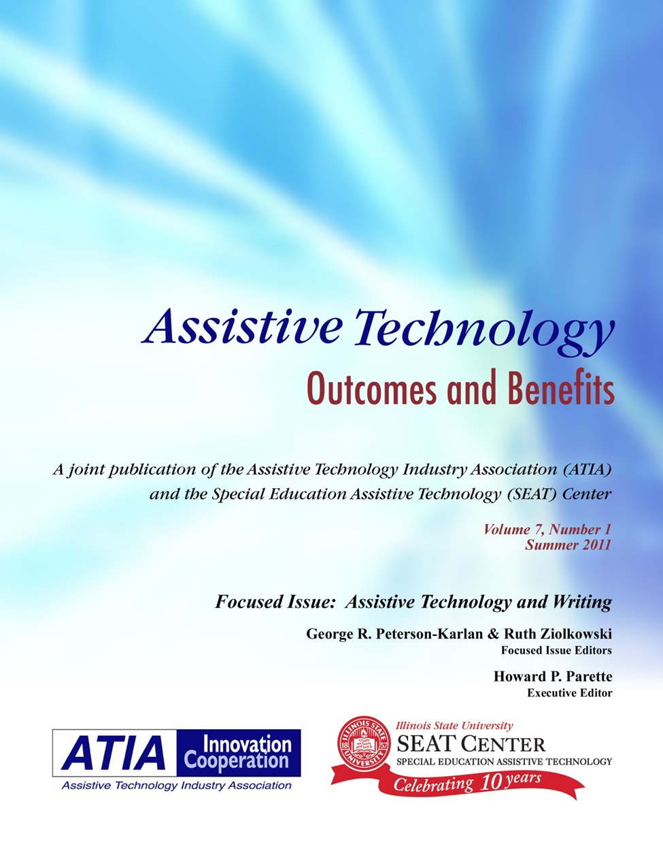

Copyright © 2011
Special Education Assistive Technology Center at Illinois State University and Assistive Technology Industry Association

ISSN 1938-7261

Assistive Technology Outcomes and Benefits
State of the Science for Technology Transfer
Summer 2011 Focused Issue
Focused Issue Editors: Executive Editor:
George R. Peterson-Karlan Howard P. Parette
Department of Special Education Special Education Assistive Technology Center
Illinois State University Illinois State University

Ruth Ziolkowski
Don Johnston Incorporated

Production Manager: Brian W. Wojcik
Assistive Technology Outcomes and Benefits (ATOB) is a collaborative peer-reviewed publication of the Assistive Technology Industry Association (ATIA) and the Special Education Assistive Technology (SEAT) Center at Illinois State University. Delivering on the ‘D’ in R&D: Recommendations for Increasing Transfer Outcomes from Development Projects is a special issue publication of ATOB, and is one of a series of topical publications on assistive technology issues.
Editing policies of this special issue are based on the Publication Manual of the American Psychological Association (5th ed.). The content presented herein does not reflect the position or policy of ATIA or the SEAT Center and no official endorsement should be inferred.

Assistive Technology Outcomes and Benefits

Editorial Policy
Assistive Technology Outcomes and Benefits is a peer-reviewed, cross-disability, transdisciplinary journal that publishes articles related to the benefits and outcomes of assistive technology (AT) across the lifespan. The journal’s purposes are to (a) foster communication among vendors, AT Specialists, AT Consultants and other professionals that work in the field of AT, family members, and consumers with disabilities; (b) facilitate dialogue regarding effective AT practices; and (c) help practitioners, consumers, and family members advocate for effective AT practices.
Assistive Technology Outcomes and Benefits (ATOB) invites submission of manuscripts adhering to the format of the Publication Manual of the American Psychological Association (5th ed.) and which address a broad range of topics related to outcomes and benefits of AT devices and services. Manuscripts may include (a) findings of original scientific research, including group studies and single subject designs; (b) marketing research conducted relevant to specific devices having broad interest across disciplines and disabilities; (c) technical notes regarding AT product development findings; (d) qualitative studies, such as focus group and structured interview findings with consumers and their families regarding AT service delivery and associated outcomes and benefits; and (e) project/program descriptions in which AT outcomes and benefits have been documented.
ATOB will include a broad spectrum of papers on topics specifically dealing with AT outcomes and benefits issues, in (but NOT limited to) the following areas:
- Early Childhood and School-Age Populations
- Research and Product Development
- Outcomes Research
- Transitions
- Employment
- Innovative Program Descriptions
- Government Policy
Regardless of primary focus of any submission, primary consideration will be given by the journal to manuscripts presenting quantifiable results.
Types of articles that are appropriate include:
Applied/Clinical Research. This category includes original work presented with careful attention to experimental design, objective data analysis, and reference to the literature.
Case Studies. This category includes studies that involve only one or a few subjects or an informal protocol. Publication is justified if the results are potentially significant and have broad appeal to a cross-disciplinary audience.
Design. This category includes descriptions of conceptual or physical design of new AT models, techniques, or devices.
Marketing Research. This category includes industry-based research related to specific AT devices and/or services.
Project/Program Description. This category includes descriptions of grant projects, private foundation activities, institutes, and centers having specific goals, objectives, and outcomes related to AT outcomes and benefits.
In all categories, authors MUST include a section titled Outcomes and Benefits containing a discussion related to outcomes and benefits of the AT devices/services addressed in the article.
For specific manuscript preparation guidelines, contributors should refer to the Guidelines for Authors at http://atia.org/

Assistive Technology Outcomes and Benefits

Focused Issue, Summer 2011

Table of Contents

An Introduction to the Assistive Technology and Writing Focused Issue |  | vi
George R. Peterson-Karlan
Ruth Ziolkowski
Developing Technology-Supported, Evidence-Based Writing Instruction for Adolescents with Significant Writing Disabilities |  | 1
Barbara A. Wollak
David A. Koppenhaver
Using Simultaneous Prompting and Computer-Assisted Instruction to Teach Story Writing to  Students with Autism |  | 24
Robert C. Pennington
Melinda Jones-Ault
John W. Schuster
Ann Sanders

Technology to Support Writing by Students with Learning and Academic Disabilities: Recent  Research Trends and Findings |  | 39
 | George r. Peterson-Karlan

© 2011, Assistive Technology Industry Association (ATIA) and Special Education Assistive Technology (SEAT) Center.

Assistive Technology Outcomes and Benefits

Editorial Policy
Assistive Technology Outcomes and Benefits is a peer-reviewed, cross-disability, transdisciplinary journal that publishes articles related to the benefits and outcomes of assistive technology (AT) across the lifespan. The journal’s purposes are to (a) foster communication among vendors, AT Specialists, AT Consultants and other professionals that work in the field of AT, family members, and consumers with disabilities; (b) facilitate dialogue regarding effective AT practices; and (c) help practitioners, consumers, and family members advocate for effective AT practices.

Assistive Technology Outcomes and Benefits invites submission of manuscripts of original work for publication consideration. Only original papers that address outcomes and benefits related to AT devices and services will be accepted. These may include (a) findings of original scientific research, including group studies and single subject designs; (b) marketing research conducted relevant to specific devices having broad interest across disciplines and disabilities; (c) technical notes regarding AT product development findings; (d) qualitative studies, such as focus group and structured interview findings with consumers and their families regarding AT service delivery and associated outcomes and benefits; and (e) project/program descriptions in which AT outcomes and benefits have been documented.
ATOB will include a broad spectrum of papers on topics specifically dealing with AT outcomes and benefits issues, in (but NOT limited to) the following areas:
Transitions
Employment
Outcomes Research
Innovative Program Descriptions
Government Policy
Research and Development
Low Incidence Populations

Submission Categories
Articles may be submitted under two categories—Voices from the Field and Voices from the Industry.

Voices from the Field
Articles submitted under this category should come from professionals who are involved in some aspect of AT service delivery with persons having disabilities, or from family members and/or consumers with disabilities.

Voices from the Industry
Articles submitted under this category should come from professionals involved in developing and marketing specific AT devices and services.
Within each of these two categories, authors have a range of options for the type of manuscript submitted. Regardless of the type of article submitted, primary consideration will be given by the journal to work that has quantifiable results.
Types of articles that are appropriate include:
Applied/Clinical Research. This category includes original work presented with careful attention to experimental design, objective data analysis, and reference to the literature.
Case Studies. This category includes studies that involve only one or a few subjects or an informal protocol. Publication is justified if the results are potentially significant and have broad appeal to a cross-disciplinary audience.
Design. This category includes descriptions of conceptual or physical design of new AT models, techniques, or devices.
Marketing Research. This category includes industry-based research related to specific AT devices and/or services.
Project/Program Description. This category includes descriptions of grant projects, private foundation activities, institutes, and centers having specific goals and objectives related to AT outcomes and benefits.
In all categories, authors MUST include a section titled Outcomes and Benefits containing a discussion related to outcomes and benefits of the AT devices/services addressed in the article.

For specific manuscript preparation guidelines, contributors should refer to the Guidelines for Authors at http://atia.org/

An Introduction to the Assistive Technology and Writing Focused Issue

George R. Peterson-Karlan, Ph.D.
Guest Editor
Illinois State University

Ruth Ziolkowski, OTR, MBA
Guest Editor
Don Johnston Incorporated

In Fall of 2010, a call for papers was sent out from Assistive Technology Benefits and Outcomes (ATOB) for a Special Issue on Writing. Unfortunately, the response did not meet our expectations. In our experience, difficulty in writing is one of the primary drivers of an assistive technology (AT) evaluation for students who are not progressing in the academic curriculum. What could be more critical than being able to express thoughts and communicate to others in writing, besides be able to get and use information from print (reading)? In higher education, organized, coherent writing is an essential form of assessment of deeper levels of learning and thought. In business, writing is an essential skill in an information and communication technology-dominated business world (National Commission on Writing, 2004). Being able to write well matters! (National Commission on Writing, 2003, 2006; National Writing Project & Nagin, 2006). In the new networked society, writing in the form of tweets (140 characters of information) and blogs has become a hallmark of the Net 2.0 socially-connected world. Is the importance we place on ensuring our students become competent writers diminishing?
We believe that using AT for writing is one of the dominant areas of the AT field, yet there is little research being done. Does this mean we know all there is to know about AT and writing? Does it mean that we still do not know what to research or what data to collect? Is it due to the fact that reading has been a core focus of Reading First and other federal initiatives such as standardized assessment? Is it due to the changing nature of writing using blogs, wikis and other forms of writing? Is it due to the dominance of multiple-choice, short answer standardized state-wide assessment? If the latter is the case, writing seems not to matter. States are dropping writing assessments due to the cost of scoring them. Where writing assessments are still used, the use of paper-and-pencil writing samples may further erode the integration of technology-based writing in the middle and high school writing curriculum (Russell & Abrams, 2004).
Research in education is hard (Berliner, 2002). Special education research, because of its complexity, may be the hardest of the hardest-to-do science. One feature of special education research that makes it more complex is the variability of the participants. (Odom, Brantlinger, Gersten, Horner, Thompson, & Harris, 2005). In addition, textbooks on educational research describe the methodology that investigators should follow, but they usually do not provide a succinct or understandable set of indicators that are useful for individuals who lack graduate training on research methodology (Odom et al.). Many areas of writing are difficult to assess. While ‘quality of writing’ is recognized as a hallmark outcome measure (Graham & Perin, 2007), nevertheless writing remains a complex process with multiple variables contributing to writing competence and with attendant issues with reliability of assessments (Benson & Campbell, 2009).
But amidst the potential for doom and gloom, in this is special edition, are two exciting research projects demonstrating promising practices for students demonstrating emergent writing skill. One study (Wollack & Koppenhaver) focused on instructional and technology-based writing supports while engaging students in new digital, socially-networked writing genres of email buddies and blog writing experiences. A second study (Pennington, Ault, Schuster, & Sanders) focuses on writing prompts and computer-assisted instruction to support writing outcomes for students with autism spectrum disorders.
Finally, a descriptive synthesis of research on technology supports for writing is presented that provides an overview of digital tools and trends in research over 25+ years. This article clearly identifies the gaps between what we think we know, what we actually know, and what we need to know. The digital tools to support writing exist, but more research is needed to establish these technologies as evidence-based practices (Peterson-Karlan & Parette, 2007).
We hope this special edition encourages you to start your own research project. Gathering data on the work that you are doing with your students and to help the AT field create a wealth of evidence of best practices.
Writing matters. Technology matters. Research matters!

References
Benson, B. J. & Campbell, H. M. (2009). Assessment of student writing with curriculum-based measures. In G. A. Troia (Ed.), Instruction and assessment for struggling writers: Evidence-based practices. New York: Guilford.
Berliner, D. C. (2002). Educational research: The hardest science of all. Educational Researcher, 31(8), 18-20.
Graham, S., & Perin, D. (2007). Writing next: Effective strategies to improve writing of adolescents in middle and high schools. Retrieved from http://www.all4ed.org/publications/WritingNext/index.html
National Commission on Writing. (2003). The neglected R: The need for a writing revolution. Retrieved from http://www.writingcommission.org/
National Commission on Writing. (2004). Writing: A ticket to work...Or a ticket out. Retrieved from http://www.writingcommission.org/
National Commission on Writing. (2006). Writing and school reform. Retrieved from http://www.writingcommission.org/
National Writing Project, & Nagin, C. (2006). Because writing matters: Improving student writing in our schools. San Francisco: Jossey-Bass.
National Writing Project, DeVoss, D. N., Eidman-Aadahl, E., & Hicks, T. (2010). Because digital writing matters: Improving student writing in online and multimedia environments. San Francisco, CA: Jossey-Bass.
Odom, S. L., Brantlinger, E., Gersten, R., Horner, R. H., Thompson, B., & Harris, K. R. (2005). Research in special education: Scientific methods and evidence-based practices. Exceptional Children, 71, 137-148.
Peterson-Karlan, G. R., & Parette, H. P. (2007). Evidence-based practice and the consideration of assistive technology. Assistive Technology Outcomes and Benefits, 4(1), 130-139.
Russell, M., & Abrams, L. (2004). Instructional uses of computers for writing: The effect of state testing programs. Teachers College Record, 106, 1332-1357.

Developing Technology-Supported, Evidence-Based Writing Instruction for Adolescents with Significant Writing Disabilities

Barbara A. Wollak
University of St. Thomas

David A. Koppenhaver
Appalachian State University

Abstract: Writing is a recursive and complex set of cognitive processes that can be taught effectively to students with disabilities. Employing an adapted cognitive theory of writing, a broad view of what constitutes evidence, and the support of a variety of assistive and internet-based technologies, we developed a writing instructional program to meet the needs of novice adolescent writers with significant disabilities. In this paper, we share the principles and processes we engaged in to develop and implement a writing instructional program as well as how students responded to the program.
Keywords: Writing, Writing instruction, Internet, Evidence-based instruction
Writing is an essential academic, employment, and life skill. In academic settings, students use writing to learn a variety of subject matter, to communicate their understanding to teachers and classmates, and to express themselves. Adolescents and adults gain access to employment through letters of inquiry and introduction, and improve their effectiveness and status in the workplace by writing memoranda, directions, analyses, syntheses, and summaries. Throughout our lives, writing helps us establish and maintain social relationships, share experiences and feelings, record personal events and insights, and organize activities and events.
Writing is particularly important for students with disabilities because it enhances communication, increases independence, and makes a unique contribution to literacy learning. Students with disabilities who can write clearly have enormous access to the world through the Internet. Students with complex communication needs who can write clearly also can generate unique and precise face-to-face messages (Blackstone, 1989). Finally, while writing is one component of comprehensive literacy instruction, it is also essential in helping some students learn to read (Clay, 1998). Written message construction slows down the processing of letters, sounds, words, and texts and consequently allows students with disabilities to examine more carefully how print works.

Writing Challenges for Students with Disabilities
A variety of factors contribute to widespread writing difficulties for students with disabilities (see e.g., Sturm & Koppenhaver, 2000). Many students experience language delays or impairments, which contribute to struggles in producing written language. Physical or sensory impairments, and limited access to needed assistive technologies, restrict learning opportunities for others. Instruction focused on skill exercises with few composition opportunities, or low expectations of adults at home or school, slow progress. Still other students are taught by under-prepared professionals. For example, in Minnesota, current licensure standards do not require teachers of students with developmental cognitive disabilities to have specific literacy methods coursework (Minnesota Administrative Rules, 2010).
In 2003, seeking to improve writing outcomes for adolescents with disabilities at a mid-western, mid-sized junior high school, a collaborative partnership between students in the Inclusion Program and preservice teachers at a nearby college was created and implemented. After discussing the types of students in their respective classes and the students’ learning needs, the authors, a speech-language pathologist and a literacy professor, initiated an e-pal exchange, which required and promoted writing in a virtual social network. The writing program evolved and included evidence-based practices, and incorporation of a wide range of assistive and Internet-based technologies. In this seven-year case study, we discuss how and why (a) the program was designed, (b) a variety of assistive and Internet-based technologies were selected and integrated into classroom activities, (c) students were taught to use the technologies, and (d) students responded to the social-communication writing program.

A Theory of Writing
From the beginning, we sought a theory of writing to guide our instructional decision-making and technology selection for two main reasons: comprehensiveness and efficiency. Students served by the Inclusion Program were diverse in their needs and interests. We worried that in the absence of a guiding theory, we might waste valuable instructional time with generic instructional approaches or technologies, or worse, fail to provide needed instruction or supportive technologies.
After much consideration we selected the Flower and Hayes (1981) model of the cognitive processes underlying writing. We appreciated that it addressed writing as a complex interplay of thinking processes. This seemed in accord with our own observations of the difficulties that students with disabilities experienced in planning and organizing their ideas, and in expressing them coherently. More important, however, research suggested that the model was quite accurate, explaining approximately 87 percent of the variance in student writing quality (Breetvelt, van den Bergh, & Rijlaarsdam, 1994). We respected the model, because it had been derived by the authors from empirical evidence as they carefully studied transcripts of real writers thinking aloud in the act of composing. Finally, we determined that this theory was widely respected in the writing community, having been cited more than 1,400 times to date [and more than 2,500 times if we included the companion Hayes and Flower (1980) article] according to a readily available search engine, Google Scholar.
Flower and Hayes (1981) propose that the constructs necessary to written communication include planning, translating, and reviewing. Planning involves setting goals, formulating ideas, and organizing thoughts. Planning addresses questions of why we want to write any given text and what we want to share. Translating is the process of converting nonlinear and overlapping experiences and ideas (e.g., sensory images, feelings, or impressions) into linear, written language using print conventions. Reviewing requires both revising (i.e., examining, ordering, and reordering texts to best effect) and evaluating the text according to the author’s plan.
Modifications to the Original Theory.
We combined elements of two other theories with Flower and Hayes (1981), because they helped us better consider the complex writing challenges of students with disabilities. First, we added a construct called production. Production describes the process of using a pencil, or an alternative writing tool, to put words on paper, or an alternative technology such as a computer monitor, in visible or tactile form. We recognized that many students with disabilities have to attend to the use of their pencil more consciously and specifically than typically-developing students who have mastered pencil use or touch-typing. Students with physical, cognitive, or sensory disabilities must always direct substantial attention to the use of their writing implements (Koppenhaver, Pierce, Steelman, & Yoder, 1994).
Next, drawing on the work of van Kraayenoord, Moni, Jobling, Koppenhaver, and Elkins (2004), we added two contextual factors to the original model: motivation and social context. Motivation affects the writer’s willingness to actively engage the writing processes individually or together, while the social context impacts motivation and the rest of the writing model. We believed, initially, that these two contexts might be most dramatically changed through the use of our fledgling e-pal plans and incorporation of assistive technologies.
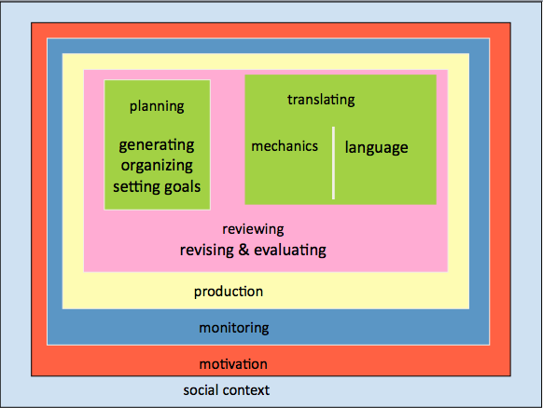

Figure 1. A situated cognitive model of writing.

We considered the resulting model an example of situated cognition (Gee, 2001), and we pictured it in our minds and practice as seen in Figure 1. That is, the model portrayed for us the nature of writing in classrooms serving children with disabilities. It enabled us to act on our belief that all students can learn to write by helping us more systematically consider what we might need to provide, support, or modify in order to improve student writing experiences and outcomes. It also allowed us to consider which technologies we might employ to best address which specific student needs. Finally, it made it possible for us to explore what we needed to learn next in order to more effectively assist student learning.
Believing that the cognitive constructs of writing are similar across individuals with and without disabilities (see e.g., Sturm & Koppenhaver, 2000), we began to explore the literature on both typically developing children and children with disabilities. What we have concluded from that research in the years since is described next.

Typically-Developing and Low-Achieving Writers
We were able to identify two large-scale meta-analyses by Hillocks (1984) and Graham and Perin (2007). Hillocks’ meta-analysis included 60 studies conducted between 1963 and 1982 and 75 experimental treatments of writing instruction with students in elementary and secondary school. The most effective instructional mode, what Hillocks described as the environmental mode, involved activities with clear and specific objectives, engagement of students with one another in a particular aspect of writing (e.g., planning), and high levels of student interaction with one another about those activities. In examining Hillocks’s instructional focus, five instructional strategies demonstrated positive effects on achievement: inquiry, rubrics, sentence combining, the use of writing models, and free writing.
Graham and Perin (2007), in the most thorough and comprehensive review to date, identified 123 studies since the 1960s and 154 experimental treatments of writing instruction involving students in grades 4-12. Like Hillocks (1984), these authors reported that effective instructional strategies included inquiry, sentence combining, rubrics, and the use of models. The authors also reported that the most effective instructional strategies explicitly taught students planning, translation, and revision strategies, as well as how to write summaries. In addition, scaffolding strategies with positive effects included prewriting activities, peer assistance, and process writing approaches. Word processing also improved student-writing quality.

Student Writers with Significant Disabilities
Our literature searches involving students with significant disabilities did not yield similarly detailed results. What we discovered was that much more research had focused on reading than on writing, was descriptive rather than experimental, and focused on skills instruction disconnected from larger writing interventions. At the same time, however, we found little to suggest any real differences in what is effective.
Research on students with autism spectrum disorders (ASD), for example, suggested the effectiveness of a variety of practices documented by Hillocks (1984) and Graham and Perin (2007) with typically developing students. Rousseau, Krantz, Poulson, Kitson, and McClannahan (1994) demonstrated that a sentence-combining strategy led to writing quality gains for three students with autism spectrum disorders and moderate intellectual disabilities. Colasent and Griffith (1998) found that drawing and retelling the meaning of stories orally and in writing (i.e., a summarization strategy), led to improved writing for three young adolescents with ASD and moderate intellectual disabilities. Bedrosian, Lasker, Speidel and Politsch (2003) conducted a comprehensive (and successful) intervention involving an adolescent with ASD and strategies documented as effective in typically developing students. These included (a) peer assistance, (b) process writing, (c) use of a story map strategy, and (d) explicit instruction.
Similarly, we could find little on students with significant disabilities. Kliewer and Biklen (2001) related the case of Kimberly, a student with visual impairments and severe intellectual disabilities. Peer assistance in an inclusive classroom, and use of captioned photos from home, assisted Kimberly in writing with increasing quality and independence across a school year. Blischak (1995) documented the case of Thomas, a nine-year-old child with multiple disabilities. His team provided him with adapted and inclusive literacy experiences leading to his growth in reading and writing through second grade. These experiences included the use of tactile books, enlarged print, communication symbols to request books and print experiences, alphabet access on his communication device, and encouragement to engage in invented spelling. Koppenhaver, Evans, and Yoder (1991) concluded that literate adults with severe physical and communication impairments had attended schools that provided them much of what is known about best practice in typically developing students.
A review by Erickson, Hanser, Hatch, and Sanders (2009) identified no studies of writing instruction for students with significant intellectual disabilities. However, in examining research on students with mild intellectual disabilities, the authors reported that the research supported two approaches found effective for typically developing students: writing strategy instruction (Graham & Perin, 2007) and student collaboration (Graham & Perin; Hillocks, 1984).

New Literacies
As if learning to read and write text weren’t sufficiently complex, an explosion of technologies (e.g., laptops, netbooks, hand-held devices, and e-text readers), increased access to the Internet, and Web 2.0 applications (e.g., (micro-)blogs, wikis, and social networking sites) have dramatically impacted the ways that people use text in social contexts. As e-mail has supplanted letter-writing and texting has become the preferred teen communication mode (Lenhart, 2010), being able to read and write conventional text is now insufficient. To socially engage with peers and young adults, students must be able to navigate, comprehend, analyze, synthesize, and construct digital texts and multimedia on the World Wide Web (Leu & Kinzer, 2000).
Leu (1997) was one of the first scholars to perceive a particular challenge of these new literacies: their deictic nature. Linguists describe deictic words as those whose meaning is dependent either on the time or space in which they are spoken or the perspective of the speaker. For example, tomorrow, today, or yesterday might be any day of the week depending on when they are spoken. I and you are not the same meaning if I speak them or you speak them, and here may be there to me if it is here to you. Deictic terms are difficult for developing language learners because their particular meaning is always dependent on something or someone else. Leu argues that new literacies also are deictic because (a) we continually reshape our definition of literacy based on new technologies; and (b) every text on the Internet can ultimately be connected to and, consequently defined by, every other. The meaning of hypertexts, such as those found on the Internet, depends as much on readers and which hyperlinks they choose to follow as it does on the original author’s intent. Teachers who apply new technologies in their classrooms do more than motivate their students--they prepare them for a technologically-infused world.
We were particularly interested in Stanford & Siders’s (2001) study that found e-pal exchanges led to greater gains than a pen pal partnership between preservice teachers and students with and without learning disabilities. Given evidence that struggling writers (Allington, 2006), students with learning disabilities (Leinhardt, Zigmond, & Cooley, 1984), and typically developing students (Graham & Perin, 2007) improve the quality of their writing when they increase the quantity of their writing, it was interesting to us to see how relatively simple it might be to effect positive change.

Literacy Program Beginnings
Armed with a theory of writing and evidence of what works, we initiated the technology-supported literacy program. The e-pal program seemed to be a practical way to motivate adolescents, increase writing quantity, and begin to explore new literacies for inclusion students (and their teachers). The collaboration was initiated between the students in the Inclusion Program and preservice teachers. This collaborative project has evolved over the past seven years, but the e-pal component has remained at the heart of the program.
Table 1
E-Pal Participant Characteristics

Junior High Students (N=110 7th and 8th students) | Preservice Teachers (N=240 undergraduate students)
88 had significant disabilities including autism, intellectual disabilities, physical impairments, or other health impairments and were eligible to take the modified state reading test; all read from below pre-primer to the 2nd grade level and had limited or no writing experience. | Enrolled in introductory reading methods courses for elementary preservice teachers, inclusive education methods, or introductory reading methods courses for preservice special education teachers.
22 had learning disabilities, emotional/behavioral disorders, physical impairments or hearing impairments; 20 read at or below the second grade level; 2 read at the 5th grade level but experienced pragmatic and written language difficulties; and had beginning writing skills. | Participation was a course requirement accounting for 10% of final course grade.
95 students received speech and language services.

E-mail communication and blogging comments were composed during speech/language therapy sessions or during special education literacy classes. | E-mail communication and blogging comments were composed as an ongoing homework assignment throughout the semester.

Participants, Structure, and Protections
Students in the Inclusion Program (see Table 1) were identified as having moderate to severe intellectual disabilities, autism spectrum disorders, physical impairments, or other health impairments. Most came to seventh grade with limited reading skills. For many, literacy instruction had been restricted to sight word instruction, copying and handwriting exercises, and grammar worksheets. As a consequence of their learning difficulties and these instructional activities disconnected from either their needs or evidenced-based instruction, most of them had negative attitudes about reading and writing. The students received specialized instruction for reading and math but participated fully in regular education health, social studies, and science classes. Students participated in the e-pal program for up to two years.
College student e-pals (see Table 1) initially were undergraduate teacher education students enrolled in an inclusive education methods course at a mid-western college. In subsequent semesters we involved undergraduates enrolled in an introductory reading methods course at a second university. We envisioned the e-pal program as an ideal opportunity for undergraduate students to gain experience with students with disabilities while increasing understanding of their learning difficulties and technologies to support their learning. Undergraduates were told to: (a) get to know your e-pals through writing; (b) provide good language models by writing at the level of your e-pals; (c) respond to e-mails within 24 hours of receipt; (d) click reply to respond to your e-pals, so that their message is included with yours to provide a context for any needed teacher assistance; and (e) send blind copies of the e-mails to both authors, so that either e-pal partner could be supported as necessary. Undergraduates participating in the program changed with each new semester.
Parents of the junior high students were notified about the project and told that teachers would be monitoring the e-mails. Parents were informed that all e-mails would be printed out and sent home for additional reading practice. Initially the school e-mail system was used, but eventually we switched to Gaggle (http://www.gaggle.net), which offered a free e-mail program for schools. Today Gaggle supports additional message board and blog capabilities. The advantages of Gaggle e-mail were many but included first author control of all student e-mail to monitor the frequency and content of writing; Gaggle blocking of questionable language through administrator controls; and speech support within the program that could be used when reading or writing e-mails.

Writing Structure
The junior high school students were taught a writing structure that included beginning each e-mail with a greeting, answering their e-pal’s questions, asking a new question, and concluding with a signature. This format supported not only the planning process (Flower & Hayes, 1981) but also the pragmatic rules of social communication: (a) knowing to answer when a question has been asked; (b) being able to participate in a conversation by taking turns; (c) being aware of the need to introduce a topic of conversation in order to support listener understanding; (d) knowing which words or sentence types to use when initiating a conversation or response; and (e) maintaining or changing a topic appropriately (Bowen, 2001).
Students were taught pragmatics by comparing an e-mail to an e-pal with a conversation. A greeting such as “Hi Linda,” would be appropriate to initiate a conversation or an e-mail. Students were taught that the next part of the e-mail should consist of answering the college e-pals’ questions or commenting about what the e-pals had written. It was explained that, as in a conversation, topic maintenance is important. After answering their e-pals’ questions, the junior high students were instructed to ask a new question related to the same topic or to initiate a new topic, as would be appropriate in a face-to-face conversation. Termination of a conversation or e-mail was the final step and consisted of closings such as, “Your friend” followed by the junior high student’s name.
Prior to launching the e-pal program, the first author found that some of the student spellings consisted of drawings and random letters that demonstrated little apparent awareness of sound-letter correspondences within words. Most of the students were able to spell the beginning and ending sounds of most words logically. All of the students found translation extremely difficult; they simply could not spell the words they wanted to write. To provide a successful, motivating, and independent writing experience, students were taught to use Co:Writer®, now in version 6.0 (Don Johnston, Inc., 2010). Co:Writer®is an intelligent word prediction program that provides spelling, grammar, and speech support. One language/literacy group session of 30 minutes was devoted to this instruction at the beginning of each school year. Since nearly all of the junior high students participated in the project for two years, this was a refresher for most of the eighth graders. An LCD projector was connected to the computer and Gaggle e-mail opened up. After the speech-language pathologist discussed and modeled the use of Co:Writer®in Gaggle, a wireless keyboard was passed from student to student. The group would dictate a sentence as each student practiced using Co:Writer®with the wireless keyboard.
Initially a paraprofessional, a special education teacher, or the speech-language pathologist (SLP) monitored each student’s use of Co:Writer®. Custom dictionaries were created in Co:Writer® with words such as the school’s name and the e-pal’s name, so that those words readily appeared in the prediction screens. Attention was paid to the words each student wrote so that frequently-used words could be added to that student’s custom dictionary. The ‘learn new vocabulary feature’ was turned off, so that misspelled words weren’t added to the predictions. In most cases, Co:Writer® was able to predict the word the student wanted to write, even if the student only knew the initial letter of a word.
Approximately 80% of the students learned to use Co:Writer® independently within six class sessions of the initial demonstration and guided practice. If students needed additional support, they were encouraged to seek peer assistance. If students had questions after that, they were instructed to ask the teacher or a paraprofessional. One student, an adolescent with autism, did not require the software because of her excellent spelling skills.
The remaining 20% of the students had greater difficulties learning to use Co:Writer® for two different reasons. Although their texts contained numerous spelling errors, half of these students had conventional spelling skills and were accustomed to composing text on a word processor. While the software supported correct spelling, the students felt that using the program slowed their composing process too much. The remaining students who struggled were those who had never composed text and often sought to copy text rather than compose e-mail messages. To teach them that writing involved composing their own ideas, they were introduced to Clicker 4, now in version 5.0 (Crick Software, 2011). Then, as soon as they grasped that concept, they were transitioned to Co:Writer®. See Appendix A for a description of the training provided in using these and other software.
One student came to seventh grade knowing just 13 alphabet letters. He had good expressive language skills but no sound-to-letter correspondence. He was taught to dictate what he wanted to write. With knowledge of his intended message, the SLP would then prompt him in the following ways, “Say the first word in your head. What does hi start with?” During the first few weeks, the student would propose random letters, and the SLP would then tell which letter to try. Because of the use of custom dictionaries and the quality of prediction in Co:Writer®, the student was able to use the speech support in the prediction windows to locate the word he wanted to spell. By the end of eighth grade, this student was able to determine the first letter of the word he sought, find that letter on the keyboard, and write more independently.
Paraprofessionals helped students learn to use the e-mail structure, prompting them as needed at each step of the process. Staff members were instructed not to correct spelling or grammar but rather to encourage student independence by responding, “Say it in your head and type the way you think the word is spelled.” The prediction in Co:Writer® was so accurate that the students’ target word usually appeared. Students quickly learned to click in the prediction screen in order to hear words they could not read. One of the better spellers in the group made the comment that seeing words spelled correctly in Co:Writer® helped him spell them more accurately even when he used pencil and paper. Research with developing writers suggested that if we were consistent in this encouragement, students would attempt to write longer texts with more varied word choice, take greater ownership of their writing, and skills would improve over time because of the use of a real audience and Co:Writer® (Clarke, 1988; Williams, 2002).
To further increase not only student independence but also improve writing quality, students were asked to read what they had written and to have the computer read aloud their texts using the speech feature of Gaggle e-mail. Students were always given the option of revising, editing, or sending e-mails as written. In this way, both our instructional guidance and the Gaggle technology supported translation but also provided increased opportunity for review and evaluation--not skills our students, or most beginning writers, tended to engage in without prompting.
E-pal relationships were concluded at the end of each college semester, and new partnerships began with the next. By the second semester, the first author had created a rubric addressing e-mail format, spellchecking, and e-mail review. The rubric, essentially a checklist of questions about each step of the e-mail writing process, asked students to mark off each item as they completed it (see Figure 2).
The rubric, another evidence-based strategy (Graham & Perin, 2007; Hillocks, 1984), was given to staff to remind them what they might need to prompt as students composed, and to students to encourage them to monitor their writing.
By referencing our writing model (see Figure 1), we were better able to understand why the project seemed so successful for the junior high school students with significant disabilities. Planning was supported by the e-mail text structure (see Figure 1 for an example). Spelling difficulties (i.e., translation) were supported with Co:Writer®. Revising was encouraged by the rubric and supported by rereading and listening to the e-mails in Gaggle before sending. Motivation could not have been higher because of student independence, authentic writing, and student success. Students eagerly sat down to write their college e-pals and waited impatiently for responses, checking and rechecking their e-mail accounts. Evidence-based practices included the use of writing models, prewriting as e-pal messages were reviewed, strategy instruction (e.g., use of speech feedback to review messages or use of Co:Writer® to improve spelling), rubrics, and use of a word processor (Graham & Perin, 2007).

Virtual Authors Blog

Have you:
read the latest e-mail from your e-pal?
selected “reply”?
written a greeting?
answered your e-pal’s questions?
asked your e-pal a new question?
included a closing or good-bye?
used the spellchecker and corrected misspelled words?
read the e-mail to yourself?
read the e-mail using Gaggle speech support?
revised the e-mail if it didn’t sound right or make sense?
sent the e-mail?

Figure 2. E-Mail Rubric
In 2006, with the teachers and students now feeling confident about e-pal writing, the Virtual Authors Blog (http://www.
hpjh.blogspot.com) was created. The blog provided students with additional authentic and motivating opportunities to read and write, and it provided the preservice teachers with an additional way to observe the interests and abilities of their e-pals. Each week the SLP and the students posted an entry, and then the students commented online in response to the entry. Parents, teachers, and college e-pals were also encouraged to comment online in order to provide good writing models and more authentic reading opportunities for students.
Many students in the Inclusion Program had language difficulties, specifically in asking and answering ‘wh’ questions, so these types of questions were posted regularly in the blog entries. Questions reflected a variety of student interests including (a) current events (What will you do on Halloween?); (b) school curricula (What is your favorite fact about the sun? Why?); (c) comparisons (What do you like best about where you live?); and (d) popular culture (Who is your favorite baseball player? Why?) .
The ability to ask and answer questions was something the e-pal text structure supported through practice. By adding the questions each week to the blog and discussing them with students in mini-lessons, three evidence-based practices were incorporated: models, peer assistance, and explicit instruction (Graham & Perin, 2007; Hillocks, 1984). Additionally, a sentence transformation model was included in blog posts for students who had difficulty answering questions. For example, for the questions, “What is your favorite food? Why?” the response structure, “My favorite food is …, because…” was included. This employed two evidence-based strategies, the use of a written model and a prewriting scaffold (Graham & Perin; Hillocks).

Deeper Into New Literacies
As e-pal interactions and blog writing continued to develop among students, we continued to explore additional supports. One clear challenge was the students’ relatively limited understanding of the world; they could not write about what they did not know. The students’ had limited background knowledge due to a variety of challenges, including limited social studies and science instruction prior to entering the Inclusion Program, learning difficulties and disabilities, living in homes of poverty, and learning English as a second language.
One of the ways we began to build background knowledge was by embedding slideshows on various topics into the Virtual Authors Blog. Slide (http://www.slide.com), Flixtime (http://flixtime.com), and Animoto (http://www.animoto.com) provided a variety of easy-to-use features for creating slideshows from photos or video, adding text and music, and including different options to increase student engagement in the material. Flickr (http://www.flickr.com/) images were used to avoid copyright issues. Some of the slideshows were created during a language and literacy group either to support activities in that class or in the students’ regular education classes.
Students took turns helping to create blog questions and posts. On one occasion, a student verbally generated questions for the blog, “What do you like best about fall? Why?” He then searched the public domain photos in Flickr’s creative commons (http://www.flickr.com/creativecommons/) for related pictures. The SLP assisted him in transferring the photos into an online slideshow (http://tinyurl.com/3pzfb28) that provided all of the students with background knowledge that helped them decide how to respond to the questions.
For a posting on favorite African American heroes, students each chose their own book. A computer was attached to an LCD projector, and students took turns discussing and selecting pictures to write about from those downloaded earlier by the first author. They shared a wireless keyboard, used Co:Writer®, and assisted one another in summarizing important information about the heroes.
This instructional activity provided the widest variety of instructional supports of any implemented to that point in the writing program, addressing every aspect of the model we had developed. Working from the outside in (see Figure 1), this activity continued building the classroom writing community, which created an appropriate social context for learning without fear of embarrassment or failure. Motivation and engagement were increased because students were given choice and each became the classroom expert on an individual hero. Monitoring took place as the group assisted one another in determining what and how to communicate about each hero. Text production was facilitated through use of the shared wireless keyboard. Planning was accomplished through student reading about each hero prior to the writing activity. Translation was supported not only through Co:Writer® but also through peer suggestions. Evidence-based practices included peer assistance and mini-lessons on summarization (Graham & Perin, 2007).
Summarization was taught by the SLP through think-alouds: “I want to summarize what we just read. I’m thinking that the most important things about what we read were…” The group practiced ‘50-cent summaries.’ Each word cost five cents, so the group would have to summarize the targeted text in 10 words or less. Suggestions would be written on the board, and then edited by the group, making sure that the resulting summary not only cost 50 cents or less but also was an accurate reflection of the important ideas in the text. Students were highly motivated to stay within their budget.
Voicethread (http://voicethread.com), a web-based technology offered free to educators, was used extensively in the Virtual Authors Blog. Voicethread allows users to create multimedia texts and obtain direct feedback from the audience. One favorite of both the junior high school students and the university e-pals was The Important Book (http://voicethread.com/?#u7667.b456443.i2427489). Based on Margaret Wise Brown’s (1949) original children’s book, this patterned text describes a variety of familiar objects and ideas by listing attributes and uses. Students used the text structure to write about their e-pals. Next they arranged the images and text in PowerPoint™, which was uploaded to Voicethread. Finally, students recorded themselves reading their individual pages. Students were highly motivated to produce an excellent recording for their e-pals, often practicing rereading their pages. The college e-pals were so impressed with their junior high e-pals’ creation that they replied with their own (https://voicethread.com/
?#u8135.b469272.i2495958) and gained firsthand experience with new literacies.

Microblogging with Twitter
Students were set up with Twitter accounts (http://www.twitter.com) as another motivating and authentic writing opportunity. Because tweets are limited to 140 characters, beginning writers did not find the task overwhelming. All but two students liked this idea and requested Twitter accounts. Students and teachers followed each other’s tweets, and preferences were set so that outsiders had to be invited in order to follow a student. Students attached Co:Writer® to their tweets to continue to support their spelling. They also chose to follow groups like the Jonas Brothers and the local professional hockey team, thereby increasing their reading volume. With Twitter, students were now choosing to read and write even more, including during free time!
Students also learned important lessons about the public nature of the Internet (e.g., do not post what you do not want everyone to know). One male student regretted posting that he liked another female student. He learned a lesson just like anyone else who has posted questionable content on sites like Facebook only to suffer repercussions from family or employers.

Instant Messaging
On several occasions collaborative groups of junior high students had instant message conversations with the university students. For the junior high students, Co:Writer® was attached to the instant message system, and students were able to help each other compose messages. On one occasion, the university students wrote, “Cheer for our basketball team. They made the Final Four.” The junior high students responded, “Who cares about basketball? Cheer for our hockey team who made the Frozen Four.” The college students messaged, “Who cares about hockey?” By this time the junior high students were laughing so hard they had difficulty typing. They finally wrote, “Okay, we’ll cheer for your team if you cheer for ours.”
Student writing quality and other language skills improved over time. With the use of assistive or web technologies, as well as instructional strategies, students wrote more independently. By the time they left Highland Park Junior High, they understood how to convey their own thoughts.

Outcomes and Benefits
The instructional program described in this paper is not a formal research study. It is instead a description of the use of a theory of writing to guide instructional planning and program development as well as careful technology selection in the support of student writing growth. Consequently, no formal quantitative or qualitative analyses were drawn upon in describing the program’s outcomes and benefits. Rather, we drew informal conclusions that rely upon informal teacher observations, teacher notes on interactions with participants, notes from conversations with parents and staff, emails exchanged between the authors, and the students’ e-mails, blog comments, and other multimedia compositions. We present the following summary of these informal observations tentatively, relying upon other scholars to explore the effectiveness of such an instructional approach ultimately with more rigorous research designs.
The benefits of this evidence-based writing program divided primarily into two categories: (a) increased student motivation, and (b) growth in written communication skills. Students were motivated by writing for real audiences in valued social contexts supported by technology. As they learned to use a variety of assistive and web-based technologies, and engaged in interactive literacy learning opportunities, their skill and independence in written composition also grew. They readily assisted one another and engaged in every aspect of the writing process from planning to composing to revising and editing. We address these two areas of student outcomes below.

Student Outcomes: Increased Motivation
Each semester, one of the questions on the blog asked students how they felt about having an e-pal. Across the seven years, all but two of the 110 students reported that they enjoyed the experience. The other two rated the experience as “okay,” but noted that they preferred writing their e-pals to other school assignments. More than one student wrote comments such as, “I like having pen pals because it is fun talking about sports,” “a pen pal is a friend you can talk to if you are sad or happy,” “you are my best friend,” and “when I don’t feel like playing with my brother, I can write to my pen pal.”
Experienced student participants understood that their e-pal relationship ended at the conclusion of each semester and were eager to meet their new e-pals at the start of the next semester. When inevitable start-up delays were encountered each semester, the growing question from junior high students was reiterated, “How much longer until we get new pen pals?”
Occasionally, e-pal friendships lasted longer than a single semester. Tatyana, for example, was a university foreign exchange student from Russia who wrote in her final e-mail to Latrese, “I don’t know where in the world I’ll be next year, but wherever that is, I’ll write to you.” Latrese, a reluctant and struggling writer prior to the e-pal experience, and Tatyana sustained their e-mail friendship for another three semesters, until Latrese completed eighth grade and moved on to high school.
Even for e-pal partnerships fitting the more usual single semester exchange, junior high students did not see e-mailing, blogging, or tweeting as academic tasks so much as social activities. Most checked their e-mail repeatedly throughout the day. Most students viewed their e-pal partners as friends and confidantes. They wrote about birthdays, sports, music, television shows, and boredom. They sought them out for advice in dealing with school and personal problems.
This personal correspondence often changed student views about the writing process and themselves as writers. For example, two students, who initially reported that they “hated writing,” changed their responses to “love writing” after their first semester in the program. Although neither student had access to computers at home, both started writing regularly in the evenings and on weekends with paper and pencil. Another student decided that she wanted to become a “famous writer.” On more than one occasion she wrote stories and sent them to the second author. This same student requested a portable word wall for her home to assist her writing.
University e-pals found the program motivating as well. In course evaluations and reflections, they typically reported that they were moved by the sincerity of their e-pals, intrigued by the technologies that the students used, and surprised that friendships could grow through e-mail in such a short time span. Students were often disappointed that their e-pal had not written them as frequently as a fellow student, but when the first author shared background information at the end of each semester about the students’ home life, disabilities, and learning needs, the disappointment usually disappeared. Comments like Nathan’s were representative of the tone and feelings of most of the university participants. Nathan wrote at the conclusion of the semester, “I enjoy learning things that will help me in my future teaching. I love talking to my e-buddy because he is awesome. Hank is the man and I feel like I have made a lifelong friend. I hope to stay in contact with him even after this year is over. Hank, if you read this buddy, you are the coolest kid ever!”
Sometimes there was a mismatch in the number of e-pals at each site, so one student or the other might have two e-pals. Leslie, a student preparing to become a speech-language pathologist, wrote,
I love having two e-pals! John and Daryn are great fun to e-mail back and forth with. It has been really nice getting to know them. Thank you for this opportunity. It has been a great learning experience, besides gaining two new friends.
She continued writing after her semester concluded until the end of the school year even though she was packing for a cross-country move.
The writing program motivated students to such an extent that they did not view the writing as schoolwork and sought it out even when it was not required. Perhaps the greatest testament to the motivating influences of the program occurred when a typically developing student in regular education approached the first author and asked with great sincerity if he could sign up for speech, so that he could “get one of those college e-pals.”

Student Outcomes: Written Communication Growth.
With the support of assistive technology, all students exiting the Inclusion Program after eighth grade have achieved the ability to write connected text independently. Initially, some students would regularly seek and request “something to copy” during writing time. By eighth grade, however, they understood that writing was about conveying one’s own thoughts on paper. Teachers in the regular education classes noted how students were both more eager and more capable in class writing tasks.
The growth in written communication of several students is described below, beginning with John. He, like many students with a diagnosis of autism, had great difficulties in processing oral language. As an entering seventh grader he demonstrated knowledge of about 20 sight words but was unable to read connected text at even a pre-primer level with understanding. He readily copied text but was unable to write generative text. He found ‘wh’ questions difficult to understand, particularly questions beginning with “why.” When the e-pal and blogging project were explained to John’s mother, and the emphasis on ‘wh’ questions overviewed, she expressed serious doubts about his ability to manage. She felt that having an e-pal and responding to questions would simply be too abstract for him to understand.
Assistance was provided to John to get started writing by introducing him to Clicker, a picture-supported word processor. This helped him transition from copying to composing. As soon as John began to understand that writing was generating his own thoughts, the first author replaced Clicker with Co:Writer®. John quickly learned how to use the speech feedback feature to assist him in composing words he could not spell.
During his first semester he typically wrote short, heavily-prompted responses to his e-mail partner. For example, on one occasion the SLP began by asking, “What greeting do you want to use?” John said, “Hi.” That prompt was enough for John to type an ‘h’ and then find “hi” among the predictions in Co:Writer®. Next he was told, “You need to write the name of your e-pal.” John attempted to spell “Angela.” A similar process was used for the remainder of the email, with verbal prompting to get John to answer his e-pal’s questions, ask a new question, and end with a closing. Here’s the message that resulted:
Hi angala. How are you. I am great. I like this movie. Stup up 2. my favorite color is blue. My favorite almalls is cow. My favorite to sprots. Is football. What to do this weekend. Your friend john.
Initially the SLP had to prompt John word-by-word in order to get him to write a sentence. Verbal prompting was employed with John because he tried to copy written text rather than compose messages. Two years later, his familiarity with the e-mail structure and basic sentence structures with Co:Writer® support allowed him to independently write messages like the following:
Hi lindsay how are you. I am great. What favorite is house. I went to see a meeting jay and lizard. I want to see a steve blues and mailboxs. What do this weekend. I went to see a rides a mat eddie birthday partys. I went to see a pop and food to drink. I went to see a mats friend. I went to see a grandpa grandma. I went to see a appiebees. Talk to you later. John.
His e-mails had roughly doubled in length, from 30-40 words to 80-90, as had his sentence length (from three to four words to six). He was comfortable expressing feelings and describing actions. His vocabulary, spelling, and ability to communicate were growing. What his mother valued as much as John’s growth in his written communication was his increased ability to communicate face-to-face and understand ‘wh’ questions. This became most evident in the spring of his 8th grade year when he became upset. When his mother asked, “Why were you so upset,” he replied, “Because April (his paraprofessional) was not there.” John had learned the meaning of ‘wh’ questions and used that understanding to communicate his feelings.
Chuck, another student with a diagnosis of autism, had difficulties understanding and expressing language when he entered the program. In seventh grade, upon entry into the program, he wrote sentences like “pen pal is like send your friends and your message” and “my most annoying insects is gnat because they suck blood like others of insects.” Written language seemed to help Chuck better understand both written and oral language. He seemed to benefit especially from instruction in the use of sentence frames and sentence combining (Graham & Perin, 2007; Hillocks, 1984). For example, in response to instruction in the use of one early sentence frame, “My favorite food is…because…,” Chuck wrote, “My favorite food is double cheeseburger because it taste juicy.” By eighth grade, Chuck wrote sentences like, “The most important thing about my e-pal, Kaitlyne, is that she is charming. She is a good friend and she is a football fan.” Both his writing and his speech demonstrated improved sentence structure and complexity.
Davey, a young man with Down syndrome and complex communication needs, was approximately 40% intelligible to familiar listeners. At the beginning of seventh grade, he could read some sight words but his only writing was copying. On an informal reading inventory he placed at the pre-primer level on word identification but was unable to reach criterion at that level in reading or listening comprehension tasks. When spelling unknown single-syllable words, Davey could represent initial and final sounds logically.
Davey especially benefited from the level playing field created by e-mail communication and the e-pal project structure. The semester he began participating in the project, his college e-pal did not know that Davey had significant communication problems. He also had no idea that Davey was a reluctant oral communicator because of his communication impairments. He was unaware that it may have taken Danny up to 30 minutes to compose a four-sentence e-mail. Like John, Davey was transitioned from copier to a composer by using Clicker.
As he became a writer, Davey revealed his love for humor and would always include a joke at the end of his e-mail. His college counterpart would reciprocate. Davey’s mother reported that the printed e-mails were the first thing out of Davey’s backpack, and that he would read them to his family. Davey’s mother also reported her surprise when Danny went to a movie with a friend and then independently composed a thank you note to the friend.
By his second year in the project, Davey’s transformation as a writer was remarkable. He was using Co:Writer® to independently compose e-mails like the following:
Hola Barbara, My favorite subject is math. I really like baseball. I like playing with my dog Buster. Do you have any pets? What did the hot dog say when it won the race? I'm the wiener! Adios Davy
Another student, Jason, had a rare neurological condition and knew just 13 letters of the alphabet when he arrived in seventh grade. He was unable to identify letter-sound correspondences. A custom dictionary was created for him in Co:Writer®, and he was taught how to use the spelling prediction. Initially he could not even produce a logical first letter, so his teachers would tell him the first letter. By using the speech support in Co:Writer®, he then found the word he wanted. By eighth grade he developed the ability to logically predict the initial letters of words he wanted to write and was able to write independently with the support of this software.

General Outcomes and Benefits
Beyond student growth in motivation and written communication, this program offers a variety of more general contributions to the assistive technology outcomes literature. The program model points to the value of research and practice integration. In this particular case, the integration led to the identification of a writing theory and the selection of evidence-based practices to address components of the model and more specifically target student needs. Research did not just inform instruction; it unified program design and implementation.
In addition, the instructional design bridged the needs of students in a university preservice teaching program and a junior high school inclusion program. This particular model enabled students with disabilities to effectively address their learning needs by engaging in purposeful social interactions via technology-supported written language use. It also enabled university students to better understand the interests and learning needs of diverse, beginning writers with a wide range of disabilities. Every e-mail interaction and blog posting provided a virtual practicum experience for preservice teachers on the value of real audiences, the range of literacy- and student-centered applications of assistive technology, the power of engaged learning, and the nature of diverse learners. The instructional design enacted one of the strengths of the Internet, the ability to offer cost-effective and efficient virtual experiences that dramatically enrich the learning opportunities of both diverse learners and preservice teachers.
Finally, the instructional design enabled us to become more intentional and thoughtful educators. The theoretical framework guided our thinking about student needs, instructional strategies, and the selection and use of assistive technologies. We read and discussed both the theoretical model and research on best practice in written language intervention. We suggested readings to one another, searched the Internet for technologies to address particular aspects of the model, and frequently discussed a wide range of instructional issues via Skype™ (http://www.skype.com) and email. Theory became the road map to our planning, professional reading and discussions, and our teaching.
The program has met the test of face validity. The staff observed changes in the engagement of students and growth in their written language abilities. The program was valued by the community, receiving media attention and winning awards in the school district’s annual Technology Student Showcase for six consecutive years. The awards, which were incorporated into the program to expand successful student writing opportunities included two computers, a video camera, a wireless keyboard, two digital cameras, and flash drives. The program is established and valued; it remains now for scholars to design more formal studies of its component contributions and composite value.

Research Implications
There are many limitations to this case study of the implementation of a theoretically-driven and technology-supported writing program. The program described here is the result of a thoughtful and long-term collaboration, but is not the result of formal study. As noted, a theory of writing guided three important tasks intended to improve student learning outcomes: a review of research on best practices in writing; the selection and design of instructional approaches based on those best practices; and the careful selection of technologies intended to support various aspects of the writing process, particularly those observed to cause student difficulties.
Several key elements of the program seem to suggest promising directions for more formal research studies. First, it would be useful to conduct a formal quantitative analysis of the program described here, which involved theoretically-driven instructional decision-making and technology-supported writing, learning, and interaction. Relevant student measures might include changes in student motivation to write, written language quantity and quality both within and beyond the classroom, and engagement in lessons.
Second, using models of the writing process (e.g., Flower and Hayes, 1981), researchers might examine the contributions of specific technologies in addressing identified student needs according to the models and the generalized impact of that technology use on overall writing quality. That is, these studies should not be limited to an examination of the effects of the technology-supported intervention on the targeted skill (e.g., spelling, grammar, planning), but should also examine whether use of that technology increased student independence in the writing process and ability to communicate more clearly in written language tasks to specific audiences.
Third, it has been observed that there are a variety of barriers impeding effective integration of technology into classroom instruction. Integration seems to proceed when one of two types of change occur in teacher beliefs. First-order change is that which allows teachers to become more effective and efficient in their teaching without challenging their fundamental beliefs about instruction. Second-order change requires teachers to more deeply examine their beliefs about their current teaching practices and develop new roles and practices (Cuban, 1988; Ertmer, Addison, Lane, Ross, & Woods, 1999). Research might explore the extent to which models with instructional implications (e.g., Flower & Hayes, 1981) enable teachers to make one or both types of change and integrate technology which not only supports their new and deeper understanding of student learning but also allows them to teach more effectively and efficiently.
Along the same lines, an increasing array of technology was integrated over time in this program, but the goal was never to increase technology integration. The goal was to engage students in learning to write. Technologies were initially selected because they addressed an aspect of the model; they were retained in the program because students found them engaging and produced better writing. Researchers might explore more systematically the ways in which theoretically-sound curricular and instructional decision-making leads to successful technology integration.

Conclusions
Samuel Johnson (1811) wrote that, “Marriage has many pains, but celibacy has few pleasures” (p. 92). The program described here represents a successful marriage of theory, research, and practice. It is not without its pains, not the least of which is the need for more formal study now that it has been created. However, it also has many pleasures. Programmatic coherence was achieved by framing instructional decision-making with a theory of writing. Technology integration was organized around the components of the theoretical model and student needs. Students with disabilities and significant literacy needs wrote better and enjoyed it more. And, finally, assistive and Web-based technologies not only supported student learning and engagement but also expanded their curriculum far beyond the classroom walls.

References
Allington, R. L. (2006). What really matters for struggling readers: Designing research-based programs (2nd ed.). Boston: Allyn and Bacon.
Bedrosian, J. L., Lasker, J., Speidel, K., & Politsch, A. (2003). Enhancing the written narrative skills of an AAC student with autism: Evidence-based research issues. Topics in Language Disorders, 23, 305-324.
Blackstone, S. (1989). The 3 R’s of reading, writing, and reasoning. Augmentative Communication News, 2(1), 1-3.
Blischak, D. M. (1995). Thomas the writer: Case study of a child with severe physical, speech and visual impairments. Language, Speech, and Hearing Services in Schools, 26, 11-20.
Bowen, C. (2001). Semantic and pragmatic difficulties and semantic pragmatic language disorder. Retrieved from http://www.speech-language-therapy.com/spld.htm.
Breetvelt, I., van den Bergh, H., & Rijlaarsdam, G. (1994). Relations between writing processes and text quality: When and how? Cognition and Instruction, 12, 103-123.
Brown, M.W. (1949). The important book. New York: HarperCollins.
Clarke, L. K. (1988). Invented versus traditional spelling in first graders’ writings: Effects on learning to spell and read. Research in the Teaching of English, 22, 281-309.
Clay, M. M. (1998). By different paths to common outcomes. York, ME: Stenhouse.
Colasent, R., & Griffith, P. L. (1998). Autism and literacy: Looking into the classroom with rabbit stories. Reading Teacher, 51, 414-420.
Crick Software, Inc. (2011). Clicker (Version 5.0) [Computer software]. Westport, CT. Retrieved from http://www.cricksoft.com/us/products/tools/clicker/home.aspx.
Cuban, L. (1988). The managerial imperative and the practice of leadership in schools. Albany, NY: State University of New York Press. Retrieved from http://tinyurl.com/
3tl757a.
Don Johnston, Inc. (2010). Co:Writer (Version 6.0) [Computer software]. Volo, IL. Retrieved from http://www.donjohnston.com/products/cowriter/index.html.
Erickson, K., Hanser, G., Hatch, P., & Sanders, E. (2009). Research-based practices for creating access to the general curriculum in reading and literacy for students with significant intellectual disabilities. Chapel Hill, NC: Center for Literacy and Disability Studies, University of North Carolina.
Ertmer, P. A., Addison, P., Lane, M., Ross, E., Woods, D. (1999). Examining teachers’ beliefs about the role of technology in the elementary classroom. Journal of Research on Computing in Education, 32(1), 54-72.
Flower, L. S., & Hayes, J. R. (1981). A cognitive process theory of writing. College Composition and Communication, 32, 365-87.
Gee, J. P. (2001). Reading as situated language: A sociocognitive perspective. Journal of Adolescent and Adult Literacy, 44, 714-725.
Graham, S., & Perin, D. (2007). A meta-analysis of writing instruction for adolescent students. Journal of Educational Psychology, 99, 445-476.
Hayes, J. R., & Flower, L. S. (1980). Identifying the organization of writing processes. In L. Gregg & E. Steinberg (Eds.), Cognitive processes in writing: An interdisciplinary approach (pp. 3-30). Hillsdale, NJ: Erlbaum.
Hillocks, G., Jr. (1984). What works in teaching composition: A meta-analysis of experimental treatment studies. American Journal of Education, 93(1), 133-170.
Johnson, S. (1811). The history of Rasselas, Prince of Abissinia. Boston: J. Belcher. Retrieved from http://tinyurl.com/3ty54xw.
Kliewer, C., & Biklen, D. (2001). “School’s not really a place for reading”: A research synthesis of the literate lives of students with severe disabilities. JASH, 26(1), 1-12.
Koppenhaver, D. A., Evans, D. A., & Yoder D. E. (1991). Childhood reading and writing experiences of literate adults with severe speech and motor impairments. Augmentative and Alternative Communication, 7(1), 20-33.
Koppenhaver, D. A., Pierce, P. L., Steelman, J. D., & Yoder, D. E. (1994). Contexts of early literacy intervention for children with developmental disabilities. In M. E. Fey, J. Windsor, & S. F. Warren (Eds.), Language intervention volume 5: Preschool through the elementary years (pp. 241-274). Baltimore: Brookes.
Leinhardt, G., Zigmond, N., & Cooley, W. W. (1981). Reading instruction and its effects. American Educational Research Journal, 18, 343-361.
Lenhart, A. (2010). Teens, cell phones, and texting: Text messaging becomes centerpiece communication. Retrieved from http://pewresearch.org/pubs/1572/teens-cell-phones-text-messages.
Leu, D. J., Jr. (1997). Caity’s question: Literacy as deixis on the internet. Reading Teacher, 51, 62-67.
Leu, D. J., Jr., & Kinzer, C. K. (2000). The convergence of literacy instruction with networked technologies for information and communication. Reading Research Quarterly, 35, 108-127
Minnesota Administrative Rules. 8710.5400 Teachers of special education: Developmental disabilities. Retrieved from https://www.revisor.mn.gov/
rules/?id=8710.5400.
Rousseau, M. K., Krantz, P. J., Poulson, C. L., Kitson, M. E., and McClannahan, L. E. (1994). Sentence combining as a technique for increasing adjective use in writing by students with autism. Research in Developmental Disabilities, 15(1), 19-37.
Stanford, P., & Sider, J. (2001). E-pal writing! Teaching Exceptional Children, 34(2), 21-24.
Sturm, J., & Koppenhaver, D. A. (2000). Supporting writing development in adolescents with developmental disabilities. Topics in Language Disorders, 20(2), 73-92.
van Kraayenoord, C. E., Moni, K. B., Jobling, A., Koppenhaver, D., & Elkins, J. (2004). Developing the writing of middle school students with developmental disabilities: The WriteIdeas model of writing. Literacy Learning: The Middle Years, 12(2), 36-46.
Williams, S. C. (2002). Word-prediction software can help students write. Teaching Exceptional Children, 34(3), 72-78.

Appendix A
Principle Assistive Technologies (AT)/Technologies Used in Program, Purpose, and Teaching Methods
Technologies | Purpose | Teaching Methods Overview
Clicker 4 http://tinyurl.com/3oust7p | To teach students to generate their own ideas rather than copy text. | 1) Parents wrote in notebook about their child’s interests and activities.  2) Clicker grids containing choices with picture support were created based on parents’ information (e.g. Hi Jolene, I have a dog/cat. Do you have a pet/brother? Your friend, John)  3) Students created sentences using the picture grid. (e.g., Hi Jolene, I have a cat. Do you have a pet? Your friend, John.)  4) Prompting and modeling were conducted by the SLP as needed to get student choices to match information supplied by parents and to teach topic maintenance.  5) After a sentence was created, the text was sent to the word processor in Clicker.  6) Finally, students were taught to select the text, copy it, and paste it into the e-mail.
Co:Writer 6  http://tinyurl.com/lar3hy | To provide spelling and grammar support. | 1) A demonstration of Co:Writer and guided practice was conducted for students including how to:  a. open up Co:Writer in e-mail;  b. consider what to write and type the first letter of the first word of the message;  c. visually scan the resulting predictions using the down arrow key to control speech support as needed;  d. select the intended word by either typing its number in the list, using the down arrow key and selecting it, or by using the mouse;  e. press the right arrow key for more choices if the intended word was not among the predictions;  f. think of and type the second letter in the intended word if the word was still not among the predictions.  2) Additional support and prompting was provided individually or in small groups as needed.
Gaggle  https://gaggle.net/ | To allow staff to monitor all e-mails on demand and to filter inappropriate content.  To provide students with speech support and spellchecking. | 1) Usernames and passwords were created for students.  2) Students were taught to:  a. open the Gaggle site in their browser, enter their usernames and passwords, and then open Co:Writer;  b. check for new e-mails;  c. read new e-mails (with speech support if needed).  d. type their e-mails and use spellchecking;  e. read over their e-mail messages;  f. use speech support in Gaggle to read the e-mail again;  g. revise or send e-mails as desired;  3) Staff printed e-mails for students to take home and read to family and friends.
VoiceThread  http://voicethread.com/ | To enable groups to create online texts with teacher guidance and record students reading the texts. | 1) Students were read a patterned children’s book (e.g., The Important Book by Margaret Wise Brown).  2) A template based on the text structure of the book was presented to students in PowerPoint™.  3) Students attached Co:Writer to a PowerPoint slide and wrote an individual page for each of their e-pals (e.g., “The important thing about Linda is that she likes movies just like me.”)  4) The resulting class e-book created with PowerPoint™ slides was uploaded to VoiceThread.  5) Students then used the comment feature in VoiceThread to read aloud and record their individually authored slides.  6) The resulting VoiceThread e-book was then linked to the Virtual Authors blog.
Blogger http://www.blogger.com | To provide students with (a) a motivating, age-appropriate means of writing and reading, and (b) to present them with other similar tools by embedding free  technologies | 1) A blog was created with privacy settings to restrict access.  2) With student input, a new question was posted weekly as a blog entry.  3) Students were taught to:  a. read the question, examine the accompanying pictures or video, and then click on “comments.”
Blogger http://www.blogger.com (continued) | To enable family and friends to read and comment on student writing and multimedia projects. | b. attach Co:Writer to the comments window, click on “Name,” and type their first names.  c. Use Co:Writer to type their responses, and then clicked on “Publish Your Comment” when they were finished.  4) The college students also responded to the weekly blog questions, thereby providing good written language models.  5) Family and friends were invited to visit the blog and to post responses if they desired.
Animoto  http://animoto.com/  Slide®  http://www.slide.com/  Flixtime  http://flixtime.com/ | To build student background knowledge relative to the weekly questions by creating a variety of video slideshows. | 1) Students took turns determining blog questions.  2) SLP controlled the keyboard and web-based tools while students selected pictures and music for the videos.  3) Students attached Co:Writer to the pictures in order to write captions.  4) The resulting videos were then linked with the target questions on the blog.
Flickr® http://www.flickr.com/creativecommons/ | To remove copyright issues as pictures were inserted into various student projects. | This was a tool used primarily by staff.
Twitter  http://twitter.com/ | To provide students with a motivating, age-appropriate means of writing and reading that was not overwhelming since tweets are limited to 140 characters. | 1) SLP created user names and passwords for students.  2) Privacy settings were selected so that followers had to be approved.  3) Students and teachers were linked to each other.  4) Students were taught to attach Co:Writer to “What’s Happening” window to create a tweet.

Using Simultaneous Prompting and Computer-Assisted Instruction to Teach Story Writing to Students with Autism

Robert C. Pennington
University of Louisville Autism Center

Melinda Jones Ault
Appalachian State University

John W. Schuster
University of Kentucky

Ann Sanders
Jefferson County Public Schools

Abstract: In the current study, the researchers evaluated the effects of simultaneous prompting and computer-assisted instruction on the story-writing responses of 3 males with autism, 7 to 10 years of age. Classroom teachers conducted all probe and training sessions. The researchers used a multiple baseline across participants design to evaluate the efficacy of the intervention. In addition, they used pre-posttest measures to assess the generalization of acquired skills across untrained story topics and different response topographies. The data indicated that simultaneous prompting and computer-assisted instruction were effective in improving the story-writing skills of all 3 participants. Two of the participants demonstrated maintenance and generalization of trained responses.
Keywords: Autism, Written expression, Simultaneous prompting, Computer-assisted instruction

Introduction
Written expression is a fundamental skill for individuals in educational and community contexts. In schools, students use written language to demonstrate their acquisition of content (Mercer & Mercer, 2005). Upon graduation, students are expected to write proficiently across purposes and for a variety of audiences. In community contexts, the utility of written communication extends to almost every facet of daily life. Employers increasingly demand that applicants demonstrate proficient writing skills upon entry to the workforce (National Commission on Writing, 2004). Social networks now require that members interact via electronic written messages (e.g., e-mail, texts, Facebook©). Finally, people have come to rely on a variety of text-based tools (e.g., PDA, smart phone apps, planners) to document and organize their lives.

Addressing Written Expression in Students with Autism
Unfortunately, researchers have suggested that individuals with autism spectrum disorders (ASD) may have difficulty acquiring writing skills (Gabig, 2008; Myles, Huggins, Rome-Lake, Barnhill, & Griswold, 2003). This is especially problematic in light of data indicating that many students with ASD acquire a limited range of vocal communication skills (Miranda-Linne & Melin, 1997). Fortunately, researchers have demonstrated that written text can effectively replace or augment vocal communication. In an early study, LaVigna (1977) demonstrated that students with autism could make requests by exchanging cards depicting written texts for preferred items. Researchers also have reported an improved quality in the conversation of individuals with ASD when they are given the opportunity to type communicative responses (Forsey, Bird, & Bedrosian, 1996; Schairer & Nelson, 1996).
Despite the importance of acquiring writing skills for students with ASD, there has been limited research in the area of teaching writing to these students. The majority of research in the area of written expression has focused on spelling responses. Stromer, MacKay, Howell, and McVay (1996) evaluated the effects of computer-assisted instruction (CAI) and delayed word construction procedures on the spelling performance of a 21-year-old male with ASD. They demonstrated that the intervention was effective and that the participant generalized spelling skills to handwritten responses. Sugasawara and Yamamoto (2007) used CAI to teach the construction of Japanese characters to a 4-year-old male with pervasive developmental disorder. The student acquired the target responses and also demonstrated gains in vocal reading of the characters. Kinney, Vedora, and Stromer (2003) reported that the computer presentation of video clips depicting an adult modeling correct spelling responses was effective in teaching an 8-year-old female with autism to spell trained and untrained words. Finally, two research teams evaluated the effects of using a copy-and-cover method (Cuvo, Ashley, Marso, Zhang, & Fry, 1995) and a voice output communication aid to 5 children with autism, ages 9 to 12 years. In addition, both teams compared feedback conditions (i.e., print, speech, print + speech) and found differential effects on measures of efficiency across the participants (Schlosser & Blischak, 2004; Schlosser, Blischak, Belfiore, Bartley, & Barnett, 1998).
Two investigations have addressed the development of basic expository writing responses. Basil and Reyes (2003) evaluated the effects of a computerized software package (i.e., Delta Messages; Nelson & Heimann, 1995) on the sentence construction skills of 2 students with autism, ages 8 and 14 years. Both students acquired targeted responses, but one of the students demonstrated additional gains in handwritten responses and on measures of phonological awareness. Yamamoto and Miya (1999) also used CAI to teach sentence construction tasks to students with ASD. Three students, ranging in age from 6 to 10 years, acquired computer-based target responses, but also demonstrated generalized gains across handwritten and vocal topographies.
Five teams of researchers have evaluated complex writing responses. Rousseau, Krantz, Poulson, Kitson, and McClannahan (1994) used a sentence-combining technique to increase the use of adjectives for 3 males with ASD, ages 11 to 13 years. Bedrosian, Lasker, Speidel, and Politsch (2003) used a multi-component intervention package to increase the number of words used, peer interactions, and revisions made during the joint writing activities of a 14-year-old male with ASD and a peer without disabilities. The package, which consisted of the use of an assistive augmentative communication device, story maps, storyboards, and adult modeling, was effective in improving the participant’s narrative writings skills. Delano (2007a, 2007b) conducted two studies investigating the use of self-regulated strategy development procedures (SRSD; Graham, Harris, McArthur, & Schwartz, 1991) to improve the narrative writings skills of students with Asperger’s syndrome (AS). In the first investigation, Delano used video self-modeling of the SRSD strategies to increase the number of words and functional elements used by 3 males with AS, ages 13 to 17 years, in persuasive writing compositions. The students demonstrated gains in target responses but also generalized their newly acquired skills to expository writing. In the second investigation, Delano used a preference interview and SRSD to increase the use of action words, describing words, and revisions by a 12-year-old male with AS during story writing activities. The participant demonstrated gains across all measures. Finally, Asaro and Saddler (2009) investigated the use of SRSD during instruction of a 10-year-old male with AS. They delivered scaffolded instruction across seven lessons designed to teach the participant strategies for planning and revision. Following intervention, the participant demonstrated gains in the number of story elements used and on measures of overall writing quality.

Incorporating Response Prompting Procedures during Instruction
The majority of the articles described the use of various prompts to elicit student responses, but many failed to provide operationalized procedures for the delivery of those prompts. Response prompting procedures serve as a critical component of instruction for students with disabilities and have been evaluated and refined through a wide body of research (Morse & Schuster, 2004; Schuster, Morse, Ault, Doyle, Crawford, & Wolery, 1998; Walker, 2008). One of the most recent innovations in response prompting procedures has been the development of simultaneous prompting (SP; Gibson & Schuster, 1992). Simultaneous prompting involves the consistent delivery of a controlling prompt immediately following the presentation of the discriminative stimulus (e.g., task directive). In other words, during all instructional trials, a prompt is provided that ensures the student will produce a correct response. Additionally, since the student is never given the opportunity to respond without the prompt, transfer of stimulus control is assessed in probe trials that precede training trials on each day of instruction (Schuster, Griffen, & Wolery, 1992). Simultaneous prompting has been effective in the instruction of a wide range of skills to a heterogeneous group of students (Morse & Schuster). Recently, data from several studies have indicated that SP is effective during the instruction of students with ASD (Akmanoglu & Batu, 2004; Akmanoglu-Uludag, & Batu, 2005; Kurt & Tekin-Iftar, 2008). To date, SP has never been evaluated in the context of writing instruction for students with ASD.

Application of Computer-Assisted Instruction
In addition, the majority of research teams used CAI as a component of writing intervention for students with ASD. Computer-assisted instruction refers to the use of a computer-technology as a learning medium that presents learning materials and/or check’s learner’s knowledge (Anohina, 2005). Several researchers have suggested that CAI is compatible with the characteristics of individuals with ASD (Higgins & Boone, 1996; Moore, McGrath, & Thorpe, 2000). For example, during CAI, learners with ASD have access to controlled presentations of relevant instructional stimuli while simultaneous avoiding many of the social communicative demands associated with traditional instruction. Though a growing body of research supports the promise of CAI for students with ASD, there are limited data demonstrating its efficacy during writing instruction for this population (Pennington, 2010).
In the current study, the researcher addressed two questions. First, to what extent is SP effective in teaching students with ASD to construct computer-based stories? Second, to what extent do students generalize skills acquired through the use of SP and CAI to untrained story topics and across different response topographies (i.e., vocal, handwriting)?

Method

Participants
Students. The participants attended a school located in a large metropolitan district in which the one of the authors had served previously as an autism resource teacher. The authors contacted the teacher, and she identified potential participants. The participants were selected following the screening procedures described below. Three males ranging in age from 7 to 10 years with autism participated. All 3 participants received special education services in self-contained classrooms for children with ASD. In addition, they received school-based speech-language and occupational therapy services. Their individualized educational programs contained goals related to communication, literacy, functional mathematics, and the reduction of aberrant behaviors. Paul was a 7-year-old white male with autism. He scored a 35 on the Childhood Autism Rating Scale (CARS; Schopler, Reichler, & Renner, 1988) and a 43 on the Kaufman Assessment Battery for Children (K-ABC; Kaufman & Kaufman, 1983). These were the most current scores available from the school system. Paul’s individualized education program addressed writing 4- to 5-word sentences, writing three sentences about a topic, answering ‘wh’ questions, and counting money. Paul’s teacher reported that he demonstrated strengths in task initiation, early academic skills, requesting, and computer skills. His weaknesses were in on-task behavior, generative writing, and vocal communication.
Caleb was a 10-year-old white male with autism. He scored a 39 on the CARS. No other assessment data were available in his records. Caleb’s individualized education program addressed reading sight words, requesting help, counting coins, and sequencing three events. Caleb’s teacher reported that he demonstrated strengths in basic academic concepts (i.e., number, letter, and object identification), computer skills, and adaptive skills. Caleb’s weaknesses were in compliance, generative writing, and vocal communication,
Jason was an 8-year-old white male with autism. He scored a 30 on the CARS and a 65 on the Battelle Developmental Inventory (BDI; Newborg et al., 1984). Jason’s individualized education program addressed reading sight words, identifying the larger number, completing work, and making requests for preferred activities. Jason’s teacher reported that he demonstrated strengths in following simple directions and basic academic concepts. Jason demonstrated weaknesses in on-task behavior, generative writing, and vocal communication.
Instructors. Two classroom teachers conducted all sessions. The first had a Master’s degree in special education and 8 years of experience teaching individuals with ASD. She had extensive experience in using response prompting procedures and CAI. After the first two participants reached criterion, the first teacher left on a maternity leave and was replaced by a substitute teacher. The second teacher had a Master’s degree in special education and 30 years of experience working with individuals with moderate to severe disabilities and ASD. She also had previous experience using response prompting procedures.
Others. The researcher provided all teacher trainings and collected reliability data. The researcher had a doctoral degree in special education and 14 years of teaching experience. In addition, the researcher had extensive experience in using response prompting procedures and CAI to teach students with ASD.

Settings and Arrangement
The classroom teachers conducted all sessions in a 1:1 format within a self-contained classroom for children with ASD. The classroom staff consisted of 1 teacher and 2 teacher assistants. Six students, ranging in age from 6 to 11 years, attended the classroom. Sessions occurred daily with the exception of student or teacher absences. Sessions lasted approximately 5 to 10 min. The classroom teacher placed a laptop computer in the back corner of the classroom on a 55 x120 cm rectangular table. The teacher and the student sat next to each other, facing the laptop, with their backs to the rest of the class. A felt screen blocked other students from approaching the instructional area. During all sessions, paraprofessionals delivered instruction to the remaining five students.

Materials
The classroom teacher conducted all sessions on an IBM personal computer. The computer was equipped with a touch screen and Clicker 5TM (Crick Software, Inc., 2005) software. The researcher used Clicker 5TM to create three story templates to use during instruction and one template that remained as an untrained stimulus to test generalization. The templates consisted of cells containing one word. Cells containing non-subject nouns also contained pictures (i.e., color line drawings).
The researcher arranged the cells into four vertical columns by subjects, articles, verbs, and objects. An example of a template is in Figure 1. The researcher used an Olympus WS-300M voice recorder to record vocal generalization probes. One student, Caleb, used a word processor to type his responses during the writing generalization probe. His teacher reported that he typically used a word processor during writing activities due to fine motor skill deficits.
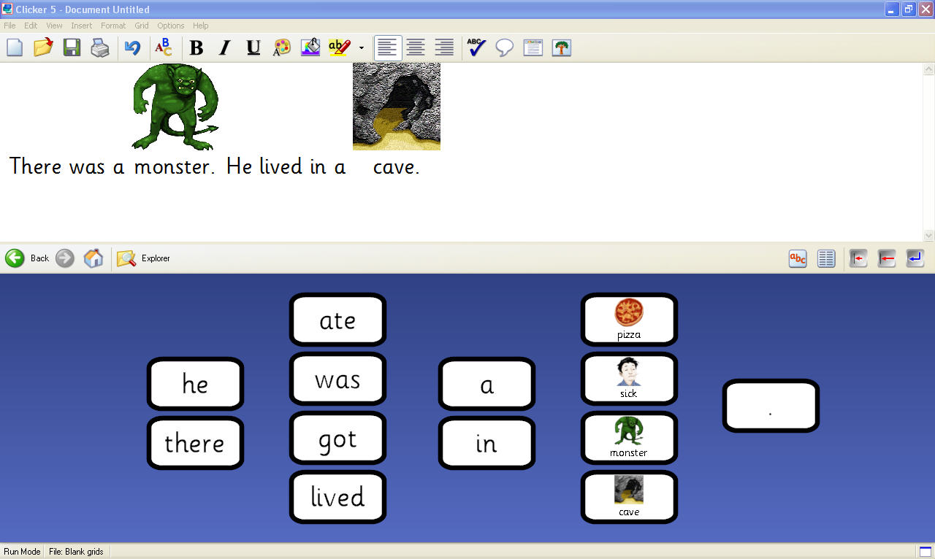

Figure 1. Example of story template developed on Clicker 5™.

General Procedures
The researcher trained a classroom teacher to use a SP procedure to teach 3 students to write a story using Clicker 5TM. The classroom teacher conducted all probe and training sessions at approximately the same time each morning. Each session consisted of a single daily probe in which the teacher randomly presented one of three story templates. The teacher then delivered instruction on three story templates in random order.
To assess generalization, the researcher presented a fourth story template to 2 of the participants before and after training conditions. This template remained untrained during the investigation. In addition, the researcher conducted story-telling and story-writing probes prior to and following instruction for 2 of the students.

Screening
The researcher informally assessed four students to determine if they had the prerequisite skills for participation in the study. The assessment consisted of a teacher interview, classroom observation, and one session of direct testing. One student did not meet the prerequisite of staying in the instructional area for at least 10 min and as a result, did not participate in the study. During direct testing, the teacher asked the students to touch a cell on the computer screen. If the student touched the cell within 5 s, he was considered to have the prerequisite skill of touching an isolated area (approximately 1.5 cm2) on a computer screen. Three students met the inclusion criteria of being able to (a) stay in an instructional area for 10 min; (b) follow verbal one-step directions; (c) respond following a gestural point prompt; and (d) demonstrate the ability to touch an isolated area (approximately 1.5 cm²) on a computer screen.
In addition, the researcher and classroom teacher screened the students to ensure that they did not already possess the skills targeted for instruction. During screening, the teacher presented each of the 4 story-writing templates and presented the request, “Write a story.” The teacher waited 90 s for the student to respond. If a participant constructed at least one sentence using a particular template then it would not be used in the study to ensure help ensure the tasks were equally novel across participants.

Teacher Training
The researcher trained the primary teacher across several days. On the first training session, the researcher described the purpose of the study and outlined the general procedures. The researcher then sent the written instructional procedures to the teacher via e-mail. During the second training session, the researcher reviewed, answered questions related to, and subsequently modeled the procedures. The researcher then observed the classroom teacher performing the probe and instructional procedures and delivered feedback. On the final day, the researcher observed the teacher during initial instruction with the participants.

Task Analysis
The researcher developed a task analysis of the steps required to complete the story-writing task. Each step consisted of the construction of a single sentence. Each story was comprised of 4 sentences that were to be completed in a prescribed order. The first sentence in each story introduced a character (i.e., There was a monster.). The second introduced a setting (i.e., He lived in a cave.). In the third sentence, the character performed an action (i.e., He ate a pizza.). Finally, the fourth sentence described a resulting action or consequence (i.e., He got sick).

Baseline/Probe Procedures
Full probe. The teacher conducted full probe sessions across all participants prior to the beginning of the study. In addition, she conducted full probe sessions prior to initiating training for the second and third participants. Each full probe condition lasted a minimum of 3 sessions. During each full probe session, the teacher randomly selected one of the three story-writing templates and opened it on the computer desktop. The teacher stated the student’s name and waited for his attention. Then she delivered the task directive, “Write a story” and waited 5 s for the student to respond. The teacher used a multiple opportunity format. If the student selected a cell out of the prescribed order or did not respond within 5 s, the screen was covered with a white board and the teacher constructed the sentence. The teacher then delivered the vocal directive, “Keep going” and waited 5 s for the student to write the next sentence. These steps were repeated for all 4 sentences.
The researcher defined a correct response as starting sentence construction within 5 s, constructing a complete sentence, and constructing the sentence in the prescribed order within the story. Incorrect responses were defined as (a) not initiating the sentence within 5 s following the task directive or the completion of the previous sentence, (b) not selecting the next word in a sentence within 5 s of the selecting the previous word, (c) writing the words in the sentences out of prescribed order, and (d) omitting a word in the sentence.
Daily probes. The teacher conducted a daily probe prior to story writing instruction. Daily probes were conducted using procedures identical to those during full probe sessions.

Simultaneous Prompting
During training, the teacher randomly selected a computer template and opened it on the computer desktop. The teacher delivered an attentional cue by saying the student’s name or the directive, “Look.” Once the student was oriented towards the computer screen, the teacher delivered the directive, “Write a story” immediately followed by a controlling prompt (i.e., pointing to each cell). The teacher waited 5 s for the student to select each cell following the teacher prompt. The teacher delivered descriptive verbal praise following the student’s construction of each sentence. The teacher continued to prompt word selection until the student had completed the story. Upon completion, the teacher selected the playback button and the computer provided auditory feedback (i.e., reading of the story). During training, the teacher presented all three templates in random order.

Maintenance Procedures
The teacher conducted maintenance probes for 2 of the participants using procedures identical to full and daily probe sessions. The school year ended prior to the third student’s meeting of the criterion for acquisition of the targeted skill. The teacher conducted maintenance probe sessions on the 10th and 28th day following criterion for Paul. For Caleb, maintenance probes were administered at 12 and 32 days following acquisition.

Generalization Procedures
The researcher conducted three sets of generalization probes. First, the researcher assessed the generalization of story writing skills to a novel story template. Second, the researcher assessed generalization across two response topographies (i.e., vocal response, handwriting).
The researchers assessed the generalization of skills to untrained stimuli using pre -posttest procedures. Prior to instruction, the classroom teacher presented a fourth story template to each student using procedures identical to those used during daily probe sessions. This story template remained untrained throughout instructional conditions. Following the meeting of criterion by each student, the researcher presented the untrained story template as it was presented prior to instruction. The researcher then compared the number of words and sentences generated in pretest and posttest measures.
The researchers assessed the generalization of skills across response topographies using pre-posttest procedures. Prior to instruction, the researcher asked each of the students to first tell and then write a story. The researcher recorded the number of words and sentences generated during the pretest. Following training, the researcher conducted a posttest using identical procedures. The researcher compared the number of words and sentences generated in pretest to posttest responses.

Experimental Design
The researcher used a multiple probe (MP) design across participants to evaluate the effects of SP and CAI on generative story writing. The researcher selected the MP design for its ability to limit threats to internal validity that may be present in instructional settings. The delayed introduction of an intervention across three tiers reduced history threats related to general intervention in special education classroom settings and maturation threats involving the typical development of young children (Gast, 2010).

Reliability
The researcher collected reliability data on both dependent and independent variables. During reliability data collection, the researcher sat behind the teacher and student while recording responses on a data sheet. The researcher calculated inter-observer agreement (IOA) by dividing the number of agreements by the sum of agreements and disagreements and then multiplying by 100 (Gast, 2010). Inter-observer agreement data collection occurred at least once per baseline, training, maintenance, and generalization conditions for two of the participants. Since Jason did not reach criterion, IOA was collected at least once per baseline and training conditions. For Paul, the researcher collected IOA data on 33% of baseline probes, 11% of probes during training conditions, 100% of generalization probes, and 50% of maintenance probes. For Caleb, the researcher collected data on 33% of baseline probes, 22% of daily probes during training conditions, 50% of generalization probes, and 50% of maintenance probes. For Jason, interobserver agreement data collection occurred during 25% of baseline probes and 16% of daily probes during training conditions. Overall, agreements for Paul, Caleb, and Jason were 100%, 100%, and 100%, respectively.
The researcher also collected independent variable reliability data for each participant at least twice per condition. For Jason, data were collected during training and baseline sessions. Procedural reliability was calculated by dividing the number of observed teacher behaviors by the number of planned teacher behaviors and the multiplying by 100 (Gast, 2010). The researcher assessed the performance of 14 teacher behaviors (e.g., delivery of attention prompt, points to each word and waits 5 s for student to respond, praises correct responses). For Paul and Caleb, independent reliability data indicated levels of accuracy to be 100% and 92%, respectively. For Jason, accuracy was calculated to be 95%.

Results
Two of the 3 participants reached criterion using the SP procedure (see Figure 2). Additionally, both participants demonstrated some generalized responses across novel stimuli and response topographies. One participant demonstrated noticeable improvement, but his training condition was terminated due to the end of the school year. As a result, the researchers did not conduct analyses of generalization and maintenance.
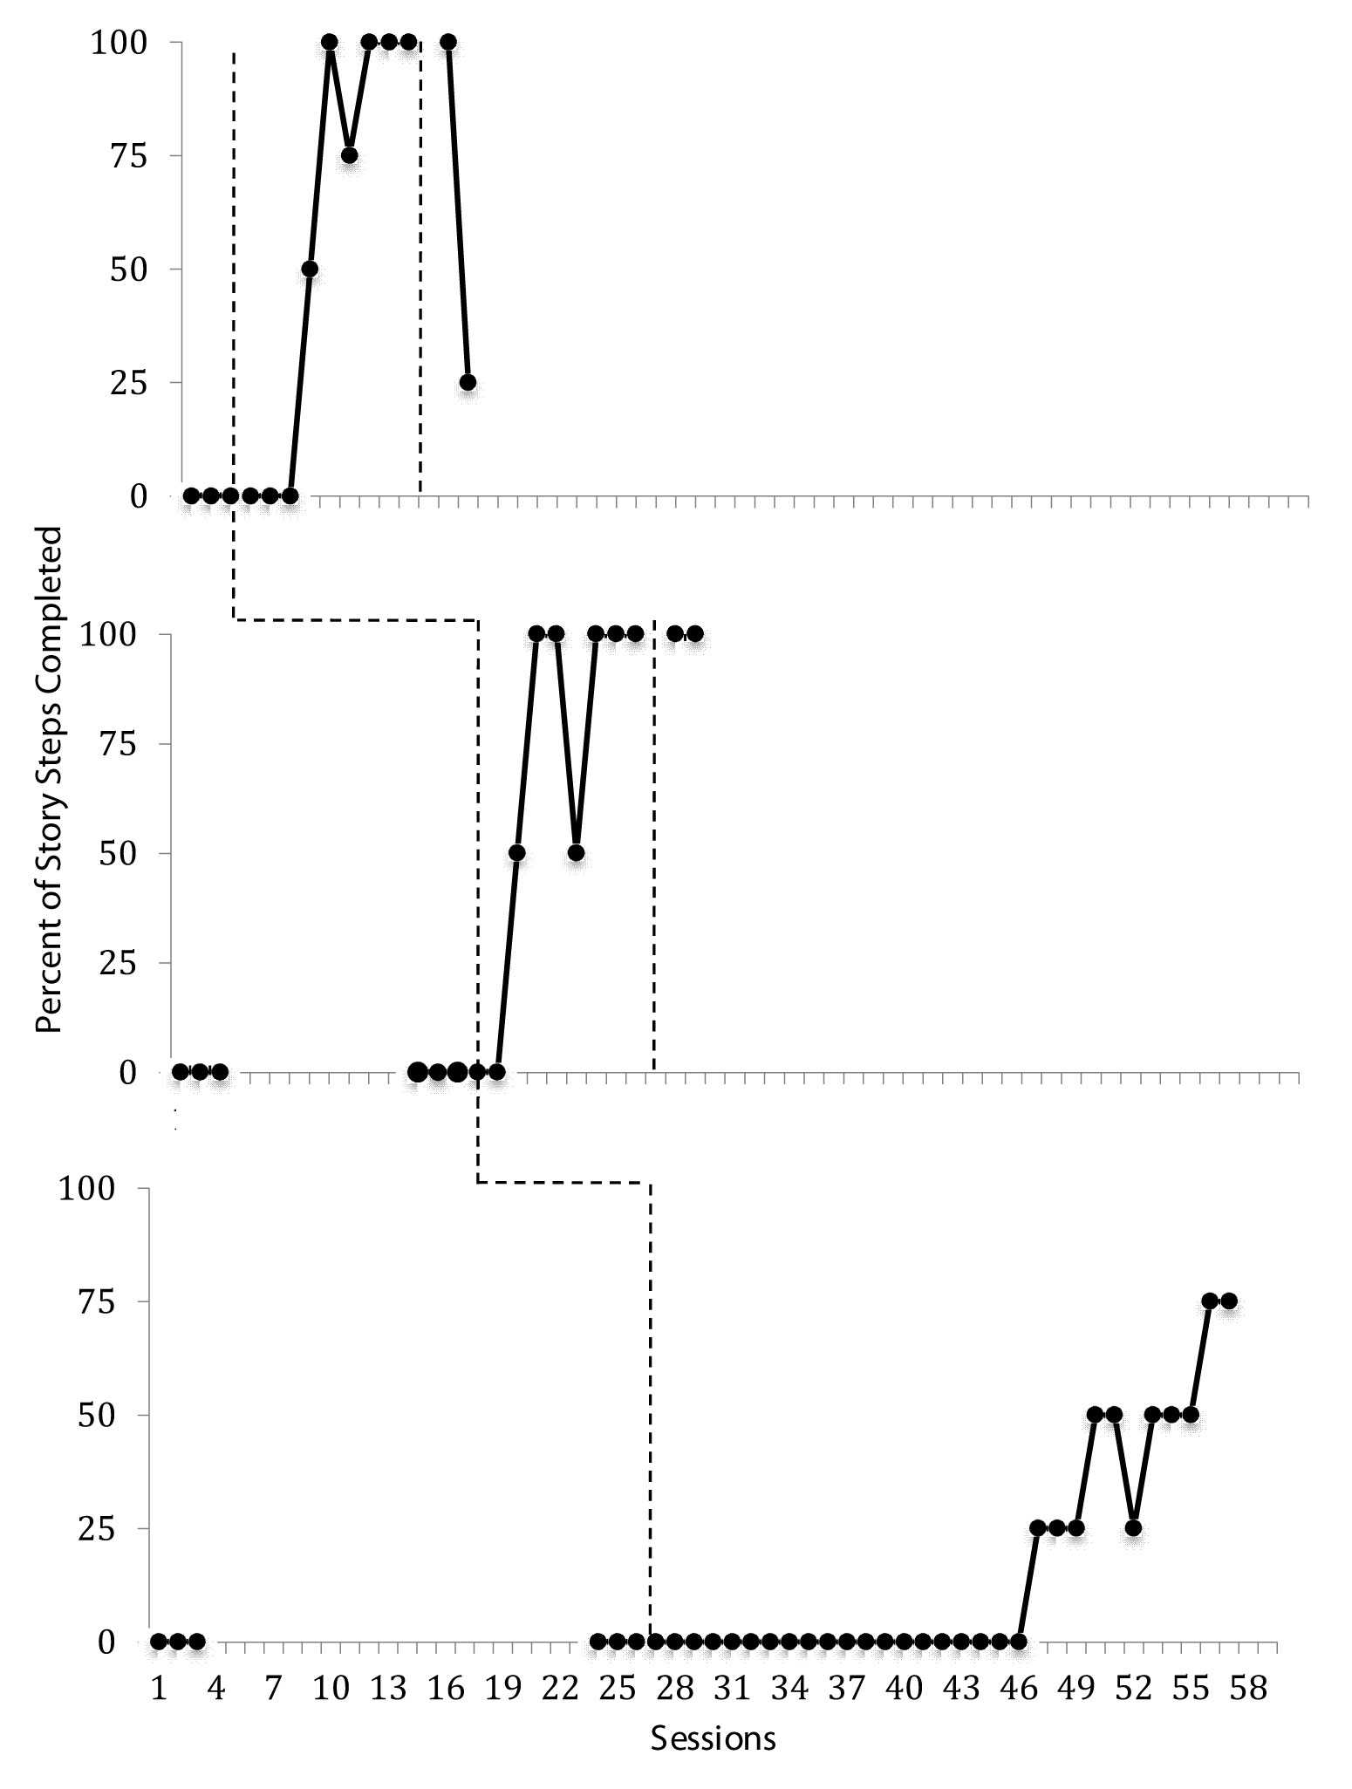

Figure 2. Student performance of computer-based story-writing tasks.

Paul. During baseline sessions, Paul constructed 0% of the stories using Clicker5 software. During the instructional phase, Paul reached the criterion within 9 sessions. The researchers conducted maintenance probe sessions 2 and 4 weeks following training. Paul constructed 100% of the prescribed sentences at 2 weeks. At 4 weeks, Paul was able to construct four related sentences (i.e., ‘There was alien,’ ‘He lived in space,’ ‘He ate popsicles,’ ‘He visited earth’), but only 25% of the steps were scored as correct due to article omissions and sentence order errors. As depicted in Table 1, Paul generated no words or sentences during the generalization pretest on a novel story template. Following training on the generalization posttest, Paul constructed two sentences and three additional words (i.e., ‘There was a robot,’ ‘He flew in a space rocket, a rocket, high’). During the writing pretest, Paul constructed two unrelated sentences consisting of a total of seven words. Following training, he wrote four related sentences consisting of 16 words.
During the vocalization pretest, Paul spoke seven words in response to the teacher directive, “Tell me a story” (i.e., “fable, seventeen, My name is a Fat”). Following training, Paul spoke 16 words (i.e., “There was a king, He lived in a castle, He saved a princess, He got married”).
Caleb. During baseline, Caleb constructed 0% of a story using Clicker 5TM software. During the instructional phase, Caleb also reached the criterion within 9 sessions. The researchers conducted maintenance probe sessions 2 and 4 weeks following training. Caleb constructed 100% of a story during both sessions. During the generalization pretest on a novel story template, Caleb generated 0 sentences and words. Following training on the generalization posttest, Caleb constructed four sentences consisting of 16 words (i.e., ‘There was an alien,’ ‘He lived in a rocket,’ ‘He lived in space,’ ‘He built high’). During the writing pretest, Caleb wrote no words. Following instruction, he generated four words (i.e., ‘king,’ ‘castle,’ ‘princess,’ ‘married’).

Table 1
Number of Words and Sentences in Pretest and Posttest Responses

Student  Variables | N words |  | N Sentences
 | Pretest | Posttest | Pretest | Posttest
Paul
Novel CAI template | 0 | 13 | 0 | 2
Written responses | 7 | 16 | 2 | 4
 |  |  | (Unrelated)
Vocal response  Caleb | 7 | 16 | 1 | 4
Novel CAI template | 0 | 16 | 0 | 4
Written responses | 0 | 4 | 0 | 0
Vocal response | 1 | 41 | 0 | 6

During the vocalization pretest, Caleb spoke one word in response to the teacher directive, “Tell me a story” (i.e., “there”). Following training, Caleb spoke 41 words:
I’ll show you a story, I read a story about a king, This story is about an alien, This story is about when a king tried to live in a castle, The king saved a princess, So he got married.
Jason. During baseline, Jason constructed 0% of a story using Clicker 5TM software. During the instructional phase, Caleb constructed 75% of a story using the computer-based templates. Instruction occurred across 31 sessions but was terminated at the end of the school year.

Outcomes and Benefits
In general, the researchers demonstrated that the use of SP was effective in teaching participants to construct simple stories. Following training, all of the participants demonstrated gains in computer-based story construction responses. Two of the participants performed to criterion levels and one participant reached 75% of criterion prior to the termination of the study at the end of the school year. In addition, two of the participants demonstrated varying degrees of generalization and maintenance across novel story templates and response topographies
Several findings warrant further discussion. First, both Paul and Casey demonstrated generalization from computer-based construction tasks to vocal responses. Impairment in vocal communication is a cardinal feature of autism, thus any intervention that increases vocal behavior is compelling. It also is important to note that vocal communication was not targeted for instruction during the intervention. This suggests that the intervention was efficient in that it may have resulted in the acquisition of non-targeted behaviors. Further analysis of these preliminary findings is warranted.
Second, it should be noted that the participants might have demonstrated performance that was not captured by the data. The researcher used stringent response criteria that were not sensitive to the generation of thought units (Hunt, 1965). A thought unit (T-unit) is a word or set of words that express an independent idea or concept. Educators have used the number of T-units to evaluate the development of their students’ writing skills (Rousseau et al., 1994). The participants in the current study generated T-units prior to the accurate construction of targeted sentences. For example, Jason consistently generated thought units related to the target stimulus after 7 dys of training (i.e., “There was castle”). Additionally, Paul generated four T-units related to the target stimulus 4 wks following training, though his data indicated that he only constructed one correct sentence.
Finally, the use of CAI and SP required minimal instructional time. Training sessions lasted approximately 5 min. This is critical in that many young children with ASD may not have the prerequisite skills to engage in instructional activities for long periods of time. Simultaneous prompting is a valuable tool for educators working with students that use assistive technology. Since it involves the application of a prompt that ensures that the student will respond correctly upon first application, instructors may instruct students on the technical aspects of how to use the technology (i.e., operational competence) while simultaneously teaching a target skill. In the current analysis, instruction towards operational competence was embedded within the steps of the task analysis. For example, step 1 required the student to select a cell in the correct order and to do so within 5 s. Therefore, the motor and fluency aspects of the response were taught at the same time as the cognitive aspects of the writing task (Light, Beukelman, & Riechle, 2003). Additionally, SP is simplistic in that it does not require instructors to consider a hierarchy of prompts or to adjust prompt delay intervals during instructional conditions. This reduced complexity may be especially useful to instructors when introducing instruction in the context of new technologies.

Limitations
Several limitations should be noted. First, the researcher did not acquire the recommended three replications of the treatment effects. The school year concluded prior to the end of the study and the researchers terminated training for Jacob. Second, the introduction of the substitute teacher may have contributed to Jason’s slow progress during training and should be considered a weakness of the current study. Jason’s rates of correct responding might have been affected by a lack of rapport with the substitute teacher, the teacher’s limited experience in using CAI, or a failure to generalize instructional behaviors to the novel staff person. Third, the researchers did not assess the students’ ability to read the words used in story writing tasks prior to instruction. Differences in student’s rates of acquisition may have been related to their reading ability. Finally, the repeated presentation of only three different story templates may have contributed to the participants’ acquisition of story writing responses. Future researchers should investigate the effects of more varied and complex templates on the acquisition of student responses.

Future Research
The findings of this preliminary study suggest that SP and CAI were useful during the instruction of story writing for students with ASD. Future research should address the effects of SP and CAI on other writing skills. For instance, investigators might consider evaluating Clicker 5TM during instruction on writing personal narratives, or nonfiction pieces related to grade-level core content. Researchers also might investigate the use of selection-based writing technologies for use by individuals with ASD during e-mail and text messaging correspondence.
There are several variables within Clicker 5TM that should be investigated. First, researchers should compare the effects of the pictures used during selection-based writing interventions. Research has indicated that pictures paired with sight words may serve to block their acquisition (Didden, Prinsen, & Sigafoos, 2000). It should be empirically validated whether pictures have the same effects during writing instruction. In addition, researchers need to determine the best arrangements for words/symbols in selection-based writing programs. In the current study, the researcher embedded intra-stimulus prompts within the templates. Word choices for sentence completion were arranged from left to right and in order of subject, verb, and predicate. Future researchers should look at the effects of randomly arranging words/symbols within arrays of choices on the generalization of writing skills.
Finally, it has been noted that students’ reading ability was not assessed prior to instruction. Researchers should investigate the impact of reading ability on the generation of story responses for students with ASD. In addition, researchers should evaluate to what extent reading responses can be acquired through observational learning during computer assisted story-writing instruction.

References
Akmanoglu, N., & Batu, S. (2004). Teaching pointing to numerals to individuals with autism using simultaneous prompting. Education and Training in Developmental Disabilities, 39, 326-336.
Akmanoglu-Uludag, N., & Batu, S. (2005). Teaching naming to individuals with autism using simultaneous prompting. Education and Training in Developmental Disabilities, 40, 401-410.

Anohina, A. (2005). Analysis of the terminology used in the field of virtual learning. Journal of Educational Technology and Society, 8, 91-102.
Asaro, K., & Saddler, B. (2009). Effects of planning instruction on a young writer with Asperger syndrome. Intervention in School and Clinic, 44, 268-275.
Basil, C., & Reyes, S. (2003). Acquisition of literacy skills by children with severe disability. Child Language Teaching and Therapy, 19, 27-49.
Bedrosian, J., Lasker, J., Speidel, K., & Politsch, A. (2003). Enhancing the written narrative skills of AAC students with autism: Evidence-based research issues. Topics in Language Disorders, 23, 305-324.
Crick Software, Inc. (2005). Clicker5™ [Computer software]. Wesport, CT: Author.
Cuvo, A. J., Ashley, K. M., Marso, K. J., Zhang, B. L., & Fry, T. A. (1995). Effect of response practice variable on learning spelling and sight vocabulary. Journal of Applied Behavior Analysis, 8, 155-173.
Delano, M. E. (2007a). Improving written language performance of adolescents with Asperger syndrome. Journal of Applied Behavior Analysis, 40, 345-351.
Delano, M. E. (2007b). Use of strategy instruction to improve the story writing skills of a student with Asperger syndrome. Focus on Autism and Other Developmental Disabilities, 22, 252-258.
Didden, R., Prinsen, H., & Sigafoos, J. (2000). The blocking effect of pictorial prompts on sight-word reading. Journal of Applied Behavior Analysis, 33, 317-320.
Forsey, J., Bird, E. K., & Bedrosian, J. (1996). Brief report: The effects of typed and spoken modality combinations on the language performance of adults with autism. Journal of Autism and Developmental Disorders, 26, 643-649.
Gabig, C. S. (2008). Verbal working memory and story retelling in school-age children with autism. Language, Speech, and Hearing Services in Schools, 39, 498-511.
Gast, D. L. (2010). Single subject research methodology in behavioral sciences. New York: Routledge.
Gibson, A. N., & Schuster, J. W. (1992). The use of simultaneous prompting for teaching expressive word recognition to preschool children. Topics in Early Childhood Special Education, 12, 247-267.
Graham, S., Harris, K. R., MacArthur, C., & Schwartz, S. (1991). Writing and writing instruction for students with learning disabilities: Review of a research program. Learning Disability Quarterly, 14, 89-114.
Higgins, K., & Boone, R. (1996). Creating individualized computer-assisted instruction for students with autism using multi-media authoring software. Focus on Autism and Other Developmental Disabilities, 11, 69-79.
Hunt, K. W. (1965). Grammatical structures written at three grade levels. (Research Report No. 3). Champaign, IL: National Council of Teachers of English.
Kaufman, A. S., & Kaufman, N. L. (1983). Kaufman Assessment Battery for Children. Bloomington. MN: Pearson Assessments.
Kinney, E. M., Vedora, J., & Stromer, R. (2003). Computer-presented video models to teach generative spelling to a child with an autism spectrum disorder. Journal of Positive Behavior Interventions, 5, 22-29.
Kurt, O., & Tekin-Iftar, E. (2008). A comparison of constant time delay and simultaneous prompting within embedded instruction on teaching leisure skills to children with autism. Topics in Early Childhood Special Education, 28(1), 53-64.
Lavigna, G. (1977). Communication training in mute autism adolescents using the written word. Journal of Autism and Childhood Schizophrenia, 7, 135-149.
Light, J. C., Beukelman, D. R., & Reichle, J. (Eds.). (2003). Communicative competence for individuals who use AAC: From research to effective practice. Baltimore: Brookes.
Mercer, C. D., & Mercer, A. R. (1998). Teaching students with learning problems. Upper Saddle River, NJ: Prentice-Hall.
Miranda-Linne, F. M., & Melin, L. (1997). A comparison of speaking and mute individuals with autism and autism-like conditions on the autism behavior checklist. Journal of Autism and Developmental Disorders, 27, 245-264.
Moore, D., McGrath, P., & Thorpe, J. (2000). Computer-aided learning for people with autism: A framework for research and development. Innovations in Education and Training International, 37, 218-227.
Morse, T. E., & Schuster, J. W. (2004). Simultaneous prompting: A review of literature. Education and Training in Developmental Disabilities. 39, 153-168.
Myles, B. S., Huggins, A., Rome-Lake, M., Hagiwara, T., Barnhill, G. P., & Griswold, D. E. (2003). Written profiles of children and youth with Asperger Syndrome: From research to practice. Education and Training in Developmental Disabilities, 38, 362-369.
National Commission on Writing. (2004). Writing: A ticket to work… or a ticket out: A survey of business leaders. Retrieved from http://www.collegeboard.com/prod_downloads/writingcom/writing-ticket-to-work.pdf
Nelson, K. E., & Heimann, M. (1995). Delta Messages [Computer software]. Goteberg, Sweden: Warriors Mark.
Newborg, J., Stock, J., Wnek, L., Guidubaldi, J., Svinicki, J., Dickson, J., et al. (1984). Battelle Developmental Inventory (2nd ed.). Rolling Meadows, IL: Riverside.
Pennington, R. (2010). Computer-assisted instruction for teaching academic skills to students with autism spectrum disorders: A review of literature. Focus on Autism and Other Developmental Disabilities, 25, 239-248.
Rousseau, M. K., Krantz, P. J., Poulson, C. L., Kitson, M. E., & McClannahon, L. E. (1994). Sentence combining as a technique for increasing adjective use in writing by students with autism. Research in Developmental Disabilities, 15(1), 19-37.
Schairer, K. S., & Nelson, N. W. (1996). Communicative possibilities of written conversations with adolescents who have autism. Child Language Teaching & Therapy, 12, 164-180.
Schlosser, R. W., & Blischak, D. M. (2004). Effects of speech and print feedback on spelling by children with autism. Journal of Speech, Language, and Hearing Research, 47, 848-862.
Schlosser, R. W., Blischak, D. M., Belfiore, P. J., Bartley, C., & Barnett, N. (1998). Effects of synthetic speech output and orthographic feedback on spelling in a student with autism: A preliminary study. Journal of Autism and Developmental Disorders, 28, 309-319.
Schopler, E., Reichler, R. J., & Renner, B. R. (1988). Childhood Autism Rating Scale (CARS). Boston, MA: Pearson.
Schuster, J. W., Griffen, A. K., & Wolery, M. (1992). Comparison of simultaneous prompting and constant time delay procedures in teaching sight words to elementary students with moderate mental retardation. Journal of Behavioral Education, 2, 305-325.
Schuster, J. W., Morse, T. E., Ault, M. J., Doyle, P. M., Crawford, M. R., & Wolery, M. (1998). Constant time delay with chained tasks: A review of the literature. Education and Treatment of Children, 21(1), 74-107.
Stromer, R., Mackay, H. A., Howell, S. R., & McVay, A. A. (1996). Teaching computer-based spelling to individuals with developmental and hearing disabilities: Transfer of stimulus control to writing tasks. Journal of Applied Behavior Analysis, 29, 25-42.
Sugasawara, H., & Yamamoto, J. (2007). Computer-based teaching of word construction ad reading in two students with developmental disabilities, Behavioral Interventions, 22, 263-277.
Walker, G. (2008). Constant and progressive time delay procedures for teaching children with autism: A literature review. Journal of Autism and Developmental Disorders, 38, 261-275.

Yamamoto, J., & Miya, T. (1999). Acquisition and transfer of sentence construction in autistic students: Analysis by computer-based teaching. Research in Developmental Disabilities, 20, 355-377.

Technology to Support Writing by Students with Learning and Academic Disabilities:

Recent Research Trends and Findings

George R. Peterson-Karlan
Special Education Assistive Technology Center
Illinois State University

Abstract: The trends and findings from a descriptive analysis of 25 years of research studies examining the effectiveness of technology to support the compositional writing of students with learning and academic disabilities are presented. A corpus of 85 applied research studies of writing technology effectiveness was identified from among 249 items in the scholarly literature. The use of technologies to support each of the components of the writing process is reported in terms of the research designs used, the writing processes supported, and the historical trends in research publication. The research designs represented in the research base suggests that, overall, there is a developed program of research; however, this does not hold for the individual writing process areas (planning, transcription, editing, and revising). Among the four process areas, the largest number of studies is of technologies to support transcription with revising the next most frequent and few studies of planning/organization and editing. Comparison of the historical trends in research to trends in technology development revealed that little new research investigating basic digital writing support tools, as used by students with learning and academic disabilities, has appeared in the last 10 years despite the growth and development of technology. Across the total corpus of applied research studies, basic evidence-based practice criteria related to number of studies and number of participants was not met in the areas of planning and organization, editing, and revising technologies. Applied research studies of the effectiveness of transcription tools nearly meet the criteria for number of studies and number of participants, and nearly enough to warrant further analysis of study quality and effect sizes. Taken together these findings underscore the critical need for further research on the effectiveness of contemporary technologies to support compositional writing.
Keywords: Technology, Composition, Writing, Research trends, Learning disabilities, Disabilities
Acknowledgements
Portions of this work were supported by grants to the Special Education Assistive Technology (SEAT) Center at Illinois State University from the U.S. Department of Education, and from the National Center for Technology Innovation (The Effectiveness of SOLO™ Upon the Writing Outcomes of Students with Learning and Academic Disabilities). Opinions expressed herein are the authors’ own and do not reflect policies of either agency.
Writing matters. Along with reading comprehension, writing proficiency predicts academic success (Graham & Perin, 2007), develops higher-order thinking skills (National Writing Project & Nagin, 2006), is an essential ‘threshold skill’ for hiring and promotion (National Commission on Writing, 2004), and is a basic requirement for participation in civic life and a global economy (Graham & Perin; National Commission on Writing, 2003). However, writing achievement is not where it is expected to be and not where it needs to be. State governments report that, despite the high level of educational attainment of state employees compared with that of the general public, approximately 30% of professional employees fail to meet state writing expectations (National Commission on Writing, 2006). Nearly one-third of students who intend to enter higher education have not attained the readiness benchmarks for college-level English composition courses (ACT, 2005). According to the National Assessment of Educational Progress (NAEP; Persky, Daane, & Ying, 2002), many students (51%–58%) are at a basic level of writing, which is below the desired proficient level. Those 16%–22% of students below even the basic level of writing reported by the NAEP are struggling writers, called low-achieving writers by Graham and Perin (2007). They include students identified as having learning disabilities (LD) as well as others with academic and learning difficulties whose writing skills are not adequate to meet classroom demands (Graham & Perin). The findings of the NAEP for ‘students with disabilities,’ which here refers to all students with disabilities who completed the NAEP writing assessment, are sobering. In 2007, students with disabilities received an average scale score of 119 at the 8th grade and 118 at the 12th-grade levels as compared to 160 and 156 (max = 300). From 1998 to 2007, the gap between students with and without disabilities has remained about 40 points with only a 9% increase in scores. The 2007 results translate to poor levels of writing attainment; 45% of students with disabilities are below the basic level of proficiency (8% without disabilities) while 49% are at only a basic level (56% without disabilities) and only 6% are at the proficient level (33% without disabilities; U.S. Department of Education, Institute of Education Sciences, National Center for Education Statistics, National Assessment of Educational Progress (NAEP), 1998, 2002 and 2007 Writing Assessment, n.d). More than six times as many students with disabilities performed below the basic level than did their typical peers.
If writing matters, then writing instruction needs to improve (Graham & Perin, 2007; National Commission on Writing, 2006; National Writing Project & Nagin, 2006). The research-based models and methods for teaching good writing are known (National Commission on Writing; National Writing Project & Nagin). Good writers use three primary, recursive processes: (a) planning (generating ideas, setting goals, and organizing, referred to in this paper as “planning”); (b) translating (turning plans into written language, referred to here as “transcription”); and (c) reviewing (herein referred to as “editing and revising”) (National Writing Project & Nagin). These processes are represented in instruction as writing strategies wherein students are provided (a) models; (b) some direct instruction; (c) some kind of scaffolding (an explicit framework or sequence of steps) that gives them an organizational scheme; and (d) guidelines for using inquiry strategies (e.g., imagining a situation from a perspective different than one’s own, comparing and contrasting cases, explaining how evidence supports a claim) (National Writing Project & Nagin).
Despite agreement about what constitutes good writing instruction, effective strategies are not widely used (National Commission on Writing, 2003, 2006). To bring about reform in writing instruction, the National Commission on Writing (2003) noted four challenges to education professionals: (a) increase the amount of time that students spend writing, (b) improve the assessment of writing, (c) apply emerging writing technologies, and (d) provide professional development for all teachers.

Technology to Support Writing
Among national organizations considering writing outcomes, there is widespread acceptance that writing has moved from a paper and pen activity to one that is technology-driven. Throughout this report, the term ‘technology’ will refer to digital technology. Technologies are recognized as having potential both to support writing and the teaching of writing (National Commission on Writing, 2003; National Writing Project & Nagin, 2006) and to represent new venues for writing itself (National Council of Teachers of English, 2004). Three approaches to technology have emerged from this discussion: technology-supported writing, technology-enabled writing, and multimedia writing.
Technology-supported writing can advance all phases of writing—planning, transcribing, and editing and revising using tools, which include, but are not limited to, the word processor. But technology also enables writing in new ways. Technology provides new sources for and means of obtaining information (e.g., the Internet, search engines) and enables sharing, editing, and collaboration among writers, teachers, and peers. The ability to work from remote locations permits students to gauge the quality of their writing and their level of skill against those of peers elsewhere (National Commission on Writing, 2003, 2006; National Writing Project & Nagin, 2006). Finally, technology transforms writing by introducing new electronic genres and multimedia forms. In these new genres and forms, composing involves a combination of media, including print, still images, video, and sound (National Council of Teachers of English, 2004). The movement from writing as a pen-and-pencil enterprise to one including dramatically different forms of creation, expression and communication is explored in Because Digital Writing Matters (National Writing Project & DeVoss, Eidman-Aadahl, & Hicks, 2010). Digital writing is defined as “compositions created with, and oftentimes for reading or viewing on a computer or other device that is connected to the Internet” (National Writing Project & DeVoss et al., p. 7). The tools used for composing are not limited to the word processor. They include many digital forms of encoding (recording) information including scanners, digital cameras, voice recorders. Networked connectivity permits writers to “draw from myriad sources, use a range of media, craft various types of communication representing a range of tools and genres, and distribute that work almost instantaneously and sometimes globally” (National Writing Project & DeVoss et al., p. 7).
But, where are schools and students with disabilities in all of this? The assessment of writing in statewide high stakes testing may be both a driver and an inhibitor of writing instruction and assessments in schools. While proponents of the new forms of digital writing decry the old ‘scripted genres’ as being limiting to students development of 21st century writing skills (National Writing Project & DeVoss et al. 2010), assessments such as the National Assessment of Educational Progress (NAEP) use traditional genres or purposes for writing (e.g., narrative, informative, persuasive) that have defined structures and requirements for the compositions. In addition, the use of the word processor as a tool to assess writing is not even standard among states (Russell & Abrams, 2004; Russell, Goldberg, & O'Connor, 2003). While empirical research suggests that digital natives perform better when using word processors (Russell, 1999; Russell & Haney, 1997; Russell & Plati, 2001, 2002), surveys indicate that non-use of word processing on statewide assessments may be influencing teachers to avoid their use and emphasize paper and pencil writing to prepare students for testing (Russell & Abrams). While the new tools, media, and forms may be the now-and-future, the old media and forms continue to be the now-and-now. For students with disabilities to make advances in writing performance on measures like the NAEP, there needs to be a critical examination of the tools and technologies that may provide compensatory benefit, i.e., that assist these students to overcome barriers created by a range of persistent cognitive and physical factors (Peterson-Karlan & Parette, 2008).

Writing Problems of Students with Learning and Academic Disabilities
Students with learning and academic disabilities demonstrate an impressive array of problems in writing. Based upon a corpus of 41 research studies, Newcomer & Barenbaum (1991) produced the seminal review of the written composing abilities of children with learning disabilities covering the decade of 1980-1990. This summary served as the impetus for much of the subsequent research in this area--research that either more fully detailed the characteristics outlined by Newcomer and Barenbaum or that attempted to remediate the problems identified by these authors through a variety of teaching and/or technological approaches. Relative to typically developing peers, students with learning disabilities have decreased skills that do not improve over time or years in school (under typical conditions of instruction). In comparison to typical peers, students with learning disabilities (a) make more mechanical errors, including spelling, punctuation, and capitalization (fourth grade through college), with spelling errors the most pronounced; (b) make more subject/predicate agreement (syntax) errors; (c) are less fluent (i.e., use fewer words, particularly those with seven letters; produce fewer sentences, and use less variety of words); and (d) do not exhibit an increase in fluency with age (maturity).
Overall, in narrative writing, students with learning disabilities reflect a paucity of ideas that prevents them from embellishing their narratives and, as a result, produce qualitatively perfunctory stories that may not meet the minimal requirements for a story. Problems with cohesiveness suggest an inability to retain an overview of purpose or direction of the composition (lack a story ‘plan’), instead writing any thought that occurs -- indiscriminately and often inappropriately. Data suggests that students with learning disabilities have only cursory knowledge of what a story is and do not know or remember how to expand a composition beyond this level, lacking the composing skills to identify organization problems during revision (Newcomer & Brenbaum, 1991).
Overall, in expository writing, students with learning disabilities produce compositions exhibiting mechanical errors, irrelevancies, redundancies, early termination, lack of coherence and organization. The type of text structure of the composition differentially affects the type and extent of errors. Sequencing appears to be the easiest text structure and compare/contrast the most difficult. The problems exhibited by students with learning disabilities were not only more frequent compared to typically achieving peers at grade level, but were significantly worse than underachieving students matched for reading level and IQ. Metacognitive research in this corpus focused upon expository, rather than narrative, composing and compositions. Specific analysis of the use of metacognitive knowledge and cognitive strategies while writing reveals that students with learning disabilities compared to typical peers demonstrate (a) less knowledge of steps in the writing process, including the relevance of planning; (b) less knowledge of the structures of various expository texts; (c) fewer procedures for generating, selecting, and integrating information from multiple sources; and (d) fewer strategies for organizing and presenting expository ideas, including modeled strategies.
There is a long history to the suggestion that technology can be particularly advantageous for students with learning and academic disabilities in remediating or compensating for these problems. Word processors, word prediction, spell checkers, text-to-speech, and organization tools have all been extensively discussed as helping or having potential to help students with disabilities to engage in the many levels of cognition required to produce coherent, organized, audience-aware, and conventionally accurate compositions (e.g., Forgrave, 2002; Hunt-Berg & Rankin, 1994; MacArthur, 2000, 2009a, 2009b; Montgomery & Marks, 2006; Sitko, Laine, & Sitko, 2005; Zhao, 2007). However, only recently has there been systematic examination of the existing evidence base using historical and meta-analytic synthesis techniques that might support such claims (Cochran-Smith, 1991; Goldberg, Russell & Cook, 2003; Graham & Perrin, 2007, Okolo & Bouck, 2007; Peterson-Karlan & Parette, 2007b; Rogers & Graham, 2008). Based upon a comprehensive compilation and examination of the literature related to the use of technology to support writing by students with learning and academic disabilities (Peterson-Karlan 2011; Peterson-Karlan & Parette, 2007b), this paper reports on the characteristics of this literature base, trends in research over time, and implications for conclusions regarding the effectiveness of technology as related to specific components of the writing process. The overall purpose is to determine what is known from empirical research regarding technologies to support writing and whether technology to support writing is an evidence-based practice.

Compiling and Synthesizing the Research Literature
To identify published articles related to technology that supports writing by students with learning and academic disabilities, multiple searches were completed using the Academic Search Premier, ERIC-OVID, and PsycINFO electronic databases (search range 1994-2010). Each search was refined with a three-phase process whereby initial search terms were modified, with each subsequent search using keyword and title descriptors identified from the previous search. Where available, text searches of these terms were also completed. Hand searches were conducted of 15 journals known to publish articles on the topic (search range 2003-2005); subsequently, “hand searches” of the electronic article listings of a number of the most cited journals using the databases were conducted (search range 2005-2010). For each article identified, ancestor searches of the references cited in the article were also completed. Ancestor searches were useful in identifying literature from the 1985-1994 range of years. If authors appeared to have multiple publications in the search area of interest or if certain authors were cited frequently in the identified literature, additional author searches were conducted, using the three databases to identify any appropriate systematic lines of research. Complete details of the search methodology are available elsewhere (Peterson-Karlan, 2011).
For each item of literature, a complete APA-formatted reference was created in an electronic software database (Endnote®). To synthesize the findings, each item of literature was coded in the reference database (Endnote®) using the descriptor terms reported below in the results section; in general the categories included type of article, type of research design, writing process investigated or discussed, and specific technology tool. Based on the writing process and technology, tables of findings were also created for all research studies. Complete details and the table of findings are available elsewhere (Peterson-Karlan, 2011). The descriptors and tables of findings were used to prepare the summaries and general findings reported herein.
Descriptive research synthesis using these approaches is useful in (a) determining the size of the evidence base, (b) identifying trends in research, and (c) identifying the design characteristics of the evidence base. Descriptive research synthesis also is useful in identifying relevant variables investigated across the evidence base related to both the process and products of writing; in determining what we know and what we need to know; in helping to interpret “what we know” regarding the chronological development of the writing technology; and in identifying limits to our conclusions in light of the extent of the evidence base, the research designs used, and the development of technology over time. Descriptive research syntheses can provide the information needed to conduct meta-analyses of the evidence base to determine effect sizes, which yield quantitative measures of the effectiveness of technology to support writing across the evidence base (see e.g., Goldberg et al., 2003; Graham & Perin, 2007; Rogers & Graham, 2008).
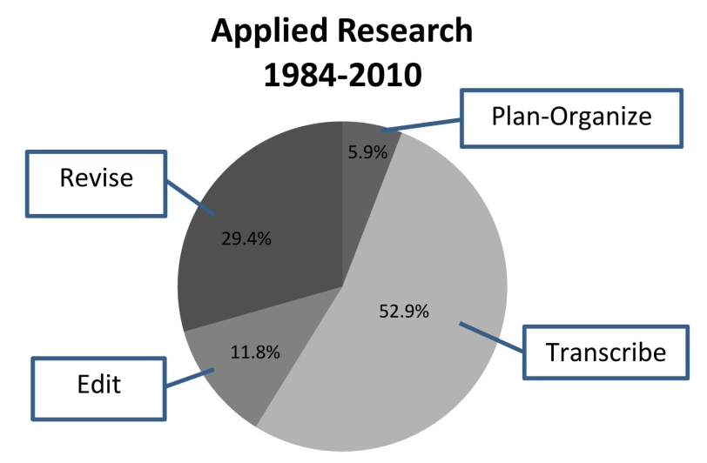
Figure 1. The final literature collection.

Overall Characteristics and Trends in the Evidence Base
There were 249 items of literature in the final database (see Figure 1). Of these, 33.7% (N=85; see Appendix A for a listing of these studies by writing process) were applied research studies of writing technologies, while 39.3% (N=99) were categorized as background or basic research on the technologies themselves. Such research includes studies of writing technology by typically developing students only and studies of the functionality of the technology itself, e.g., the accuracy of spellchecker accuracy in detecting and suggesting replacements for words misspelled by students with learning and academic disabilities. The remainder of the literature base consisted of (a) articles, books and chapters that discuss the process of writing and/or approaches to using technology to support writing or describe the problems exhibited by students with learning and academic disabilities when writing (19%, N=48); (b) national reports on the status of writing (3.6%, N=9); and (c) meta-analytic research syntheses of effectiveness of instructional approaches to improving writing or technology to support writing with typical students and/or students with disabilities (4.4%, N=11).

Research Designs Used to Examine Technology Effectiveness
The issues related to the need for, difficulty in establishing, and characteristics of standards or criteria for an evidence-based practice for special education have been addressed extensively elsewhere (Odom, Brantlinger, Gersten, Horner, Thompson, & Harris, 2005; Peterson-Karlan & Parette, 2007a). Of specific interest in this discussion is the contribution of research design to the emergence of claims of effectiveness of a practice. Within the larger discussion, a point of agreement is that there are three central research questions addressed in educational and special education research: (a) What is happening (description)? (b) Is there a systematic effect (cause)? and (c) Why or how is it happening (process or mechanism)?
There is further agreement that each type of question is both scientific and requires different methodology (Odom et al., 2005). Four different research design methodologies have been identified as appropriate for addressing these questions: (a) experimental group; (b) correlational; (c) single-subject; and (d) qualitative (Odom et al.; Peterson-Karlan & Parette, 2007a). Experimental group designs include both ‘random assignment experiments,’ more commonly referred to as the randomized controlled trial (RCT), and quasi-experimental designs, which involve use of subjects as their own controls (e.g., the repeated measures design). While RCT designs have been cited as the highest standard for research on the effectiveness of a treatment or intervention practice (Odom et al.; U. S. Department of Education, 2003), other designs also permit analysis of competing explanations for the effectiveness of a practice (Peterson-Karlan & Parette).
To understand the contribution of various research methods or designs in determining the effectiveness of technology to support compositional writing by students with learning and academic disabilities, it may best to view the development of the evidence base as an ‘emerging program of research.’ Levin, O’Donnell and Kratochill (as cited in Odom et al., 2005) have proposed four stages of research within which certain designs are most appropriate. In Stage 1, preliminary ideas, hypotheses, and observations are obtained and explored using case studies and qualitative and correlational designs. In Stage 2, controlled laboratory experiments or classroom-based systematic observations and experiments are conducted using qualitative, single-subject, quasi-experimental, and experimental (RCT) designs to explore the questions of cause, process, or mechanism. In Stage 3, results of the prior research are used to design well-documented large-scale studies to determine the effectiveness of a practice or intervention. The RCT design is considered to be the ‘gold standard’ for such research, although an argument for the appropriateness of large scale single subject design studies has also been made (Horner et al., 2005; Odom et al.). The final stage of the research process determines those factors that lead to adaption of effective practices in typical school systems under naturally occurring conditions and requires the application of a number of research methods.
The foregoing discussion suggests that the issue is not excluding studies from this review based on some judgment as to the ‘value’ of the design, but rather, that the various designs provide perspective on the development of a program of research on technology to support writing. In general, case studies are indicative of an early stage of exploration while small-N single-subject studies reflect an emergence of early ‘scientific knowledge.’ Large-N single-subject, quasi-experimental, and ‘true’ experimental design studies represent a more rigorous knowledge base capable of substantially eliminating plausible competing explanations for obtained results, and present ‘strong evidence’ of effectiveness (Peterson-Karlan & Parette, 2007a; U. S. Department of Education, 2003).
Within the group of applied research studies examining the effects of technology to support compositional writing by students with learning and academic disabilities (N=85), there is a fairly equal representation of empirical research designs (See Figure 2) with experimental (use of control groups) the most frequent design (N=18), and both quasi-experimental (e.g., within subjects repeated measure) and single-subject designs (e.g., multiple baseline across participants) being about equally represented (N=12 and 13 respectively.) Case studies represent only 20% of the overall direct evidence base (N=17). These findings suggest that the evidence-base does represent a developed program of research overall; however, as discussed next, this is not equally true for research on technology to support each aspect of the writing process.
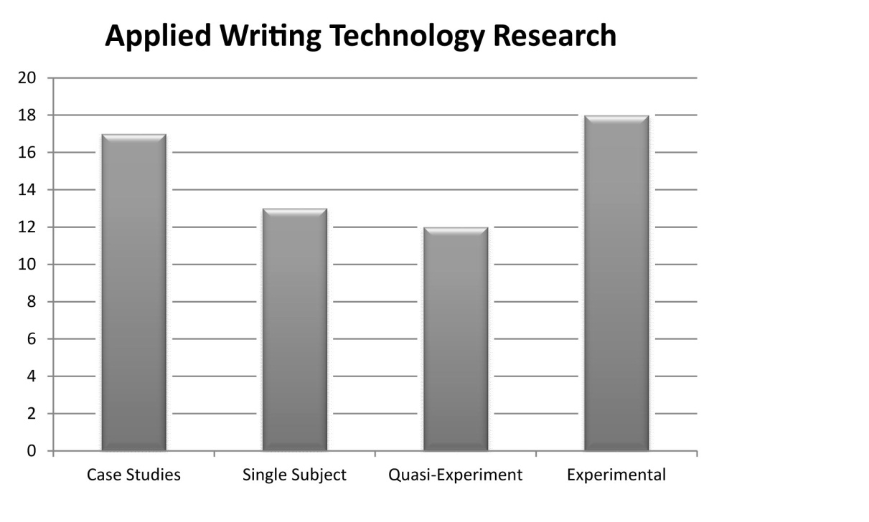
Figure 2. Research designs used.

Within the total group of applied research studies, the most frequent writing process examined has been transcription (53%, N=45) with nearly 1,400 students with learning and academic disabilities and typical peers included in studies examining the effectiveness of technology to support transcription (see Figure 3). Studies of the use of technology to support the revision process are next most frequent among all applied research studies (29.4%, N=25), but including a much smaller number of students with and without learning and academic disabilities (N=115). Much less frequent in the evidence base are studies of the use of technology to support editing (11.8%, N=10) and the planning and organizing processes (5.9%, N=5). While transcription is an important process, representing the ability to generate text that is both legible and conventionally accurate (spelling, punctuation, grammar), planning and organization are perhaps more important to producing compositions that are coherent, organized, understandable, and interesting to the reader. Despite the fact that technologies to support for the critical planning and organization processes in compositional writing exist (e.g, Draft:Builder®; Inspiration®), lack of an evidence base for students with learning and academic disabilities is a serious deficiency of the research field.
Figure 4 shows the distribution of research designs used in the studies of technologies to support compositional writing by students with learning and academic disabilities across the four writing processes. There are few planning research studies (N=5) with those including mostly quasi-experimental (N=4) and experimental (N=1) designs. Transcription research studies include cases studies (32%, N=12) single-subject design studies (26%, N=10), quasi-experimental designs (10.5%, N=4), and experimental designs (32%, N=12). Editing research studies (N=10) include an equal proportion of case studies (N=3), quasi-experimental (N=3), and experimental (N=3) design studies with only one single-subject design study. Revising research studies (N=7) include an equal proportion of case studies (N=2), single subject (N=2), and experimental (N=2) design studies with only one quasi-experimental design study. These numbers indicate that the transcription, editing and revising research base demonstrates a trend toward increasing maturity in the scope and purpose of the research but little volume on which meta-analytic techniques can be applied to render quantitative conclusions about the effect of technology on the writing process for students with learning and academic disabilities. The extent of the research base needed for this type of analysis will be addressed in more detail below.
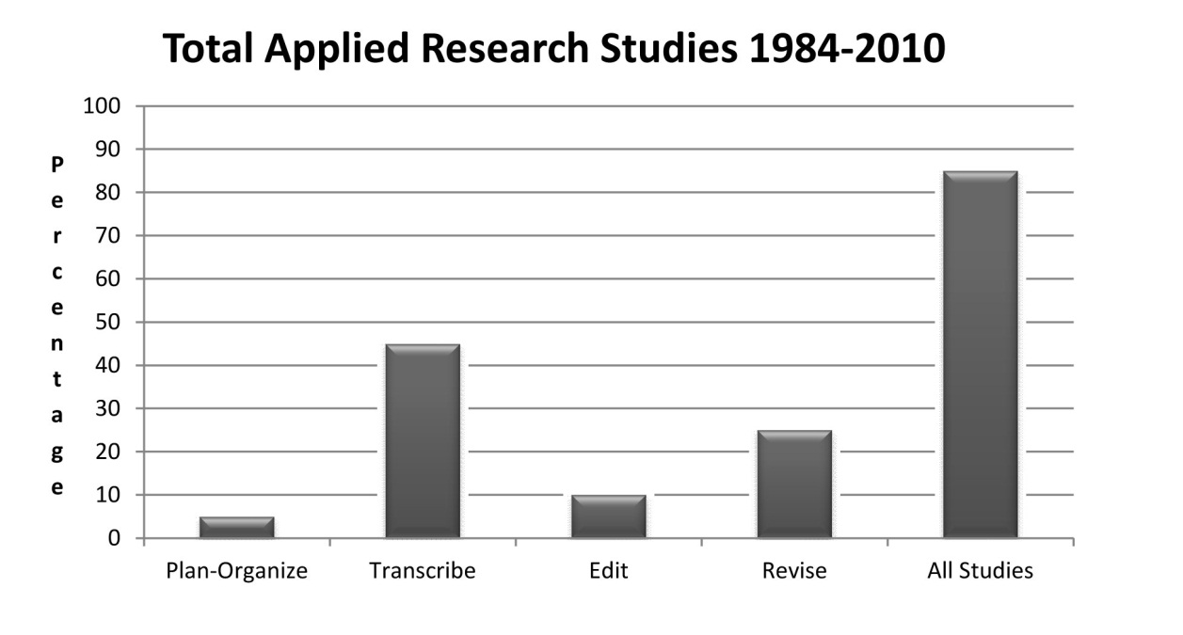
Figure 3. Research studies by writing process.

Historical Trends in Technology Research
The research base compiled here extends over a period of 26 years (1984-2010). During this time, many technological advances were made in the underlying operating systems and application technologies. Any conclusions about the effectiveness of the technology or the generalizability of the findings in supporting compositional writing by students with learning and academic disabilities must be viewed relative to the development of the technology itself over time. Thus, it is necessary to examine the historical trends in development and publication of the research base. Figure 5 presents the overall historical trends in applied research on technology to support compositional writing by these students. Examination of the frequency of applied research studies yields a disturbing conclusion; as technology availability has exploded in the last 10 years (Parette, Peterson-Karlan, & Wojcik, 2005), the frequency of applied research investigating the use of technology to support compositional writing by student with learning and academic disabilities across all four writing processes has declined dramatically. In the last five years (2006-2010), only five studies were located, with only 13 in the previous five years (2001-2005). That is less than two studies per year! In contrast, in the 16-year period of 1984-2000, there were 65 such studies published in peer-reviewed journals, representing 4.3 published studies per year. It would be erroneous to conclude that perhaps we had acquired all the information, or ‘answers,’ that we needed in that first 15-year period.
Examination of the research with students with learning and academic disabilities using technology to support transcription provides evidence that such a conclusion is incorrect (see Figure 6). The peak in frequency of studies came in the 5-year period of 1984-1990 that preceded introduction of Microsoft® Word for Windows®, the first Microsoft® word processor with a graphical user interface (GUI). In the next five years, there was 40% less research examining the use of the ‘new’ GUI word processors to support the transcription of students with learning and academic disabilities. The frequency of such research has continued to decline despite the improvements to and enhanced features of the GUI word processor. It would be difficult to argue that the findings for the effectiveness of word processors in improving aspects of compositional writing would be equivalent for non-GUI and GUI-based word processors. Graphical, menu driven interfaces support recognition of features, e.g. spellcheck), rather than recall of command prompts (e.g. c:\\print), and What-You-See-is-What-You-Get (WSYWIG) views of the final written product. Similarly, interpretation of applied research examining the effectiveness of speech recognition (speech-to-text) technology is limited by the change in the technology from discrete speech recognition (e.g., VoiceType) to continuous speech recognition (e.g., Dragon Dictate) that occurred in 1999. There were an equal number of studies published before and after the technological change; however, not all of the subsequent studies investigated the newer technology (Peterson-Karlan, 2011). Continuous speech recognition continues to evolve and develop technologically with many of the issues of training time and recognition accuracy having been addressed (by developer report) with little if any new empirical studies of its use by students with learning and academic disabilities to support compositional writing. Word prediction shows a similar trend having a peak in 1996-2000 (five studies) and a subsequent decline. As addressed below, all of these declines in well-designed empirical research have an impact upon our ability to formulate conclusions about technology as an evidence-based practice.
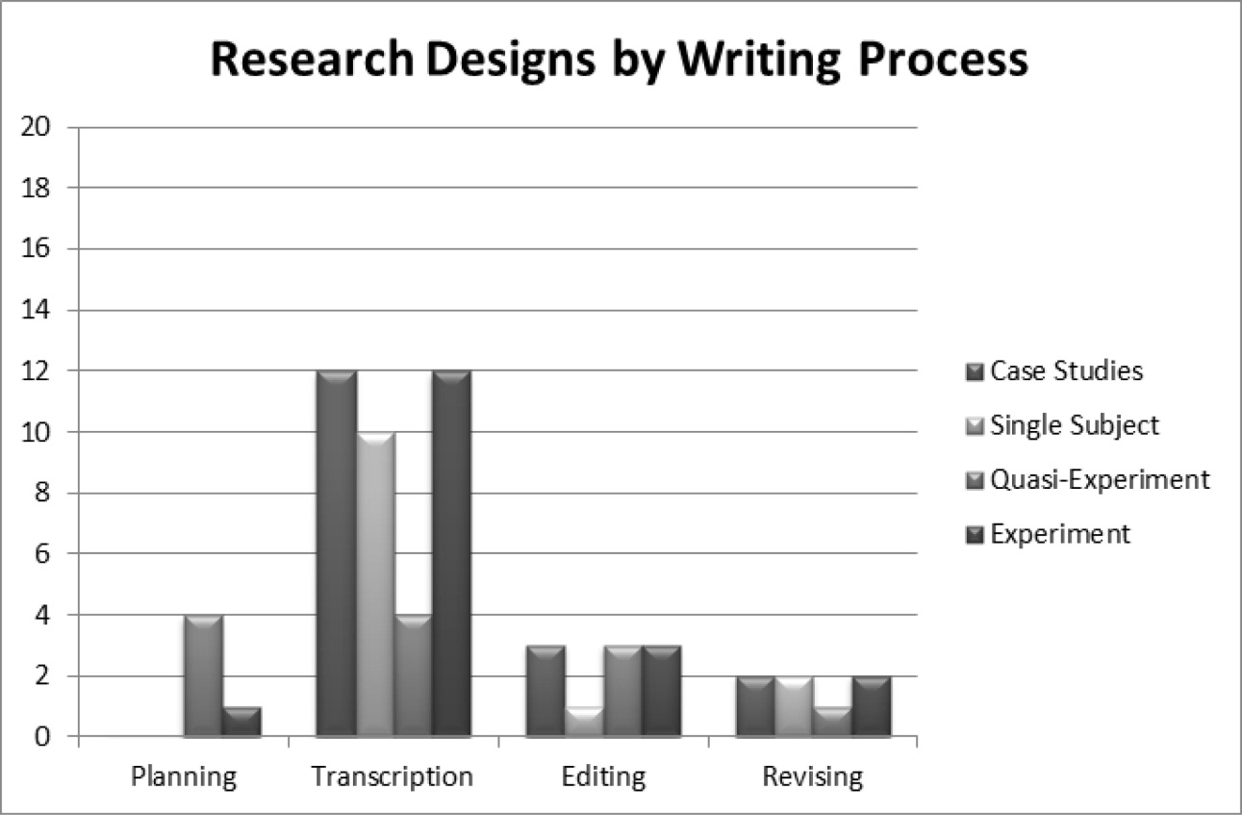
Figure 4. Frequency of research studies by design across the writing processes.

Technologies that Support Compositional Writing Across the Critical Writing Processes
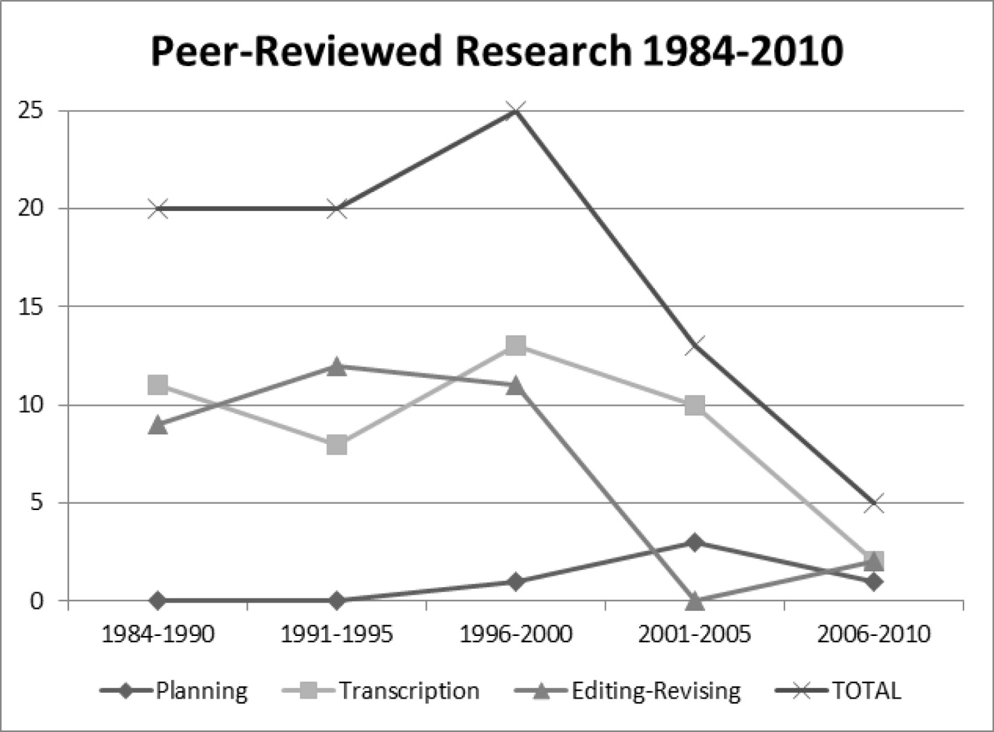
Figure 5. Frequency of applied research with students with learning and academic disabilities.

Despite the limitations of the overall scope and currency of the evidence base, it is still useful to examine the frequency and characteristics of the research base for the various tools that are available to support each of the four compositional writing processes. In addition, it is also useful to identify what we know and what we do not know based on existing evidence, despite the limited scope. This section will address the overall characteristics and general findings from the research; detailed analyses are available elsewhere (Peterson-Karlan, 2011).

Technology to Support Planning
There are only five studies in the research base that have examined the effect of using digital planning and organization tools on the compositional writing of students with learning and academic disabilities (see Table 1) [See also Appendix A]. Among these five studies are one that examined the use of a prompted outline tool, and four that examined the use of prompted graphic organizers. In all four studies, these tools were combined with use of a word processor to produce the written composition. ‘Prompt’ is used here to refer to on-screen text that provides specific content or procedural prompts; if text-to-speech were available, auditory presentation of the prompt was also possible. Unfortunately, three of the studies used technology that is not commercially available; the technology was custom developed for the series of research studies in order to provide ‘proof of concept.’
What we do know is based both on direct evidence (i.e., direct investigation of the effectiveness of the digital tool), and indirect evidence (i.e., direct evidence of an effective strategy that is applied to a tool that uses the strategy). A large base of indirect evidence (Englert, Manalo, & Zhao, 2004; Englert, Wu, & Zhao, 2005; Englert, Zhao, Dunsmore, Collings, & Wolbers, 2007; Graham, MacArthur, & Fitzgerald, 2007) suggests that the planning and organization skills of students with learning and academic disabilities can be improved and that tools must provide both procedural facilitation and text structure supports. Market survey indicates that such tools exist (e.g., Draft:Builder®; Kurzweil 3000; Read & Write Gold). However, there is a great need for additional research that directly examines the effectiveness of these tools on the compositional writing of students with learning and academic disabilities.
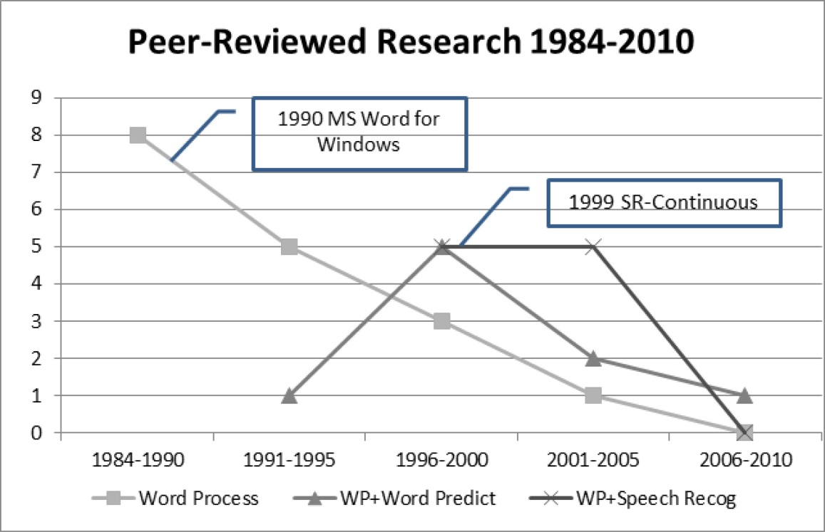
Figure 6. Frequency of applied transcription research studies with students with learning and academic disabilities.

Technology to Support Transcription
Table 1
Applied Research Studies with Students with Learning and Academic Disabilities by Writing Process and Digital Tool 1984-2010

Writing Process | Digital Tool | N of Studies | % of Studies
Plan-Organize | Word Processor (WP) + Prompted Outline | 1 | 20.0%
Plan-Organize | WP + Prompted Graphic Organizer | 1 | 20.0%
Plan-Organize | WP + Graphic Organizer + Prompts | 3 | 60.0%
Transcribe | Keyboarding | 9 | 20.0%
Transcribe | Word Processor (WP) | 17 | 37.8%
Transcribe | WP + Word Prediction | 9 | 20.0%
Transcribe | WP + Speech Recognition | 10 | 22.2%
Edit | Spellchecker | 9 | 90.0%
Edit | Grammar checker | 1 | 10.0%
Revise | Word Processor (WP) | 8 | 32.0%
Revise | WP + Peer Strategies | 10 | 40.0%
Revise | WP + Procedural Facilitation | 2 | 8.0%
Revise | WP + Digital Prompting | 1 | 4.0%
Revise | WP + Text-to-Speech | 4 | 16.0%

There are a total of 45 applied studies in the research base that have examined the effect of transcription tools on compositional writing by students with learning and academic disabilities; this includes (see Table 1) studies of keyboard training or use (N=9), word processors use (N=17), use of word processors with word prediction (N=9), and use of speech recognition word processors (N=10). Given the problems associated with technological development discussed above, a number of tentative findings can be drawn from this research. First, word processors used alone increase the legibility of the written composition and increase transcription speed; however, only to the extent that students have obtained ‘competent’ levels of keyboarding speed. Word prediction, when used with word processors, increases transcription accuracy, may increase word fluency (which was often not measured), and may increase compositional quality (although not directly). Writing quality is a multi-dimensional outcome construct (Graham & Perin, 2007) of which word fluency is only one aspect. Increases in word fluency when using word prediction contribute, in part, to compositional quality but not to the effect that organization or use of detail does, for example. The research with students with learning and academic disabilities using current, continuous speech recognition systems is too limited, and the variables involving both the technology (e.g., recognition accuracy) and the user (e.g., severity of spelling errors, operational competence in transcription and transcription error correction) are too complex to yield any useful tentative conclusions beyond the fact the students can learn to use them to produce written compositions.

Technology to Support Editing and Revising
As used here, editing is the process of ‘proofreading’ the written composition, either after or during transcription for accuracy of spelling, punctuation and grammar The primary editing tool that has been investigated is the word processor spellchecker (N=9 studies) with only one study found investigating use of a grammar checker by students with learning and academic disabilities (see Table 1). This research yields one preliminary finding: that teaching students with learning and academic disabilities to use spellchecking strategies combined with text-to-speech output spellcheckers increases compositional accuracy. These findings are further limited to the more recent word processors that use new algorithms for identifying errors and suggesting alternative words.
Table 2
Criteria for an ‘Evidence-Based Practice’

Quasi-Experimental & Experimental Design Studies | Single-Subject Design Studies
There are at least four acceptable quality studies, or two high quality studies that support the practice;  and  The weighted effect size is significantly greater than zero. | The experimental effects of minimally acceptable studies must be replicated across  - A minimum of five acceptable single-subject studies  - Conducted by at least three different researchers across at least three different geographical locations  - And include a total of at least 20 participants

As used here, revising is the process of making improvements to the structure of the composition including organization, coherence, use of detail, etc. There are 25 applied studies of revising written compositions by students with learning and academic disabilities in the research evidence base. The majority these being either investigation of the use of the word processor alone (N=8) or in combination with either procedural facilitation (strategy use; N=2) or peer review strategies (N=10). There are a very small number of studies investigating the use of a digital prompting tool (N=1) and use of text-to-speech aided screen review of the written composition (N=4). The major limitation to identifying any overall findings is the number of studies; there are only five studies, of all 25, that employed non-case study designs, including only two each for the effect of word processor use and word processor with procedural facilitation, and one study of the use of a digital prompting tool. This is too small a sample to draw any reliable or valid conclusions regarding the effect of technology on revising written compositions by students with learning and academic disabilities.

Conclusions and Implications
The purpose of this literature research was to determine what is known from empirical research on technologies to support writing and whether technology to support writing is an evidence-based practice. Based standards recently proposed for determining whether a practice is evidence-based, Table 2 provides the criteria for ‘acceptable’ and ‘high quality’ experimental and quasi-experimental (Gersten et al., 2005) and single-subject designs (Horner et al., 2005).
The terms acceptable and high quality refer to characteristics of the procedures and methodology of the studies; details of these internal characteristics can be found within the references cited. For this review, it is assumed that the internal characteristics have been addressed through the peer review process, although this will need to be confirmed in follow-up investigations of the studies in this evidence base. The focus here is on two necessary conditions: (a) Are there enough studies to establish an evidence-based practice? (assuming that the studies are either acceptable or of high quality); and (b) Are there enough participants in the studies to establish an evidence-based practice? Table 3 presents the results of this analysis using the evidence base identified for technology to support writing by students with learning and academic disabilities.
Table 3
Analysis of Technologies to Support Writing as Evidence-Based Practice

 | Case Studies | Single Subject | Quasi-Experiment | Experimental | TOTAL
Planning & Organization
 | N Studies
All Tools | 0 | 0 | 4 | 1 | 5
 | N Students
All Tools | -- | -- | 64 | 35 | 99
Transcription
 | N Studiesª
Word Processor (WP) | 2 | 4 | 3 | 8 | 17
WP+Word Prediction | 2 | 5 | 0 | 2 | 9
WP+Speech Recognition^{b} | 8 | 1 | 1 | 2 | 12
 | N Students
Word Processor (WP) | 12 | 19 | 106 | 794 | 931
WP+Word Prediction | 6 | 21 | 0 | 297 | 324
WP+Speech Recognition | 45 | 3 | 23 | 72 | 143
Editing
 | N Studies
Spellchecker | 3 | 1 | 3 | 2 | 9
Grammar Checker | 0 | 0 | 0 | 1 | 1
 | N Students
Spellchecker | 66 | 3 | 72 | 296 | 437
Grammar Checker | 0 | 0 | 0 | 203 | 203
Revising
 | N Studies
Word Processor (WP) | 2 | 1 | 1 | 0 | 4
WP+Procedural Facilitation^{c} | 0 | 1 | 0 | 1 | 2
WP+Digital Prompting^{d} | 0 | 0 | 0 | 1 | 1
 | N Students
Word Processor (WP) | 12 | 4 | 11 | 0 | 27
WP+Procedural Facilitation | 0 | 3 | 0 | 28 | 31
WP+Digital Prompting | 0 | 0 | 0 | 57 | 57
Notes:
ª Omitted Keyboarding Studies (N=9), ^{b} Two articles reported 2 studies, ^{c} Omitted WP+Text-to-Speech (N=4), ^{d} Omitted WP+Peer Strategies (N=10)

Planning and Organization Tools
There is not a sufficient number of experimental or quasi-experimental (N=5) nor are there any single subject design studies to support the use of digital planning and organizing tools as an evidence-based practice (See Table 3).

Transcription Tools
There are a sufficient number of experimental or quasi-experimental design studies (N=11) of the effects of word processing on the compositional writing of students with learning and academic disabilities to warrant further analysis and meta-analysis of the necessary effect sizes (see Table 3). There needs to be two additional single-subject design studies before determining whether these studies collectively support the use of the word processor as an evidence-based practice. There is not a sufficient number of experimental or quasi-experimental (N=2) design studies regarding the use of word processors with word prediction. One more single subject design study (N=5) of word predication used with a word processor is needed; however, there are a sufficient number of participants (N=21) to perhaps warrant further meta-analysis of the results of the use of these tools on the compositional writing of students with learning and academic disabilities. There are an insufficient number of either experimental or quasi-experimental (N=3) and single subject (N=1) design studies to determine whether the use of speech recognition (speech-to-text) combined with word processors is an evidence-based practice. If at least two of the experimental or quasi-experimental were found to be ‘high quality’ then a conclusion might be possible regarding the use of word prediction and speech recognition combined with word processing as evidence-based practices.

Editing & Revising Tools
The use of spellcheckers as an evidence-based practice to support compositional writing of students with learning and academic disabilities is supported by five experimental or quasi-experimental design studies, but only one single subject design study (see Table 2). If the experimental or quasi-experimental design studies meet the criteria for either acceptable or high quality studies, further analysis or meta-analysis are warranted to determine the necessary effect sizes. Grammar checkers have received little attention in the research on compositional writing by students with learning and academic disabilities; in fact, only one experimental design study could be located. Digital tools to support revising of written compositions by students with learning and academic disabilities has also received little attention, with a total of only seven studies across all three types of tools (see Table 3). There were not even two experimental or quasi-experimental design studies found for any one of the three types of tools (word processor, WP with procedural facilitation, or WP with digital prompting).

Summary
The extent and quality of the digital technology applied research evidence base reviewed here is alarming considering the: (a) importance of compositional writing in post-secondary education and in the workplace; (b) performance of struggling writers, including those with learning and academic disabilities on assessments such as the NAEP; (c) significant trends in writing technology development over the past 25 years; and (d) trends in availability and use of computers and digital technologies by all school-aged children, including those who struggle to write. While there may be just enough applied research to establish ‘promising’ technology practices and, in a few cases, perhaps even ‘evidence-based practices,’ there are major gaps at all levels of the writing process in the applied research base. Of perhaps greatest concern is the fact that the trends in amount or research published in peer-reviewed journals (a necessary criterion for determining an evidence-based practice) is decreasing as digital tools (e.g., netbooks and tablet computers) are increasingly present in school settings.
Given the insufficient size and the extent of outdated technology in the research base, we should be very wary of published work that recommends the use of technology to support compositional writing by these students as though it were an evidence-based practice. Similarly, published conclusions regarding the ineffectiveness of digital writing support technologies are also to be greeted with skepticism. There is one overriding conclusion that presents itself without even the support of meta-analytic analysis of the existing research base: We need more and better research on current technologies that support compositional writing by students with learning and academic disabilities and we need it now! The questions to be answered are not new. Is it effective in improving the quality of compositions? While this is the ultimate outcome of students with learning and academic disabilities using technology to write, in the larger scope of a research program, another question is equally, if not more, relevant: How does technology support compositional writing? To address this question, it will be necessary to measure more than compositional quality using, for example, 6-trait rubrics. A range of variables has been identified through systematic synthesis of the existing research that impact the overall quality of compositions produced by students with learning and academic disabilities (Peterson-Karlan, 2011; Peterson-Karlan & Parette, 2007). These variables include, among others, operational competence in using technology, organization and completeness of the content structure of the various compositional writing tasks (e.g., narrative, compare-and-contrast expository, persuasive argument, etc); transcription speed; conventional accuracy (spelling, punctuation, grammar); and word fluency and use of supporting detail. In the systematic program of research that is needed, current and emerging technologies will be integrated with those writing interventions that have been demonstrated to be effective (e.g., Graham, MacArthur, & Fitzgerald, 2007; Graham & Perin, 2007). Such research will systematically expand our knowledge and establish effective technology-supported instructional practices for students with learning and academic disabilities who struggle to write in a digital age.

References
ACT. (2005). Crisis at the core: Preparing all students for college and work. Retrieved from http://www.act.org/path/policy/alert/crisis.html
Cochran-Smith, M. (1991). Word processing and writing in elementary classrooms: A critical review of the literature. Review of Educational Research, 61(1), 107-155.
Forgrave, K. E. (2002). Assistive technology: empowering students with learning disabilities. Clearing House, 75, 122-126.
Gersten, R., Fuchs, L. S., Compton, D., Coyne, M., Greenwood, C. R., & Innocenti, M. S. (2005). Quality indicators for group experimental and quasi-experimental research in special education. Exceptional Children, 71(2), 149-164.
Goldberg, A., Russell, M., & Cook, A. (2003). The effect of computers on student writing: A meta-analysis of studies from 1992-2002. Journal of Technology, Learning, and Assessment, 2(1), 3-51.
Graham, S., MacArthur, C. A., & Fitzgerald, J. (2007). Best practices in writing instruction. New York: Guilford.
Graham, S., & Perin, D. (2007). A meta-analysis of writing instruction for adolescent students. Journal of Educational Psychology, 99, 445-476.
Graham, S., & Perin, D. (2007). Writing next: Effective strategies to improve writing of adolescents in middle and high schools. Retrieved from http://www.all4ed.org/
publications/WritingNext/index.html
Horner, R. H., Carr, E. G., Halle, J., McGee, G., Odom, S. L., & Wolery, M. (2005). The use of single-subject research to identify evidence-based practice in special education. Exceptional Children, 71, 165-169.
Hunt-Berg, M., & Rankin, J. L. (1994). Ponder the possibilities: Computer-supported writing for struggling writers. Learning Disabilities Research and Practice, 9, 169-178.
MacArthur, C. A. (2000). New tools for writing: Assistive technology for students with writing difficulties. Topics in Language Disorders, 20(4), 85-100.
MacArthur, C. A. (2009a). Reflections on research on writing and technology for struggling writers. Learning Disabilities Research and Practice, 24, 93-103.
MacArthur, C. A. (2009b). Using technology to teach composing to struggling writers. In G. A. Troia (Ed.), Instruction and assessment for struggling writers (pp. 243-265). New York: Guilford.
Montgomery, D. J., & Marks, L. J. (2006). Using technology to build independence in writing for students with disabilities. Preventing School Failure, 50(3), 33-38.
National Commission on Writing. (2003). The Neglected R: The need for a writing revolution. Retrieved from http://www.writingcommission.org/
National Commission on Writing. (2004). Writing: A ticket to work...Or a ticket out. Retrieved from http://www.writingcommission.org/
National Commission on Writing. (2006). Writing and school reform. Retrieved from http://www.writingcommission.org/
National Council of Teachers of English. (2004). NCTE beliefs about the teaching of writing. Retrieved from http://www.ncte.org/prog/writing/research/118876htm
National Writing Project, & Nagin, C. (2006). Because writing matters: Improving student writing in our schools. San Francisco: Jossey-Bass.
National Writing Project & DeVoss, D. N., Eidman-Aadahl, E. & Hicks, T. (2010). Because digital writing matters: Improving students writing online and in multimedia environments. San Francisco: Jossey-Bass.
Newcomer, P. L., & Barenbaum, E. M. (1991). The written composing ability of children with learning disabilities: A review of the literature from 1980 to 1990. Journal of learning Disabilities, 24, 578-593.
Odom, S. L., Brantlinger, E., Gersten, R., Horner, R. H., Thompson, B., & Harris, K. R. (2005). Research in special education: Scientific methods and evidence-based practices. Exceptional Children, 71, 137-148.
Okolo, C. M., & Bouck, E. C. (2007). Research about assistive technology: What have we learned? Journal of Special Education Technology, 22(3), 19-33.
Parette, H. P., Peterson-Karlan, G. R., & Wojcik, B. W. (2005). The state of assistive technology services nationally and implications for future development. Assistive Technology Outcomes and Benefits, 2(1), 13-24.
Persky, H. R., Daane, M. C., & Ying, J. (2002). The Nation's report card: Writing 2002. Retrieved from http://nces.ed.gov/
nationsreportcard/writing/results2002/
Peterson-Karlan, G. R. (2011). Technology to support writing by learners with academic & learning disabilities: What we know and what we need to know–1978-2010. Normal, IL: Illinois State University.
Peterson-Karlan, G. R., & Parette, H. P. (2007a). Evidence-based practice and the consideration of assistive technology. Assistive Technology Outcomes and Benefits, 4(1), 130-139.
Peterson-Karlan, G. R., & Parette, H. P. (2007b). Supporting struggling writers using technology: Evidence-based instruction and decision-making. Retrieved from http://www.cited.org/library/resourcedocs/TechnologyToSupportWritingSummary.pdf
Peterson-Karlan, G. R., & Parette, H. P. (2008). Integrating assistive technology into the curriculum. In H. P. Parette & G. R. Peterson-Karlan (Eds.), Research-based and emerging best practices in developmental disabilities (pp. 183-214). Austin: TX: Pro-Ed.
Rogers, L. A., & Graham, S. (2008). A meta-analysis of single subject design writing intervention research. Journal of Educational Psychology, 100, 879-906.
Russell, M. (1999). Testing on computers: A follow-up study comparing performance on computer and on paper. Education Policy Analysis Archives, 7(20), 1-50. Retrieved from http://epaa.asu.edu/ojs/article/
viewFile/555/678
Russell, M., & Abrams, L. (2004). Instructional uses of computers for writing: The effect of state testing programs. Teachers College Record, 106, 1332-1357.
Russell, M., Goldberg, A., & O'Connor, K. (2003). Computer-based testing and validity: A look back into the future. Assessment in Education: Principles, Policy & Practice, 10, 279-293.
Russell, M., & Haney, W. (1997). Testing writing on computers: An experiment comparing student performance on text conducted via computer and via paper-and-pencil. Education Policy Analysis Archives, 5(3), 1-15. Retrieved from http://epaa.asu.edu/ojs/article/viewFile/604/726
Russell, M., & Plati, T. (2001). Effects of computer versus paper administration of a state-mandated writing assessment. Teachers College Record [Online]. Retrieved from http://www.tcrecord.org.proxy.lib.ilstu.edu/library/PrintContent.asp?ContentID=10709
Russell, M., & Plati, T. (2002). Does it matter with what I write? Comparing performance on paper, computer and portable writing devices [Electronic version]. Current Issues in Education 5(4). Retrieved from http://cie.ed.asu.edu/
volume5/number4/
Sitko, M. C., Laine, C. J., & Sitko, C. J. (2005). Writing tools: Technology & strategies for struggling writers. In D. L. Edyburn, K. Higgins, & R. Boone (Eds.), Handbook of special education research and practice (pp. 571-598). Whitefish Bay, WI: Knowledge by Design.
U. S. Department of Education. (2003). Identifying and implementing educational practices supported by rigorous evidence: A user friendly guide. Retrieved from http://www2.ed.gov/rschstat/research/pubs/rigorousevid/rigorousevid.pdf
U.S. Department of Education, Institute of Education Sciences, National Center for Education Statistics, National Assessment of Educational Progress (NAEP), 1998, 2002 and 2007 Writing Assessment. (n.d). Retrieved from http://nationsreportcard.gov/writing_2007/w0002.asp
Zhao, Y. (2007). Speech technology and its potential for special education. Journal of Special Education Technology, 22(3), 35-41.

Appendix A.
Applied Research on Digital Technology to Support Instruction by Students with Learning and Academic Disabilities
Planning and Organization (N=5)
Bahr, C. M., Nelson, N. W., & Van Meter, A. (1996). The effects of text-based and graphics-based software tools on planning and organizing of stories. Journal of Learning Disabilities, 29, 355-370.
Englert, C. S., Manalo, M., & Zhao, Y. (2004). I can do it better on the computer: The effects of technology-enabled scaffolding on young writers' composition. Journal of Special Education Technology, 19(1), 5-21.
Englert, C. S., Wu, X., & Zhao, Y. (2005). Cognitive tools for writing: Scaffolding the performance of students through technology. Learning Disabilities Research and Practice, 20, 184-198.
Englert, C. S., Zhao, Y., Dunsmore, K., Collings, N. Y., & Wolbers, K. (2007). Scaffolding the writing of students with disabilities through procedural facilitation: Using an internet-based technology to improve performance. Learning Disability Quarterly, 30(1), 9-29.
Sturm, J. M., & Rankin-Erickson, J. L. (2002). Effects of hand-drawn and computer-generated concept mapping on the expository writing of middle school students with learning disabilities. Learning Disabilities Research and Practice, 17, 124-139.

Transcription (N=44)
Arnold, V., Joyner, R. L., Schmidt, B. J., & White, C. D. (1997). Establishing electronic keyboarding speed and accuracy timed-writing standards for postsecondary students. Business Education Forum, 51(3), 33-38.
Christensen, C. A. (2004). Relationship between orthographic-motor integration and computer use for the production of creative and well-structured written text. British Journal of Educational Psychology, 74, 551-564.
Coniam, D. (2001). Word-processing "efficiency” — by means of personalized word-frequency lists. Journal of Technical Writing and Communication, 31, 175-187.
Connelly, V., Gee, D., & Walsh, E. (2007). A comparison of keyboarded and handwritten compositions and the relationship with transcription speed. British Journal of Educational Psychology, 77, 479-492.
Crealock, C., & Sitko, M. (1990). Comparison between computer and handwriting technologies in writing training with learning disabled students. International Journal of Special Education, 5, 173-183.
Cullen, J., Richards, S. B., & Frank, C. L. (2008). Using software to enhance the writing skills of students with special needs. Journal of Special Education Technology, 23, 33-43.
Dalton, D. W., & Hannafin, M. J. (1987). The effects of word processing on written composition. Journal of Educational Research, 80, 338-342.
Faris-Cole, D., & Lewis, R. (2001). Exploring speech recognition technology: Children with learning and emotional/behavioral disorders. Learning Disabilities: A Multidisciplinary Journal, 11(1), 3-12.
Handley-More, D., Deitz, J., Billingsley, F. F., & Coggins, T. E. (2003). Facilitating written work using computer word processing and word prediction. American Journal of Occupational Therapy, 57, 139-151.
Hetzroni, O. E., & Shrieber, B. (2004). Word processing as an assistive technology tool for enhancing academic outcomes of students with writing disabilities in the general classroom. Journal of Learning Disabilities, 37, 143-154.
Higgins, E. L., & Raskind, M. H. (1995). Compensatory effectiveness of speech recognition on the written composition performance of postsecondary students with learning disabilities. Learning Disability Quarterly, 18, 159-174.
Jacobi, C. (1986). Word processing for special needs students: Is there really a gain? Educational Technology, 26, 36-39.
Kerchner, L. B., & Kistinger, B. J. (1984). Language processing/word processing: Written expression, computers and learning disabled students. Learning Disability Quarterly, 7, 329-335.
Koorland, M. A., Edwards, B. J., & Doak, P. (1996). Evaluating a systematic keyboarding strategy for students with learning disabilities. Computers in the Schools, 12(3), 13-20.
Langone, J., Levine, B., Clees, T. J., Malone, M., & Koorland, M. A. (1996). The differential effects of a typing tutor and microcomputer-based word processing on the writing samples of elementary students with behavior disorders. Journal of Research on Computing in Education, 29, 141-158.
Langone, J., Willis, C., & Malone, D. M. (1994/1995). Effects of computer-based word processing versus paper/pencil activities on the paragraph construction of elementary students with learning disabilities. Journal of Research on Computing in Education, 27, 171-183
Lewis, R. B., Graves, A. W., Ashton, T. M., & Kieley, C. L. (1998). Word processing tools for students with learning disabilities: A comparison of strategies to increase text entry speed. Learning Disabilities Research and Practice, 13, 95-108.
Litten, M. (1999). Introducing voice recognition to dyslexic users in a specialist school. Dyslexia, 5, 118-122.
MacArthur, C. A. (1998). From illegible to understandable: How word recognition and speech synthesis can help. Teaching Exceptional Children, 30(6), 66-71.
MacArthur, C. A. (1998). Word processing with speech synthesis and word prediction: Effects on the dialogue journal writing of students with learning disabilities. Learning Disability Quarterly, 21, 151-166.
MacArthur, C. A. (1999). Word prediction for students with severe spelling problems. Learning Disability Quarterly, 22, 158-172.
MacArthur, C. A., & Cavalier, A. R. (2004). Dictation and speech recognition technology as test accommodations. Exceptional Children, 71, 43-58.
MacArthur, C. A., & Graham, S. (1987). Learning disabled students' composing under three methods of text production: Handwriting, word processing, and dictation. Journal of Special Education, 21(3), 22-42.
MacArthur, C. A., Graham, S., & Schwartz, S. S. (1993). Integrating strategy instruction and word processing into a process approach to writing instruction. School Psychology Review, 22, 671-681.
MacArthur, C. A., Graham, S., Schwartz, S. S., & Schafer, W. (1995). Evaluation of a writing instruction model that integrated a process approach, strategy instruction, and word processing. Learning Disability Quarterly, 18, 278-291.
MacArthur, C. A., Schwartz, S. S., & Graham, S. (1991). A model for writing instruction: Integrating word processing and strategy instruction into a process approach to writing. Learning Disabilities Research and Practice, 6, 230-236.
MacArthur, C. A., & Shneiderman, B. (1986). Learning disabled students' difficulties in learning to use a word processor: Implications for instruction and software evaluation. Journal of Learning Disabilities, 19, 248-253.

Millar, D. C., McNaughton, D. B., & Light, J. C. (2005). A comparison of accuracy and rate of transcription by adults with learning disabilities using a continuous speech recognition system and a traditional computer keyboard. Journal of Postsecondary Education and Disability, 18(1), 12-22.
Morocco, C. C., Dalton, B., & Tivnan, T. (1992). The impact of computer-supported writing instruction on fourth-grade students with and without learning disabilities. Reading and Writing Quarterly, 8, 87-113.
Neuman, S. B., & Cobb-Morroco, C. (1987/1988). Writing with word processors for remedial students. The Computing Teacher (December/January), 45-47, 61.
Neuman, S. B., & Morocco, C. C. (1987). Two hands is hard for me: Keyboarding and learning disabled children. Educational Technology, 27, 36-38.
Nichols, L. M. (1995). A comparison of two methods for teaching keyboarding in the elementary school. Computers in the Schools, 11(4), 15-25.
O'Hare, E. A., & McTear, M. F. (1999). Speech recognition in the secondary school classroom: An exploratory study. Computers and Education, 33(1), 27-45.
Okolo, C., Hinsey, M., & Yousefian, B. (1990). Learning disabled students' acquisition of keyboarding skills and continuing motivation under drill-and-practice and game conditions. Learning Disabilities Research and Practice, 5, 100-109.
Outhred, L. (1989). Word processing: Its impact on children's writing. Journal of Learning Disabilities, 22, 262-264.
Quinlan, T. (2004). Speech recognition technology and students with writing difficulties: Improving fluency. Journal of Educational Psychology, 96, 337-346.
Roberts, K. D., & Stodden, R. A. (2005). The use of voice recognition software as a compensatory strategy for postsecondary education students receiving services under the category of learning disabled. Journal of Vocational Rehabilitation, 22(1), 49-64.
Sanderson, A. (1999). Voice recognition software: A panacea for dyslexic learners or a frustrating hindrance. Dyslexia, 5, 114-118.
Utay, C., & Utay, J. (1997). Peer-assisted learning: The effects of cooperative learning and cross-age peer tutoring with word processing on writing skills of students with learning disabilities. Journal of Computing in Childhood Education, 8, 165-185.
Vacc, N. N. (1987). Word processor versus handwriting: A comparative study of writing samples produced by mildly mentally handicapped students. Exceptional Children, 54, 156-165.
Wetzel, K. (1996). Speech-recognizing computers: A written-communication tool for students with learning disabilities? Journal of Learning Disabilities, 29, 371-380.
Williams, S. C. (2002). How speech-feedback and word-prediction software can help students write. Teaching Exceptional Children, 34(3), 72-78.
Zhang, Y. (2000). Technology and the writing skills of students with learning disabilities. Journal of Research on Computing in Education, 32, 467-478.
Zhang, Y., Brooks, D. W., Fields, T., & Redelfs, M. (1995). Quality of writing by elementary students with learning disabilities. Journal of Research on Computing in Education, 27, 483-499.

Editing & Revising (N=34)
Borgh, K., & Dickson, W. P. (1992). The effects on children's writing of adding speech synthesis to a word processor. Journal of Research on Computing in Education, 24, 533-544.
Cullen, J., Richards, S. B., & Frank, C. L. (2008). Using software to enhance the writing skills of students with special needs. Journal of Special Education Technology, 23, 33-43.

Daiute, C. (1986). Physical and cognitive factors in revising: Insights from studies with computers. Research in the Teaching of English, 20, 141-158.
Daiute, C., & Kruidenier, J. (1985). A self-questioning strategy to increase young writers' revising processes. Applied Psycholinguistics, 6, 307-318.
Dalton, B., Winbury, N. E., & Cobb-Morroco, C. (1990). "If you could just push a button": Two fourth grade boys with learning disabilities learn to use a computer spelling checker. Journal of Special Education Technology, 10, 177-191.
Gerlach, G. J., Johnson, J. R., & Ouyang, R. (1991). Using an electronic spell checker to correct misspelled words and verify correctly spelled words. Reading Improvement, 28, 188-194.
Graham, S., & MacArthur, C. A. (1988). Improving learning disabled students' skills at revising essays produced on a word processor: Self-instructional strategy training. Journal of Special Education, 22, 133-152.
Gupta, R. (1998). Can spelling checkers help the novice writer? British Journal of Educational Technology, 29, 255-266.
Jacobi, C. (1986). Word processing for special needs students: Is there really a gain? Educational Technology, 26, 36-39.
Jinkerson, L., & Baggett, P. (1993). Spell checkers: Aids in identifying and correcting spelling errors. Journal of Computing in Childhood Education, 4, 291-306.
Jones, I. (1994). The effect of a word processor on the written composition of second-grade pupils. Computers in the Schools, 11(2), 43-54.
Kurth, R., J. (1987). Using word processing to enhance revision strategies during student writing activities. Educational Technology, 27, 13-19.
Lange, A. A., McPhillips, M., Mulhern, J., & Wylie, J. (2006). Assistive software tools for secondary-level students with literacy difficulties. Journal of Special Education Technology, 21(3), 13-22.
Lewis, R. B., Ashton, T. M., Haapa, B., Kieley, C. L., & Fielden, C. (1999). Improving the writing skills of students with learning disabilities: Are word processors with spelling and grammar checkers useful? Learning Disabilities: A Multidisciplinary Journal, 9(3), 87-98.
Lewis, R. B., Graves, A. W., Ashton, T. M., & Kieley, C. L. (1998). Word processing tools for students with learning disabilities: A comparison of strategies to increase text entry speed. Learning Disabilities Research and Practice, 13, 95-108.
MacArthur, C. A. (1994). Peers + word processing + strategies = A powerful combination for revising student writing. Teaching Exceptional Children, 27(1), 24-29.
MacArthur, C. A. (1996). Using technology to enhance the writing processes of students with learning disabilities. Journal of Learning Disabilities, 29, 344-354.
MacArthur, C. A., & Graham, S. (1987). Learning disabled students' composing under three methods of text production: Handwriting, word processing, and dictation. Journal of Special Education, 21(3), 22-42.
MacArthur, C. A., Graham, S., Haynes, J. B., & DeLaPaz, S. (1996). Spelling checkers and students with learning disabilities: Performance comparisons and impact on spelling. Journal of Special Education, 30(1), 35-57.
MacArthur, C. A., Graham, S., & Schwartz, S. S. (1993). Integrating strategy instruction and word processing into a process approach to writing instruction. School Psychology Review, 22, 671-681.
MacArthur, C. A., Graham, S., Schwartz, S. S., & Schafer, W. (1995). Evaluation of a writing instruction model that integrated a process approach, strategy instruction, and word processing. Learning Disability Quarterly, 18, 278-291.
MacArthur, C. A., Schwartz, S. S., & Graham, S. (1991). Effects of a reciprocal peer revision strategy in special education classrooms. Learning Disabilities Research and Practice, 6, 201-210.

MacArthur, C. A., Schwartz, S. S., & Graham, S. (1991). A model for writing instruction: Integrating word processing and strategy instruction into a process approach to writing. Learning Disabilities Research and Practice, 6, 230-236.
MacArthur, C. A., & Shneiderman, B. (1986). Learning disabled students' difficulties in learning to use a word processor: Implications for instruction and software evaluation. Journal of Learning Disabilities, 19, 248-253.
McNaughton, D., Hughes, C., & Clark, K. (1997). The effect of five proofreading conditions on the spelling performance of college students with learning disabilities. Journal of Learning Disabilities, 30, 643-651.
McNaughton, D., Hughes, C., & Ofiesh, N. (1997). Proofreading for students with learning disabilities: Integrating computer and strategy use. Learning Disabilities Research and Practice, 12, 16-28.
Owston, R. D., & Wideman, H. H. (1997). Word processors and children's writing in a high-computer access setting. Journal of Research on Computing in Education, 30, 202-219.
Raskind, M. H., & Higgins, E. L. (1995). Effects of speech synthesis on the proofreading efficiency of postsecondary students with learning disabilities. Learning Disability Quarterly, 18, 141-158.
Stoddard, B., & MacArthur, C. A. (1993). A peer editor strategy: Guiding learning-disabled students in response and revision. Research in the Teaching of English, 27(1), 76-103.
Vacc, N. N. (1987). Word processor versus handwriting: A comparative study of writing samples produced by mildly mentally handicapped students. Exceptional Children, 54, 156-165.
Wong, B. Y. L. (1994). Teaching problem learners revision skills and sensitivity to audience through two instructional modes: Student-teacher versus student-student interactive dialogues. Learning Disabilities Research and Practice, 9, 78-90.
Wong, B. Y. L. (2000). Writing strategies instruction for expository essays for adolescents with and without learning disabilities. Topics in Language Disorders, 20(4), 29-44.
Wong, B. Y. L., Butler, D. L., Ficzere, S. A., & Kuperis, S. (1997). Teaching adolescents with learning disabilities and low achievers to plan, write, and revise compare-and-contrast essays. Learning Disabilities Research and Practice, 12, 2-15.
Wong, B. Y. L., L, B. D., Ficzere, S. A., & Kuperis, S. (1996). Teaching low achievers and students with learning disabilities to plan, write, and revise opinion essays. Journal of Learning Disabilities, 29, 197-212.


CALL FOR PAPERS

Assistive Technology Outcomes and Benefits
SPECIAL ISSUE on Assistive Technology and Higher Education

Volume 8, Spring 2012
Submission deadline: October 15, 2011

Special Issue Editor:
Jeffrey P. Bakken, Illinois State University

The Special Issue Editor of Assistive Technology Outcomes seeks manuscript submissions addressing the use of technology to teach or support higher education curricula. Authors are encouraged to focus on the outcomes and benefits of the use of instructional, assistive, and/or information and communication technologies for (a) the preparation of preservice students, (b) issues and strategies regarding technology integration in the curriculum, and (c) innovative models.

Manuscripts must adhere to APA (5th ed.) format, and be no longer than 25 pp. of text, including tables, figures, and references. An abstract must be included along with a specific section in the manuscript narrative titled ‘Outcomes and Benefits.’ Tables must be created using the table feature in a word processing program (i.e., no carriage returns for setting up columns). All figures should be in a .jpg, .tiff, or other high quality format compatible with Microsoft® Word and appropriately placed within the narrative. (NOTE: Do NOT use graphics features within Microsoft® Word to create figures; all figures must be created in an appropriate graphics software program allowing the user to save in a .jpg or .tiff format and embed the figure in narrative).

Timelines for publication of this special issue:
Article Submission Deadline: October 15, 2010
Reviews Completed: November 15, 2011
Revisions Due to Editors: December 15, 2011
Editors Revise: January 15, 2012
Layout and production: February 15, 2012

To be considered, all manuscripts should be sent electronically as an attachment to the Special Issue Editor: jpbakke@ilstu.edu by October 15.
For specific information on how to submit manuscripts see the Guidelines for Authors at http://atobjournal.org
Book Notes (2–4 pages) offers reviews of current books and other publications of interest to individuals involved in teacher preparation. Only reviews of recently published books will be considered. Book reviews are solicited by invitation; however, persons interested in doing a review may contact the Editor.
Manuscript Preparation and Submission
All original manuscripts should be submitted directly to the Special Issue Editor, Jeff Bakken, (jpbakke@ilstu.edu) as an email attachment in MS Word format along with a cover letter stating that the manuscript has not been published elsewhere and is currently not under consideration by another journal or publisher. Address: Jeffrey P. Bakken, Special Issue Editor, Assistive Technology Outcomes and Benefits, Department of Special Education, Illinois State University, Box 5910, Normal, IL 61790-5910.
Guidelines specified in the Publication Manual of the American Psychological Association (APA; 5th ed., 2001) must be followed. All submissions will be initially reviewed by the Editor for appropriateness prior to sending to reviewers, and will be returned to any author/s if proper APA formatting is not present.
General
- Manuscript cover page should include
  - Running head with pagination (and on each successive page)
  - Title (up to 10 words)
  - Author’(s’) full name(s)
  - Organization(s)
  - Full contact information of the corresponding author, including email address, postal address, telephone, and fax numbers
- Abstract (75 to 150 words) presenting the main points of the manuscript and the conclusions regarding outcomes and benefits
- Keywords: 3-4 keywords, separated by commas (e.g., Assistive technology, Direct instruction, Product development)
- Manuscripts should be double spaced, using left justification, Times or Times New Roman font, and 12-pt. type.
- Main body of paper using APA (5th ed.) format and appropriate heading styles. Manuscripts should be no more than 25 pages in length (double-spaced), including references, tables, and figures. A heading titled ‘Outcomes and Benefits’ must be included at the end of the manuscript.
- Set all margins to 1 inch on 8½ in. x 11 in. paper.
- Place all figures and tables on the page in which they occur IF they fit within the margins of the page. If a table must be presented in horizontal format (i.e., 11 in. x 8½ in) it should be attached at the back of the manuscript, with brackets indicating its location in boldface, enclosed in angle brackets, on a separate line. Example: <Table 1 here>
- Do NOT use the tab key or space bar for head alignments and centering functions in tables. Use the tab settings such that all elements in a column have the same alignment. DO NOT USE THE SPACE BAR OR TAB KEY when entering references. Set reference entries with a hanging indent of three spaces.
- Use double quotation marks ONLY for quoted material with appropriate citation; use single quotation marks or italics for narrative emphasis.
- Do not use endnotes or footnotes.
- The Editor will acknowledge receipt of a submitted article immediately.
- Authors are encouraged to write in the third person and use ‘person-first’ language, i.e., the individual precedes the disability. For example, phrases such as ‘persons with disabilities,’ ‘students with mental retardation,’ ‘and ‘adults with cognitive impairments’ are more appropriate than such phrases as ‘the disabled,’ ‘learning disabled students,’ or ‘mentally retarded adults.’
Artwork
All figures included in manuscripts must be provided in production-ready format. Acceptable electronic formats for figures or other art include JPG, TIFF, and EPS. Word Art is unacceptable. Scans must be at least 300 dpi (sometimes called lpi). On acceptance of a manuscript and at the galley review stage, authors will be asked to provide alternative text descriptions for artwork.
Permissions
Authors are responsible for obtaining written permissions and/or fees for use of or adapted materials including figures, tables, art, and extensive quotes taken directly—or adapted in minor ways—from another source. If fees or permissions are required for use or adaptation of materials included in the manuscript, authors should begin the request process as soon as possible. [Note: Authors should not assume that material taken from software or downloaded from the Internet may be used without obtaining permission.] Failure to obtain permission will result in either removal of the particular item or the article being pulled from the journal issue.
Ordering Journal Copies
Information regarding all issues of ATOB is available at the ATOB Web site (http://atobjournal.org). Each issue is available in hardcopy format by clicking on ATOB Online Print-On-Demand. The journal is also archived in ERIC and Ebsco Host. A complimentary .pdf file of the published article will be sent to each author via email.
Editor
Howard P. Parette, Jr.
Department of Special Education
Illinois State University
Box 5910
Normal, IL 61790-5910
E-mail: hpparet@ilstu.edu

